School Name
Title of Handbook
AY XX/XX

Table of Contents
1. General Regulations 2
2. Student Services 2
2.1 Academic Support 8
2.2 Health and Wellbeing Support 8
2.3 Getting Involved 8
2.4 Financial Support 9
2.5 Administrative Support 9
2.6 Your Tutor 10
2.7 Postgraduate Advisory Service 10
2.8 The Academic Registry 11
2.9 Information on key campus locations 11
2.10 Student Representation and Governance 11
2.11 Careers Information 12
3. Academic Writing 13
3.1 Plagiarism and Referencing Guide 13
3.2 Research Ethics 13
4. General Information 14
4.1 Emergency Procedure 14
4.2 Health and Safety Statements 14
4.3 COVID-19 Information 14
4.4 Data Protection 14
4.5 Explanation of ECTS Weighting 15
4.6 Links to Further University Policies and Procedures 15

Trinity Visual Identity Guidelines
Trinity Handbook Template

Accessible Information Policy

Note: This document is a template for Schools/Disciplines. There may be additions/amendments appropriate to the needs of an individual School that reflect the local regulations of the School/Discipline and are in accordance with the Calendar.

General Regulations
Standard Text: In the event of any conflict or inconsistency between the General Regulations published in the University Calendar and information contained in programme or local handbooks, the provisions of the General Regulations in the Calendar will prevail.
Reference/Source
Calendar
Calendar Part II, Part B: General Regulations and Information
Calendar Part III, Section 1: General Academic Regulations

Student Services
Student Services has developed the handbook (embedded below) outlining the support services provided to undergraduate and postgraduate students. The handbook and further information is available from their website and in the Student Services Handbook. School/Department Handbooks can provide a link to the PDF or embed the PDF within the Handbook itself.
Reference/Source: Student Supports & Services

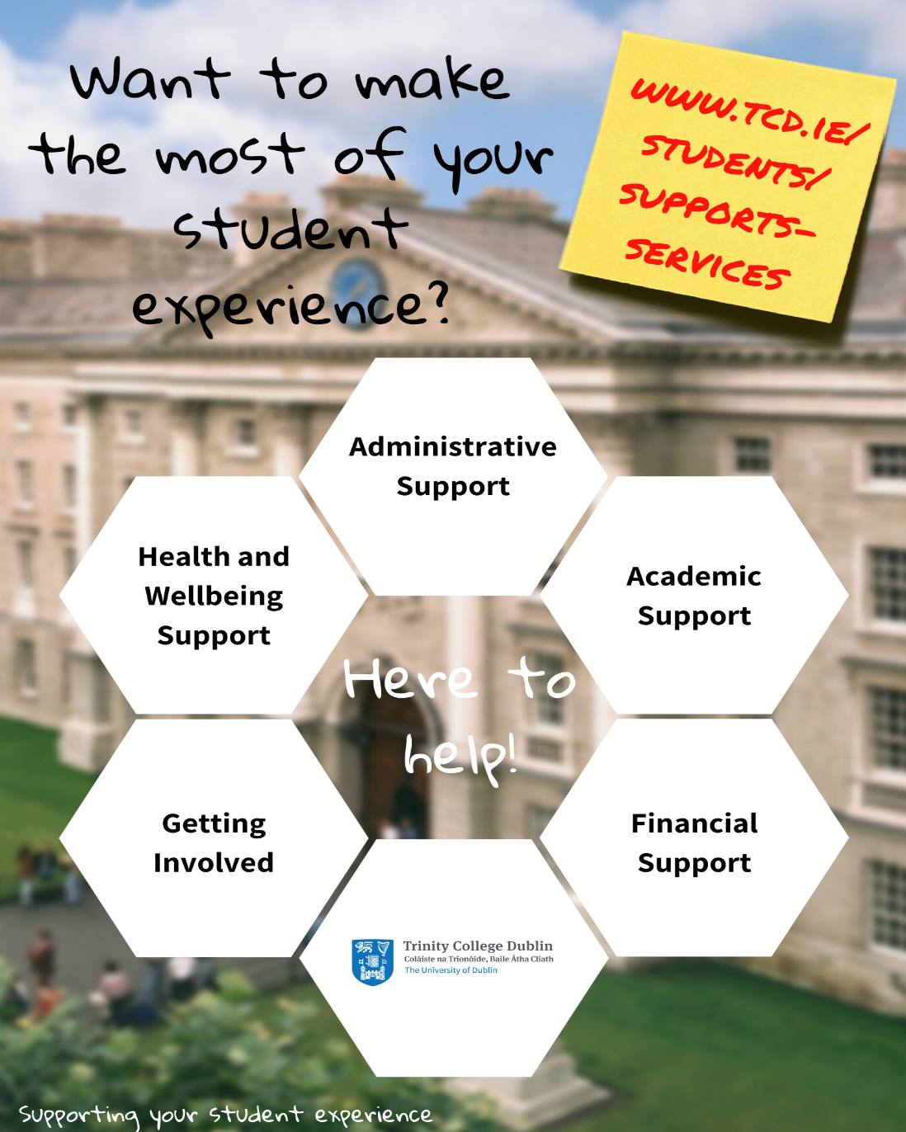
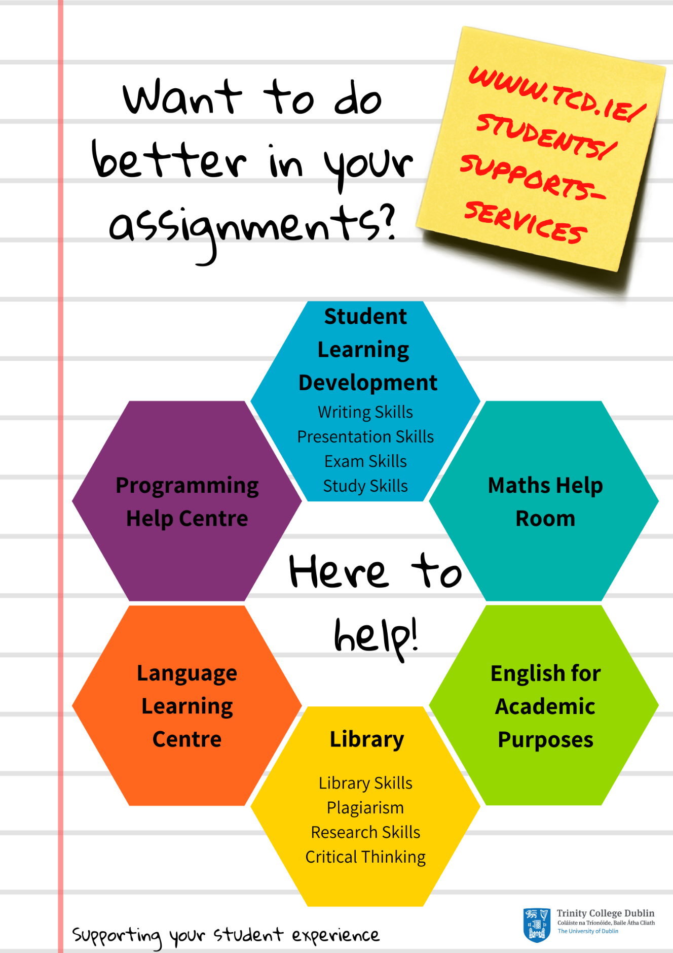
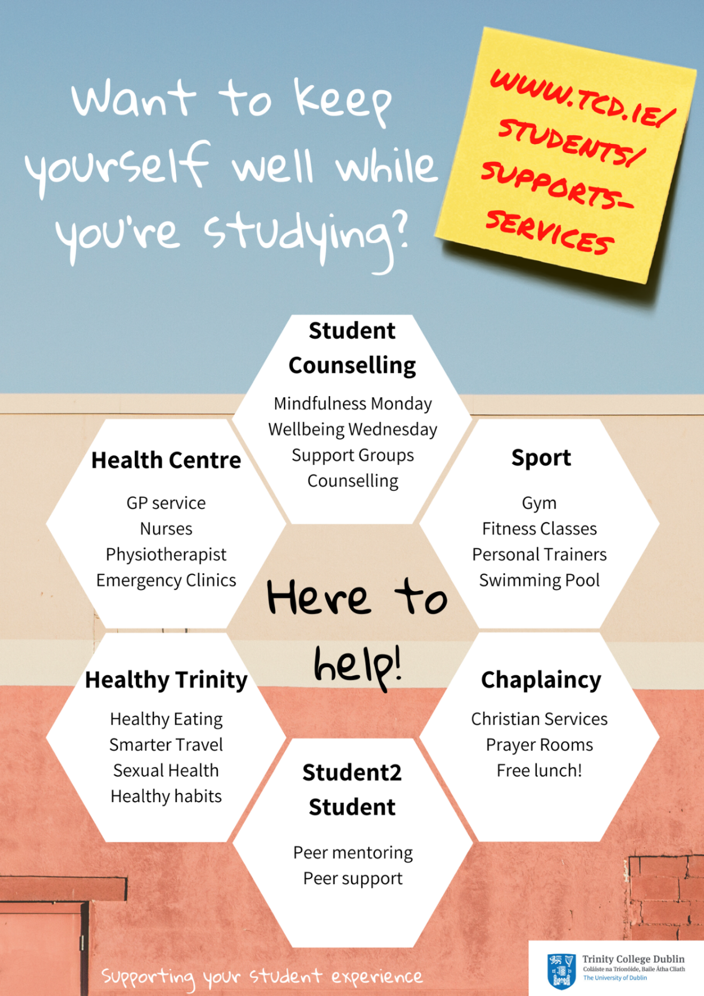
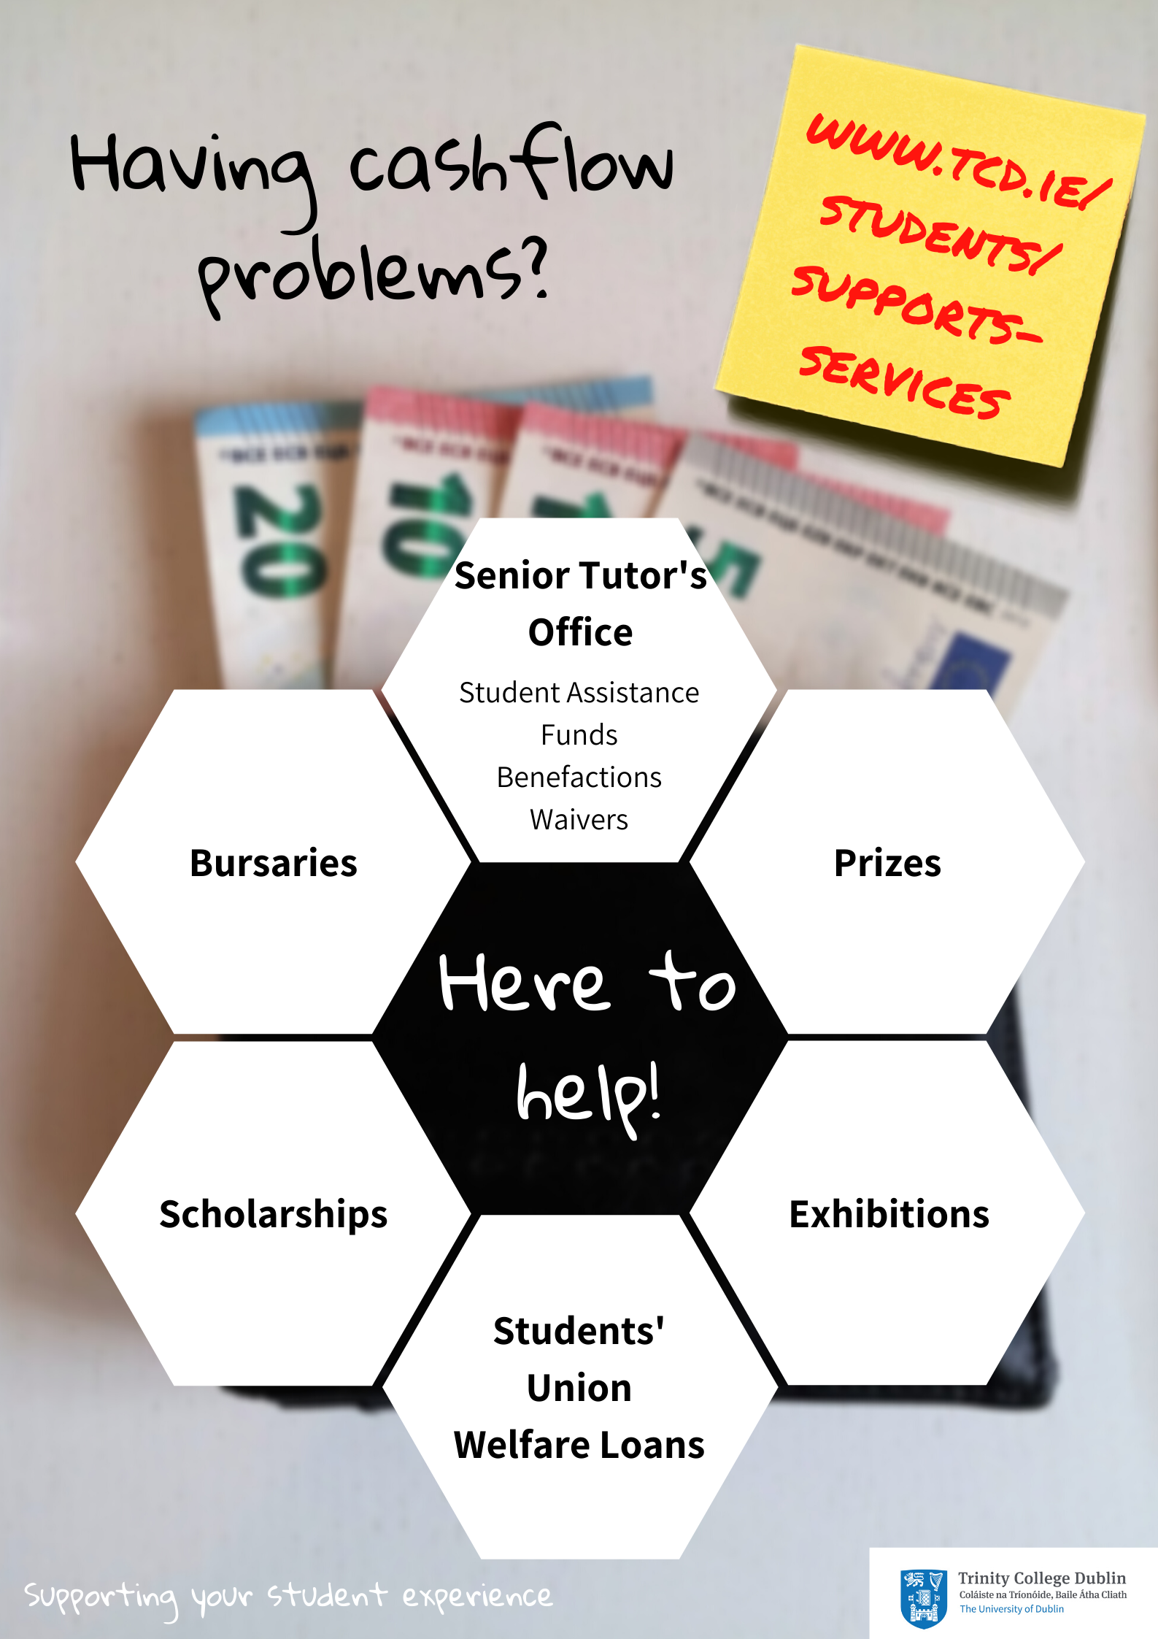

Academic Support
Student Learning Development | http://student-learning.tcd.ie/
The Library | http://www.tcd.ie/library/
Maths Help Room | http://maths.tcd.ie/outreach/helproom/
Undergraduate Programming Centre | http://www.scss.tcd.ie/misc/psc/
Language Learning Centre | http://www.tcd.ie/slscs/clcs/llc/
English for Academic Purposes | https://www.tcd.ie/slscs/english/
Disability Service | http://www.tcd.ie/disability/
Careers Service | http://www.tcd.ie/Careers/

Health and Wellbeing Support
Student Counselling | http://www.tcd.ie/Student_Counselling/
Health Centre | http://www.tcd.ie/collegehealth/
Sport | http://www.tcd.ie/Sport/
Healthy Trinity | http://www.tcd.ie/healthytrinity/
Student2Student | http://student2student.tcd.ie/
Chaplaincy | http://www.tcd.ie/Chaplaincy/

Getting Involved
Students’ Union | http://www.tcdsu.org/
Graduate Students’ Union | http://www.tcdgsu.ie/
Clubs | http://www.tcd.ie/Sport/student-sport/
Societies | http://trinitysocieties.ie/
Volunteering | http://www.tcd.ie/civicengagement/
Entrepreneurship/Tangent | http://www.tcd.ie/tangent/
Global Room | http://www.tcd.ie/study/international/trinity-life/global-room/

Financial Support
Senior Tutor’s Office | http://www.tcd.ie/seniortutor/students/undergraduate/financial-assistance/
Students’ Union Welfare Loans | http://www.tcdsu.org/welfare/
Bursaries/Prizes (Undergraduate) | http://www.tcd.ie/calendar/undergraduate-studies/  (Part D: 11 - Prizes and other awards)
Bursaries/Prizes (Postgraduate) | https://www.tcd.ie/calendar/graduate-studies-higher-degrees/  (Section XI: Postgraduate Awards and Travel Funds)
Exhibitions | http://www.tcd.ie/calendar/undergraduate-studies/ (Part D: 9 - Entrance Awards)
Scholarships | http://www.tcd.ie/study/undergraduate/scholarships-funding/
*Remember, you can ask your Tutor for advice and guidance about anything and they will point you in the right direction

Administrative Support
Your Tutor | http://www.tcd.ie/seniortutor/
Postgraduate Advisory Service | http://www.tcd.ie/seniortutor/students/postgraduate/
Academic Registry | http://www.tcd.ie/academicregistry/

Your Tutor
All registered full-degree undergraduate students are allocated a Tutor when starting in College. Your Tutor is a member of academic staff who is appointed to look after the general welfare and development of all students in their care.
You should see your Tutor whenever you have a question or are worried or concerned about any aspect of College life or your personal life, in particular if it is affecting your academic work. Everything you say to your Tutor is in strict confidence. Unless you give them permission to do so, they will not give any information to anybody else, whether inside College or outside (not to your parents/family for example). Your Tutor can help you only if they know you are facing difficulties, so if you are worried about anything go and see your Tutor before things get out of hand. Whilst your Tutor may not be able to solve the underlying problem, they can help you find the best way to limit the impact of your situation on your College work. Tutors can help with academic advice, changing course, withdrawing from College, exam regulations, financial assistance and personal advice.

Postgraduate Advisory Service
The Postgraduate Advisory Service offers free, independent, and confidential support, guidance and advocacy to registered postgraduate students. They are here to provide support on any matter that may impact upon your time as a postgraduate at Trinity.
Some of the most common issues students come to PAS to discuss include: study-related stress or worry; concerns about academic progress; supervisor-relationship concerns; extensions and going off-books; queries regarding regulations and academic appeals; bullying; plagiarism and disciplinary cases, financial assistance.

The Academic Registry
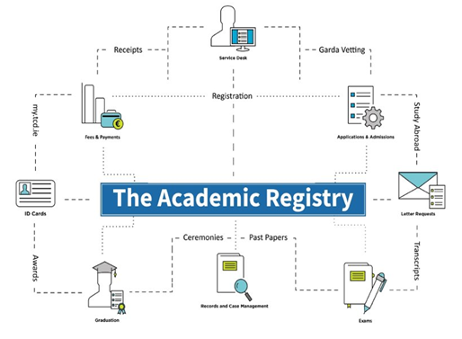

Information on key campus locations
You may include information on key campus locations relevant to your School’s students.
Click or tap here to enter text.

Reference/Source
Student Supports & Services
Interactive College Map

Student Representation and Governance
Information on the TCDSU and GSU, incl. student representation structures, are available at the following links:
TCDSU
TCDSU Student Representation Overview
TCD GSU
GSU - Student Representation Overview

Careers Information
Information on Careers for your students
Click or tap here to enter text.
References/Sources:
Trinity Careers Service
Careers - PG Focus

Academic Writing

Academic Integrity and Referencing Guide
Standard Text to be copied from the Calendar with a link to the Plagiarism Policy included.
A link to the Library Guidelines for Avoiding Plagiarism and a link to the Declaration text for submitted assignments.
Should there be local policy on referencing or programme copy of the Plagiarism declaration, relevant links and/or details to inform students.
Click or tap here to enter text.
References/Sources:
Calendar Part II, Part B: General Regulations
Calendar Part III, Section 1: General Academic Regulations
Statement of Principles on Integrity
Plagiarism Policy
Library Guides - Avoiding Plagiarism
Plagiarism Declaration

Research Ethics
On relevant programmes, Schools should provide relevant links and information regarding good practice in research, as well as provide information on College and Faculty policies and procedures.
Click or tap here to enter text.
Research Ethics
Policy on Good Research Practice
Ethics Policy

General Information

Emergency Procedure
In the event of an emergency, dial Security Services on Extension 1999
Security Services provide a 24-hour service to the College community, 365 days a year. They are the liaison to the Fire, Garda and Ambulance services and all staff and students are advised to always telephone Extension 1999 (+353 1 896 1999) in case of an emergency.
Should you require any emergency or rescue services on campus, you must contact Security Services. This includes chemical spills, personal injury or first aid assistance.
It is recommended that all students save at least one emergency contact in their phone under ICE (In Case of Emergency).

Health and Safety Statements
Applicable information relating to health and safety in the classroom, laboratories, or other locations as relevant
Click or tap here to enter text.

COVID-19 Information
Information and links relating to COVID-19 and Trinity’s Resumption of Activities plan

TCD COVID-19 and Return to Campus
TCD Statements
HSE COVID-19

Data Protection
Information on Data Protection regarding your student data is available from:
Data Protection for Student Data

Explanation of ECTS Weighting
The European Credit Transfer and Accumulation System (ECTS) is an academic credit system based on the estimated student workload required to achieve the objectives of a module or programme of study. It is designed to enable academic recognition for periods of study, to facilitate student mobility and credit accumulation and transfer. The ECTS is the recommended credit system for higher education in Ireland and across the European Higher Education Area.
The ECTS weighting for a module is a measure of the student input or workload required for that module, based on factors such as the number of contact hours, the number and length of written or verbally presented assessment exercises, class preparation and private study time, laboratory classes, examinations, clinical attendance, professional training placements, and so on as appropriate. There is no intrinsic relationship between the credit volume of a module and its level of difficulty.
The European norm for full-time study over one academic year is 60 credits. Within Undergraduate courses 1 credit represents 20-25 hours estimated student input, so a 10-credit module will be designed to require 200-250 hours of student input including class contact time, assessments and examinations. Within Postgraduate courses 1 credit represents 25 hours estimated student input, so a 10-credit module will be designed to require 200-250 hours of student input including class contact time, assessments and examinations.
ECTS credits are awarded to a student only upon successful completion of the programme year. Progression from one year to the next is determined by the programme regulations. Students who fail a year of their programme will not obtain credit for that year even if they have passed certain component. Exceptions to this rule are one-year and part-year visiting students, who are awarded credit for individual modules successfully completed.
Reference/Source: Description of ECTS for use in Course Handbooks

Links to Further University Policies and Procedures
The following are links of where to find further information on University regulations, policies, and procedures that you may find useful as a student:
All Academic Policies
Student Complaints Procedure
Dignity & Respect Policy
Equality Policy

