Online Application Guide
for nonEU full degree undergraduate courses at
Trinity College Dublin, the University of Dublin

Introduction
All undergraduate applications are processed and assessed by the Academic Registry. All final outcomes will be communicated to you through the MyTCD portal (www.my.tcd.ie). Therefore, we strongly advise that you regularly log into the MyTCD portal and check if any further actions need to be taken by you at any stage of the application/admission process.

The application process for undergraduate studies at Trinity College Dublin (TCD) is different for EU and nonEU applicants. NonEU applicants apply to a course in Trinity via the courses section on the TCD website (www.tcd.ie/courses).

Course List on TCD Website
At first, you will need to select a course from the list of undergraduate courses available at the below location https://www.tcd.ie/courses/undergraduate/az/

In order to be considered for admission you are required to satisfy the admission requirements specific to your chosen course. Admission requirements are given in detail for each course as per the example screen below.

If you meet the admissions requirements, you can apply to the course by clicking on the link under nonEU applicants.

On clicking the link under the Apply section, the applicant is directed to www.my.tcd.ie (the portal).

Setting up an account on www.my.tcd.ie
The www.my.tcd.ie portal home screen presents the applicant with two options. Unless you are a registered user on the www.my.tcd.ie portal, you will need to create a new user account by clicking on the ‘New User’ button, available on the right hand side of the screen presented below.

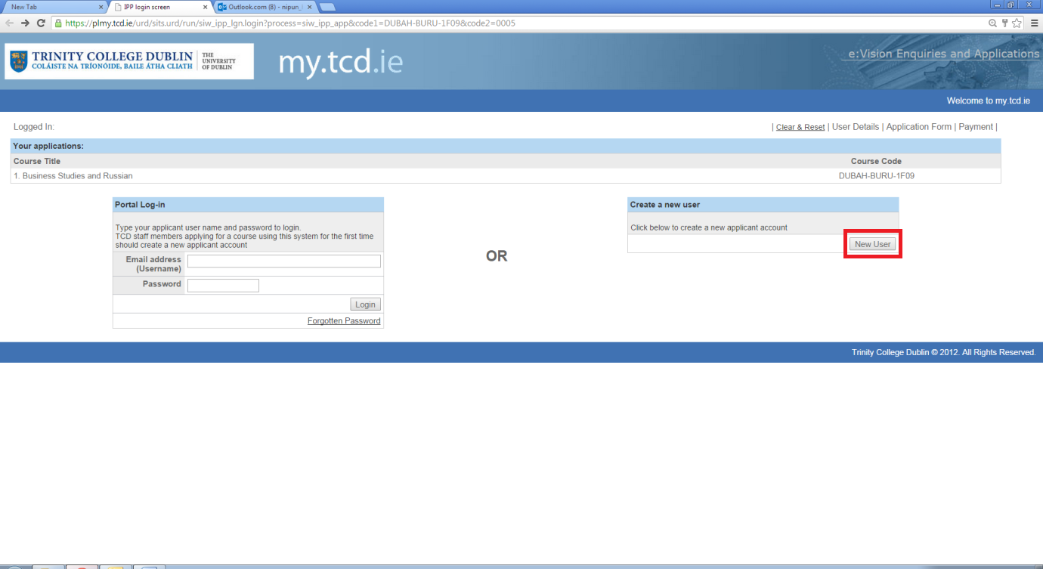

Creating a new account is simple and quick, you only need to enter your basic personal details (title, name, DOB and email ID) on a short form and create a login password to get access to the portal.
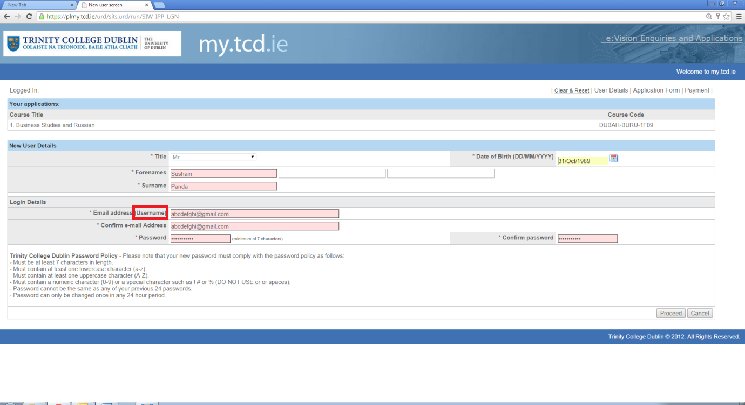
Please Note
* There is no separate username for your account on www.my.tcd.ie. Your email ID will act as your username, for logging into the portal.

Logging into your Account
After you have set up your account on www.my.tcd.ie you may log into your account from the link by entering your email address (username) and password on the left side of the screen shown below and click on login.

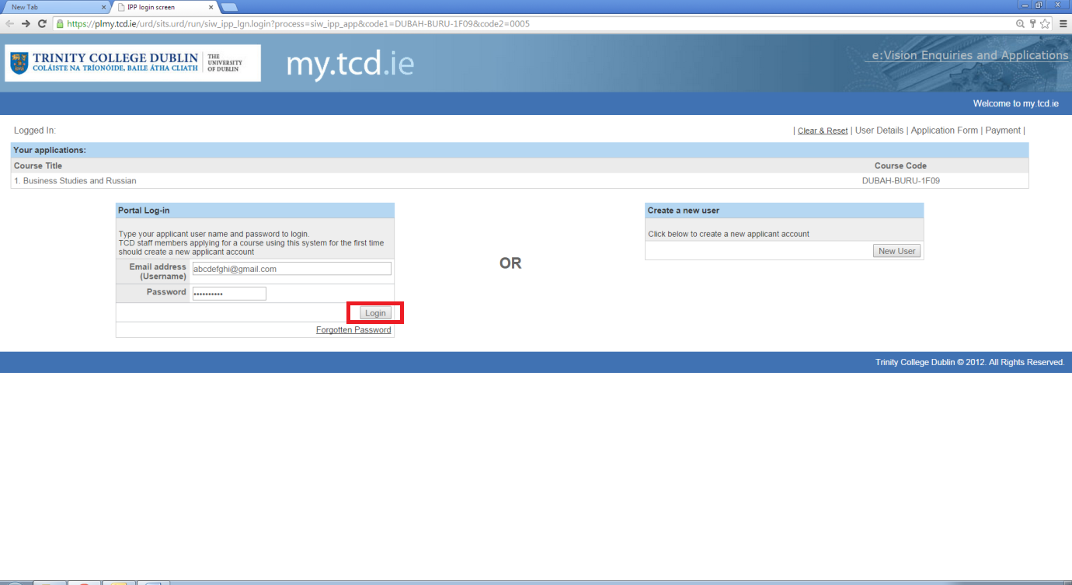

Please note that there is a provision to recover your account, in case you forget your password. You may click on the ‘forgotten password’ link (below the login button) which will direct you to a screen that requires entering your email ID, surname and DOB.

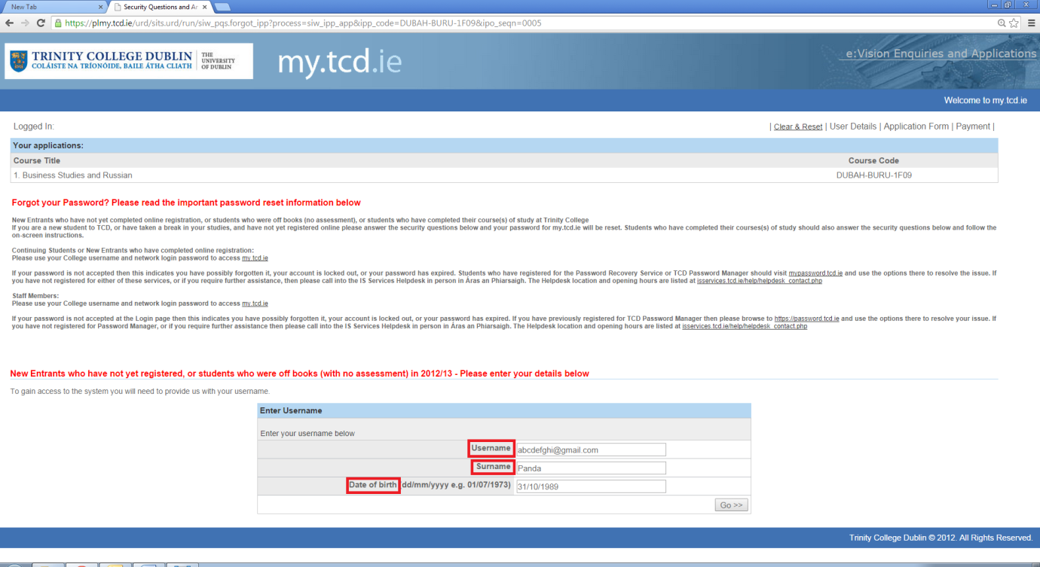

If the information entered on this screen matches with what you provided initially, you will recieve a password reset link to your registered email ID. By clicking on the link, you are directed to a page where you can reset your password.

User Details
After providing the correct credentials and successfully logging onto www.my.tcd.ie, you will be presented with a screen that displays all your saved user details. Here you are also given options to amend your details and change your password, if you wish to. From this screen you may opt to go to a previously saved application or proceed with a new one.

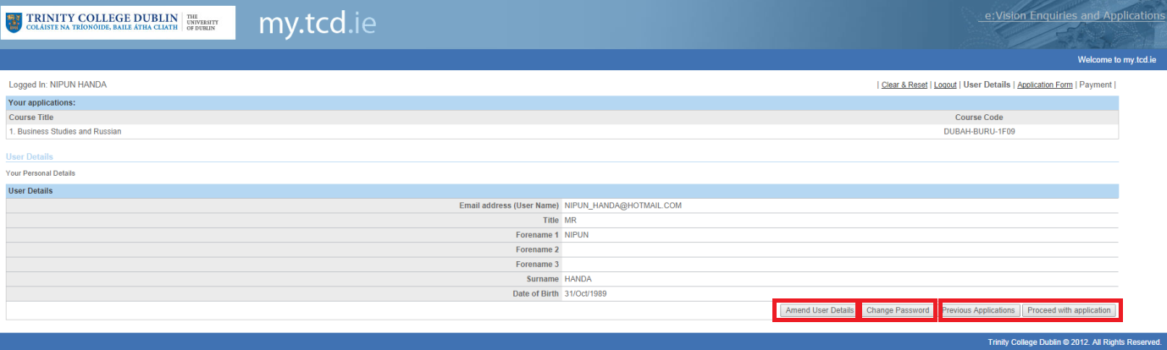

The Application Form
Once this initial account creation is completed you are directed to proceed with your application by filling out a form. The application form is divided into different tabs. The tabs are Personal Details, Education & Qualifications, Experience, Additional Information, Personal Statement, References, Supporting Documents and Declaration. You can navigate through the application form using the tabs (on the top) or the Save & Proceed/Back buttons on the bottom of the screen.
You should go through the Application Guidance notes before you fill out each page of the form. In each tab, mandatory fields are marked with an asterisk (*). A traffic light system is in operation so tabs that have been completed have a green dot. A red dot means that a section has not been fully completed. Any mandatory questions that you do not answer will be highlighted to you.

You can save your application and exit out of the portal at any time. On doing so, an email will be sent to you containing a link which allows you to access and proceed with your application again at any time.

Please Note
Without completing the mandatory fields, you cannot ‘SUBMIT’ the application form.

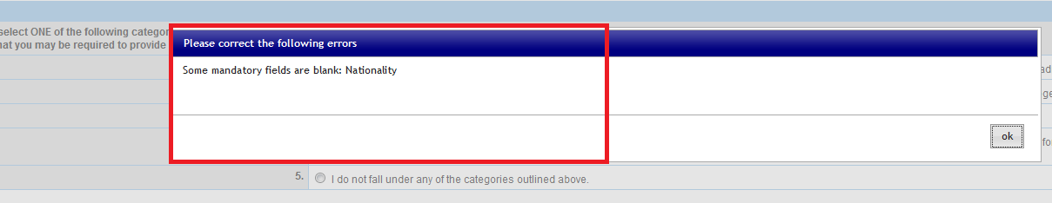

Tab-1: Personal Details

Under this Tab, you are required to
- Check the highlighted box to allow TCD staff to assist you with the application process
- Complete the personal details section
- Provide contact details (including your home address)
- Provide your correspondance address (if it is different from your home address)
- Choose your applicant status
- Provide further details about yourself
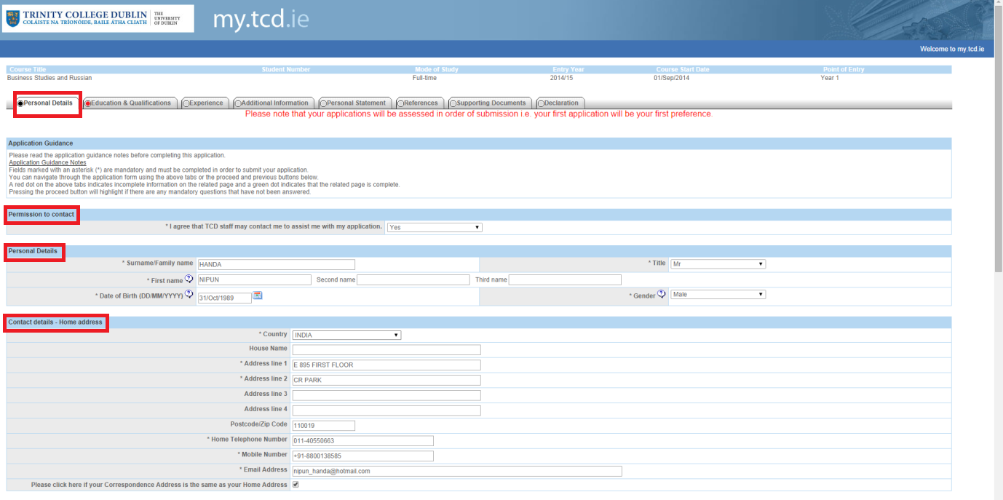

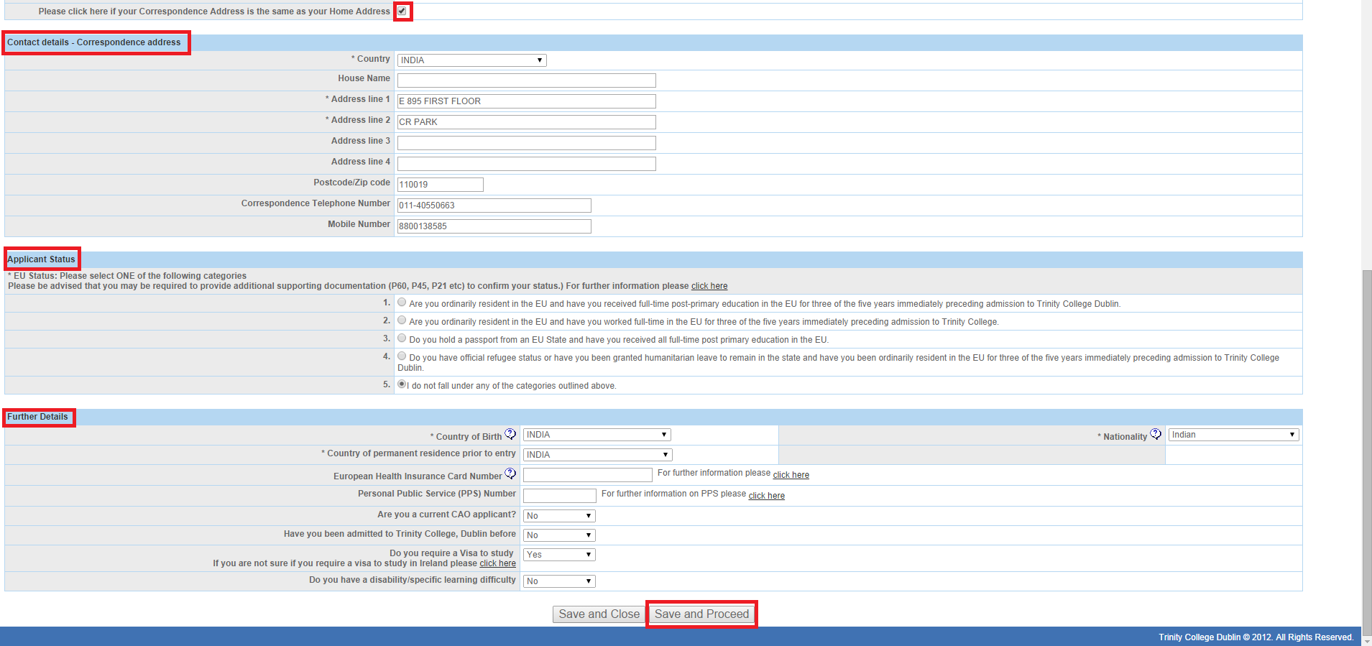

Please Note
Under the applicant status, all nonEU applicants must select Option No.4 or No. 5, as appropriate.

Tab-2: Education & Qualifications

Under this Tab, you are required to
- Fill out information about your Second Level Education (School).
- Fill out the level of study, grades/marks achieved and date of examination for each subject of your Second Level Examinations.

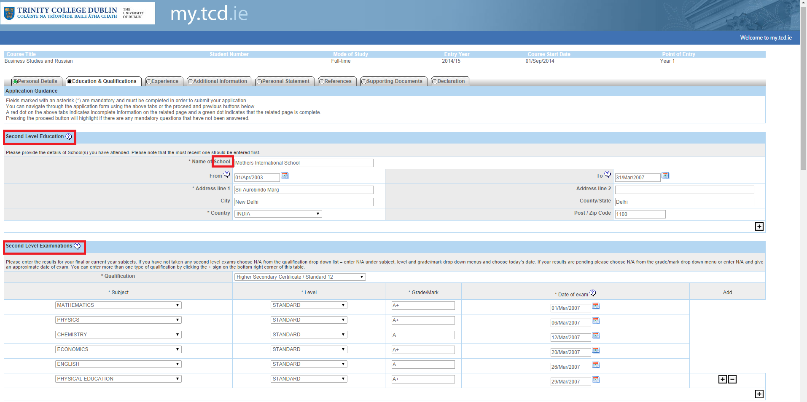

- Highest 3rd Level Qualification or equivalent (Degree, Masters etc. – if applicable)
- Provide Additional Relevant Qaulifications
- Any other Relevant Qualifications

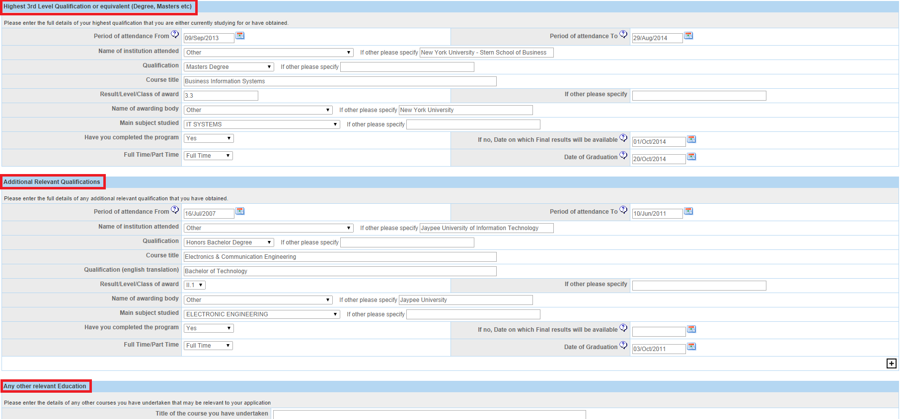

- SAT/ACT/AP Results
- English Language Proficiency requirements are detailed at http://www.tcd.ie/study/eu/undergraduate/admission-requirements/english-language/index.php )

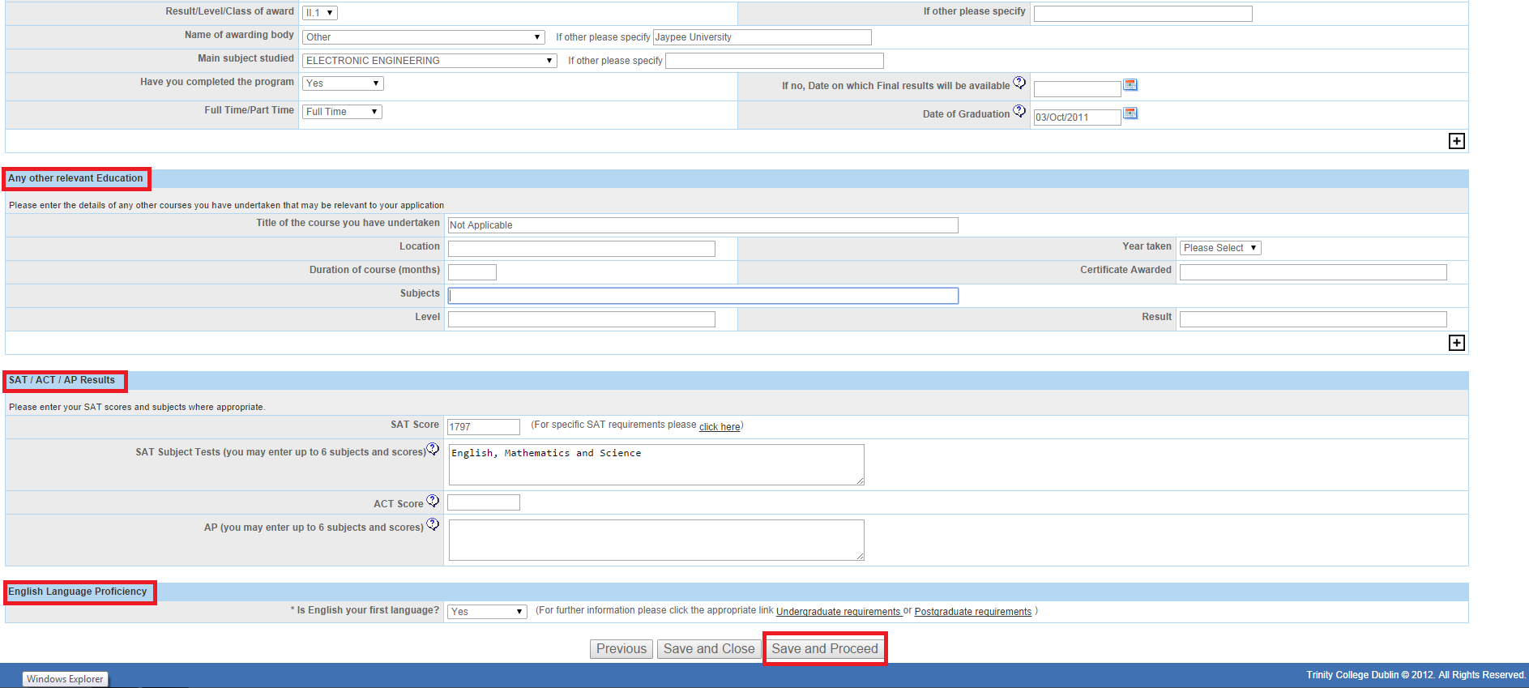

Tab-3: Experience

Under this Tab, you are asked to
- Complete the details about your Employment History/ Work Experience
- Complete the details about your Volunteer Experience

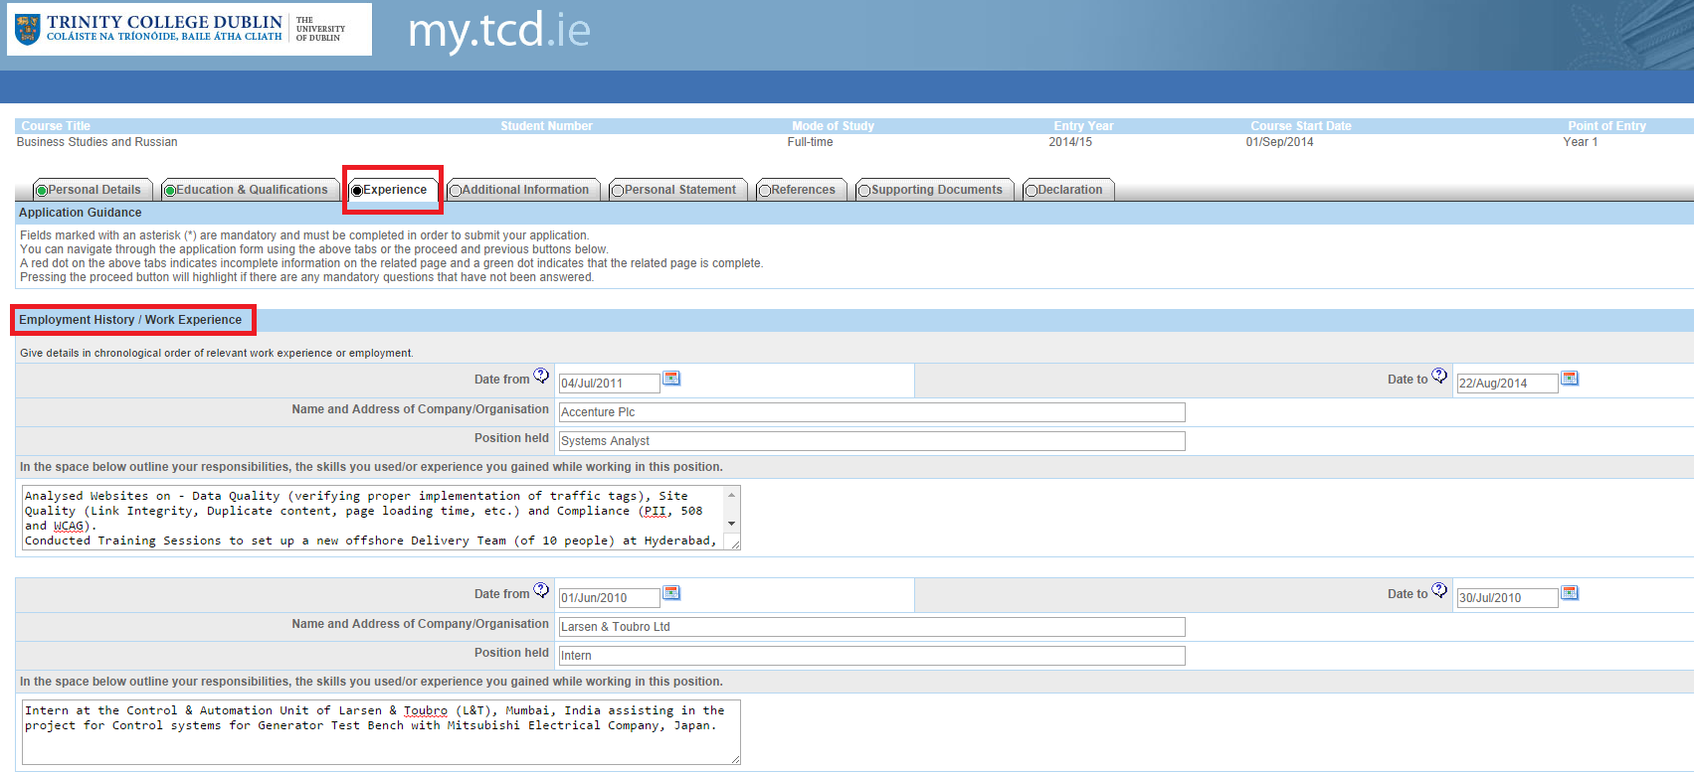

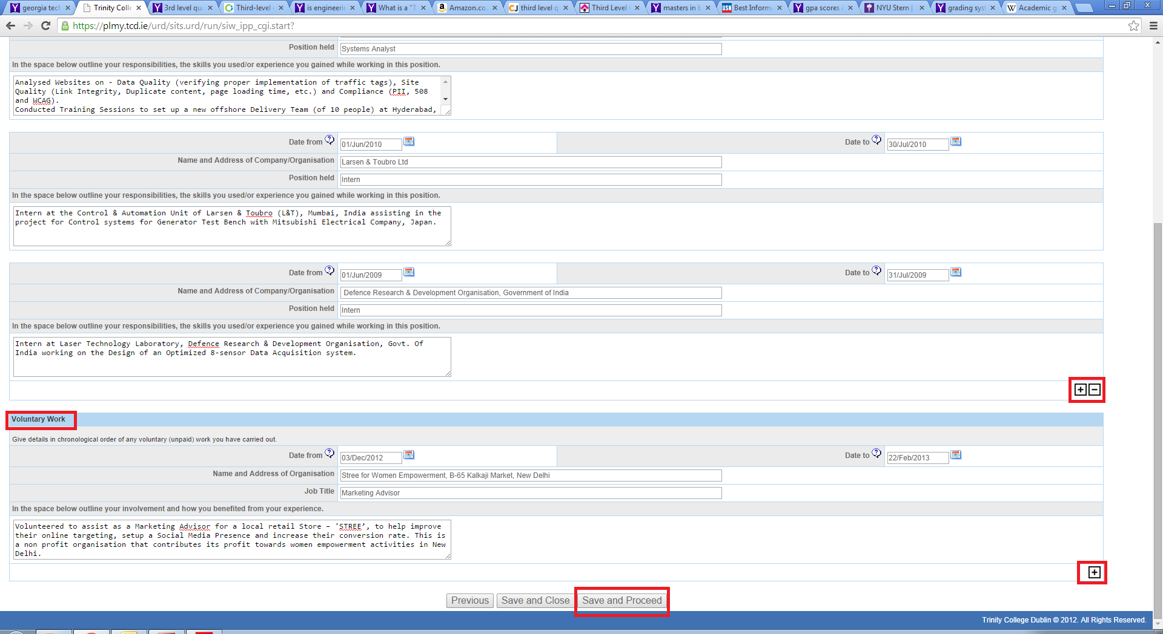

Please Note
*None of the sections on this page are mandatory, however if you have any work experience or volunteer experience, it would be worth mentioning under this section to enable the assessors develop a fuller picture of your personality and preferences.
**In case you have additional work/volunteer experience, you may choose to add more, by clickong the ‘+’ box located ón the right-hand side of the screen. This will allow you to provide more information about your experience.

Tab-4: Additional Information

Under this Tab, you are required to fill out
- Where you heard about the course?
- How do you intend to fund your education?

Tab-5: Personal Statement

Under this Tab, you must fill out
- The Academic Statement (max 500 words)
- Any additional information in support of your application (max 500 words)

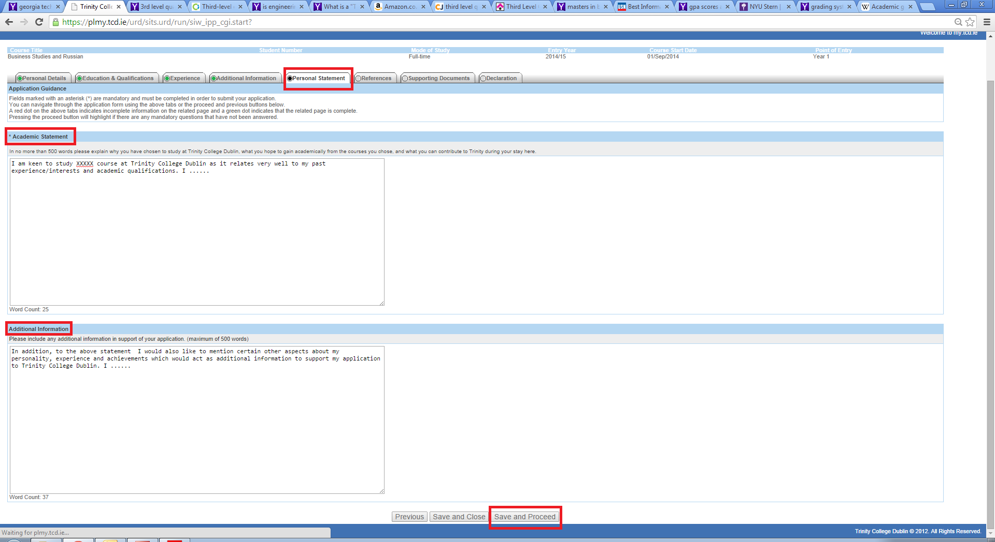

Tab-6: References

Under this Tab, you are required to fill out the name and contact details for two referees, who will be able to elaborate on your academic achievements /work experience/personality.

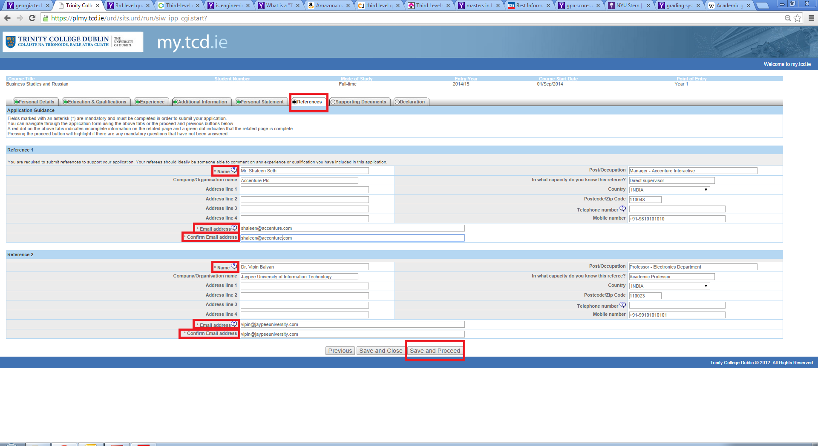
Guidelines for Submitting References

The Academic Registry requests letters of recommendation from School Counselors and academic teachers so that we may better understand applicants in the context of the classroom and in their school community at large. The letters of recommendation should offer information that either expands upon something the Assessors learn from the student's application or informs of something entirely new. Key points to be considered by those writing on behalf of an applicant include the following:
- How the student challenged himself/herself in a specific circumstance or set of circumstances
- How the student displayed true passion for an academic subject or activity
- How the student achieved something unprecedented in either the recommender's career or the history of the high school
- Your academic reference should also include predicted results where students are taking A Levels/ International Baccalaureate/ Standard 12 - exams.
Recommendations may also include any anecdote that epitomizes the student's abilities, character, and persona. Overall, letters of recommendation should provide a more detailed sense of the student in and out of the classroom. If students wish to submit additional letters of recommendation from teachers, coaches, employers, or anyone else who can bring something new to the application, they may include those as well.
List of accepted referees.
  - Academic Teacher
  - School Counsellor
  - Supervisor (if previously employed)
  - Others
Please Note
* At a minimum, you are required to provide the names and email address of both your referees.
** You may choose to complete the other fields in respect of the nominated referees presented on the screen.

Tab -7: Supporting Documents

Under this Tab, you are required to attach all supporting documents to your application. The mandatory document to be attached under this section is an Identity paper, i.e. a copy of your passport. However, it is advisable to attach other relevant documents as well such as – your CV, copies of degree certification, SAT/AP/ACT scores and any other document that you believe would add credibility and/or help authenticate the information you have provided on the application form.

Please note – All supporting documents must be submitted through the my.tcd.ie portal only.

The identified essential documents are:
- Proof of identity (copy of passport) - *Mandatory*
- Curriculum Vitae – if applicable
- Certified true copy of final second level qualifications
- Certified true copy of SAT/AP/ACT scores for American (applicable for US and Canadian applicants)
- Certified true copy of IELTS, Cambridge Advanced/Proficiency, and TOEFL scores, for applicants whose first language is not English.
- Please note that where the statement of examination results is in a language other than English, applicants should submit a certified true translation of the statement along with a certified true copy of their results with the application.
- Up-to-date official high school transcript sent from High School. Interim transcripts will suffice for assessment purposes, however original transcripts must be provided and verified prior to registration at TCD.
- Your academic reference should also include predicted results where students are taking A Levels/ International Baccalaureate/ Standard 12 – exams.
- A certified true copy is a photocopy of an original document that has been signed and stamped by a school principal or another official.
- You may only attach documents as per the TCD specified file formats (.txt, .doc, .gif, .jpeg, .jpg, .docx, .rtf, .pdf).

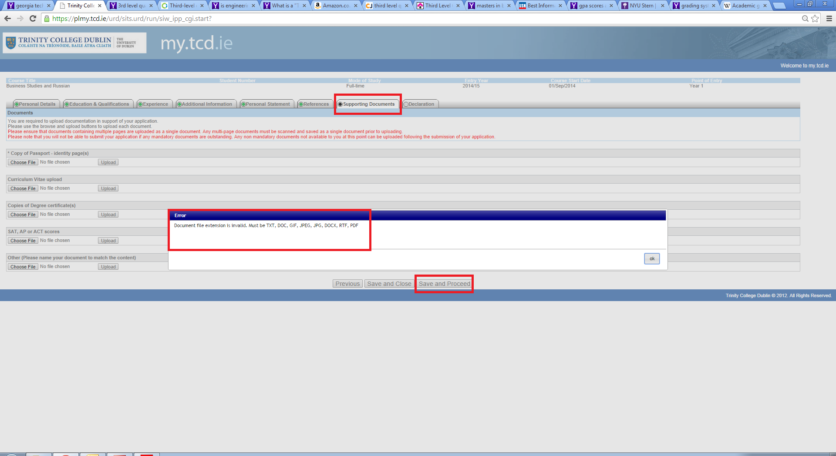

Tab -8: Declaration

Under this Tab, you are expected to read the statement about TCD’s policy on the Privacy & Protection of Data. Before you proceed to the next screen you are required to check the highlighted box confirming that the information provided by you may be used for compiling general statistical reports.

Under this Tab, you are also given the option to nominate upto two people, who may be allowed to contact the University and discuss your application on your behalf.

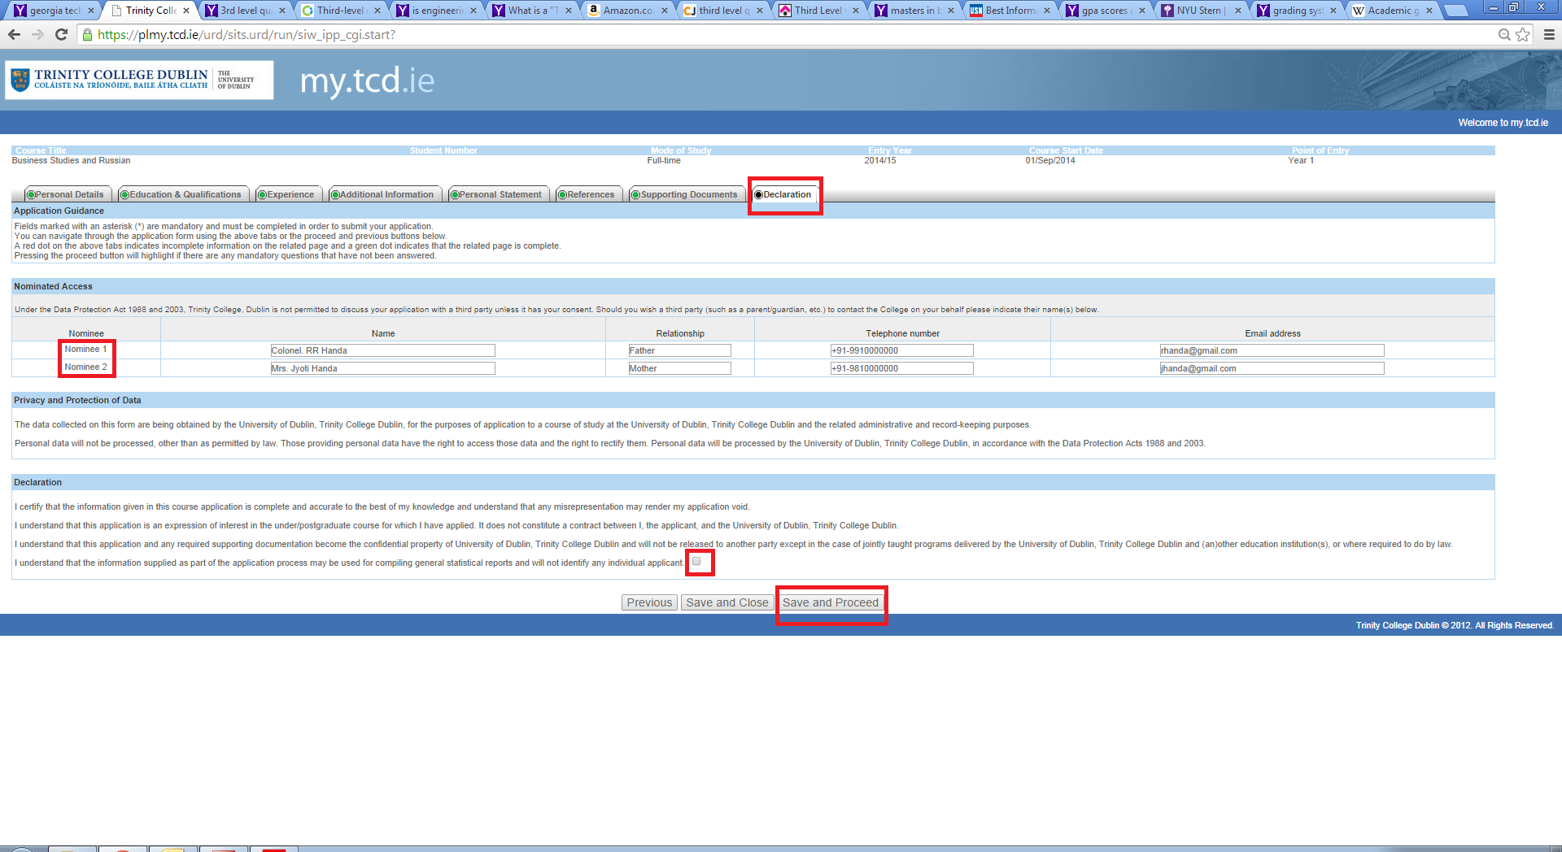

Application Payment Fees
On completion of the application form, all applicants need to pay the application fee (35 Euro) either through online payment or EFT. Applicants are encouraged to pay via the online payment option.
Please Note - Only after you make the payment, your application will be fully submitted to undergo a review.

Option 1: Online Payment

Option2: Offline EFT Payment
If you chose to pay through this option, please remember that the application will not be fully submitted until the payment is recieved by Trinty College Dublin. This may take up to five working days.
After submitting your application
Once you have sucessfully submitted an online application you will be sent an acknowledgement to the email address you provided while setting up your user account on www.my.tcd.ie applicant portal. The my.tcd.ie portal will allow you to both send and receive communications in regard to your application to Trinity College Dublin. You will be able to track the progress of your application; update your personal information, view decisions made on your application(s) and accept any offer you may receive.

Enquiries
Queries relating to the online application process and specific admissions requirements should be directed to the Academic Registry using the ASK TCD button (within my.tcd.ie portal) or by sending an email to academic.registry@tcd.ie.
For all other general nonEU admission enquiries, or to contact someone responsible for your country or region, please contact the Global Relations Team at international@tcd.ie.

Key pointers to remember
* In order to assess applications, all mandatory supporting documents and references must be submitted with the application form.
**Keep checking your account on www.my.tcd.ie regularly. The Academic Registry may send out communications directed to you through the portal once your application has gone through the initial review proccess.
**Please note, the information entered inside the screeenshots provided in the document is for the purposes of helping you understand the process. Kindly do not copy/immitate this information and as it will not benefit you in any way.

