Introduction
This document has been created to help students and staff from the School of Linguistic, Speech and Communication Sciences complete a Research Ethics Committee (REC) application. This type of research is an online, anonymous survey with non-vulnerable people. This example was created because this is a very common type of research study in our School.

About this Example
A student called Ash is creating a survey designed for deaf and hard of hearing (HoH) people to complete. Ash wants to do research about the barriers that these people experience. Specifically, the research wants to identify how commonly deaf and HoH people encounter public announcements on different types of public transport, how accessible those announcements are, and whether the announcements cause any distress or inconvenience to the participant.

Tips and Advice
Comments have been added into this document to help explain why certain questions were answered in the way shown. You may need to select Show Comments under Review in Microsoft Word to view them. Your own REC application should not include comments.

SCHOOL OF LINGUISTIC, SPEECH AND COMMUNICATION SCIENCES

TRINITY COLLEGE DUBLIN

RESEARCH ETHICS APPLICATION FORM

PLEASE NOTE THE FOLLOWING:
- Incomplete applications cannot be processed and will be returned for completion.
- Forms without the applicant(s) and research supervisor(s) (for student applications) confirmation of declaration/s section/s completed cannot be processed.
- Applications must be typed and not hand-written and submitted as a single document (application & all appendices)

Please complete the application form and return one electronic copy (with supervisor signature) to:

slscs@tcd.ie

APPLICANT NAME: | Ash Kelly
APPLICANT EMAIL: | kellya123@tcd.ie |  |  |  |  |  |  |  |  |  | (Please use your tcd.ie email address)
SLSCS STAFF MEMBER? | Yes ☐ |  |  | Job title
STUDENT NUMBER | 12345678
SLSCS STUDENT? | UG |  | MSc |  | ☐ | MPhil | ☐ |  | MLitt |  |  | ☐
 | PhD | ☐ | CLCS |  | ☐ | CSLC | ☐ |  | CDS
SUPERVISOR NAME: | Dr Kris Moore
SUPERVISOR EMAIL: | moorek123@tcd.ie |  |  |  |  |  |  |  |  |  | (Please use their tcd.ie email address)
PROJECT TITLE: | Announcements on Irish Public Transport: Barriers for Deaf and Hard of Hearing People
IS THIS A FULL RESUBMISSION OF A PREVIOUS APPLICATION? |  |  |  |  |  |  |  | Yes |  | ☐ |  |  |  | No
IS THIS ELIGIBLE FOR A FAST-TRACK APPLICATION? |  |  |  |  |  |  |  | Yes |  |  |  |  |  | No | ☐

SPECIFY YOUR ROLE IN PROJECT |  | Principal Investigator |  |  | Co-investigator |  | ☐
Please provide the name, qualification and position of each person associated with this research project
Name & Qualification | Position & primary employer |  | Role in research project |  |  | Email Address
Do not forget to add your details and your supervisor’s details here. List all researchers.
Ash Kelly | Student (Trinity College Dublin) |  | Researcher |  |  | kellya123@tcd.ie
Kris Moore | Assistant Professor (Trinity College Dublin) |  | Supervisor |  |  | moorek123@tcd.ie

SECTION 1 - BEFORE YOU PROCEED

Projects that collect personal data may require a Data Protection Risk Assessment (DPRA) or Data Protection Impact Assessment (DPIA). Personal data means information that can make a person identifiable e.g., their name, email address, location data, voice, or a photo/video of that person. Sometimes data collected from a research study makes someone identifiable by combining collected data together. For example, a survey of students in a class could collect age, gender, and nationality information. None of these are personal data, but there might only be one 35-year-old male from Italy in that class, which makes the person identifiable. Trinity provides a training course to help you understand data protection:
https://www.tcd.ie/dataprotection/training/

If your research collects personal data, then you must check and discuss with your supervisor whether you need to complete a DPRA or DPIA. Most research that collects personal data will require a DPIA. You can find templates for these and more information here:
https://www.tcd.ie/dataprotection/riskassessments/
If your research does not collect personal data, then it is collecting anonymous data, which does not require a DPRA or DPIA. Research should never collect personal data unless absolutely necessary.

DPRAs and DPIAs should ideally be completed and approved before you submit your ethics application. These are submitted to the Data Protection Office (DPO) at: dataprotection@tcd.ie. Waiting times for DPO approval can be lengthy, so we advise starting this process as soon as possible. You may submit your ethics application before you have received DPO approval, but be aware that the DPO may recommend changes that will then require you to resubmit a revised application to the Research Ethics Committee.

Does your project require: | DPRA | ☐ | DPIA | ☐
If you ticked one of the above, please answer the following
Have you submitted this yet? | Yes | ☐ | No | ☐
Have you received DPO approval yet? | Yes | ☐ | No | ☐

You do not need to attach your DPRA or DPIA as part of this ethics application, but please attach your approval letter if you have one.

Research in Other Countries

If your research will collect or process data in another country, you must adhere to national laws and provide that information in this application form. Remember that any data being transmitted within or outside the EU is subject to General Data Protection Regulations (GDPR).

IMPORTANT

Examples of completed ethics application forms are available on our website. We strongly recommend that you look at the examples before completing your own application.

https://www.tcd.ie/slscs/research/ethics/

SECTION 2 – DETAILS OF RESEARCH PROJECT AND PARTICIPANT SELECTION

2.1 Details of any funding body (write no funding if applicable):
No funding.

2.2 Dates & duration of research activities:
Proposed start date for fieldwork/data collection (please provide specific planned start date which should not precede research ethics approval): | 01/11/2023 | Proposed end date of fieldwork/data collection (please provide specific planned end date): | 01/03/2024

2.3 What are the primary location(s) for data collection? For example, classroom, clinic, lab, participants’ home, place of convenience for participants. Researchers conducting fieldwork in participants’ home should ensure they have familiarised themselves with the Lone Researcher Guidelines on the School website.
Participants will take this online survey from a place of their convenience at a time of their convenience.

2.4 Please provide a brief outline of the proposed project (maximum 400 words in total). This should include aim(s) and objective(s), background, research question(s) or hypothesis, research design.

(a) Aims/objectives and theoretical background
Aims:
This project seeks to understand whether and how often deaf and hard of hearing (HoH) people face barriers using public transport. It will identify the impact of these barriers on the lives of deaf/HoH people. The project will provide policymakers with evidence of the experiences of deaf/HoH people in Ireland, in order to understand whether services should be improved.

Background:
The Accessibility of Public Transport for People with Disabilities (2018) document produced by the Houses of the Oireachtas identified that deaf/HoH people experience certain barriers to public transport use that are not encountered by hearing individuals. While recommendations were made in that document, their implementation and impact on daily lives of deaf/HoH people have never been measured.

Orczyk & Młodystach (2022) and Młodystach, Orczyk & Tomaszewski (2023) profiled the experiences of deaf and HoH people using public transport in Poland. They found that barriers frequently related to problems speaking with drivers and hearing audio messages played in vehicles and at stations. No similar study has been conducted as yet in Ireland.

(b) Research question(s) or hypothesis
Questions:
- How often do deaf/HoH people encounter difficulties with announcements on public transport and what is the nature of those difficulties?
- What impact does this have on their lives?

Hypothesis:
Młodystach, Orczyk & Tomaszewski (2023) noted difficulties using public transport for deaf/HoH people, despite EU regulations that are designed to prevent such barriers. They noted that the enforcement of EU policy is a problem for addressing barriers. We therefore hypothesise that the same problem exists in Ireland; that deaf/HoH people encounter regular problems accessing announcements on public transport and that this interferes with their daily lives.

(c) Research design. Please briefly describe the project research design/methodology. Provide your inclusion & exclusion criteria (if relevant).
This is an online survey of non-vulnerable adults. The research is a cross-sectional, mixed-methods survey. Participants are asked to take the survey only once. Quantitative responses will be analysed using descriptive and inferential statistics. Qualitative responses will be analysed using Thematic Analysis, Content Analysis, or both.

Inclusion Criteria:
- Adults (≥18 years of age)
- Self-identify as deaf or hard of hearing
- Have used public transport in the last month in the Republic of Ireland

Exclusion Criteria:
- People who do not understand written English

2.5 Please describe recruitment, sampling and data collection procedures
(a) Please specify exactly how participants will be recruited and what steps you will take to access the sample. This should include who will make contact at each stage of the study, including information regarding gatekeeper(s) for this study (if applicable). If you are using social media to advertise your research, you cannot tag individuals in posts, but you can tag organisations.
This research will use convenience and snowball sampling. The Irish Deaf Society will be contacted to ask them to advertise the study on their social media and on the News page of their website. They will therefore act as a gatekeeper for this study. Example advertisements for their social media and news are in Appendix B.

The researcher and supervisor will also advertise the research on their own social media accounts, as well as the Centre for Deaf Studies social media. Organisations for deaf and HoH people in Ireland will be tagged, so that they have the option of sharing this research. Advertisements on social media will also act as gatekeepers.

Finally, participants themselves may share the survey with people they know who meet the inclusion/exclusion criteria. Participants may therefore also act as gatekeepers.

(b) Please describe expected sample size and composition.
The expected sample size is approximately 300-500 adults. We seek to include both deaf and HoH adults, but that cannot be controlled.

(c) Data collection procedures. Please tick the research instruments you intend to use (ensuring you append copies of each instrument) and (ii) provide an estimation of the time commitment involved for participants/respondents.

(i) Please tick as many boxes as relevant to your project:

 | Questionnaires | ☐ | Video Recordings
☐ | Interviews | ☐ | Observations
☐ | Focus Groups | ☐ | Classroom Intervention
☐ | Audio Recordings | ☐ | Ethnographic Research
☐ | Other (please specify):

(ii) Estimation of the time commitment involved for participants:

One minute to read Participant Information Leaflet (first page of survey). Five to ten minutes to complete remainder of survey.

SECTION 3 – INFORMED CONSENT

Consent means agreement to participate in research. While you are completing this section, remember that you must provide evidence of the following legal requirements for consent:
Consent must be… | What this means for the participant
Freely given | They are not pressured or influenced into taking part.
Informed and specific | They know exactly what is involved in the research, how their data will be used now, and in the future, and how to withdraw from the research.
Unambiguous | They have provided a clear indication that they wish to participate, and this has been recorded by the researcher.

3.1 Please give details of how information will be provided to participants to ensure that they can make a fully informed decision about participation. Please include a description of who will provide this information. This information is usually provided in a Participant Information Leaflet or on the first page of a survey.

The first page of the survey (Appendix C) will serve as the Participant Information Leaflet for this research. This provides detailed information about the study purpose and details of what to expect.

3.2 Please give details of who will obtain consent from participants and how it will be done. This is usually through a consent form. For online surveys where a separate consent form is not used, please describe how explicit consent will be sought (e.g., through the participant clicking ‘I agree to proceed’).

Participants are advised that once they click ‘I agree’ on the first page of the survey (Appendix C), they are providing consent to participate.

3.3 Children (<18 years) cannot legally consent to research, so consent must be obtained from their parents or legal guardians (no other adults can give consent). You must however also obtain assent from children, i.e., their agreement to participate. Please attach all consent and assent research forms as an appendix to this application. If you are recruiting participants from other countries, check the legal age of majority. Anyone below that age is considered a child. If you will not be recruiting children, select N/A.

Working with children: will assent be obtained from any children under 18?
YES | ☐ | NO | ☐ | N/A

Will informed consent be obtained from parents/legal guardians on behalf of any children under 18?
YES | ☐ | NO | ☐ | N/A

3.4 Please specify if you will allow for a time interval between providing your participants with information about the research and seeking their consent. A time period of 3-7 days is usually used if participants will be participating in an experiment or complex piece of research. Surveys do not usually require a time interval.

Participants will take the survey at a time of their choosing, so no time interval is used.

3.5 Will the participants be specifically recruited from any of the following groups (tick as appropriate):
PLEASE TICK THE APPROPRIATE BOX | YES | NO
Children under 18 years of age | ☐
Adults with learning disabilities | ☐
Adults with language or communication difficulties | ☐
Adults who have dementia | ☐
Adults with mental illness | ☐
Clinical population | ☐
Participants in an unequal power relationship with the researcher (e.g. lecturer/student) | ☐
Other groups who may be considered vulnerable (please specify below) | ☐

N/A.

3.6 If participants are to be specifically recruited from any of the groups listed above, please give details of:
(a) Any special steps taken to ensure that participants from vulnerable groups are as fully informed as possible about the nature of their involvement:
N/A

(b) Who will give consent:
N/A

(c) How consent will be obtained (e.g., will it be verbal, written, signed, or visually/gesturally indicated?):
N/A

(d) The arrangements that have been made to inform those responsible for the care of the research participants of their involvement in research:
N/A

SECTION 4 – CONFIDENTIALITY & DATA PROTECTION

This section asks about two types of data. Personal data (explained in Section 1 of this document) and sensitive data. The legal definition of sensitive data includes anything relating to:
- Racial or ethnic origin | - Religious/philosophical beliefs | - Genetic/health information
- Political opinions | - Trade union membership | - Biometric data
Other data may be sensitive, for example asking about stressful or traumatic events.

Personal and sensitive data must be secured. For electronic data, this usually means password-protection or encryption. Encryption is strongly recommended for sensitive data. If you are a student, we recommend asking your supervisor to share a OneDrive folder with you, which only you and your supervisor can access. If you are dealing with physical data (e.g., consent forms), the research supervisor should lock them in a filing cabinet in a locked office. You should store personal and sensitive data separately to reduce the risk of hacking or leaking. For example, keep participant names in one file, and their sensitive data in another file, using two different passwords. Researchers often use a code key for this, for example:

Personal Data File (code key file)
ID Code | Name | Email | Telephone
Participant1 | John Smith | John.smith@tcd.ie | 087 123 4567

Sensitive Data file
ID Code | Medical History | Religion | Trade Union Member?
Participant1 | Asthma, diabetes | Presbyterian | Yes

Data processing means collecting, storing, protecting, editing, analysing, sharing or deleting data. When listing processing activities below, you must account for all of these actions.

All research should conform to data minimisation, which means collecting the minimum amount of data necessary for the research project and keeping it for as short a time as possible. If you do not have a good reason to collect personal data, then you should not collect it. If you are a student, current Trinity policy recommends keeping your research data for the duration of your studies plus three years.

Remember, all the information in this section must match what you tell your participants in the Participant Information Leaflet (or in the first page of your survey).

4.1 Does the study involve processing personal data? Remember that consent forms and letters/emails to participants usually contain personal data.
YES | ☐ | NO

In addition to obtaining consent, researchers must identify the legal basis for processing personal data. Participants must be informed of this in the Participant Information Leaflet or first survey page. Legal guidelines state that the most common basis for processing personal data in scientific research is that it is carried out in the public interest. Please select the legal basis for processing personal data for your research.
In the public interest (recommended) | ☐
Other legal bases for consent
Consent given for specific purpose(s) | ☐ | Necessary for a contract | ☐
In the vital interests of a person | ☐ | Necessary for legal compliance | ☐
Necessary for the legitimate interests of the controller or by a third party, except where such interests are overridden by the interests or fundamental rights and freedoms of the data subject which require protection of personal data, in particular where the data subject is a child. | ☐

Identify all personal data processed by your research.
Data Collected | Justification | Processing Activities, Person Responsible, Timeframe for Destruction
Collecting:
Storing:
Protecting:
Editing/analysing:
Sharing:
Deleting:

4.2 Does the study involve processing sensitive data?
YES | ☐ | NO

Data Collected | Justification | Processing Activities, Person Responsible, Timeframe for Destruction
Collecting:
Storing:
Protecting:
Editing/analysing:
Sharing:
Deleting:

4.3 Who will be the data controller or controllers? This is usually an institution like Trinity College Dublin, but you should list other institutions if they have legal responsibility for data management (e.g., hospitals).

Trinity College Dublin

4.4 If relevant, list other agencies who will have access to personal and sensitive data.
Name | Data to be accessed and nature of data
Other institutions might have access to data, like translation or statistical companies that are supporting your project. If you are using partners like this, you should anonymise or pseudonymise the data first and explain that below.
N/A

4.5 Are there any potential confidentiality issues through identification of the study site? For example, if you were recruiting from a specific school or hospital, students or staff could be more easily identified.
YES | ☐ | NO | ☐ | N/A

If yes, please expand.

4.7 Researchers should allow the participant access to their data (and transcript for interview studies). If you will not allow this as part of your research, please justify this below and explain this in the Participant Information Leaflet or first page of your survey.

Participants cannot access their data since the survey is collected anonymously. Geolocation and IP address tracking are disabled, and no personal data is collected. As such, there is no way to identify which response belongs to a specific participant. Participants are advised of this in the first survey page (Appendix C).

4.8 According to the Health Research Regulations (2018), health research is:
- Research with the goal of understanding normal and abnormal functioning, at the molecular, cellular, organ system and whole body levels.
- Research that is specifically concerned with innovative strategies, devices, products or services for the diagnosis, treatment or prevention of human disease or injury.
- Research with the goal of improving the diagnosis and treatment (including the rehabilitation and palliation) of human disease and injury and of improving the health and quality of life of individuals.
- Research with the goal of improving the efficiency and effectiveness of health professionals and the health care system.
- Research with the goal of improving the health of the population as a whole or any part of the population through a better understanding of the ways in which social, cultural, environmental, occupational and economic factors determine health status.

Is your research classified as health research?
YES | ☐ | NO

If you answered ‘Yes’, then you must address section 4.8(a) below

4.8(a) The provision of training in data protection for anyone carrying out health research is mandatory. All researchers and students conducting health research are expected to have completed GDPR training. Section 1 contains details of GDPR training, though HSELand GDPR training is also acceptable. Please provide details of the training undertaken by all named researchers on this application.

N/A

SECTION 5 – RISK, HARM AND BENEFIT
5.1 What is the potential for an adverse outcome for research participants? For example, inconvenience, physical or emotional risk, discomfort, stress, anxiety, fatigue, or embarrassment. In low-risk projects, adverse outcomes are usually rare. Any risks identified here must also appear on the Participant Information Leaflet or first page of survey.

There is a small time inconvenience for participants. Some survey questions may cause participants to reflect on distressing situations they experienced.

5.2 Please indicate what steps you will take in order to minimise any potential adverse outcomes for research participants:
Participants are told at the beginning of the survey that it will take 5-10 minutes. They are also advised that they will be asked to think about situations involving announcements on public transport that might have inconvenienced or distressed them.

At the end of the survey, participants are given advice about who to contact if they feel they were discriminated against or would otherwise like some support.

5.3 What is the potential for benefit, if any, for research participants?
There is no direct benefit to participants, though this survey will inform participants that accessibility on public transport is a legal requirement. They may therefore feel empowered to raise this point with service providers or public policymakers.

5.4 Will payment be made to research participants?
 | ☐ | YES
 |  | NO
 | ☐ | Minimal payment to cover travel cost etc.

5.5 If you answered YES to the previous question, please specify for what purpose the payment will be made and the amount per participant:

5.6 Are you aware of any conflicts of interest that could arise in the course of this project? If your answer is YES, please give full details below:
There are no conflicts of interest anticipated.

5.7 Are there any other ethical considerations which you anticipate in relation to your study that have not been covered by the questions above? If so, what steps will you take to address these?
No additional ethical concerns have been identified.

SECTION 6 – ETHICAL APPROVAL FROM OTHER COMMITTEES
Ethical approval from the School of Linguistic, Speech & Communication Sciences Research Ethics Committee, if granted, does not supersede any requirements that external organisations may have regarding additional applications for ethics being made to local ethics committees in advance of the commencement of the study.

6.1 Does your research require ethical approval from any other organisation(s)?
YES | ☐ | (If you answer YES go to question 6.1a)
NO

6.1(a) Please give the name of ethics committee(s). State whether you have applied, or plan to apply. If you have already applied and been granted approval, please include your approval letter as an appendix to this document.

SECTION 7 – CONFIRMATION OF APPLICANT AND SUPERVISOR DECLARATIONS
APPLICANT DECLARATION: I confirm that the information provided in this form is correct, that I am not aware of any other ethical issues not addressed within this form. I understand the obligations to and the rights of participants (particularly concerning their safety and welfare, the obligation to provide information sufficient to give informed consent and the obligation to respect confidentiality).
APPLICANT CONFIRMATION OF DECLARATION:
APPLICANT NAME (PLEASE TYPE): Ash Kelly | DATE: 01/09/2023

RESEARCH SUPERVISOR CONFIRMATION OF DECLARATION :
Student applicants are required to have their Research Supervisor complete this section. Research Supervisors are required either to sign this section or send an email to the Research Ethics Committee confirming that they have reviewed the ethics application and are satisfied that it meets ethical standards. Applications without a signature or email confirmation will not be considered.
SUPERVISOR DECLARATION: As the student’s supervisor, I have read this document, and to the best of my knowledge, this project conforms to the School’s Research Ethics Guidelines.

SUPERVISOR CONFIRMATION OF DECLARATION:
SUPERVISOR NAME (PLEASE SIGN): | DATE: 03/09/2023

REMEMBER TO:
- INCLUDE ANY RELEVANT APPENDICES LIKE:
  - Participant Information Leaflet
  - Consent/assent form(s)
  - Copies of data collection tools (e.g. surveys, interview questions)
  - Letters to gatekeepers or organisations (e.g. to request they share your research)
  - Advertisements (posters, social media)
  - Data Protection Office approval of DPRA/DPIA (if you have obtained these)
- ENSURE YOUR SUPERVISOR HAS SIGNED THE FORM OR EMAILED THE REC TO CONFIRM APPROVAL
- RETURN IN A SINGLE PDF FILE TO: slscs@tcd.ie

APPENDIX A
Letter to the Gatekeeper
Dear Irish Deaf Society,

My name is Ash Kelly, and I am a student studying the Bachelor in Deaf Studies at Trinity College Dublin. I am conducting a piece of research about the experiences of deaf and hard-of-hearing adults accessing announcements on public transport in Ireland. My supervisor is Dr Kris Moore (moorek123@tcd.ie). This research is a short survey (5-10 minutes) that will capture people’s experiences. I am conducting this study to help understand whether Ireland’s public transport system meets the needs of deaf and hard-of-hearing adults.

I would be very grateful if you would consider advertising my survey on your social media and on the News section of your website. I attach some example text and an image that could be used to advertise the study, but you are welcome to amend this if you wish.

I hope that you are in a position to help, and I look forward to hearing back from you. Please do not hesitate to contact me if you have any questions.

Kind regards,
Ash Kelly
kellya123@tcd.ie

APPENDIX B
Example Text for Social Media
Are you a deaf or hard-of-hearing adult using public transport in Ireland? My name is Ash Kelly and I am conducting a survey to ask about your experiences! If you would like to find out more, please click on this link: http://bit.ly/TransportSurvey.

Example Image for Social Media
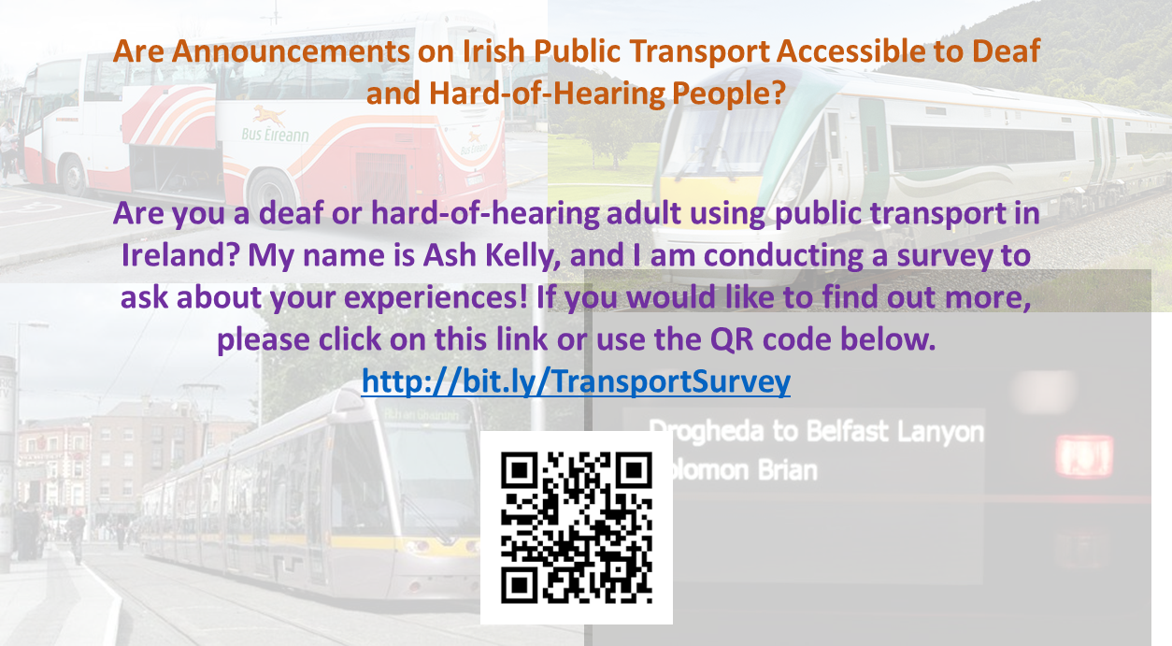
Appendix C
Survey Instrument
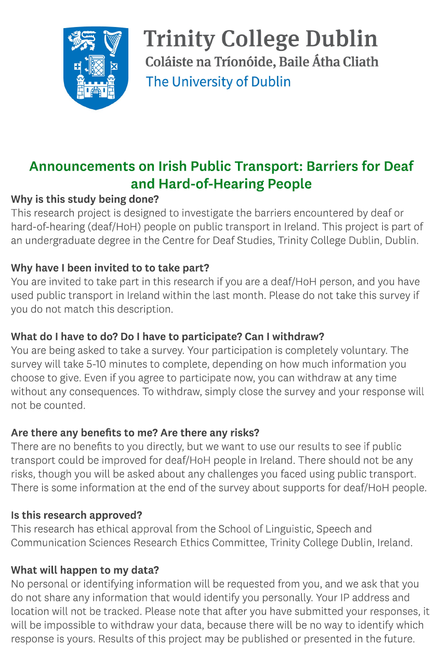
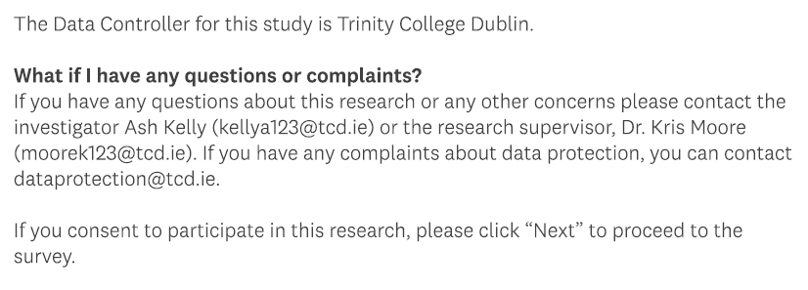

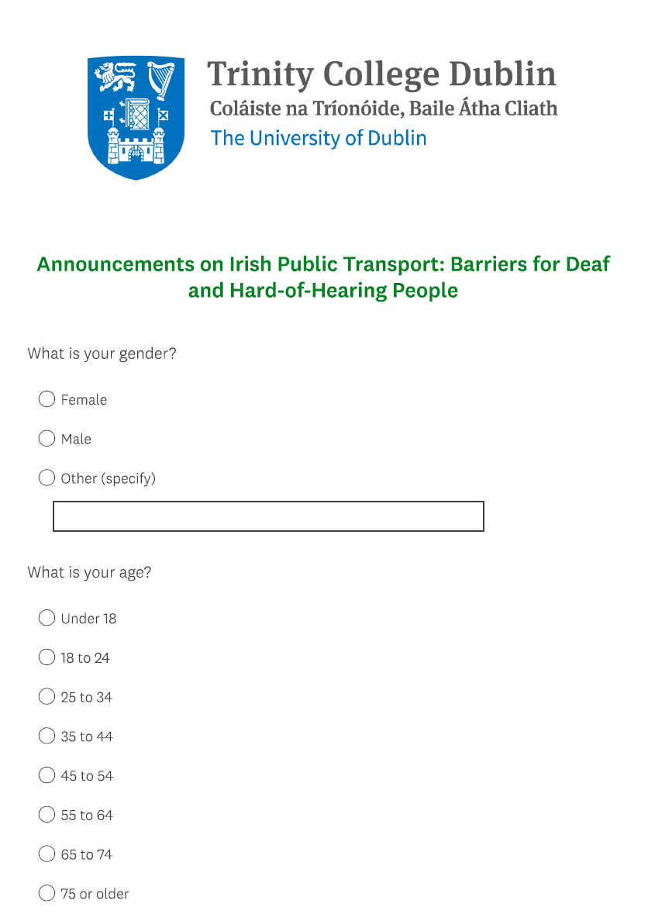
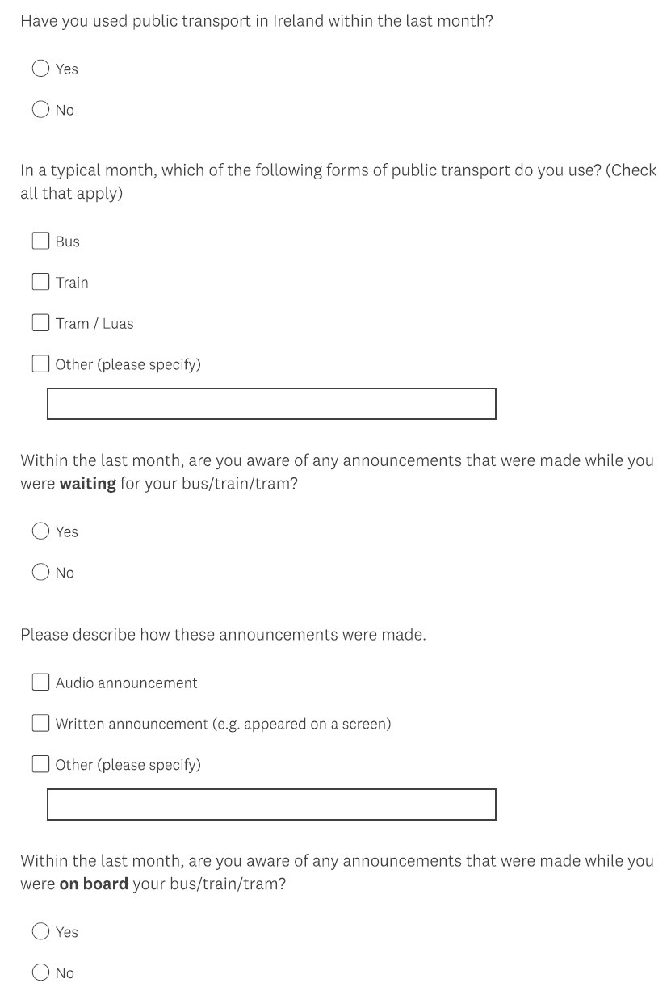

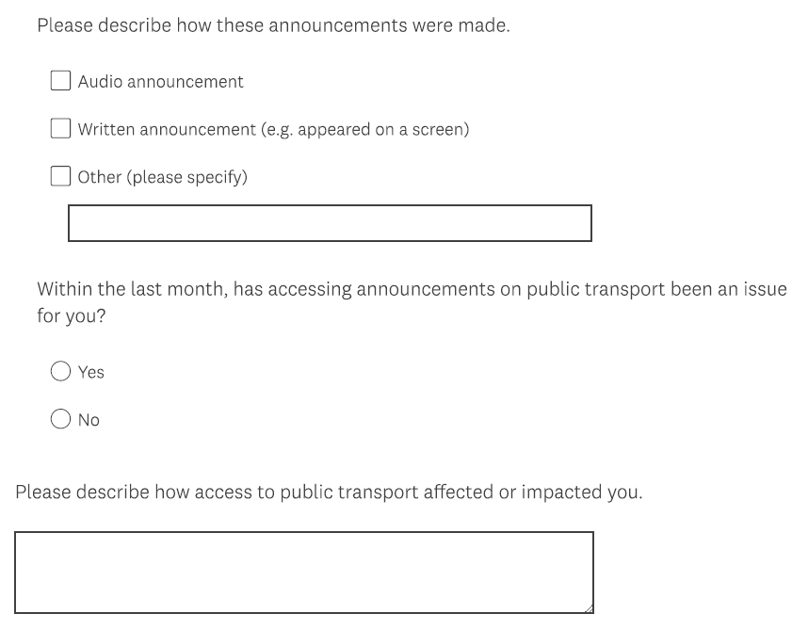
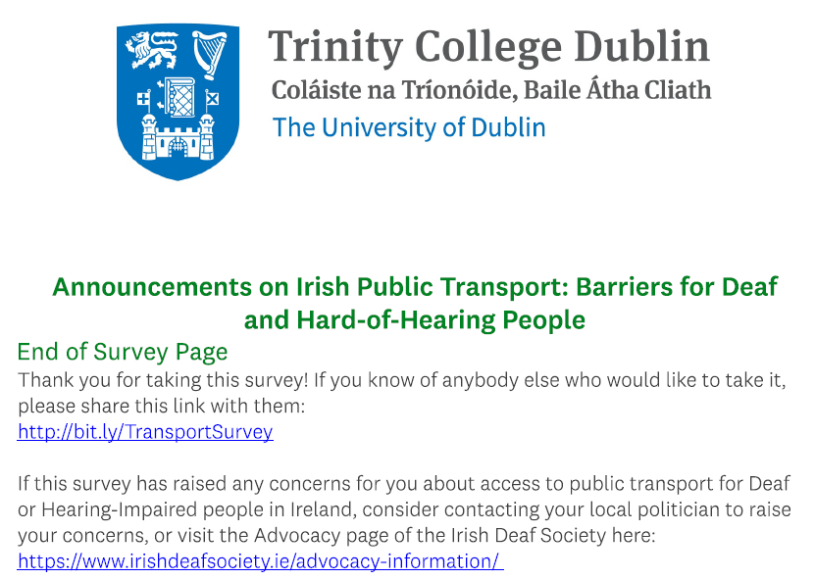

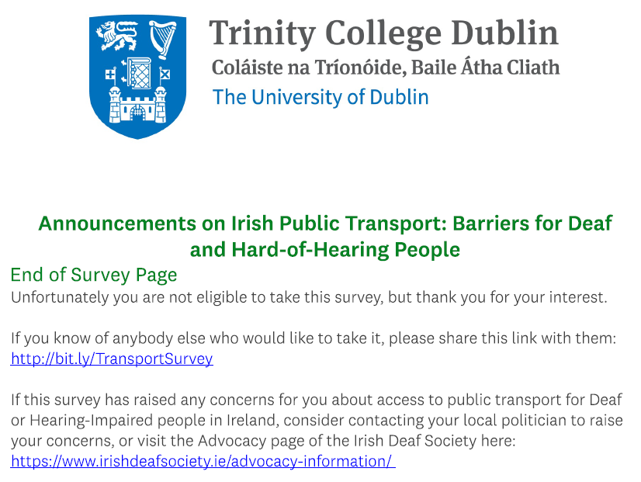

See https://www.tcd.ie/slscs/research/ethics/fast-track.php for details.

