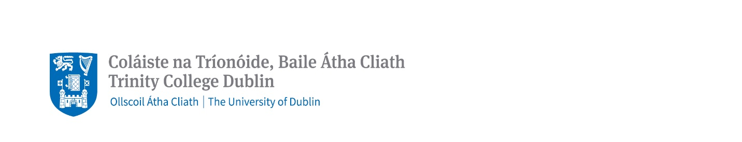
School of Linguistic Speech and Communication Sciences
Constantia Maxwell Scholarship Application Form 2024/25
Upon receipt of unconditional offer (accepted) for one of our taught MPhil and MSc degree programmes, please submit the completed scholarship form (one page in length) to slscs_dtlp@tcd.ie by 1 July 2024. Early application is encouraged. Please use subject title "Constantia Maxwell Scholarship Application” and include your 8-digit TCD application reference number and full name.

Name:
Email Address:
TCD Application Reference Number:
Taught Postgraduate Course:

Briefly describe your academic and personal achievements to date. (400 words)

Please provide a brief personal statement about your interest in your chosen postgraduate taught course. (400 words)

