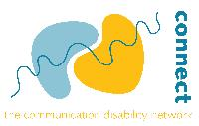

The Dublin Conversation Partner Project

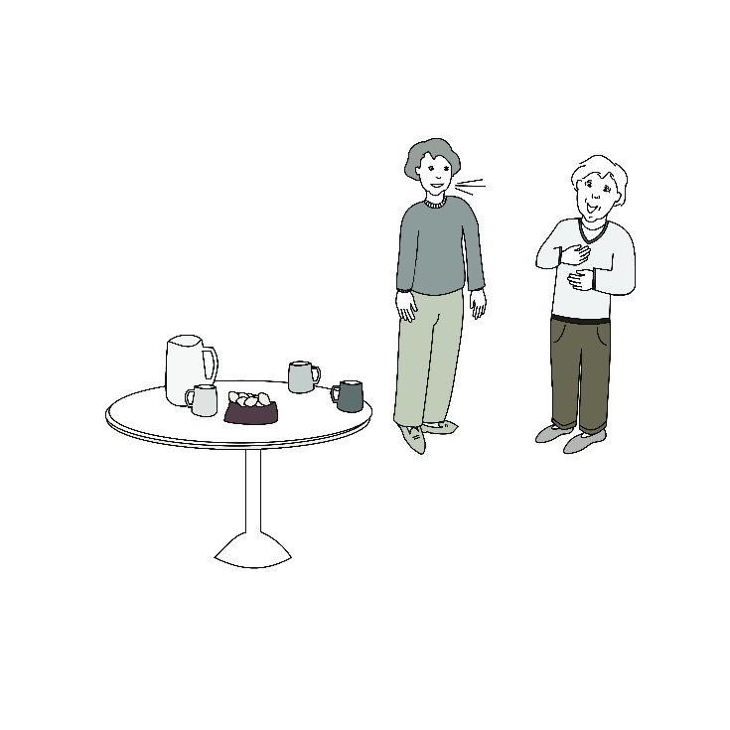

Contact: Jessica Henihan
E-mail: henihanj@tcd.ie

ABOUT THE CONVERSATION PARTNER PROJECT

Conversation partners is a programme organised
by Trinity College Dublin, and your Speech and Language Therapist. It is a project which is linked to Connect: The communication disability network in London

After training, two first year speech and language therapy students will meet with you in person in your home.
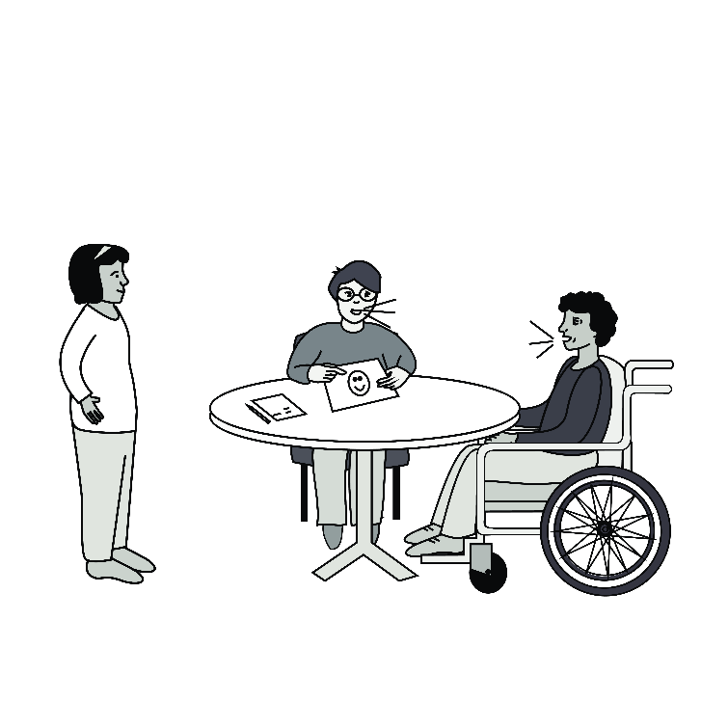

There will be an option to meet online.

The students are not qualified Speech and Language Therapists.

The students will have conversations with you.

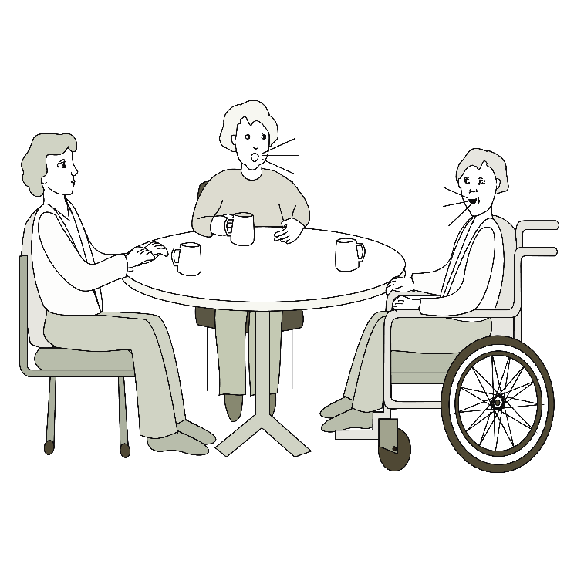
You can decide that you do not want the students to contact you.
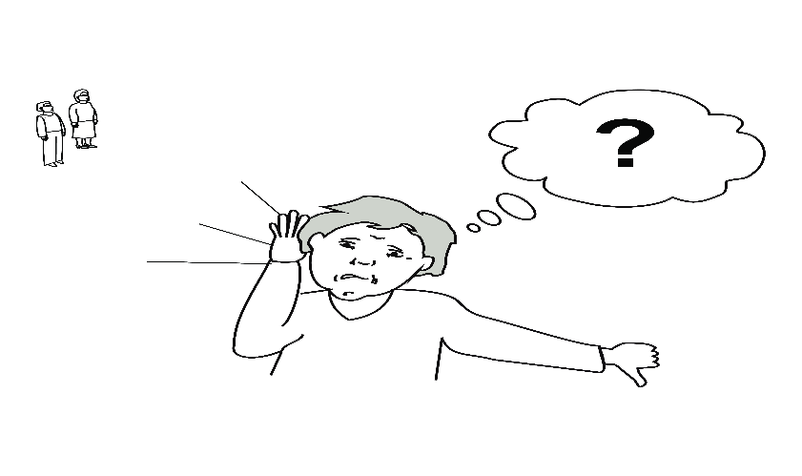

If all goes well, the students will contact you once a
week during term time (except on holidays).

These conversations will happen
on Thursdays.
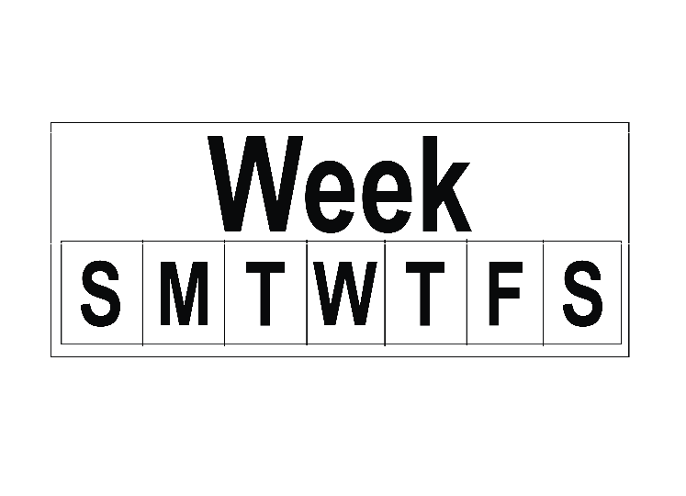

Your Speech and Language Therapist can refer you to the programme.

They will need to provide the following details
- Your name
- Your age
- Your gender
- Your phone number
- Your email address
- The details of a family member
- Comment on your access to internet and a device like an iPad, smart phone or computer

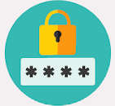
These details will be kept securely on a password protected computer.

Your details will be deleted after 2 years, unless you want to be contacted about research on aphasia in the future.
You have data rights. You have the right to:
- Access the data we collect about you;
- Correct the data;
- Request that we delete the data at any stage;
- Decide that you do not want us to use your data

You and your family can telephone your local speech and language therapist if you have any questions,

OR you can contact Jessica Henihan at henihanj@tcd.ie

CONVERSATION PARTNERS: CONSENT FORM

Conversation partners has been explained to me by:

- I would like students to visit me in person (or online)

YES ü

NO 𝙓

- I understand that my details will kept securely.

I want my details to be kept to allow me to participate in the Conversation Partner Scheme.
(These details will be kept for 2 years only).

I ALSO want my details to be kept securely and used to contact me if there is research that is relevant to me. (My details will not be shared with anybody else, but I agree to receive information about research projects related to stroke or aphasia).

Signature: ___________________________

Witness signature: Family member: ______________________

Speech and language Therapist: _________________________

How much of a problem is aphasia in your life?

I__________I__________I__________I_________I_________I
0 1 2 3 4 5

Small Problem Very Big Problem

