Optical Spectroscopy

The overall aim of this experiment is to introduce you to the principles of optical spectroscopy. The software and documents for this experiment are available in the C:\Spectroscopy folder, and you may find it convenient to use the electronic version of this document, e.g. when you are searching websites, as the document has links.

Before you begin you must complete a Risk Assessment in relation to this experiment. See instructions and links on the JS PCAM laboratory webpage.

Answer the questions below in an appropriate place in your write-up, using a bullet point to indicate that you are dealing with a specific question in this document.

For measuring emission spectra of various types, the experiment uses a small, computerized, optical fiber input, grating spectrometer that allows the rapid acquisition of a spectrum. The spectrometer is of crossed Czerny-Turner geometry and uses a 50 $μ$m diameter optical fiber to capture and input the light, and a 25$μ$m input slit. The spectrum is read out, in parallel, using a charge-coupled device (CCD) array and fed to the computer via an analogue-to-digital converter (ADC) – further details are given in the Appendix and in the OOIBase32 Software Manual.

For measuring absorption spectra, the experiment uses a typical laboratory instrument, the Biochrom Libra S22 spectrophotometer. This uses a xenon lamp as a broad band source, a diffraction grating to select light of a particular wavelength, and two silicon photodiode detectors – further details are given in the Biochrom Libra S22 Instruction Manual.

Experiment 1. Emission spectrum of a tungsten halogen lamp

Aims.
1. To record the emission spectrum of the tungsten halogen lamp of the flashlight and to become familiar with the operation of the spectrometer.
2. To determine the Spectrometer System Sensitivity as a function of wavelength.

Procedure
Attach the collimating lens to the SMA connector of the optical fiber and mount on the optical rail. Mount and roughly align the flashlight.

Start the OOIBase32 software.

View the spectrum in “Scope Mode” (“S” on the menu bar).

- Examine and explain the effect of changing the values of a) integration time b) average c) boxcar, and of selecting "correct for electrical dark" (see page 37 of the software manual). Familiarise yourself with the use of the cursor.

Find the maximum number of counts before "saturation" is reached.
- Explain why it occurs at this value.
- Explain why, in general, you should try to have a large count, but saturation must be avoided.

The emission of this tungsten halogen lamp, to a good approximation, is that of a black body radiator with a temperature of 3417 K. However, your recorded spectrum will not correspond to this because the sensitivity of the spectrometer varies with wavelength: the Appendix lists some of the reasons for this. The aim of this part of the experiment is to determine the sensitivity as a function of wavelength.

Printing spectra Use the HP DeskJet 5900 Series printer, set to Landscape in Page Setup, and use File/Print Preview to check before printing.

Carefully align the flashlight to obtain a "smooth" spectrum.
- Print a spectrum for your report

Planck’s radiation law gives the intensity $I(λ)$of a black body radiator as

$I(λ)=2π{{\text{hc}}^{2}}/[λ^{5}(\text{exp}$

The Excel spreadsheet “Calibration” is used to calculate the blackbody emission spectrum of the flashlight (the temperature of the tungsten filament is 3417 K).

Compare the blackbody curve with the flashlight data by copying the data into the first two columns of the spreadsheet (Edit/Copy Spectral Data/All Spectrometer Channels).

- Print out the calibration graph from the XL spreadsheet for your report: this shows the Spectrometer System Sensitivity as a function of wavelength.
- State the main reasons for the variation of sensitivity with wavelength.

Experiment 2. Emission spectrum of a mercury-argon discharge lamp, spectrometer resolution, and resolving power

Aims
1. To determine the wavelengths of the lines in the emission spectra of mercury and argon in the range 450–730 nm.
2. To determine the resolving power and resolution of the spectrometer.

Procedure
Attach the optical fiber SMA connector to the CAL-2000 lamp housing and view the spectrum in scope mode. Adjust the integration time and average value to obtain suitable spectra, noting that there will be both strong and weak lines in the spectra.

- Why should the boxcar parameter be set at “1” for this experiment?

Record the spectra and measure, as accurately as possible, the wavelengths of the lines. Determine the main doublet spacing at ~ 580 nm. Note that you can either use the cursor to identify the line positions and intensities (probably the quickest), or you can use Edit/Copy Spectral Data/All Spectrometer Channels/, followed by pasting the data into a new Excel spreadsheet, to allow you to identify all the peaks from the raw data.

Compare your results with the NIS basic atomic spectroscopic data handbook available at http://physics.nist.gov/PhysRefData/Handbook/element_name.htm and identify as many of the lines as possible. Note that the line intensities depend on the detail of the electrical discharge and the NIS values are thus only a guide.

For your report:
- print out a spectrum of strong lines and a spectrum of weak lines, for the range 450 nm to 730 nm;
- make a table of the wavelengths of the lines, with identification where possible;
- determine the ratio of the intensities of the 546 nm and 577 nm lines, correcting for the Spectrometer System Sensitivity, and compare the ratio with the NIS value.

The definition of optical resolution and resolving power, and guidelines on how to calculate them, are given in the Appendix.
- Measure the optical resolution and resolving power for the 546 nm and 738 nm lines near to each end of the spectrum.
- Compare the optical resolution to the spectrum of the 577 nm doublet.
- Calculate the theoretical resolving power for a 25 mm grating with 1200 lines per mm, and compare these values with those obtained by measurement. Discuss the result.
- Answer the questions in the Appendix

Experiment 3. Fluorescence spectra of ruby and rhodamine 6G

Aims

- To measure the fluorescence spectrum of ruby.
- To measure the fluorescence spectrum of rhodamine 6G.

- Measure and print out the fluorescence spectrum of the crystalline ruby rod, identify the transitions, and measure their wavelength.

Background
Ruby is chromium-doped sapphire. Sapphire is a colourless transparent crystal of alumina (Al₂O₃). The chemical formula for ruby is Al₂O₃:Cr³⁺. The notation "Cr^{3+"} indicates that the chromium atom is in a triply-ionized state inside the crystal host. In June 1960 T.H. Maiman used a ruby crystal to make the first optical laser. Experience has shown that optimum laser operation occurs with "pink" ruby where the doping is 0.03%-0.05% chromium oxide, depending upon the manner in which the ruby is to be pumped and the type of operation desired. The red (or pink) colour of ruby is due to the light absorption of the "impurity" chromium atoms. A simplified absorption spectrum of ruby is shown in Fig. 2. The two broad absorption regions centred on 400 nm and 550 nm are both used for optical pumping of the ruby. Thus most of the useful pump light for a ruby rod lies in the blue-green portion of the visible spectrum.
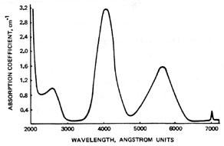
Fig. 2. Absorption spectrum of ruby.

Fig. 3 shows the energy-level diagram for a ruby laser. Many other levels are present in ruby. The state labelled ⁴A₂ is the ground state of ruby. The two transitions from this state to the ⁴F₁ and ⁴F₂ states are the two strong absorption bands in the ruby absorption spectrum (shown in Fig. 2). Cr³⁺ ions remain in these states for only ~10 ns before experiencing a spontaneous non-radiative transition to one of the two lower energy states indicated in the diagram. Lasing occurs on the transition labelled R₁ in the diagram. The fluorescent lifetime of the upper lasing state is the average time an atom remains in that state before dropping to a lower state by spontaneous emission. For ruby this is about 3 msec.
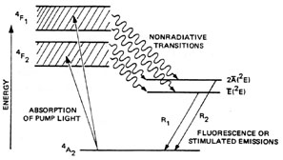
Figure 3. Energy-level diagram for a ruby laser.
The ruby crystal has a symmetry axis called the c axis. In most ruby rods this axis is perpendicular to the optical axis of the rod. The apparent darkness of such a rod will vary as the rod is rotated. When the rod appears the darkest, the direction of observation is along the c axis. This represents the greatest absorption of the ruby. Rubies are usually cylindrical with the centreline axis 60 or 90 to the optical axis.

  - Measure and print out the fluorescence spectrum of the ruby rod.

Procedure
Attach the collimating lens to the SMA connector of the optical fibre and mount on the optical rail. Mount the ruby rod and optimise the geometry to maximise the output, using the GaN diode as the excitation source.

  - The polymer rod contains the laser dye rhodamine 6G immobilised in the polymer matrix. Measure and print out the fluorescence spectrum of rhodamine 6G.

Procedure
Attach the collimating lens to the SMA connector of the optical fibre and mount on the optical rail. Mount the polymer rod and optimise the geometry to maximise the output, using the GaN diode as the excitation source.

- Explain the completely different type of spectra observed for this laser dye, when compared to the ruby crystal.

Experiment 4. Absorption spectra of rhodamine 6G solutions and cadmium telluride nanoparticles

Aims

- To measure the absorption spectra of rhodamine 6G solutions and test Beer’s Law.
- To measure the absorption spectra of CdTe nanoparticles.
- To relate the spectral maxima to the particle size.

General procedure for measuring absorption spectra
Switch on the UV spectrophotometer and allow 30mins for it to warm up.
Open the ‘Acquire’ folder in the Spectroscopy folder and open the Wavescan folder.
Open file ‘new’. Go to File/New on menu bar.
A parameters box will be displayed with the following 4 options: parameters, details, display and run options. Insert the following values.

Parameters.
Wavelength (nm): start: 350
end: 700
step: 1.00
Reference: before 1st scan
Method: Standard
Scan speed: 750nm/min
Sample: 1 of 8 (for example)

Details:
Title: Enter <filename>, e.g. “PKelly”
Enabled: tick
Update all samples: tick

Display.
Ab s% T range: Minimum 0.0
Maximum 1.0
Scan mode. Abs

Run Options.
Post Run: Save (to save the graph) & SAVE SPREADSHEET (to save the data)
View: “Individual Spectra” and “Overlay graphs”
Sample box: Insert number of samples including reference.
Function: Autoscale

Click OK

Insert samples
Place the reference sample cuvette in the blue cell holder (i.e. no.1). Put the first sample cuvette to be scanned in holder 2, and so on for the other samples. If the reference sample is not at 12 o’clock, do not try to set it manually: when scanning starts the reference sample will automatically go to the 12 o’clock position.

Acquiring the spectra
Select ‘Run’ from ‘wavescan’ menu bar and click on ‘Method’.
‘Load cell changer’ menu will be displayed. This should read “<filename>:1”, etc. If it doesn’t, return to Details , tick “Enabled” again, and repeat.
Click OK.
Scanning will commence and graphs will appear on the screen.
Go to File/Save to save scan.

- Measure and print out an overlay plot of the absorption spectra of rhodamine 6G solutions

Procedure
As described above. Insert cuvettes labelled 2, 3, 4, 5, 6, 11 and 14. These have concentrations of 0.2, 0.4, 0.8, 1.6, 3.2, 13, 26 (x 10⁻⁶ mol), respectively.

Theory
Beer’s Law relates the absorption of light as it passes through a solution to the molecular concentration:

$I=I_{0}\text{exp}(−σdn)$

where I is the emerging beam intensity, $I_{0}$ is the incident beam intensity, σ is the beam cross-section, d is the path length through the solution, and n is the number of molecules per unit volume. The absorbance, A, is measured by the spectrometer and is related to the intensities by:

$A=−\text{ln}(I/{I_{0}})$

- Plot an appropriate graph and use regression analysis to test Beer’s Law for the rhodamine 6G solutions. Discuss the result.

Procedure
Use File/Export/Spreadsheet and “Save” to save an XL spreadsheet of the data. In XL, use “=MAX($B20:$B370)” to find maximum absorbance. Plot graphs using Chart Wizard, or Chart/Chart Type/Custom Types, and tick “User defined”, and select “Beerslaw”. For linear least squares fit (regression analysis), use Tools/Data Analysis/Regression and tick “Line Fit Plots”. Enter the appropriate Y and X cell values. The template “Beerfit” can be used to re-plot the result.

- Measure and print out overlayed absorption spectra of CdTe nanoparticles

Caution.
The CdTe samples used in this experiment are extremely toxic and should be handled with great care. Gloves, safety glasses and lab coats must be worn at all times. Solid waste e.g. gloves, should be placed in the yellow sharps box provided. Any liquid waste should be placed in the waste bottle provided.
Sample preparation
Three samples, of different particle size, have been made up in Millipore water, which is also used as the reference sample. Cells containing the samples have been prepared in advance and are stored in the fridge. The samples will degrade over time when exposed to light and heat, therefore only take the samples from the fridge when you are ready to start scanning. Samples should then be returned to the fridge as soon as possible.

Procedure
Insert the three cuvettes and continue as described above.

- Relating the spectral maxima to the particle size

Theory
The simple Brus equation, describing the effect of 3D quantum confinement, links the absorption maximum, $E_{\text{max}}^{\text{abs}}$ , to the nanoparticle radius, r, via a number of material parameters:

$E_{\text{max}}^{\text{abs}}=E_{g}+\frac{h^{2}}{8r^{2}}\left\{\frac{1}{m_{e}^{}}+\frac{1}{m_{h}^{}}\right\}−\frac{1\text{.}8e^{2}}{4{\text{πε}}_{0}ε r}$

where $E_{g}$ is the band gap energy, $m_{e}^{}$ and $m_{h}^{}$ are the electron and hole effective masses, and ε is the dielectric constant of the material.
- Find values of these material parameters for CdTe on the Web or in the literature. Plot and then print out a graph of absorption maxima (in wavelength units of nm) against particle radius in nm, between 0.5 nm and 5 nm.
- Does the Brus equation work for the CdTe nanoparticles?

A phenomenological relationship has been established between $λ_{\text{max}}$ and r for CdTe [1]:

$r=0\text{.}5\left\{9\text{.}\text{8127}×{\text{10}}^{−7}λ_{\text{max}}^{3}−1\text{.}\text{7147}×{\text{10}}^{−3}λ_{\text{max}}^{2}+1\text{.}\text{0064}λ_{\text{max}}−\text{194}\text{.}\text{84}\right\}$

- Estimate the CdTe particle size for the three samples, using this equation.
Appendix A. The Spectrometer
Detailed information about the Ocean Optics spectrometer can be found at the website http://www.oceanoptics.com/homepage.asp. The PC 2000 spectrometer fits on a card that is plugged into the PC. The spectrometer (Fig. A1) is a crossed Czerny-Turner type, which uses a 50 $μ$m diameter optical fiber to input the light, together with a 25 $μ$m input slit. Once in the spectrometer, the divergent light emerging from the optical fiber is collimated by a spherical mirror. The collimated light is diffracted by a plane grating, the resulting diffracted light is focused by a second spherical mirror. An image of the spectrum is projected onto a 1-dimensional linear CCD array with 2048 elements (pixels). These reverse-biased photodiodes discharge a capacitor at a rate proportional to the photon flux. When the integration period of the detector is complete, a series of switches close and transfer the charge to a shift register. After the transfer to the shift register is complete, the switches open and the capacitors attached to the photodiodes are recharged and a new integration period begins. At the same time that light energy is being integrated, the data is read out of the shift register by an A/D card. The digitized data is then displayed on the computer.
(http://www.oceanoptics.com/Products/howccddetectorworks.asp)

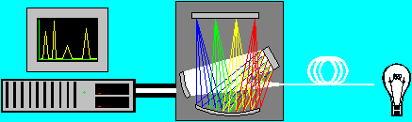
Fig. A1. The Ocean Optics PC 2000 spectrometer
(http://www.oceanoptics.com/technical/operatingprinciples.asp)

The CCD has a spectral range of 200–1100 nm, but the 1200 lines/mm, high resolution holographic grating only covers the range 440–740 nm. The efficiency of the grating varies with wavelength as shown in Fig. A2.
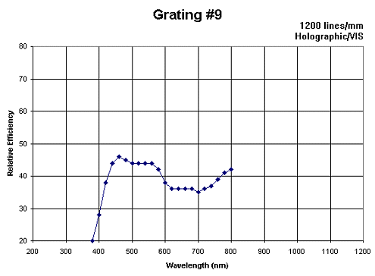
Fig. A2. Efficiency of the 1200 lines/mm visible holographic grating.
Optical resolution and resolving power
The optical resolution is taken as the full width at half maximum height (FWHM) of a line from a monochromatic source.

The chromatic resolving power, R, is defined as $R=λ/{Δλ}$ where $Δλ$ is the minimum wavelength difference that can be distinguished by the spectrometer. In these experiments you may take $Δλ$= FWHM.

The three parameters that are most important in determining the resolution are:
- The total number of lines on the grating.
- The wavelength range per pixel.
- The width of the entrance aperture.

For a grating the Rayleigh criterion gives $R=λ/{Δλ}=\text{pN}$, where p is the order number and N is the total number of lines on the grating. Obviously, for a grating of fixed width increasing the line density (i.e. lines per mm) will increase N:
  - why will this also reduce the spectral range?

Note that strong second order lines ($p=2$) may sometimes appear in the spectrum.

For a wide enough entrance aperture, the resolving power is increased by reducing the slit width:
  - why does this happen?

Table A1 shows how, for this spectrometer, the pixel resolution varies with slit width The pixel resolution is the number of pixels that will respond for a monochromatic input. The FWHM can be calculated from this, knowing the wavelength range per pixel (this in turn can be found from the spectral range and total number of pixels).

The sensitivity of the instrument varies with wavelength. Many factors affect the wavelength dependence of the sensitivity including CCD response, fiber attenuation, grating efficiency and collection optics (see http://www.oceanoptics.com/technical/systemsensitivity.asp). The only practical way to account for all these factors is to do a calibration experiment.

Table A1. Typical pixel resolution for different slit widths.
5 micron slit = | ~3.0 pixels
10 micron slit = | 3.2 pixels
25 micron slit = | 4.2 pixels
50 micron slit = | 6.5 pixels
100 micron slit = | 12.0 pixels
200 micron slit = | 24.0 pixels

Appendix B. Absorption, fluorescence and phosphorescence

Fluorescence is the emission of light that accompanies the spontaneous transition of an electron from an excited state to a lower energy state in a material. When the material is raised from the ground level, S₀ (Fig. B1), to an excited state S₁, by light absorption, it typically loses some energy via vibrational relaxation (deactivation or radiationless transition) before emission of radiation (luminescence) returns the material to vibrationally excited levels of the ground state S. If the emission process involves an intermediate metastable triplet state, T₁, of lower energy, the life of the excited state may be being fairly long (~1 msec). The former process is known as fluorescence and the latter, phosphorescence.
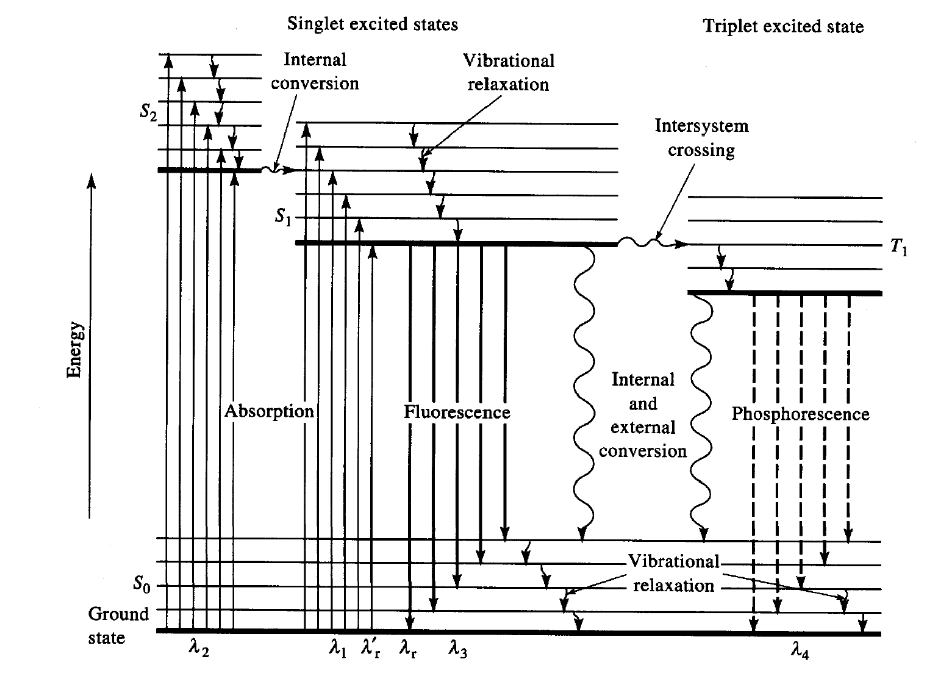
Fig. B1. Energy level diagram

