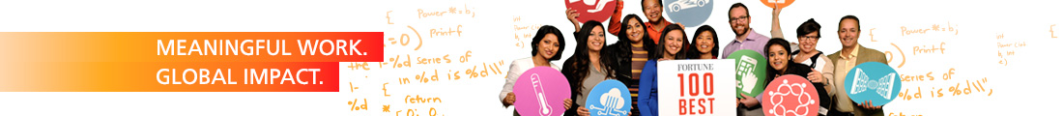

Cadence Design Systems is a pivotal leader in electronic design, building upon more than 30 years of computational software expertise. The company applies its underlying Intelligent System Design strategy to deliver software, hardware and IP that turn design concepts into reality.

Cadence customers are the world’s most innovative companies, delivering extraordinary electronic products from chips & boards to systems for the most dynamic market applications including consumer, hyperscale computing, 5G communications, automotive, aerospace industrial and health.

Cadence Ireland is entering an exciting time – we are building a new R&D Centre of Excellence here in Cork. The Custom IC, PCB and Solutions Group (CPG) is striving to make a significant contribution to advancing the state of the art tools and technology and bring the product development of the next generation of Electronic Design Automation products such as Virtuoso® and AWR® here, many of which you will be exposed to.

Of course, we also have everything else you would expect from a world class technology organization & fortune 100 company, ranked as one of the best places to work worldwide.

https://fortune.com/best-companies/2020/cadence

We are hiring and looking for interns. If you are passionate about technology and love to learn, work and grow in a multi geography and multi culture organization developing next generation software, you should apply as per below:

Job Title: Intern (Custom IC & PCB Group)

Location: Cork

Reports to: Software Engineering Director

Job Overview:

This Internship with Virtuoso and AWR product development team will help you learn RF design analysis and implementation tools, it’s software development and development processes, design and analysis of algorithms, software debugging, GUI development etc.

Role responsibilities:

The internship offers the opportunity to contribute in the development of these products and its features for our marquee customers.

Job Qualifications:
- Bachelors or Masters program in CSE or EEE
- Passion to learn and write high quality C++ using tools such as gmake, ASAN, Clang, Visual Studio etc.

