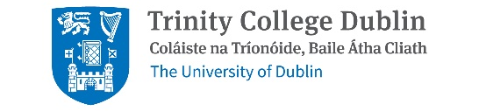 |  |  |  |  | Short Courses – Autumn 2026  REGISTRATION FORM
Name: | Click or tap here to enter text.
Address: |  |  | Click or tap here to enter text.
Phone: |  | Click or tap here to enter text. |  | E-mail: |  | Click or tap here to enter text.
Course (Module) – Please select below the module(s) you would like to take:
☐ Introducing the Old Testament/Hebrew Bible
☐ Introducing Theology: Key Questions
☐ Approaches to the Study of Religion
☐ Ethics Matters: Global Questions, Ethical Responses
☐ Jewish Thought and Practice
☐ Introduction to Hinduism and Buddhism
☐ Medieval Theology: Women, Learning, Universities
☐ Creaturely Ethics: Humans and Other Animals
☐ Philosophical and Theological Approaches to God
☐ Qu’ran: Scripture History, Literature
☐ Ethics in Sport and Media
☐ From Invasion to Exile: The Ancient Histories of Israel and Judah
☐ Christian Origins and Paul
☐ The Afterlife of Moses: Interpreting the Exodus in the Arts over the centuries
☐ Power and Politics: Liberation, Contextual, and Post-Colonial Theologies
☐ Religion, Media, and the Public Sphere
☐ Hindu Mythology
FEE: €150 (Reduced fee for students, unemployed persons & pensioners with social welfare card: €100)
Registration and payment in cash can be made in person at the School of RTPS (Old Physiology Building) from Monday to Friday, 10 AM – 12 PM; 3 PM – 4 PM.
Cheques, drafts or postal orders should be made payable to Trinity College no. 1 account. Please return cheques, drafts or postal orders to:
Executive Officer, School of Religion, Theology, and Peace Studies Building (Old Physiology Building), Trinity College Dublin, College Green, Dublin 2, D02C1F6.
For further queries, please call: 01 896 4790 or email: sradmdbln@tcd.ie or SRundergrad@tcd.ie

