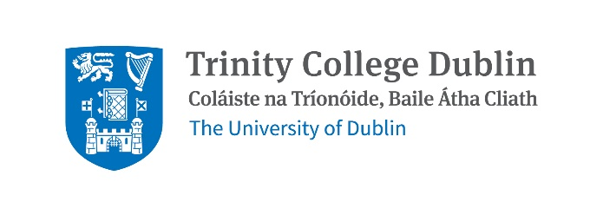
PhD studentship available on Spartina anglica (cordgrass) and salt marsh community ecology
We are seeking a highly motivated PhD candidate for a fully funded 4-year project. The PhD student will be supervised by Nessa O’Connor, Professor in Zoology, School of Natural Sciences, and co-supervised by Iris Möller, Professor of Geography, Thomas Connor, Assistant Professor (species distribution modelling), Jamie Waterman, Assistant Professor (chemical ecology) and Dr Aoife Delaney, at the National Parks and Wildlife Service (NPWS).
Project Background and Description
Spartina anglica is a robust invasive non-native grass species that occurs on intertidal sediments and can co-occur with several key salt marsh species. The main distribution of S. anglica in Ireland is on the southern, south-mid western and eastern coasts. Moreover, S. anglica is spreading at several sites within the SAC network including Bannow Bay and Castlemaine Harbour including the Annex I habitats at Páirc Náisiúnta na Mara. S. anglica can take over large areas to the exclusion of other vegetation. Dense stands of S. anglica are not thought to provide a similar habitat for biodiversity compared to the displaced native species. The ecological impacts of S. anglica occurring as a component of saltmarsh vegetation are unclear. Instances of invasion by S. anglica into saltmarsh habitat have been documented, however, it may also be the case that S. anglica fixes sediment, thereby creating the conditions for colonisation by saltmarsh species within the S. anglica sward. It is not understood fully whether the current distribution is related to historic plantings, abiotic conditions, such as climate and nutrient availability, or a combination of factors. It is possible that S. anglica expansion is linked to nutrient enrichment but this has yet to be tested. Future expansion of S. anglica may be affected by climate change, but we do not currently have a clear view of the outcome of climate change for S. anglica, or the habitats where it occurs.
The overarching aim of this project is to provide evidence for a strategy to manage the impact of S. anglica on saltmarsh in Ireland. This project has four research goals:
1. Compare historic and current nutrient levels in saltmarsh vegetation.
2. Identify the roles of nutrient availability and temperature in controlling S. anglica growth and expansion.
3. Characterise the effects of invasion by S. anglica on saltmarsh associated benthic communities (plants and invertebrates) and biogeochemical conditions.
4. Assess options for control of S. anglica in an Irish context.

Candidate Profile
The ideal candidate will:
- Hold at least an upper second class Honours Bachelor degree, preferably in Biology, Botany, Zoology, Ecology, Environmental Science, GIS, or another related discipline.
- Be actively interested and involved in some aspect of Irish ecology and conservation.
- Have demonstrable skills in field-based ecology.
- Have demonstrable skills in data handling, analysis and research.
- Have (or be willing to learn) skills in mesocosm-based ecological experiments.
- Have the ability to apply multidisciplinary techniques to address hypothesis-driven questions.
- Have a full, clean driving licence, and ability to drive in Ireland.
- Work well in a multi-disciplinary team, and be able to work independently
- Meet the Trinity postgraduate entry requirements.
Funding
This is a 4-year PhD project funded by the Trinity Research Doctoral Award Scheme in collaboration with the National Parks and Wildlife Service and covers an annual tax-free stipend of €25,000, and student fees.
Application procedure
Please send a CV and a 1-2 page personal statement detailing your interest in the project to Nessa O’Connor n.oconnor@tcd.ie by 20th May 2026.
Your CV should include the name and contact details of two references. In your personal statement, please explain both why you are specifically interested in this PhD project and why you are a strong candidate to undertake it͘.
Interviews will take place (online) in early June.
Project start date September 2026.
Please send all inquiries to Nessa O’Connor n.oconnor@tcd.ie.

