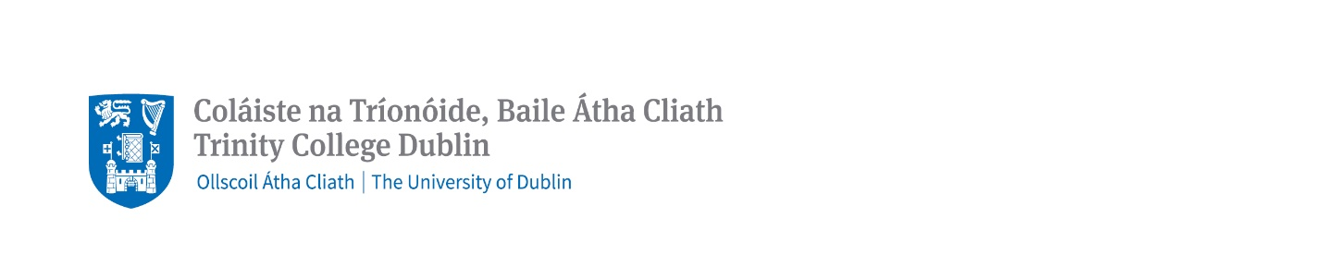
School of Law

Constantia Maxwell Scholarship Application Form 2026/2027

Upon receipt of unconditional offer (accepted) for one of our four LLM programmes, please submit the completed scholarship form (one page in length) to law.postgraduate@tcd.ie by 10am Irish Standard Time (IST) on 30 June 2026. Early application is encouraged. Please use subject title " Constantia Maxwell Scholarship Application” and include your 8-digit TCD application reference number and full name.

Name:
Country of Birth:
Email Address:
TCD Application Reference Number:

Clearly list your degree/s, the awarding university and your final degree result/GPA.

Briefly describe your academic and personal achievements to date.

We expect our students to have the potential to make exemplary contributions to society throughout their career. What contribution will you make as an LLM student and ambassador?

