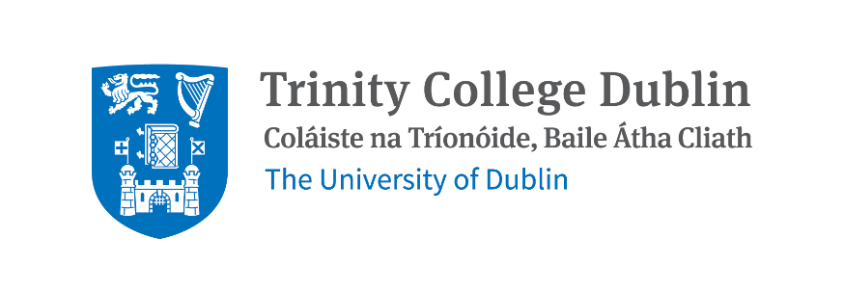

Preparing for Academic Advancement
Expression of Interest Form

The applicant should
- indicate their intention to apply for a Professor In or TCD Professor Of promotion application within the next two years;
- be available to attend each workshop, module and coaching session; and
- be in a position to commit to working with a mentor who you will be paired with (Mentors come from different Institutions).

Name
Position
Department/School/Institute

Discipline/Research focus
Work Email
Contact Number
Staff Number

Describe what you feel you would gain from participating on this programme at this stage of your career (Max word count 300)

Please include reference to any factors that impacted your academic profile/trajectory in the context of promotion to date e.g., previous periods of leave; limited opportunities; impact of Covid etc. (Max word count 500)

List the areas of interest you would like to explore as part of a mentoring relationship. These should be areas you may have gaps in or wish to further develop in. (Max word count 200)

I am available and agree to attend all dates as outlined on the course outline.

Yes

No

Do you have a preference for the gender of your mentor?

Yes - Please specify

No

Signed:

Date:

Please ensure you have reviewed the outline for the programme before completing this form.

Please email your completed application to PAA@ul.ie

Closing date for applications: 5pm 25th May 2023

Outcome will be delivered to applicants by email in week beginning 12th June 2023.

If you have questions or queries on this programme, please contact the Head of Learning & Organisation Development at staffdev@tcd.ie

