Structure of a thesis or dissertation

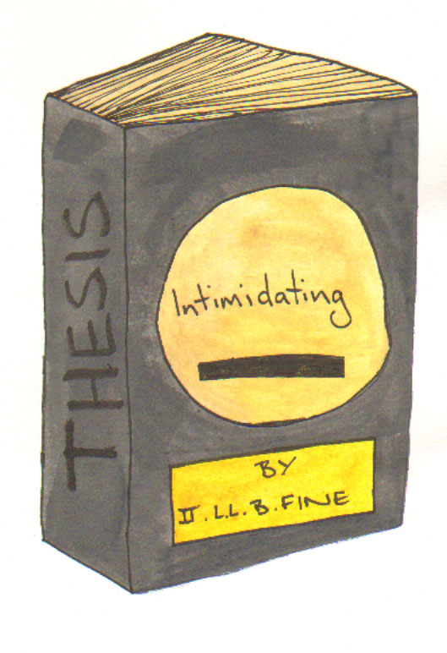

Selecting a research topic

What you choose to research will be connected to:
- the academic department(s) in which you are studying;

- the availability of a supervisor with a knowledge and interest in the subject you wish to research;

- what you already know and your enthusiasm for the subject matter;

- practical consideration around feasibility of data collection and analysis;

- the time and resources available to you.

- It is vital to choose a topic in which you are genuinely interested, and that can be sustained over several years.

Rationale and theoretical framework

Rationale:
why you are studying this topic?
how and why is it important?
have you provided evidence?

Just because you find it interesting does not mean that it is relevant or interesting to experts in your field.

Theoretical framework:

- outline existing theories related to the research topic
- how does your research relate to existing theories?
- who are the key theorists in this area?

You should be able to identify well known theorists and a reasonable breadth in the research area. If not then you may find it difficult to justify your rationale and framework.

- what are the main debates, arguments and research evidence?
- is there any aspect that has not been investigated?
- are there unresolved questions in the research field?

This is the basis for your chosen methodology which needs to be linked to this theoretical framework.

Pre-Literature Review

You should begin gathering research related literature early on, as a broad survey of the quantity and quality of literature available. The purpose is to:

- help you decide on the main issues or theoretical strands;
- reflect on where and how your proposed research fits within existing frameworks;
- avoid replicating research that has already been done;
- recognise theoretical and methodological approaches which may become problematics;
- select the most relevant research before embarking on a critical review.

Literature Review

Purpose:
- To identify what is already known
- To identify the ‘gap in knowledge’ within your topic
- To provide and overview of the research area
- To introduce questions emerging from key theories
- To demonstrate your knowledge of the subject

What should be included:

- Only research related to the topic you have chosen.
- Founding theories which are widely referred to, no matter how old.
- A focus on most recent papers if this is a widely researched area.
- Demonstration that a thorough search has been conducted.

As this is your first piece of research you are not yet an ‘expert’ in the field. Therefore it is not appropriate for you to criticise the research work of others, but you may refer to critical comments proffered by other experts, and these should be reported and discussed.

Supervision

The number of supervision sessions available to you may be limited, so you need to be fully prepared. A thesis supervisor is there to guide and advise you, but this is your work and so the drive and input must come from you.

Writing schedule

You should make sure you allocate a regular time for working on your thesis or dissertation. This is particularly important if you are working part-time. You need to review your progress regularly otherwise it is easy to

lose focus and momentum. It is helpful to note down references, ideas or things to ask your supervisor as they occur to you, especially if you are working on other things, otherwise you may forget or mislay the information.

Format

This will depend on the preferred format of your university, but your School or Department should provide a template, often in the course handbook. Generally speaking the order is:

Front cover: title, name

Title page: title of project, your name, supervisor’s name, name of university, year completed

Declaration

Contents page

Abstract

List of figures or diagrams

List of tables or illustrations

Acknowledgements

Sections and chapters

Appendices

References

- Check style requirements such as sections, sub-sections and numbering of such.
- Check whether text should be double or 1.5 spaced, check regulations for margin size, font size and acceptable font type.
- Check preferred referencing style.

Declaration

The purpose of the declaration it to formally acknowledge that your dissertation is completely your own work:

Declaration
I have read and understood the College / University statement on plagiarism.
I declare that the attached dissertation is my own, original work undertaken in partial fulfilment of my degree. I have made no use of sources, materials or assistance other than those which have been openly and fully acknowledged in the text. If any part of another person's work has been quoted, this either appears in inverted commas or (if beyond a few lines) is indented. Any direct quotation or source of ideas has been identified in the text by author, date and page number(s) immediately after such an item, and full details are provided in a reference list at the end of the text.
I understand that any breach of the fair practice regulations may result in a fail of this dissertation and that it could also involve other repercussions. I understand also that too great a reliance on the work of others may lead to a low mark.
[signed]

Abstract

A summary of the research question, methodology and findings in approximately 100 words. The purpose of an abstract is to indicate to other researchers the content of your thesis, and whether your research topic is of interest (basically is it worth reading or is the subject matter not relevant to their own investigations).

Acknowledgements

The acknowledgement section allows you an opportunity to give recognition to people who have helped you during the research and writing of your dissertation. This would normally include your supervisor and other people who may have been of assistance during your fieldwork.

