Working Memory

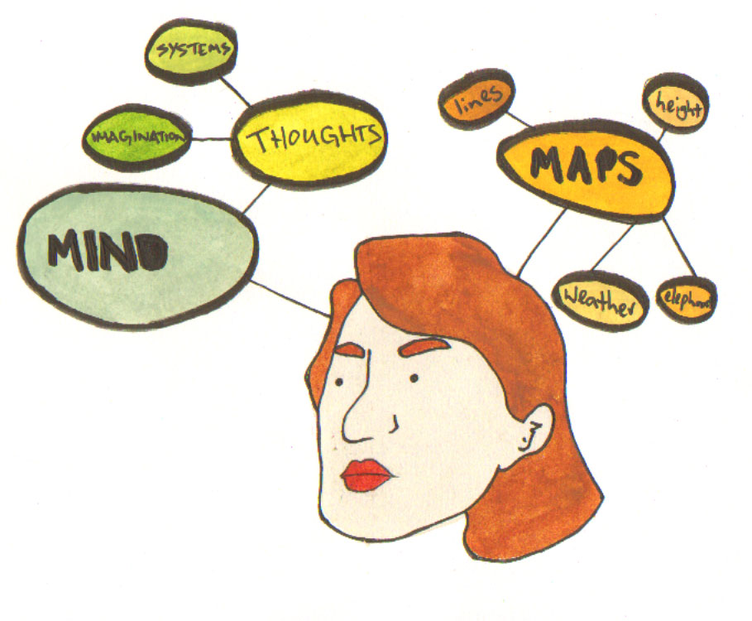

What is Working Memory?

Working memory (WM) is a cognitive function that stores data in a temporary holding space in the brain, so that data can be manipulated. For example, in order to mentally calculate 264 + 139 (i.e. without pencil and paper), a person needs to have the ability to retain the original sum in memory whilst calculating each step involved in solving the units, tens and hundreds columns.

Similar problems occur with spelling: for example in order to spell the word ‘superstitious’ it is necessary to ‘hold’ the word in WM whilst retrieving appropriate spelling rules and phonological sound units. In terms of reading this involves retaining the meaning of a question or instruction in working memory whilst retrieving the answer from long term memory.

In general, people with Specific Learning Difficulties such as dyslexia, dysgraphia, dyscalculia and ADHD have difficulties with WM which can affect reading, spelling and maths.

Improving Working Memory

There has been a great deal of research recently into training WM and how it can improve performance. There are many ‘brain training’ games available on the market, although whether these work or not is open to interpretation. However there are a number of online sites where you can try out brain training techniques, and we have selected a few that might be of interest. Warning! Don’t let this distract you from your studies!

http://www.lumosity.com/
You can log your progress on this site….
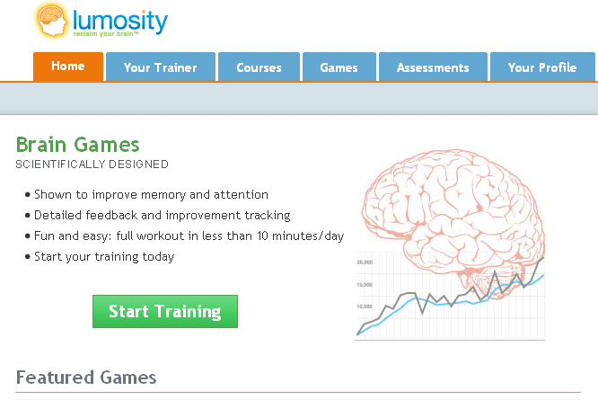

http://www.brainmetrix.com/index.htm
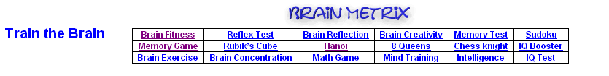

http://www.sharpbrains.com/teasers


