Using the Internet to research information



Learning about the pitfalls of the Internet

Not everything that is available on the internet is true, accurate or reliable. So it is worth investing some time into learning more about what to do, and what not to do.

One excellent resource that explains this in detail is an online tutorial called The Internet Detective, which is part of a national service for UK universities and colleges and which is available from http://www.vts.intute.ac.uk/detective/index.html

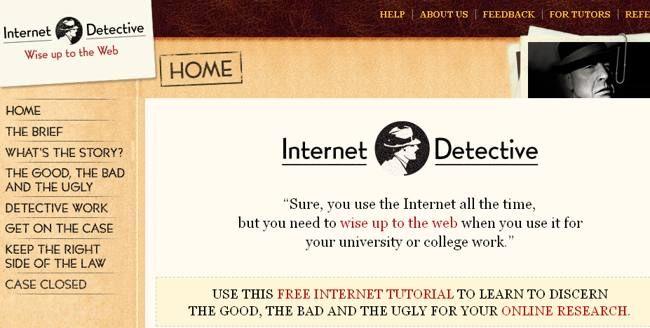

Robert Harris (2007) suggests that you evaluate the source by using CARS: Credibility, Accuracy, Reasonable and Support.

Credibility: how believable is the information? This will depend on the status and experience of the author. How well published are they? Has the article been approved to appear in a journal? How detailed is the information provided?
Accuracy: how old is the research? Have there been substantial changes to theory since then? Does the data support the claims? Is the information ‘academic’?

Search engines

Everyone has their preferred search engine and internet browser. However Google provides an excellent resource called Google Scholar.

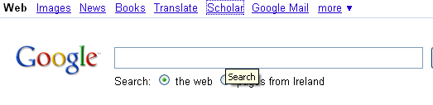

Click on Scholar and then type in your search topic.

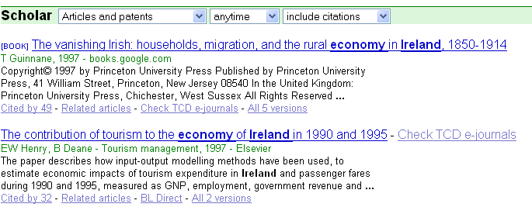

If you are conducting the search on a networked college computer, you will notice the option to ‘check TCD journals’. Clicking on this option is a faster and somewhat easier way to access research stored by the Library. If you select this option you will be directed to the Library information system:

