Essay structure

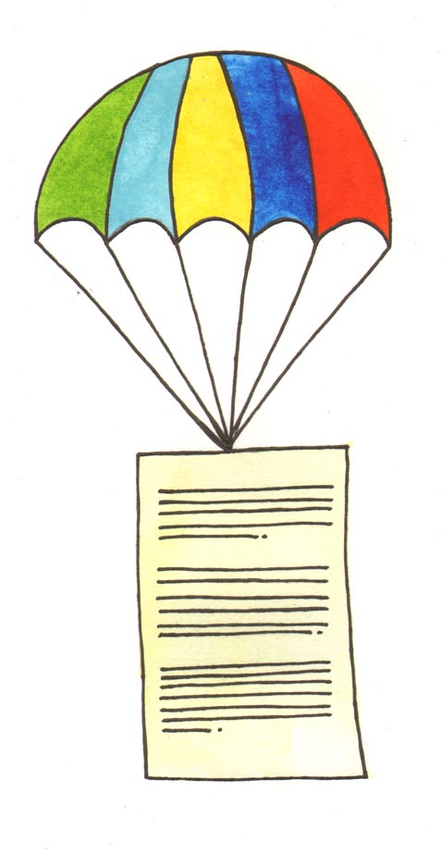

Contents

Essay structure 1

Essays: Purpose, Content, Structure 2

Introduction 2
The Purpose of the Introduction 2
The Content of the Introduction 3
The Structure of the Introduction 3

Main Body: Three Support Points 3
The Purpose of the Main Body 3
The Content of the Main Body 4
The Structure of the Main Body 4

The PEE chain 5

Sentence structure and paragraphs 6

Writing the Conclusion 7
The Purpose of the Conclusion 7
The Content of the Conclusion 7
The Structure of the Conclusion 7

Essays: Purpose, Content, Structure
Short essays are broken up into five paragraphs:
- Introduction
- Support Point 1
- Support Point 2
- Support Point 3
- Conclusion
Long essays may, of course, require more than five paragraphs. However, the number of paragraphs will always reflect a 5-part structure of Introduction, Support Point 1, Support Point 2, Support Point 3, and Conclusion. This guide will go through the five parts of the essay explaining each section under the following headings:

Purpose Content Structure

Introduction

The Purpose of the Introduction
- To convey the subject matter of the paper
- To imply the structure that your essay is going to take
- To clearly state your thesis statement

The Content of the Introduction

First, define the question in your own terms. Ask yourself: Are you setting any limits on the scope of your answer?
An example of this is if the question asks for an assessment of something vague, like ‘in modern times,’ to what time frame are you limiting your discussion:
- since the middle of the 20th century
- since the 1990s,
- since the turn of the millennium?
Explain the way in which you intend to tackle the question, the previous research on the issue, and the lines of argument you are going to pursue.

The Structure of the Introduction

The only thing you must remember when structuring your Introduction paragraph is that the ‘thesis statement’ belongs as the last line. It is a declarative sentence that asserts that which your essay will prove. A thesis statement is NOT a sentence of intent, it is a statement of position. You know you have an effective thesis statement when somebody else can take a clearly opposing position.

Main Body: Three Support Points

The Purpose of the Main Body

The purpose of the main body of the essay is to provide support for the assertion you made in your thesis statement.

The Content of the Main Body

Be specific and timely. Look at the particular topic – not on one that is roughly similar. Be selective about the material you include and, where appropriate, make every attempt to refer to the most recent critical material on the topic.

Summarise and discuss any previous research on the topic. Make sure you reference all the material you use.

Do not feel that you must agree with all of the critical material you cite. It is perfectly acceptable (and often adds a nice texture) to use a source as a position to argue against in order to support your own view.

The Structure of the Main Body

Decide in advance the type of essay you are writing. This will determine the order in which you will advance your argument.

- Compare/Contrast
- Comparative
- Evaluative, etc.

Decide in advance the order in which you will advance your argument.

- Chronologically?
- Reverse chronologically?

We recommend three support points because to have fewer is seldom adequate coverage of support. To have too many can often lead to only skimming the surface of arguments. Three is ideal because it allows you to go deeply into support without overwhelming the reader.

The PEE chain

The PEE chain is a way of writing that can provide good structure to any piece of academic writing. It will help you to construct essays and provide detail in your answers, but will also ensure that you stick to the point. PEE stands for : Point, Evidence, Explanation.

Point is a specific argument that you want to make within a paragraph.
Evidence is the information you provide that supports the argument, statement or claim that you have made. It could be a quote or a piece of technical data.
Explanation links the point and the evidence or example, and will go into more detail.

PEE writing frame

Point | What is the point you are trying to make? How does it link to the main point of the paragraph? | Research evidence indicates that…  Much has been written about the ……  Current thinking on …..
Evidence | Which example of all the evidence you have researched are you going to use to back up your point? | Wilson (2006) states that…  Research by Smith et al (2006) claims that…
Explain | How are you going to demonstrate that the example or evidence proves / supports your point? | This…..  - Supports the notion that…  - Indicates that  - Suggests that

Sentence structure and paragraphs
A paragraph is a sequence of sentences (no fewer than five) that present a brief argument with one controlling idea that relates to your thesis statement.
State the central idea of each paragraph explicitly in a topic sentence at the beginning of the paragraph. Where appropriate, the topic sentence is backed up with supporting evidence, quotations, critical opinion (references). Develop your paragraph from your topic sentence as follows:
- Explain more fully what you mean, giving definitions or indicating distinctions.
- Offer details, examples, or relevant quotations (with your comments).
- Follow through a logical sequence, showing the connections among your ideas in a recognizable pattern such as cause and effect or comparison and contrast.

A complete paragraph should contain:
Assertion (Topic sentence)
↓
Critical discussion
References
Quotations
↓
Conclusion

Try numbering your sentences to see how they correspond to this pattern. This will show if you have placed too much emphasis on one aspect of the argument of your paragraph. Such diagrams enable you to make sure that your thoughts are developed logically through a paragraph, with enough evidential support.

Writing the Conclusion

The Purpose of the Conclusion

The conclusion ‘wraps up’ your essay. It re-states your thesis statement, to remind the reader of your original assertion. It also (in slightly different wording than originally used) touches upon the three support points so that you can remind the reader of those.

The Content of the Conclusion

The conclusion should not significantly repeat material from the rest of your essay. Also, do not introduce any new information; to do so risks leaving an argument unsupported.

Make sure your conclusion sounds confident. Do not qualify your conclusion with ‘buts’ or ‘maybes’ as this will weaken the overall impact of your essay. Be upbeat; after all, you have carried out all this research and are now an expert on the topic!

The Structure of the Conclusion

The conclusion should not be longer than your introduction.

