Reading scientific texts

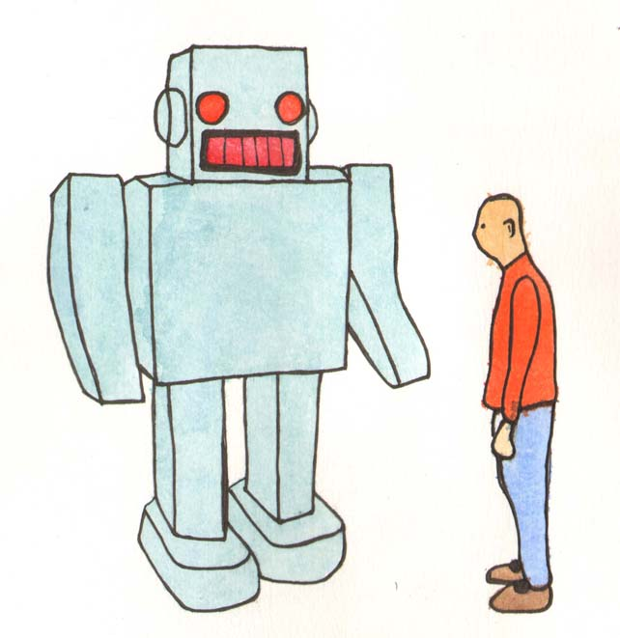

Reviewing a chapter prior to reading improves understanding of the content.

Title.
Read the title to check general content.

Headings.
Read headings or sub-headings, look at how the author / publisher has organized the material. How much of this is familiar? Do you already know a little about the subject matter?

Illustrations, diagrams, charts.
Read chart titles and labels.

Key terms.
Highlight or circle words in bold, italics or in the margin, and those words that you do not know the meaning of. Look them up in the text book glossary (normally at the back) or an online dictionary.

Summary.
Read the summary or final two paragraphs, this will give you an overview of what you should have learned by the end of the chapter.

Review questions.
If there are review questions at the end of the chapter, briefly see how many of them you can answer.

Read the Text.
Use a pen or pencil to make notes in the margin of the book (unless it is a library book!). If you really need to highlight the text, do it on the second reading. Only the most important information should be highlighted.

Review questions.
Attempt to answer the questions again. How much more did you know this time?

Problem material.
If there are any concepts, definitions, terms that you still don't understand, or if there are problems to solve that you still cannot work out, ask your teaching assistant or lecturer for help.

Try making vocabulary and concept cards to help you remember key information. You can index these alphabetically and keep them in a box. It is then simple to look up any terms that you are unsure of or have forgotten, for example:

Vocabulary card. Concept card.
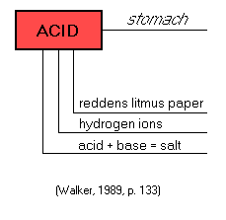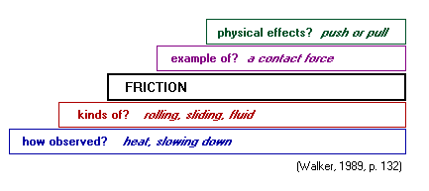

In her article ‘Developing Skills in Critiquing Research’ Barbara Kuyper (1991) suggests a checklist of 20 questions covering each section of a research paper. By checking off each item on the list as it is completed, students can ensure that they have:
- captured all relevant information
- understood the main points of the paper

Checklist for critiquing a research article

Title:
Author:
Introduction
1. Read the statement of purpose at the end of the introduction. What was the objective of the study?

2. Consider the title. Does it precisely state the subject of the paper?

3. Read the statement of purpose in the abstract. Does it match that in the introduction?

- Check the sequence of statements in the introduction. Does all information lead directly to the purpose of the study?

Methods
5. Review all methods in relation to the objective of the study. Are the methods valid for studying this problem?

6. Check the methods for essential information. Could the study be duplicated from the information given?

7. Review the methods for possible fatal flaws. Is the sample selection adequate? Is the experimental design appropriate?

- Check the sequence of statements in the methods. Does all information belong in the methods? Can the methods be subdivided for greater clarity?

Results
9. Scrutinize the data, as presented in tables and illustrations. Does the title or legend accurately describe content? Are column headings and labels accurate? Are the data organized for ready comparison and interpretation?

10. Review the results as presented in the text while referring to data in the tables and illustrations. Does the text complement, and not simply repeat, data? Are there discrepancies in results between text and tables?

11. Check all calculations and presentation of data.

- Review the results in the light of the stated objective. Does the study reveal what the researcher intended?

Discussion
13. Check the interpretation against the results. Does the discussion merely repeat the results? Does the interpretation arise logically from the data, or is too far-fetched? Have shortcomings of the research been addressed?

14. Compare the interpretation to related studies cited in the article. Is the interpretation at odds or in line with other researchers’ thinking?

15. Consider the published research on this topic. Have all key studies been considered?
- Reflect on directions for future research. Has the author suggested further work?

Overview
17. Consider the journal for which the article is intended. Are the topic and format appropriate for that journal?

18. Reread the abstract. Does it accurately summarize the article?

19. Check the structure of the article (first headings and then paragraphing). Is all material organized under the appropriate heading? Are sections subdivided logically into subsections or paragraphs?

- Reflect on the author’s thinking and writing style. Does the author present this research logically and clearly?

