Using quotations

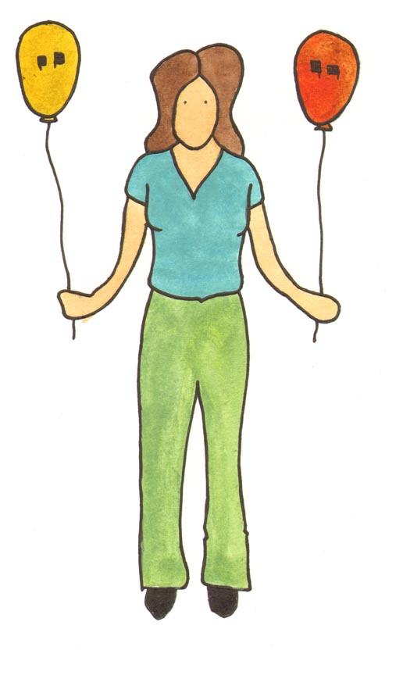

Why quote?
- To encapsulate an author's view on an important point.
- To provide background or support for your interpretations and analysis.

Some general tips for using quotations
Quote naturally – let the writer’s own words fill in some of the gaps in your own sentences – but remember to put quotation marks around them.
Don’t quote huge lengthy passages that are not relevant.
Don’t use quotations without commenting on them.
In an exam situation, paraphrasing (putting a quotation in your own words without quotation marks) is more effective than quoting inaccurately.
Don’t change the author’s meaning to suit your argument. Consider what the quotation means in its context, that is, what the author is saying or arguing.

Incorporating a quotation into your sentence
You don’t have to quote a whole sentence, but when you quote a fragment of a sentence you need to make sure that your quotation makes sense in the context of your own sentence.
Example:
Georg Lucáks famously described the genre of the novel as ‘the epic of a world that has been abandoned by God’ (page reference*)

Note: When you quote you must always give a reference to the text you are quoting from. See your departmental handbook or style guide for guidelines on how to do this.

Abbreviating a quotation
Don’t use part of a long quotation that is irrelevant to your point. If you only need part of the quote, indicate omitted words with ellipses - 3 dots in square brackets […].
Example:
Weisberg describes the novel’s audience as a type of jury weighing evidence, arguing that the use of legalistic structures […] perfectly fits the digressive tendencies of the novelistic form.

Amending a quotation

You can change words to make it fit your own sentence but the words you change must be placed in brackets.

Example:

LEAR. Mend your speech a little.
In the following quotation "her" replaces the "your" of the original so that the quote fits the point of view of the paper (third person):
When he hears Cordelia's answer, Lear seems surprised, but not dumbfounded. He advises her to ‘mend [her] speech a little.’

Formatting quotations
There are no strict rules for formatting quotations in your written work. You can consult your departmental handbook for guidelines. The following, however, are general rules.
Short quotations (up to around 30 words) can be incorporated into the text using quotation marks.
Example:
The closing scene of The Great Gatsby draws to the reader’s eyes, the experience of the Dutch settlers of the ‘fresh, green breast of the new world’.

Longer quotations should form separate paragraphs and should be indented. Indent longer quotations in a block an inch from the left margin; when a quotation is indented, quotation marks are not used. Example:
F. Scott Fitzgerald paints a highly visual picture in the surrealist style at the end of The Great Gatsby as he posits a scene of the arrival of the early Dutch settlers:
And as the moon rose higher the inessential houses began to melt away until gradually I became aware of the old island here that flowered once for Dutch sailors' eyes — a fresh, green breast of the new world.

The MLA Handbook recommends that indented quotations be double-spaced, but many instructors prefer them single-spaced. The meaning of ‘longer quotations’ varies slightly from one style system to another, but a general rule is to indent quotations that are more than two (or three) lines of verse or three (or four) lines of prose.

