Qualities of good scientific writing

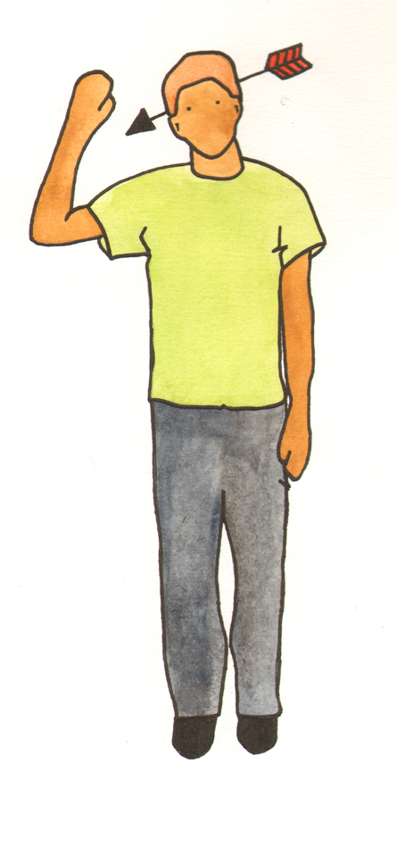
As a student in the sciences, although much of your work may be practical, it is likely that you will be required to write up your experiments in the form of a lab report. This follows a specific structure but you should also consider the style of writing that is most effective when writing a lab report.

Language does not have to be complex to be effective; in fact, the most effective scientific writing is simple and aims for accuracy, clarity and objectivity.

Accuracy
Be accurate in your descriptions, particularly when recording specifics, such as volumes, measurements and time elapsed. As you describe the experiment explain why you took particular actions. If you made any changes to the experiment record them and explain why.

Clarity
Keep your writing style clear and concise. Write out your methods on chronological order. Avoid metaphor and figurative language. Stick to facts and avoid unnecessary commentary, for example, ‘It was interesting to see that…’ Use non-textual elements (graphs, charts, equations) that are necessary for clarity and make sure they are explained properly in the text.

Objectivity - It is very important to use the passive voice to describe how something ‘was done’ thus keeping the focus on the action rather than on the people conducting the experiment. Thus write ‘The test tube was filled’ rather than ‘Tom filled the test tube.’

Check the basics

1. The content of the document, including text and other elements, is effective.

The content:
· Clearly states the purpose, providing an explicit justification for
the document.
· Explicitly defines the scope for the reader.
· Is factually correct.
· Supports the purpose thoroughly and concisely.
· Substantiates claims and, when appropriate, addresses
alternative claims.
· Shows that the writer understands the topic under discussion.
· Uses language to connect the pieces of the argument or
document.
· Uses non-textual elements (graphs, charts, equations) that are
necessary for clarity, are complete, and are referred to and
explained appropriately in the text.

2. The document is well organized for its intended audience and purpose.

The organization:
· Exhibits a logical progression and structures the content to
represent that logical progression.
· Uses headings and subheadings, when appropriate, to make the
document's organization apparent to the reader.

3. The style and tone are appropriate for the intended audience and purpose.

The style (word choice, sentence structure, voice):
· Holds the reader's interest.
· Includes a variety of sentence structures.
· Shows appropriate use of active and passive voice.
· Through vocabulary, demonstrates an understanding of the
content, concepts, and methods in the discipline.

The tone (the writers' attitude toward the reader, the topic, and themselves):
· Takes the reader's knowledge into consideration.
· Matches the purpose in the level of formality.
· Represents a voice that is authentic and credible, so the reader
believes that the writer understands the topic.

4. The document shows knowledge of writing fundamentals.
The writing:
· Conforms to conventions or requirements of the document type.
· Uses correct punctuation, grammar, usage, and spelling.
· Uses proper citation form.

5. The presentation is appropriate for the intended audience and purpose.
The presentation:
· Is designed to help the reader navigate through content.
· Provides clear labels for tables, figures, and equations and uses
sufficient space around these non-textual elements.

- The writing demonstrates an understanding of the ethics governing writing.
The writing:
· Includes citations for other's ideas, including any information and
non-textual material from sources outside the writer.
· Does not use data selectively to manipulate the reader.
· Acknowledges ideas or data that challenge the writer's
conclusions.

For further information, you may wish to consult the following:

Kirkman, John. Good style for scientific and engineering writing. London: Pitman, 1980

Woolston, Donald. Effective Writing Strategies for Engineers and Scientists. Chelsea, MI.: Lewis, 1988.

