Procrastination

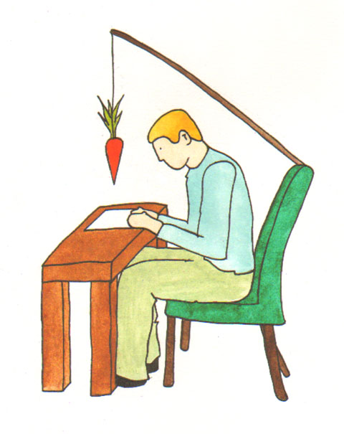

Procrastination refers to putting tasks off regularly even when we know it would be beneficial to complete them. Not all procrastination is bad, but when it affects your academic work or other areas of your life it’s time to work on it.

Some strategies are especially useful for overwhelming tasks that you tend to put off. Other strategies work for unpleasant tasks that you tend to avoid.

Examine the reason you are putting off the task; this may help you decide how to start working on overcoming the procrastination habit. See what might work for you!

Introducing……………the ‘Salami Technique’

Slice, chop or divide the task into smaller parts (by function or by time) then,

Make a plan and schedule when you’ll do the smaller task or
if you have some time, check the list and see what you can do.

Cross things off the list as you complete them.
Check out the Planning Assignments sheet for essays and projects.

Other tips to avoid avoiding………………

- • Do difficult tasks when you are freshest.

- • Make commitments – A common excuse is ‘I work better under pressure’, so create pressure. Create deadlines, put them in your diary, tell people you plan to get something done, and then they’ll ask if you got it done.

- • Take Action – sometimes just doing something creates the mood and builds momentum to continue, so decide to just do something, anything to get going – Just do it!

- • Five minutes – spend five minutes on a task; once started you may find you’ll keep going.

- • Related tasks – Do something related; also known as the back door approach! For example, if you have to start a project or essay maybe decide to just go talk to someone about it; this in turn may lead you to the library because they suggest a reference. Often it can be easier to talk to someone than having to sit down and write.

- • Keep yourself motivated by writing down your personal goals and posting them around the place where you can see them on a regular basis.

You and your environment…………

Take advantage of your moods. Do something on your list of activities you are in the mood to do.

• Give yourself a pep talk. Remind yourself of the benefits of getting the task done and the consequences of failing to do it now. Remind yourself of the emotional and physical consequences of procrastination.

• Surround yourself physically with items associated with the task. Keep your study space organised. Make sure your environment encourages you to study (limited distractions, things you need to hand).

• Make your tasks visible – set up reminders, signs, lists, notes all around you.

• Leave something definite to go back to when you finish studying – this helps to avoid pre-study fidgeting and things to distract you.

Use contingencies and rewards – something you enjoy after doing a task you’ve been putting off. For example, 20 minutes on statistics then going for a cup of coffee instead of the other way around. Also reward yourself at milestones along the way.

• Avoid self-defeating, avoidance generating beliefs and statements that tend to encourage procrastination. Such as thinking you’re not good enough or that everyone else is doing a better job or that you’ll never get it all done. Instead, use enabling and positive beliefs and attitudes.

• Get help from other people and use your friends.

• Visualise or rehearse in your imagination completing the task.

Worst First – that particularly boring or difficult task is easy to put off, in fact you’ll do anything not to get it done but better to get it out of the way first thing.

• Don’t worry about making mistakes -you only find out what works by trying things.

• Start early so you have time to procrastinate!

• Finally, don’t allow yourself to make a split-second decision to put if off yet again. Slow down the decision-making process to consider the importance of the task and the consequences of delay. Working under last minute pressure may sacrifice accuracy, damage relationships, and put your body under unnecessary stress.

