Organising your materials

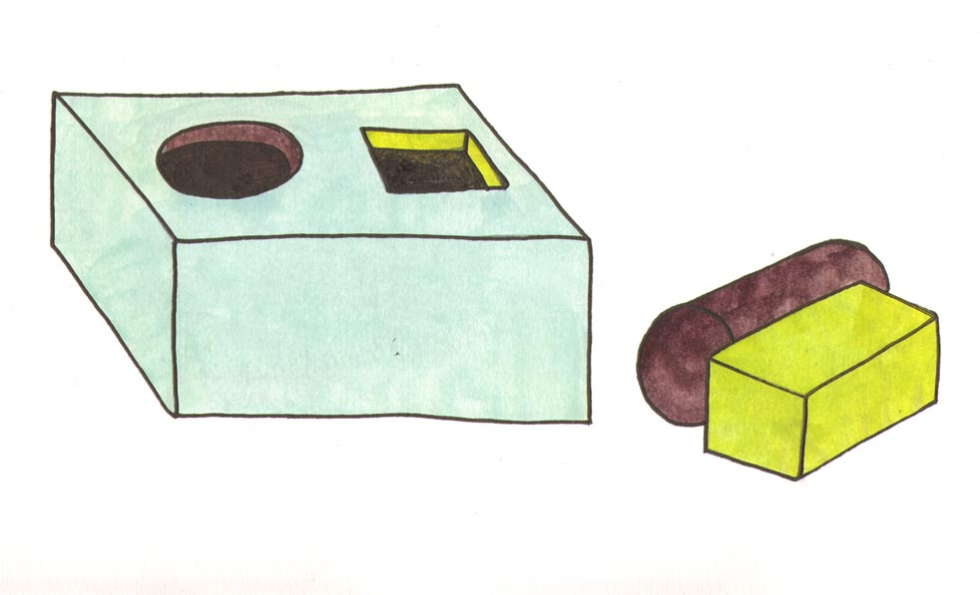

Do you find it difficult to……………

…. locate notes from specific lectures?

….have a couple of folders containing all the notes for every lecture?

- Once a week clear and sort out loose papers and handouts etc. into colour-coded or labelled files and folders. One colour for each subject.

- File lecture notes etc. in the correct file as soon as you get home.

- Label file folders, boxes, notebooks etc. using colour codes or pictures.

- Keep drawers tidy and sort similar items together.

- Clearly mark drawers in terms of what is to be kept in each.

- Use a pin board or whiteboard near your desk or computer to hold important information.

- Use a wall planner in addition to a diary, or put all your diary and timetable into Microsoft Outlook and link this to your mobile phone or Google calendar in MyZone.

- File appropriately information to be kept, and discard outdated/ irrelevant information. Make a ‘to do now’ and ‘done’ trays as well as a large bin so that you can sort as you go.

- Ask others if you are not sure what should be kept.

- Use see-through containers or clear files to store documents with colour-coded labels or use clearly labelled coloured files for different modules and projects.

- Use transparent pencil cases and purses to allow you to see the contents easily.

- Set up different folders for different modules on your computer desktop rather than having lots of individual documents cluttering up the space.

- If you have access to Blackboard / webCT, use this space to store electronic notes, assignments etc.

