Lecture Notes

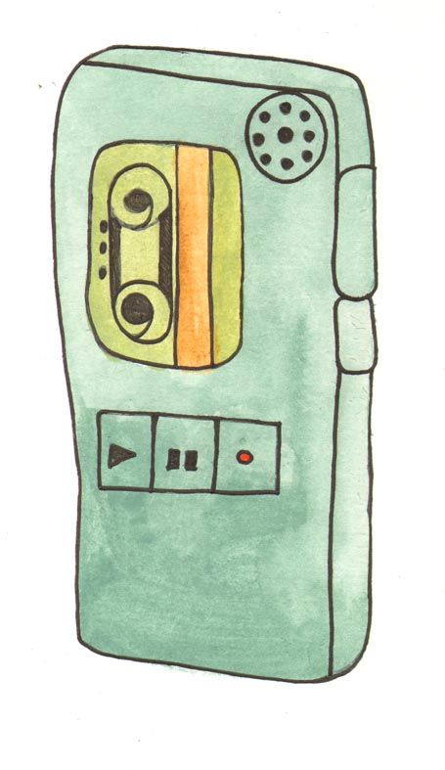

Don’t try to take down every word that the lecturer says. It is much more important that you understand what the lecture is about.
You will never be asked to reproduce lecture notes, but will be required to write exam answers or term papers which reflect that you understood the lectures and can integrate them with your reading and thinking.

Before the lecture

Ideally, you should read in advance the core text that the lecture will cover. At the minimum, ‘scan’ read the text, for headings and introductions. Familiarize yourself with key concepts and vocabulary. This gives your mind something to build on as you listen.

Get there early and have all materials out at the start of the lecture. Sit close to the front. This will minimize distraction and help you to stay ‘tuned in’ throughout the lecture.

During the lecture

Take Part. Be a critical listener and don’t be afraid to ask questions at the end of the lecture. The lecturer will often ask if there are any questions or will leave some time for discussion.

Take notes of major headings and key words. Jot down new vocabulary and look it up later. This is a very time-effective study technique, bringing you to the core of what is important in your subject. Don’t get bogged down in detail you can get from a text book.

After the lecture

Immediately after the lecture go over your notes and perhaps compare them with someone else’s. Fill in any gaps. Work out what you will have to read up on later.

Make sure you understand your notes after the lecture. They should function as memory triggers, reminding you of ideas. When reviewing your notes, ask yourself:

- What is the central thought of this lecture?
- What are the main ideas?
- Are they adequately explained in my notes?

Label and file your notes with related handouts.

When you edit your notes, think about colour coding them or use a highlighter or red pen to emphasize the most important points or definitions. Add personal insights.

List ideas to discuss in a seminar, or with your lecturer, if you need clarification.

