How to read academic texts

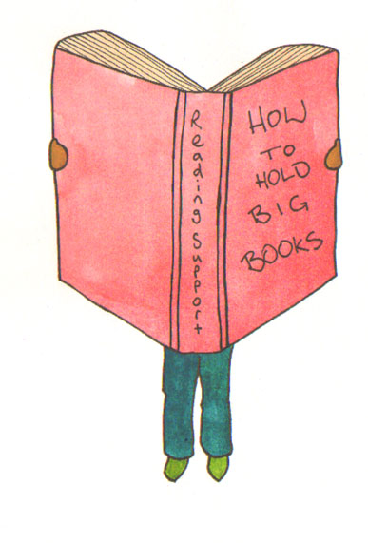

Why?

Do you know why you are reading a particular text book / journal article?
If you don’t have a clear idea of the purpose of reading a text, it will be more difficult to extract meaning from what you are reading.

What?

What information are you looking for? Is it something specific in answer to a question, is it a better understanding of a topic, are you trying to check facts? How are you going to find out whether this piece of text is relevant?

Journal article: who wrote it? Is this a known expert in the subject area? read the Abstract. It should tell you everything you need to know about the content. If it does not sound relevant, do not waste time reading it. If you aren’t sure, read the ‘findings’ and ‘conclusion’ sections to check.

Text book: read the blurb on the back cover, does it sound like a useful book? Who wrote it? Is this a known expert in the subject area?

How?

Pay attention to:
- Cover
- Table of contents
- Index
- Preface and/or introduction
- Conclusion or summary

- Pictures, graphs, tables, figures (Images usually contain much more information than straight text.)
- Section headings (These help the reader understand the book's structure.)
- Special typeface or formatting: boldface, italics, numbered items, lists
- Questions
- Vocabulary lists

Read the Contents page, which chapters are going to be relevant?

Select a chapter, read first paragraph and then chapter summary or last paragraph. This should give you an overview of content.

Read sub-headings, and any highlighted words phrases.

Review what you have found out / learned about the material so far.

Now read the whole chapter.

