Making Mindmaps

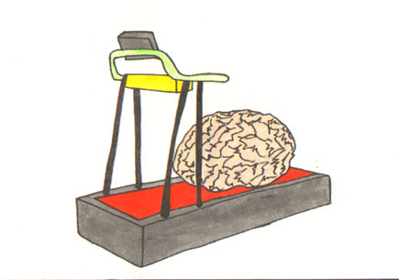

Mind maps can help you think about how to write your essay, what subjects you may need to revise, and can provide you with an overall picture that you can memorize for exams.

This is important because it allows you to ‘see’ parts may need a bit more attention. It also helps you to avoid wandering away from the point. Once you have a finished mind map you can write it up as an essay.

Mind mapping means writing down a main idea and thinking about things that may be associated. Looking for connections between ideas, and ‘mapping’ this knowledge will help you to understand and remember new information. These mind maps can be re-created in examinations.

Often students find just beginning a mind map – having to deal with a blank page – one of the most difficult aspects. A useful strategy is to get some basics down on the paper which will help your ideas to flow.

Is there another way of answering this question?

What do I already know?

What do I need to find out?

What are they asking me to do?

What do I already know?

Try and get down any information you already know about the subject. Firstly anything that comes to mind, and then other things that you might remember from class. This may only be one word and you may still need to look at your notes or text books to add more detail.

You may find that not all of the ideas you put down are relevant, or it may be that you cannot include everything. However you can work on your mind map and decide what topics, subsets or associated ideas are most important and therefore should be included.

Once you have followed the steps above, you are ready to make a first draft of a specific essay mind map. The following guidelines are suggested by Tony Buzan who is an authority on mind mapping skills.
- Use an A4 or A3 piece of paper, longest side at the top. Make sure you work with a paper colour that suits you. Some people find bright white paper difficult to work with.

- Make sure you have a selection of coloured pens or pencils. You may prefer certain colours.
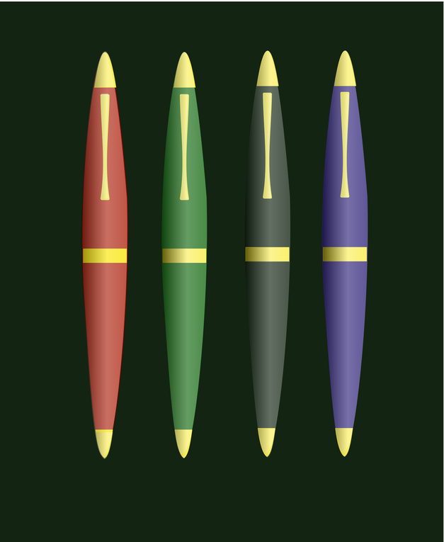
- Begin with an image in the centre of the page, approximately 6cm high and wide for an A4 piece of paper, or 10cm for A3 paper.


- Draw ‘wavy’ branches stemming from the central theme or idea and put paragraph or essay sub-headings on each branch. Use key words to label the branches.
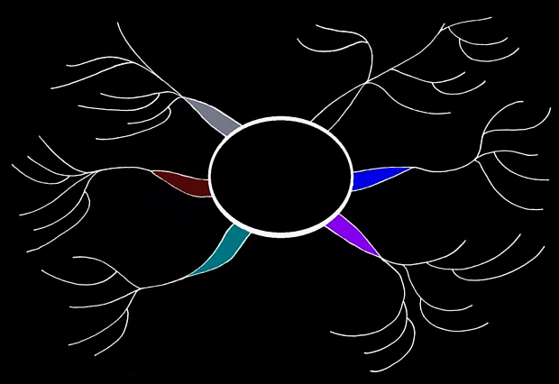
- Draw thinner branches to record detailed information.
- Use images as a shortcut to illustrate ideas. Making your mind map more personal will help you to memorize key facts.
- Use specific colours for people, topics, themes or dates and to make the mind map more colourful and memorable.
- In the first instance get your ideas on to paper quickly, you can go back and re-draw or revise at a later stage. So you should leave plenty of space between branches for additional information.
Want to see how to do it? Go to http://www.youtube.com and type in ‘how to make a mindmap’…

