Dissertations

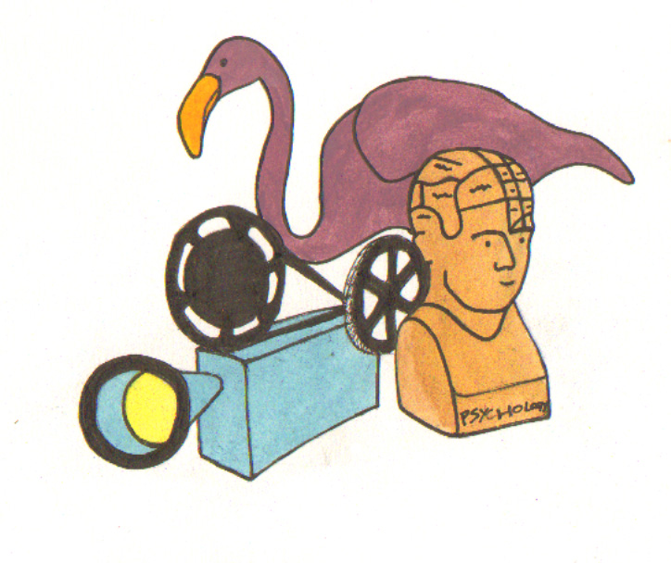

What is a dissertation?
A dissertation is ‘an extended scholarly essay, usually based upon original research, submitted for a degree or other academic qualification’ (Oxford English Dictionary).

Selecting Your Topic
It helps to have a very strong personal interest in your research topic to keep up your motivation. When selecting your topic, ask yourself:
- Is it feasible?
- Is the data available?
- Is your idea original in the context of your topic?

Your Supervisor
Your supervisor or the lecturer who has set the dissertation for assessment is there to guide you in your research, but the onus is on you to plan and write the paper.

The Ideas Stage
- Consult with your supervisor or the lecturer for whom you are writing your dissertation.
- Use databases to see what has been written on the topic and read background material for your research.
- Try to formulate a question for yourself.
- When you read, consider each article’s thesOctober 14, 2008your ideas.
- Give yourself an appropriate timetable broken into reading, evaluation, planning and writing-up.

Writing a Proposal
Your proposal is an outline of your dissertation; it may be assessed and the marks contributed to your final grade. Your proposal should:
- Identify the area of study and place it in context of related studies.
- Specify the objectives of the research.
- Summarize important previous research.
- Describe your methodology (the way you go about answering the question).
- Emphasize the importance of the subject.
- Outline assumptions underlying the research.
- Explain the value of possible outcomes.

Organising the Main Body of your Research
Organise the main body of your work around a set of questions.
Choose your methodology carefully.

Writing the dissertation
- Read other dissertations before you begin to write to get a feel for layout and style, length of sections, et cetera.
- Rewrite your proposal into dissertation sections or chapters.
- Write analytical conclusions – don’t just restate your evidence.
- When writing a thesis in chapters, it is often a good idea to write the introductory chapter last, when you have some perspective on what you have written.

Analyzing your Data
Analyse your data, showing that you have:
- Carried out an original investigation.
- Worked independently.
- Made critical use of existing material.
- Placed your findings in their wider context.

Structure of a Dissertation
You may be given information about how to present your work. If not, then here is a useful layout guide:
- Title page
- Abstract
- Acknowledgements
- Declaration
- Contents page: chapters, appendices, tables, figures, illustrations
- Chapter 1, 2, et cetera (if appropriate, depending on length)
- Conclusions
- References
- Bibliography
- Appendices – questionnaires, charts, et cetera

