Cornell Method of Note-taking

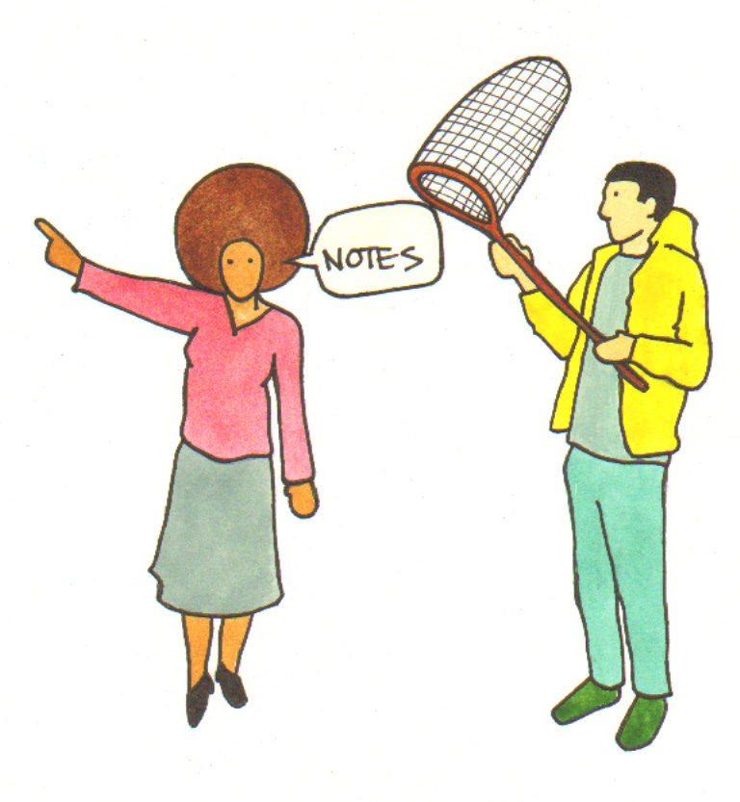
The Cornell method simply involves using a margin on the side of your page to create a section where you can add notes to your lecture notes after the lecture.

You can jot down the main points of the lecture while you are listening to it in the main section of the page. Leave plenty of space between your main notes.

After your lecture you can use the right-hand column to add keywords, definitions, questions, summaries or reference to other text books or any other notes that you may find useful.

Lecture Title, Subject, Module, Week

Notes taken during lecture | Notes taken after lecture  for example:  - Keywords  - Definitions  - Questions  - Summaries

This is an example from the Victorianism module of the English Literature course.

Richard Marsh, The Beetle, Victorianism Week 7

Notes made during lecture  Written 1897 during Fin De Siècle, time of great cultural instability.  Outsold Dracula published in same year.  The beetle – able to change shape human-beetle and also gender.  Gender. Reflects fears about instability of gender – homosexuality and the ‘new woman’ – key FDS theme. Fear that women are no longer passive, Fear of homosexuality is related to losing hold of empire.  Empire. Reverse colonialism. Threat of colonial revenge – like Haggard’s She and ‘yellow peril.’ Fear of colonial ‘other’ heightened during FDS.  London. Strong class divide.  Colonial threat is within London itself. Destruction of the beetle should restore order but this is uncertain at end of novel. Beetle could return.  Mesmerism. Burgeoning discipline of psychology. Fear of hypnosis. Svengali in Trilby. The beetle is able to control the bodies of Richard Holt, Marjorie and Paul Lessingham.  Science. Pos/neg? – capable of producing bombs. Science also comes to the rescue. Beetle squashed by train – symbolic of science. | Notes after lecture  ‘end of the century’ – see further notes on FDS  See further in Showalter, "Syphilis, Sexuality, and the Fiction of the Fin De Siècle "  ‘New woman’ 1890s–educated, employed  See notes from JF Imperialism course.  George du Maurier, Trilby (1894)  Svengali – Jewish hypnotist. Trilby becomes a talented singer under his hypnotic influence.  Read Yeazell, Sex, Politics and Science in the Nineteenth-Century Novel.

I have written enough information at the top of the page so that I can identify these notes again and file them away.

In these lecture notes the main notes have been made during the lecture. This is a skeleton of the main themes that were discussed: Gender, Empire, London and Mesmerism.

The notes in the right-hand column are further notes made after the lecture.

For example, reference was made in the lecture to the fin de siècle. After the lecture I looked that up and found that it meant ‘end of the century.’

I then studied the fin de siècle in more detail and made notes separately and I refer to them here.

I also studied my reading list for this module and identified a text that would give me more information on the theme of gender. When I make notes on these books I will easily be able to relate the information there to my lecture notes.

I also remembered that some of the issues raised about imperialism were discussed in last year’s Imperialism course so I have made a note to look at the notes from that course again.

