Supporting Students with Asperger’s Syndrome and other Autistic Spectrum Conditions in the 3rd Level College Environment
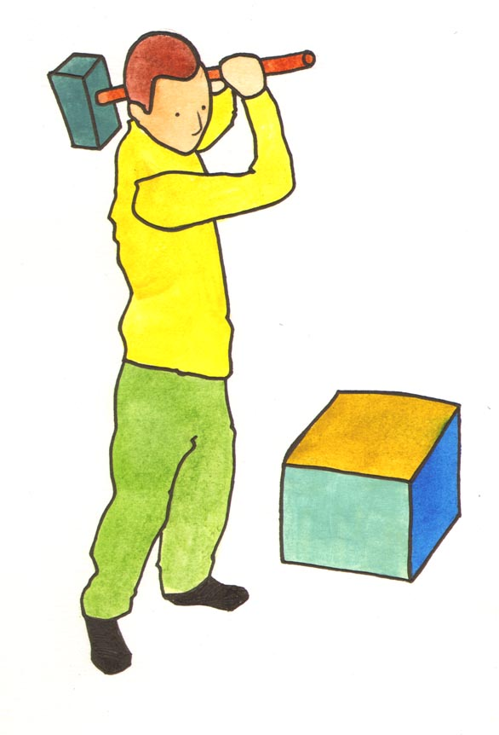
Written by Dr. Zehanne Kenny (deceased) and updated by Declan Treanor (2015)

Contents

A. What is Asperger’s Syndrome? 3
B. Characteristics of A.S. 3
C. Living Away from Home 6
D. Preparing for and having meetings 8
E. Making the Course accessible to a student with A.S. 11
F. Lectures 12
G. Using the Library 12
H. Revision and Essay Writing Strategies 13
I. Examinations preparation 14
J. Postgraduates with A.S. 16
L. Interaction with Peers 19
M. Working with Students with A.S. 21
N. Problems Typically Encountered By Students with A.S. 23
O. Checklist for Prospective Students: 25
P. Further Reading 26
Q. Useful Websites: 27

A. What is Asperger’s Syndrome?
Asperger’s Syndrome (A.S.) is a neurologically based condition, classified at the higher end of the autistic spectrum, which can manifest itself in a range of cognitive and behavioural characteristics. Certain of these, such as the ability to concentrate almost exclusively on a chosen subject, can be seen as highly positive, particularly in an academic setting. Others, however, can cause major problems, generally in the area of social communication and interaction.
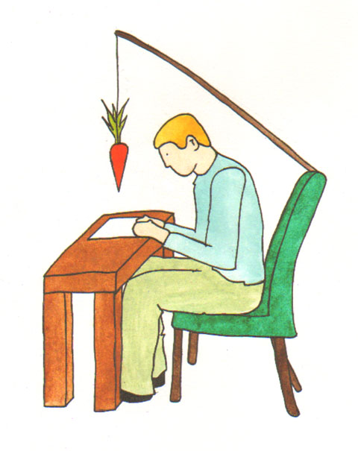

B. Characteristics of A.S.
- Due to lacking the innate ability to infer and empathise with the minds of others, often referred to as folk psychology, individuals with A.S. have poor social inter-action skills, despite possessing normal or above average IQs. This can cause specific, noticeable, behavioural anomalies, such as insensitivity to appropriate conversational cues e.g. interrupting someone who is already talking, difficulty with ‘turn taking’, also inability to decipher body language, poor eye contact, and invasion of others’ ‘personal space’. Many A.S. individuals compensate for this lack of instinctual awareness by putting their acute observational powers and intelligence to the task of learning and mimicking socially appropriate behaviours. This is sometimes referred to as ‘folk physics’ because, like scientists, the individual with A.S. studies the cause and effect mechanisms operative in everyday life and tries to behave according to a set of superficially plausible rules. Due to the highly self-conscious and effortful nature of this procedure, many individuals with A.S. prefer to avoid social situations whenever possible. Under these conditions it is not surprising that forming and maintaining friendships is difficult.
- In an effort to impose structure in, and control of, reality, many individuals with A.S. resort to rigid routines and ritualistic behaviours. Unlike the rituals associated with Obsessive Compulsive Disorder (such as frequent hand washing or excessive preoccupation with hygiene), A.S. rituals are a source of comfort, particularly during stressful situations, i.e. they are self-designed yoga-type methods of achieving calm and of becoming centred. Beneficial as these behaviours are, they also have the negative effect of making individuals with A.S. stand out as unusual or eccentric. Similarly, the need to keep as ordered an environment as possible can result in a restricted range of interests and activities, plus a fierce resistance to change.
- Many individuals with A.S. have memories that are truly incredible for facts and figures - but poor for autobiographical material, again making socially cohesive activities such as talking about one’s past and sharing mutual memories difficult if not impossible.
- On the physical side, two notable characteristics of A.S. are (1) motor clumsiness and (2) hypersensitivity to sensory stimuli, especially noise. The latter severely curtails the kinds of environments that individuals with A.S. can tolerate.

Summary of A.S. Characteristics
- Difficulties with social interaction, resulting from a lack of the innate ability to infer and empathise with other minds.
- Routines, rituals and dislike of change.
- Good factual but poor autobiographical memory.
- Physically - clumsiness and hypersensitivity to sensory stimuli, particularly noise.
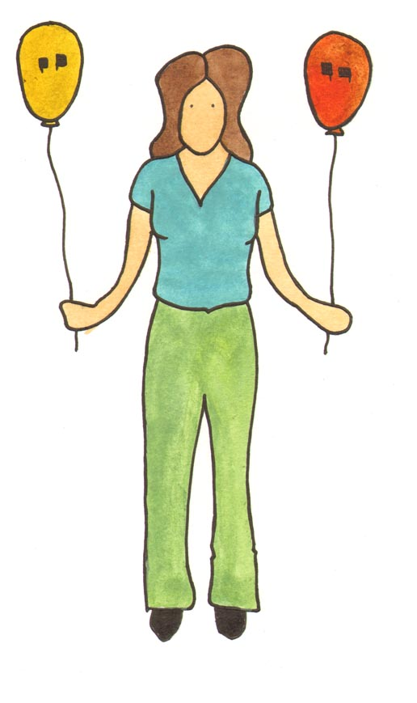

C. Living Away from Home
Leaving the home environment to take up a college course is a stressful experience for almost any student. Unfortunately, the usual coping strategies - based on peer interaction and mutual support, are unlikely to be available to students with A.S. In this regard, A.S. students experience many of the difficulties both overseas and mature students face.
There are certain provisions which can be made by college disability services.
- To lessen the strangeness of the new environment students with A.S. should be allowed to visit well in advance of term starting, be shown around and introduced to the people they will be getting support from, i.e. personal tutors and disability service personnel. They should be provided with booklets which include maps of all relevant areas - inside and outside - and with help checklists covering educational, health, counselling and technical support.
- If possible, before the student leaves home there should be a liaison between parents or carers and whoever will be involved with college disability and welfare services.
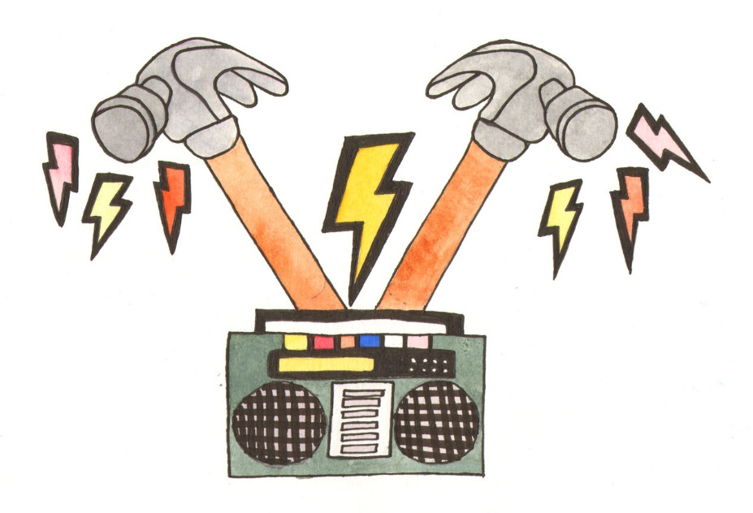
- The physical aspects of living away from home will usually be difficult for the student with A.S. whose life, up to now, has probably been very sheltered. Renting accommodation in the private sector is not an ideal situation since, if affordable, it is usually sub-standard, subject to poor facilities and high levels of noise. College rooms are a preferable alternative, although noise - and having to live in close and undesired proximity to others can be a problem. College rooms, however, may provide necessary monitoring of eating and sleeping arrangements. Poor diet is a key feature of A.S. and includes forgetting to shop, missing meals, and eating non-nutritiously. Also, taking inadequate rest or sleeping in inappropriate locations - slumped over a computer keyboard, for example - can take a toll on the health of students with A.S.
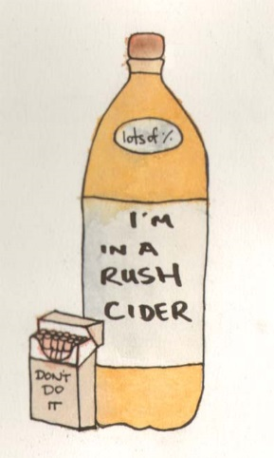
- Depressed students with A.S. may self-medicate – consuming alcohol or using drugs in solitude. This type of abuse can be more easily spotted in a residential setting, which again argues for students with A.S., whenever possible, receiving priority for college room allocation.
- Unstructured time is a major component of study at third level. In contrast with the school environment, where rigid timetabling and specified rooms were the norm, A.S. students may find the ‘freedom’ of college or university more of a curse than a gift.
The best advice to the student is to structure their own time by making up timetables, naturally giving precedence to lectures etc. The timetable should include visits to local places of interest – a local guidebook for tourists is very useful. Cinema, theatres and even grocery shopping can all be worked into the timetable, so that ‘free’ time can be fulfilling as well as being filled. Rather than being an imposition, freedom to explore –either geographically or interest-wise – can be a highly positive experience. Trying out new things is always stimulating, particularly those not involved with coursework or one’s own interest. A biologist might sample the delights of a transport museum, for example, or a chemist pay a visit to the Botanical Gardens.
Academic Supports

D. Preparing for and having meetings
- Before meeting someone with A.S. it is a good idea to prepare a checklist of points you wish to cover and questions you would like to ask. Encourage the student to do the same. This ensures that the meeting will cover all mutually relevant material and have a structure.
- Circumstances may cause you to occasionally reschedule or even cancel a meeting with a student with A.S. This is an inevitable fact of life - academic or otherwise. Unfortunately it is also an inevitable fact that the student with A.S. is liable to be devastated at the disruption. If at all possible, stick to pre-arranged meetings, and avoid being double-booked. Similarly, telling a student with A.S. that a meeting will have to be drastically curtailed due to a prior engagement is equally upsetting.
- Avoid distractions - During a meeting it would also be a good idea to place a ‘do not disturb’ sign on the door. Switch your desk phone to voicemail and, of course, switch off your mobile phone, since the interruptions caused by ringing phones, answered phones or people coming and going can cause a significant loss of concentration and disruption of the thought processes for the student with A.S.
- Noise is the bane of an A.S. student’s life. Often other sensory modalities can cause problems, such as smell or taste – but noise is by far the most intrusive. The concentration of a student with A.S. can be lost in seconds when confronted by extraneous noise. Once lost, concentration may be very hard to regain, even if the noise is removed. Please, therefore, ensure that any tutorials or one-to-one meetings are conducted in as quiet an environment as possible.
- When marking the script of a student with A.S., bear in mind that, in order to be helpful, your comments must be clear to them. A.S. makes for literal mindedness. Proverbs are not appreciated. It is better if these are excluded from what is supposed to be helpful feedback.
- Be careful about making jokes. Students with A.S. are not devoid of a sense of humour but are often unable to perceive that a joke is a joke if it occurs in an otherwise ‘serious’ academic situation. Flexibility and the ability to interpret the finer nuances of a social interaction are not A.S. traits. A joke, even if well intentioned, might, at best, fall flat but, at worst, be seen as an insulting or belittling remark. Individuals with A.S. do smile when amused, but also smile when unsure of what else to do. Past experience has taught them that a smile is usually a safe way of reacting, so do not assume that it indicates your joke was successful.
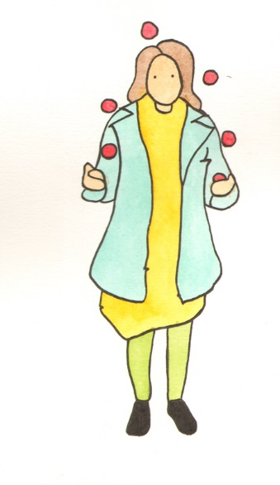
- When giving instructions to someone with A.S. it is vital to make certain they have understood. Merely asking them to repeat the instructions is insufficient. The same formula of words can carry different cases of association. What is obvious to you may not be obvious to someone with A.S. and vice versa. Sensitive and patient questioning and listening, plus a willingness to rephrase the original instructions may be necessary. Time spent in this way will generally be time saved in the long run.
- The student with A.S. needs to be shown how to communicate ideas to someone who is not privileged to their particular mind-set. As with the verbal problems mentioned above, so material presented in a paper or as an exam question can fail simply because it lacked the structure which would render it coherent. Most students with A.S. are superb researchers but need a certain degree of help in the area of presentation. Generally, once they understand the problem they will solve it with characteristic zeal and thoroughness.
- Ideally college should set aside a quiet room where students with A.S. can go - just in order to be refreshed by silence.

Summary
- Meetings – preparing a checklist helps. Avoid having to reschedule, and choose a quiet venue.
- Marking – avoid using proverbs etc., since the priority is to make certain the student understands the feedback and, if necessary, is shown how to express themselves.
- Be cautious about making jokes.
- Be aware of the fact that a student with A.S. may not share the same cases of association as you do – care must be taken in giving instructions and in assisting students with A.S. to properly convey their own ideas.

E. Making the Course accessible to a student with A.S.
Before commencing, lecturers must make certain the student with A.S. knows which type of course they are involved in:
- Is it a fact-based course? If so, an encyclopaedic knowledge will be required.
- Is it a theory-based course? In which case, the skills needed are those of reasoning, of being able to make inferences based on one or two core models, and of being able to see patterns and family resemblances in apparently diverse materials.
Generally students with A.S. are naturally superior in the first type - which often makes them excel in maths, engineering and some sciences. Extra preparation is required for the second type, which requires not only knowledge of the subject but an ability to successfully manipulate it.
In broad ranging courses, such as undergraduate degrees, many topics will be covered which seem irrelevant or even nonsensical to the student with A.S. Lecturers and tutors need to treat this seriously. Avoid making the type of blanket comment that suggests that: “This is part of the course - therefore you must pass”. Instead, listen to the reasons given by a student with A.S. which will rarely be superficial. Make clear that, while appreciating their point of view, a greater level of academic success needs to be attained before such criticisms will be respected by the academic community. Finally, make the student fully aware that, in order to reach this level, the undesirable material simply has to be endured and mastered. Once a student with A.S. properly understands this logical train of reasoning, he or she will usually override their distaste and perform satisfactorily.

F. Lectures
Some students with A.S. have problems with concentrating on long streams of verbal information, such as lectures. If this is the case, a copy of all lecture notes and/or a tape recorder should be provided. Alternatively many students with A.S. find it disturbing to sit in close proximity to others. The student is more likely to simply skip lectures than complain, so some sensitive proactive questioning is needed, and the alternative strategy of notes or recorder suggested.

G. Using the Library
- Noise - Unfortunately the average academic library is simply not quiet enough for students with A.S. Ideally they need a place to study which is both structured and familiar, such as an individual desk or carrel system in a restricted ‘special needs’ area.
- Queuing - Queuing to use photocopiers, check out books, or make enquiries is also a negative experience for most students with A.S. This is less because of the waiting involved, more because of proximity to people who may be talking among themselves, or even attempting to initiate a well-meaning but unwanted conversation.

H. Revision and Essay Writing Strategies
These ideas are targeted specifically at students with A.S.; however, they also represent good revision practice and are generally applicable. All of these suggestions can be adapted for use in writing term papers and assignments.
- Make a plan of the course material. Keep the plan simple and use no more than a page. Structure it like a family tree, with the key concepts as headings. List relevant points under each heading as though they were twigs growing from the main branch. Keep this plan handy at all times.
- Use examples wherever possible. Draw these examples from personal life experience. Examples which have a real world connotation will be easier to learn and remember. You may need to juggle your examples in a rather idiosyncratic way to make them applicable to course material, i.e. when the course talks about people, you may find it easier to substitute objects, buildings or animals. Remember - the most important thing is to make them relevant to you.
- Practise arguing with the material. Deliberately disagree with major theories. This will mean that a structured counter-position must be attained and maintained. (This exercise is invaluable - even if you actually agree with the original material.)
- Write with a target audience in mind. The ideal target audience is someone who is intelligent - but largely ignorant of the subject. The aim is to educate him/her. Anticipate the type of questions which may be raised and answer them.
Summary
- Make plans of course material.
- Idiosyncratic examples from everyday life can act as learning aids.
- Arguing against course material is a good strategy.
- Targeting answers to specific audiences can structure thought processes.

I. Examinations preparation
The following are all considered to be good practice generally; they are, however, vital when dealing with A.S. students:
1. Make sure the student has seen past exam papers. Practice going through the questions, analysing key terms such as ‘Discuss’.
2. Give the student with A.S. a timed essay, under exam conditions - or even a full-scale mock exam. In either case, provide feedback about the strengths and weaknesses of their answers.
3. Consider the issue of context. For most students with A.S. the environment is far more than a mere background. It can impose itself in many ways, negatively - in the case of unwanted noise - or positively, in creating a sense of security. An environment which is unfamiliar can be threatening, leading to stress-related problems such as mental blocks. Ideally the exam room should be one in which the student feels relaxed, preferably an alternative to large, impersonal, draughty halls with unpleasant echoes.
Support on the day of the examination
- If an alternative venue is impossible to arrange, students with A.S. should be encouraged to arrive early, and allotted their choice of seat. This will nearly always be an aisle seat, near the front of the room, thus, avoiding feelings of claustrophobia.
- Avoid having the student with A.S. queue outside. He or she will want to enter the room in as calm a state as possible - queuing with a crowd of contagiously nervous (and usually vociferously loud) people is a very negative experience.
- Encourage the student to take great care reading, understanding and deciding on the choice of question. Extra time should be allowed. Once chosen, a plan should be drawn up on a scrap of paper. The plan helps to capture vital ‘first thoughts’ on a subject and helps a structure to be maintained. (The A.S. student’s tendency to go off at a tangent is notorious!) Finally, a plan can help bridge any mental blocks which may occur.
- Avoid exposing students with A.S. to the invigilator ‘shuffle’. Patrolling the room at regular intervals may be a disciplinary requirement, but should be done with the utmost discretion - and no high heels or squeaky shoes. Similarly, the invigilators should not attempt to turn an unwieldy broadsheet newspaper or munch snacks - these are registered as noise nuisances by the student with A.S.
- Allow the student to bring a familiar object into the exam room. Once it does not violate any security rules, and is not a repository for illicit academic material (Students with A.S. very rarely cheat at anything) it should be allowed. The student with A.S. is attempting to customise an alien environment in some way - a vital strategy, however superfluous or childish it might appear. The ‘object’ may even take the form of a smell mnemonic - such as a handkerchief soaked in a perfume which resembles the potted plants in a student’s usual study room. This is a way of accessing the highly developed olfactory memory possessed by many students with A.S. Material encoded in the presence of a strong sensory stimulus can often be retrieved effortlessly under the same conditions.
Summary
- Alternative venues are preferable if possible.
- Queuing should be avoided.
- Plans on scrap paper are useful.
- Invigilators must be wary of inadvertently making noise.
- Familiar objects, such as those with odours, can act as mnemonics.

J. Postgraduates with A.S.
Supervisors
Remember that a meeting - any meeting, is a potential stressor. Minimise this by switching off all phones and leaving ‘Do Not Disturb’ on the door. If you cannot come to the meeting give as much notice as possible and sincerely apologise - anyone with A.S. will be very upset.
Feedback is vital - not only for academic work but for any interaction with the student. If the student requests a meeting be cancelled or rescheduled, or otherwise alters something prearranged, give feedback. A simple note saying “It’s OK” will prevent much unnecessary anxiety on the student’s part.
Good rules of thumb - treat a student with A.S. as if they are a foreign visitor - be polite and eager to learn about them and their customs. Do not assume they will understand the need for some form of initiatory dialogue. Ask and be prepared to explain your own position.
“I’m fine” coming from a student with A.S. A.S.D is not always the truth. You will need to sympathetically observe in order to ascertain whether they are merely using a strategy of telling you what they think you want to hear - a strategy which may have been useful in past dealings with others, but can be counterproductive in academic situations.
Structure meetings carefully, informing the student beforehand or in the opening few minutes what you wish to discuss. Silences, gaps, searching the room from mislaid material and forgetting to bring along everything required is counterproductive.
The Viva
Be careful with attempts to put the student at ease. A few minutes chatting, exchanging pleasantries about the weather can seriously destabilise someone with A.S, most of whom will only chat to established friends, and usually not in a ‘lovely day isn’t it?’ way.
Don’t expect or try to maintain eye contact. Rudeness is not involved when someone with A.S looks away or at the floor – it simply represents an alternative style of body language.
As with all meetings - interruptions should be minimised – light levels, noise, people knocking, etc. If possible the room where the viva occurs should be isolated from the main body of the college.
Structure the process and inform the student of exactly how things will go. Communicate this in advance and, once agreed, stick to it! Changes can cause major difficulties. If questions about the student’s future plans are to be included, make sure they have had adequate time to prepare an answer.
Remember - most people with A.S. will treat every question as very important. Be aware of this!
Social Supports
K. Socially Appropriate /Inappropriate Behaviours in Academic and Non-academic Situations
Many students with A.S., despite outstanding intellectual abilities, may show significant deficits in social functioning. Quite often, the chronological age of the student may be misleading, because they can often out-perform their peers intellectually, but may display the emotional and social behaviour normally associated with a much younger age group. The fact that many students with A.S. will have led relatively sheltered lives, prior to attending college, can render them extremely vulnerable to what is perceived as an unpredictably novel environment. Remedial intervention in the case of socially inappropriate or unacceptable behaviour is vital - for the sake of both the A.S. student and his or her peers. This intervention should be consciousness raising rather than punitive, and targeted to enhancing the student’s ability to function in a social setting.
Explanatory feedback should accompany all criticism of the behavioural shortcomings of students with A.S. The student should be encouraged to question the rationale behind the criticism, and their co-operation should be sought for any suggested modifications.
The language used must be sensitively tailored to fit both student and situation. It is not a good idea to assume that the student will automatically generalise from a specific to a class of behaviours. An example to illustrate this point might be: a student (male) with A.S. is told that he is staring repeatedly at another student (female). After an explanation on gender appropriate behaviour he agrees to desist. Unfortunately, he switches his staring to another (female) student.
It can be quite difficult to ascertain whether or not a student with A.S. has properly assimilated the message. A response such as ‘I understand’ may actually mean ‘Can I go now?’ Most of what is considered acceptably tacit communication in mainstream interaction may be completely missed or misunderstood by the student.
In cases where a mutual understanding simply cannot be reached, it may be necessary to get the A.S. student’s unqualified agreement that he/she will desist from the target behaviour - with or without their realisation of why it was wrong.
Inappropriate behaviour may occur in a classroom situation also. Many students with A.S., eager to learn, may regard a tutor/lecturer as a piece of equipment - something to be freely accessed, in the way of a databank. Oblivious to the correct protocol, the student may continually interrupt the session, often with highly inappropriate questions.
In such a case, it may be best that the student is instructed to make a list of questions, and to raise them privately after class, with the tutor. Harsh though this may seem it is preferable to subjecting an entire class to a series of disrupted lectures.

Summary
- Many students with A.S. have enhanced intellectual, but poor social skills.
- This can lead to inappropriate behaviour.
- Remedial intervention should be consciousness raising rather than punitive.
- Criticism should include explanatory feedback and an awareness that the tacit must be made explicit.
- Students with A.S. are not easily able to generalise from the particular - criticism of behaviour needs to address this.
- Sometimes the student must agree to desist from an inappropriate behaviour, whether or not he/she understands why.

L. Interaction with Peers
One of the biggest challenges faced at college by the student with A.S. is that of interacting socially with peers. Successful social interaction is a delicate, two-way process - one that comes naturally to most people, but has to be laboriously mastered by the student with A.S.
Although capable of using their intellectual skills to master this complex area of human functioning, the student with A.S. will rarely be able to participate fully. The system of ‘rewards/punishments’ operative, on a subliminal level, in social intercourse, simply does not apply. This system includes, for example, the ‘rewards’ of being praised, smiled at and verbally encouraged, which can seem as bewildering to the student with A.S. as the social ‘punishment’ system, e.g. being ignored or ridiculed. The preferred A.S. strategy is to ignore and avoid.
Many students with A.S. learn a few rules which allow them to plausibly socially interact - albeit peripherally. Some students with A.S. can become extremely adept, brilliantly manipulating their acquired knowledge to the extent of projecting a socially acceptable persona. Unfortunately, this is merely a mask and can be ultimately counter-productive. No student with A.S. can derive much more than a superficial satisfaction from hearing how ‘pleasant’ or ‘cheerful’ they are - when, in fact, they are acting. To be liked for something you are not is a very hollow victory, leading to a greater sense of isolation. The student with A.S. is then faced with a difficult decision – whether to keep up the exhausting effort of play acting, or reveal the truth behind the mask - and risk being abandoned.
One answer to isolation might be to join one or more of the numerous special interest college societies. Chess buffs or computer enthusiasts, for example, may profitably come together and share their time and interests.
Unfortunately, it is often the case that most societies cater for the more typical student member, who enjoys spending his/her free time in a pub or at party venues. The basic ‘interest’ of the special interest group is thus not necessarily that of the student with A.S.
Students with A.S. are, therefore, very likely to find themselves excluded from the mainstream college recreational outlets. This may drive the student to the point of dropping out of college, well before anyone else realises what is wrong.
A remedy is not easy. Ideally something like the ‘buddy system’ could provide an effective antidote - but this depends on the availability of a number of sensitive, perceptive and well-informed volunteers willing to devote sufficient time and effort.
In any case, students with A.S. should be allocated to a tutor/counsellor who is cognisant with the type of difficulties they may be experiencing, and who can establish a supportive and mutually respectful relationship with them.

Summary
- Students with A.S. have major problems socially interacting with their peers.
- Although able, intellectually, to master enough rules to appear functional, students with A.S. are largely exempt from the unwritten laws of social ‘rewards/punishments’.
- Presenting a cheerful mask can be counter-productive – it is extremely effortful and leads to being accepted for faking an unreal persona.
- Special interest groups may help - provided the group main interest is not pubs and parties.
- Social isolation can lead to dropping out of college.
- If possible, a college-run ‘buddy system’ may provide help.
- All students with A.S. should be allocated to a sympathetic tutor / counsellor.

M. Working with Students with A.S.
(Summary Section for those involved in Disability Service/Support Roles)
- It is important, when dealing with a student with A.S., to adopt the kind of pleasant but professional style that you will comfortably be able to maintain. Many service providers, with the best of intentions, attempt to come across as ‘friendly’ in an informal and sympathetic way. The problem with this approach is that it can often be misinterpreted by students with A.S., leading to much trouble in the long run. A typical scenario might go as follows: A care worker, meeting with an A.S. student for the first time, behaves in such a way that the student, rather than classifying them as friendly, classifies them as ‘friend’. The care worker is unaware of this and continues, in subsequent meetings, to behave in the same- apparently successful – way. Inevitably the time comes when the student, quite innocently, will go too far. Not necessarily in an overtly familiar manner but one in which the care worker’s personal boundaries are felt to be violated. The care worker, understandably, reacts. The student is amazed and and received can result in the student being deeply hurt and having their ability to trust people, professionals especially, severely damaged. The situation can be worsened if the student has experienced similar scenarios in the past, so bear in mind that a little boundary definition at the start is preferable to adding to the problems of someone who already has more than they need.
- The second thing to remember is that students with A.S. often have severe difficulties with processing verbal information. They find a face-to-face conversation disturbing and a telephone conversation little better. The reason for this is usually traceable to some sort of overload. Attending to the meaning of what is being said, and responding appropriately might seem easy enough, but given the situation of having a thousand-and-one vocal nuances, stresses, inflexions, plus the whole dictionary of body languages to deal with at the same time, is incredible complex. A student with A.S. will often-in the interests of extricating themselves from an uncomfortable, if not unbearable, meeting, agree, verbally and with nods, to whatever they think is wanted by the other person. Repeated ‘Are you sure that’s OK?’ will elicit the desired response. The student with A.S. achieves their aim of escape, while the other person assumes the requisite information has been received and understood. Rarely is this the case.
Long-term misunderstandings are common. Somewhere down the line, the student will be confronted with, ‘But you said you understood!’ The student, of course, did understand – they understood how to escape the immediate situation.

N. Problems Typically Encountered By Students with A.S.
Many major problems start out as extremely simple, and solvable, ones. These problems include many of the ‘housekeeping’ issues who have to leave home for a strange environment.
The problems may be anything from how to use a washing machine to where to buy a familiar brand of coffee, but, in the case of the student with A.S., the answer is not as straightforward as asking flatmates or friends for advice.
The fact of having led a hitherto sheltered, and/or reclusive life, coupled with poorly developed social skills, can plunge the student into a bewildering and barely recognisable world which he or she is expected to negotiate.
One of its most difficult aspects – especially for male students – is the proximity of so many girls! How should they be reacted to? Ignored? Avoided? Advanced on? If advanced on, how? What words should be used? What gestures? When? How much? And – crucially – how is feedback to be interpreted?
Little wonder the student often gets it wrong, since he is supposed to know the rules of a game he is playing for perhaps the first time. He may cope by copying behaviour he has seen on TV or in movies, lifting entire sections of dialogue from sitcoms then be devastated to have them greeted by laughter.
Friendships, even same sex ones, can be equally difficult to get right. The enormous effort involved in actually approaching a fellow student and initiating some kind of reciprocal relationship, however casual, can be overwhelming.
Having made one such effort, the student may believe that it is sufficient, that he or she now has a friend, and proceed to monopolise the time and company of this person. Hints to ‘back off’ will probably be misunderstood- if noticed at all – leading to either a confrontation, i.e. ‘Get out of my face!’ or a sudden severance of all links. The student is, naturally, upset and confused, however inevitable the split may have seemed to onlookers.
In such a situation the counsellor could provide the information necessary to give the episode ‘good closure’. Understanding – on an intellectual level- often enables the student to recover and move on – far more successfully than any amount of the more emotional type support normally associated with broken relationship therapy.
One reason for this is that the internal stability of student with A.S. is often a result of the stability of their external environment.
Information enabling the student to make sense of a situation can often provide the best intervention.
This notion – of providing the material from which the student can construct their own self-help strategy- should inform all help given. Whether a trained volunteer is responding to a request for bus timetables, or a professional psychologist is advising how best to interpret a supposed friend’s rejection, the goal should always be to promote independence and enhance self-esteem.
There is not a ‘normal person’ imprisoned inside a student with A.S. or a list of rules for behaviour, which, once mastered, will release this ‘normal person’. This widespread myth does as much damage to those on the Autistic Spectrum as any overtly derogatory labels such as ‘freak’ or ‘retard’.
Asperger’s Syndrome creates problems – but also confers strengths. The aim of any therapeutic intervention – should be to augment these strengths – rather than promoting the spurious concept of desirable but ultimately unattainable ‘normality’.
What is ‘normal’ for neuro-typicals is not ‘normal’ for those on the Autistic Spectrum. The way forward is to recognise and celebrate individuality, albeit individuality tuned in to coping in a social setting.

O. Checklist for Prospective Students:
Before deciding on a course of study, it would be advisable to consider the following:
- Which type of course would suit my particular learning/working style?
      - Fact-based e.g. math, engineering, some sciences
      - Theory-based i.e. one which requires the ability to manipulate facts in order to perceive patterns and make inferences (see section 4)
- How will I cope with an unstructured day? Can I provide my own work/leisure structure? (See section 2 for some suggestions)
- How will I manage housekeeping? (Not only shopping/cooking/washing etc., but budgeting and bill paying).
- Do I know where and how to get help if I need it?
- Do I have a plan B if I realise that I cannot cope? Self-esteem will be a major casualty of ‘failure’. It is much better to set up alternatives in advance. An attitude of ‘try and see’ is more practical than one of unrealistic optimism. This way, there is no such thing as ‘failure’, only adventures on the route to eventual success.
- Finally, ask yourself, ‘Why am I doing this?’ Is it because your parents want you to? Is it because you envisage a glittering, well-paid career?
Be prepared to do some honest self-questioning before rather than after starting your course.

P. Further Reading
This document represents a synthesis of some of the most up to date work currently being undertaken in the field of Autistic Spectrum Disorder Research. Those interested in more specific aspects may find the following list of books helpful:
1. Attwood, Tony. Asperger’s Syndrome: A Guide for Parents and Professionals. Jessica Kingsley Publishers, London, 1998.
2. Baron-Cohen, Simon. The Essential Difference: Men, Women and the Extreme Male Brain. Allen Lane, London, 2003.
3. Fitzgerald, Michael. Autism and Creativity. Brunner Routledge, Hove & New York, 2004.
4. Frith, U. (Ed.) Autism and Asperger’s Syndrome. Cambridge University Press, Cambridge, 1991.
5. Fullerton, Ann (Ed.), Joyce Stratton, Phyllis Coyne and Carol Grey. Higher Functioning Adolescents and Young Adults with Autism: A Teachers’ Guide. PRO-ED, Austin, Texas, 1996.
6. Smith Myles, Brenda and Richard L. Simpson. Asperger’s Syndrome: A Guide for Educators and Parents. PRO-ED, Austin, Texas, 1998.
7. Stillman, William. Demystifying the Autistic Experience. Jessica Kingsley Publishers, London & Philadelphia, 2003.
8. Wiley, Liane Holliday. Pretending to be Normal: Living with Asperger’s Syndrome. Jessica Kingsley Publishers, London & Philadelphia, 1999.
9. Williams, Donna. Exposure Anxiety - The Invisible Cage: An Exploration of Self-Protection Responses in the Autistic Spectrum and Beyond. Jessica Kingsley Publishers, London & Philadelphia, 2003.

Q. Useful Websites:
www.autism-society.org
http://www.autism.com
www.autism-resources.com
www.iol.ie/~isa1/
(Websites are constantly changing. These were accessible at time of compilation - June 2006)

