Alternatives to the classic mindmap

Whilst the classic ‘Buzan’ mind map works very well for some people, for others drawing, colouring and doodling connections between ideas does not come so easily. Whilst you may be a visual learner, you may feel that you don’t have the skills (or the time!) to work so creatively. There are a number of ways in which you can use mind mapping technique in a slightly different way.

Trees and diagrams

Beginning an essay or revision plan with a blank tree or diagram is often a good way to get started. These come in a variety of shapes and styles depending on your spatial preference.

Thinking guides

You can use these to play around with your initial thoughts for an essay. The following examples are available as free downloads to print out from http://www.exploratree.org.uk You need to register on this website to be able to save your plan but it has some excellent guides to kick start your thinking.

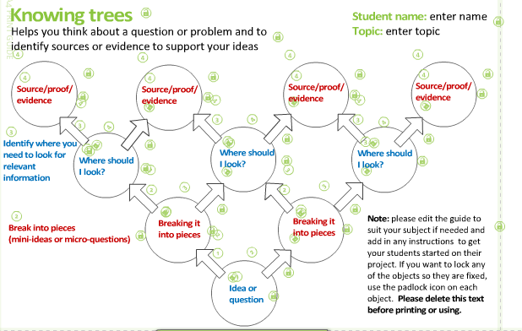

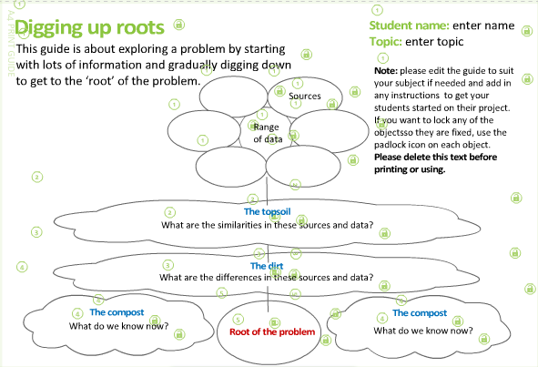

Spider diagrams

Spider diagrams are perhaps the most traditionally used method of mind mapping. The most useful thing about this format is that you can manipulate it to suit your spatial preference. For example as free form:

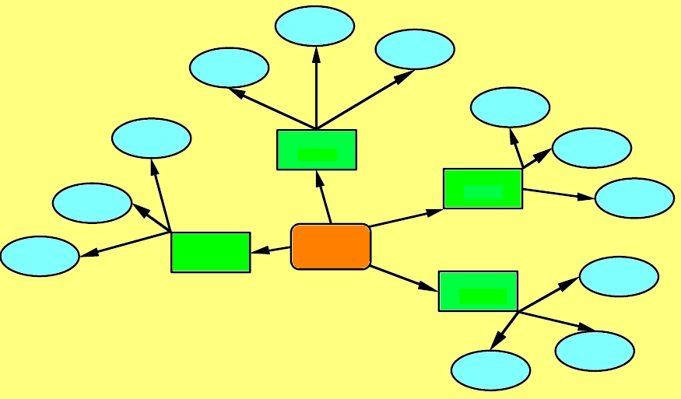
Descending hierarchy

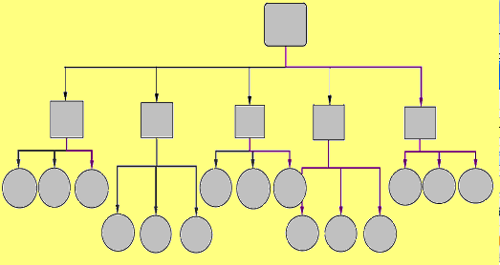

Vertical

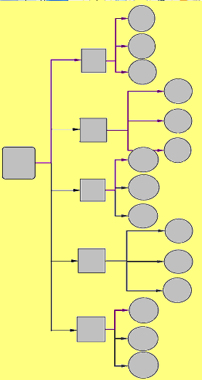

Wall charts and planners

Lists and frames are useful if you are decisive and a clear thinker. If you are likely to change your ideas or approach, re-writing can be very time consuming. If you are a kinaesthetic / visual learner you may like to combine these two elements into a mind map that is editable and which you can manipulate until you are happy with the finished structure.

A really good example here on Flickr http://www.flickr.com/photos/mangtronix/sets/72157594533099929/

How to do it:

- Get a packet of coloured post-it notes and a large A2 or A3 piece of paper. You could use an old piece of wrapping paper, turn it over to the blank side.

- Secure the paper to a wall.

- Write your ideas / points / evidence / explanation on to separate post-it notes (key notes).

- Transfer these to your blank paper. You can then position your key notes around the paper frame, grouping them together or forming clusters. This may take several days until you are satisfied with the finished map.

The role of the nurse in health promotion

Writing frames and lists

You may prefer to structure a framework for your essay in a more linear way, identifying paragraph topics and content using key words and phrases.

Essay question________________________________________________________

Introduction _________________________
_________________________
_________________________

Paragraph / point 1 _________________________ include ____________________
Heading 1 _____________________
_____________________

point 2 _________________________ include _____________________
_____________________
_____________________

point 3 _________________________ include _____________________
_____________________
_____________________

Paragraph /
Heading 2 point 1 _________________________ include _____________________
_____________________
_____________________

point 2 _________________________ include ____________________
_____________________
_____________________

point 3 _________________________ include _____________________
_____________________
_____________________

Paragraph /
Heading 3 point 1 _________________________ include _____________________
_____________________
_____________________

point 2 _________________________ include _____________________
_____________________
_____________________

point 3 _________________________ include _____________________
_____________________
_____________________

Conclusion _________________________
_________________________
_________________________

The folded paper approach

- Take a piece of blank A4 paper.

- Fold it in half, then half again, and finally fold in half once more.

- Unfold. You should now see 8 rectangles marked.

- Write down your key ideas or points you want to make, you might use single words, pictures, phrases.

- Cut into rectangles. You can now move these around and re-position the order of your points until you are satisfied that you have a structure you are happy with. You can use as many pieces of paper as you think you will need.

