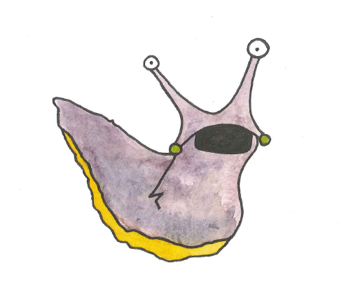

The Zen approach to taking exams

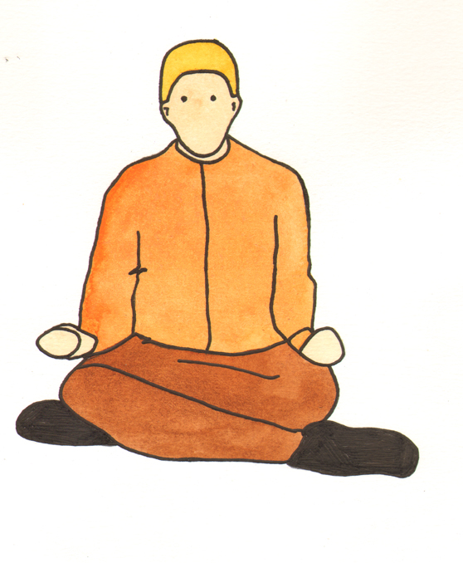


Arrive early, after a good breakfast. Relax. Don’t talk to your classmates if you think it might make you anxious.



Make sure you have your exam number and any other documents you need, pens, pencils, ruler and calculator.

Follow the invigilator’s instructions - invigilators are helpful; don’t view them as the ‘exam police’.

It is best not to leave early, but if you do leave early, make sure you're completely finished. Don't leave early for any other reason. (Another reason may be something that an invigilator can help you with – for example having to go to the bathroom).


Budgeting time in exams

Budgeting your time in exams is really important! Exams are planned according to the time set, for example, 6 questions in a 3 hour exam. Don't try to do brilliantly in one question at the expense of another – there is a better balance if you cover every question required.
Do your strongest question first; this gives you extra time for the questions you might find a bit harder.

Conquering Writer's Block
What if you can't start writing? Analyze the question and put it into your own words. Write the introduction - limit the scope of your answer to three main points. Make a 3-point plan.
Try mind-mapping. Are there any key phrases that the examiner will want you to include? Can you recall / visualize a mind map you made?
If you are stuck during the exam, re-read the question - think of all possible angles to answering it.
Don’t panic

It is not uncommon to panic in an exam if your mind goes blank. Try to overcome this feeling of anxiety.
- Take a complete break for a minute or two.
- Close your eyes.
- Breathe deeply.
- Let your shoulders drop.
- Return to your paper and re-read the question or re-read your answer if you have started writing.
Taking the exam
Underline the key word(s) that tell you what to do for each question. Make sure you can understand the question and can rephrase it in your own words.
Choose an organizational pattern appropriate for each key word and plan your answers on rough work paper or in the margins.
Write your answers as quickly and as legibly as you can; do not take the time to recopy.
Begin each answer with one or two sentences that summarize your answer. If possible, write this so that it rephrases the question.
Support your answer with references to the material you have studied.
Proofread your answers for content, spelling and grammar. Jot down any extra ideas you forgot to include.
……..and finally………

Remember that examiners are looking for marks to give you, rather than seeking a way to fail you. So help them out!

Exam Health (Why sleep is good…)
Stay healthy - eat well, sleep well and stay off the caffeine. Some people make changes such as drinking more coffee or Red Bull or other stimulants - don't!!
The only way to maintain alertness and concentration are through getting enough sleep and through studying consistently, little and often.

Do something active when you take a break from study: perhaps go to the gym or take a walk. Get plenty of fresh air and light. It is best not to meet friends for study breaks, until you have done plenty of work - it can be distracting.

