Starting revision

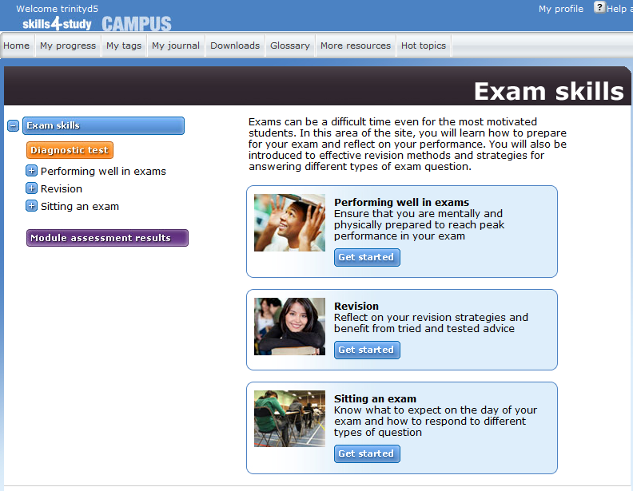

Customize your study environment

- Eliminate distractions such as noise, or clutter on your desk.
- Keep a window open for fresh air.
- One of the biggest distractions from study is anxiety. Don’t pile too many books and notes in front of you to tackle in one session. Select a manageable amount of work for one session, like one chapter of a book.
- Plan to do a hard section in your first study session of the day. After a break, review what you did in the first section, then move on to something easier or more enjoyable.

Things to know about memory

- We remember things more easily if we organize them into patterns or groups.

- We are more likely to remember things we understand or already know something about.

- Our memory works by building links.

Understanding is the first step to remembering

In order to memorize, you must understand the information you want to remember.

If you understand information, you should be able to

- put it into your own words
- explain it to someone else.

Methods to help you improve concentration

- Plan your study time. Decide at which time of day you work best (morning, afternoon, evening) and use this for private study.

- Plan regular breaks, for example, 50 minutes of study followed by ten minutes break. If you cannot concentrate for that long, then try a half hourly pattern:

25 minutes study – 5 minute break,
20 minutes study – 10 minute break.

- Do something physical in your break: like go for a ten-minute walk.

- Try to build up the amount of time you can concentrate.

- Feeling tired can mean you are bored with a particular subject. Try switching to another topic and see if you get a second wind.

- Vary tasks so that you don’t get stuck for too long on something difficult.

- Vary sources so that you are not always reading. Use CD-rom, internet, video, tapes and /or group discussion.

Make study sheets

- Study sheets are comprehensive notes that are a combination of lecture notes and text notes as well as research information and your own ideas. Making these sheets will show you how all the information you pick up from different sources interrelates.

- The idea of study sheets is to condense your course into a manageable size of work. Condense further as you commit ideas to long-term memory. After you have re-read study notes a number of times, draw a line through the parts you can recall without reading the notes. Condense the notes again with only the information you didn’t remember. Keep the old study notes in case you need to rub out the pencil lines and re-read the full notes before an exam.

- Try to condense your study sheets onto 3” by 5” cards. Write words and short phrases. They’re easier for your mind to remember and take up less space.

Separate main ideas and details. Highlight key vocabulary and definitions.

