How to memorize

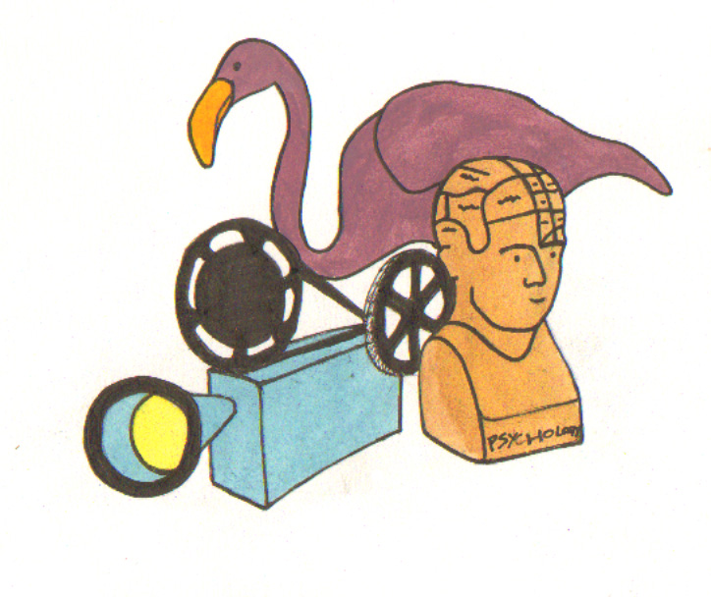

Methods to help you to memorize:

- Before you begin a study session, plan what you want to remember.
- Write condensed notes of information you need to remember and repeat them aloud.
- Paraphrase a text (put it into your own words).
- Write summaries (could be a paragraph, notes, drawing etc.).
- Highlight the key words in the text that the ideas are centred around.
- Quiz yourself.
- Outline paragraphs using headings.
- Classification (labelling, categorising, ordering), for example:

Type of disease:
1. Symptoms
2. Case studies
3. Treatment.

- Visualise (create mental pictures, draw diagrams).
- Review your work at the end of the study session.
- Make associations between the new information and other things you are learning.

Strategies for learning by heart

- Look, say, cover, write and check
- Use mnemonic devices, including
Acronyms (Naughty Elephants Squirt Water for compass points)
Rhymes (a very simple example is the '30 days hath September' rhyme).
- Memorize by Association
(An excerpt from Phil Race, Study Science Successfully. Cambridge: National Extension College, 1983)

This involves linking the information to be memorised to something else quite different, but readily available.

Suppose there are several things I need to remember when I go to a conference:

Socks, something amusing to read on the train, keys, pencil sharpener, watch, umbrella, train timetable, map, food for journey, don’t forget to bring wife a present back!

Below, I have made a list using
The numbers 1 to 10
A key-word which more-or-less sounds like the number
For each number I can think of a picture associating the thing to be remembered with the key word

1 fun something amusing to read
2 shoe socks
3 she bring back present for wife
4 door keys
5 knife pencil sharpener
6 ticks watch
7 heaven umbrella (rain from heavens!)
8 wait timetable (avoid waiting)
9 sign map
10 hen (egg sandwiches!) food for journey

This set of key words will not mean much to you because you didn’t invent it, so now it’s time you made some of your own.

Some of the examples I have given may seem ridiculous to you. It is precisely because something is ridiculous that it proves very memorable. So, when you use memory by association to learn pieces of scientific information, the more zany the mental pictures connecting the given information to your key words, the more sure your recall will be.

Flashcards

Make a set of quiz cards – you can buy packs of index cards from Easons. Write a cue word or question on one side, and the answer, solution or an example on the other side. Go through these whilst travelling into college. Ask a friend or family member to test you.

