Disability Awareness

Information for staff on supporting students with disabilities in Trinity College Dublin.

Contents
Introduction 4
Role of the College Disability Service: 5
General strategies staff can use to support students with disabilities 6
Supporting students with Autistic Spectrum Disorder or Asperger’s Syndrome 8
Introduction: 8
Difficulties that may be experienced by university students with ASD or Asperger’s Syndrome 8
Strategies staff can use to support students with ASD or Asperger’s Syndrome 9
Further information 10
Supporting students with ADD or ADHD 11
Introduction: 11
Difficulties that may be experienced by university students with ADHD 11
Strategies staff can use to support students 11
Further information: 13
Supporting students who are blind or visually impaired 14
Introduction 14
Difficulties that may be experienced by university students who are blind or visually impaired 14
Strategies staff can use to support students 15
Further information 16
Supporting students who are D/deaf or Hard of Hearing 17
Introduction 17
Difficulties that may be experienced by university students who are D/deaf or Hard of Hearing
Communicating with a student who is D/deaf or Hard of Hearing: 19
Strategies staff can use to support students: 21
Further information 22
Supporting students with Developmental Co-ordination Disorder (DCD) or dyspraxia 23
Introduction 23
Difficulties that may be experienced by university students with DCD or dyspraxia 23
Suggestions for staff to support students 24
Further information 25
Supporting students with neurological conditions 26
Introduction 26
Difficulties that may be experienced by university students with neurological conditions 26
Strategies staff can use to support students 26
Further information 28
Supporting students with mental health difficulties 29
Introduction 29
Difficulties that may be experienced by university students with mental health difficulties 30
Strategies staff can use to support students 30
Further information 31
Supporting students with physical disabilities 33
Introduction 33
Difficulties that may be experienced by university students with physical disabilities 33
Strategies for staff to support students 34
Further information 35
Supporting students with specific learning difficulties 36
Introduction 36
Difficulties that may be experienced by university students with specific learning difficulties 37
Suggestions for staff to support students 37
Further information 38
Supporting students with significant ongoing illnesses 39
Introduction 39
Difficulties that may be experienced by university students with ongoing illnesses 39
Strategies staff can use to support students 39
Further information 40

Introduction

The legal definition of disability, which is outlined in the Equal Status Acts (2000-as amended), defines disability as follows:
- “the total or partial absence of a person’s bodily or mental functions, including the absence of a part of a person’s body,
- the presence in the body of organisms causing or likely to cause, chronic disease or illness,
- the malfunction, malformation or disfigurement of a part of a person’s body,
- a condition or malfunction which results in a person learning differently from a person without the condition or malfunction, or
- a condition, illness or disease which affects a person’s thought processes, perception of reality, emotions or judgement or which results in disturbed behaviour.”

The number of students with disabilities in Trinity College increases every year. This means that as a College community, we need to become increasingly aware of the types of disabilities, and how they may impact on students in a university environment. We must recognise that in many instances, the College environment can create ‘disability’ by following practices that are non-inclusive and are barriers to participation. Willingness among staff to accommodate and support students makes a significant difference to a student’s experience of higher education. Please see the most recent Disability Service Annual Report for student statistics, the breakdown of disability types in College and further information about the Disability Service activities. See also the Trinity College Equality Policy.
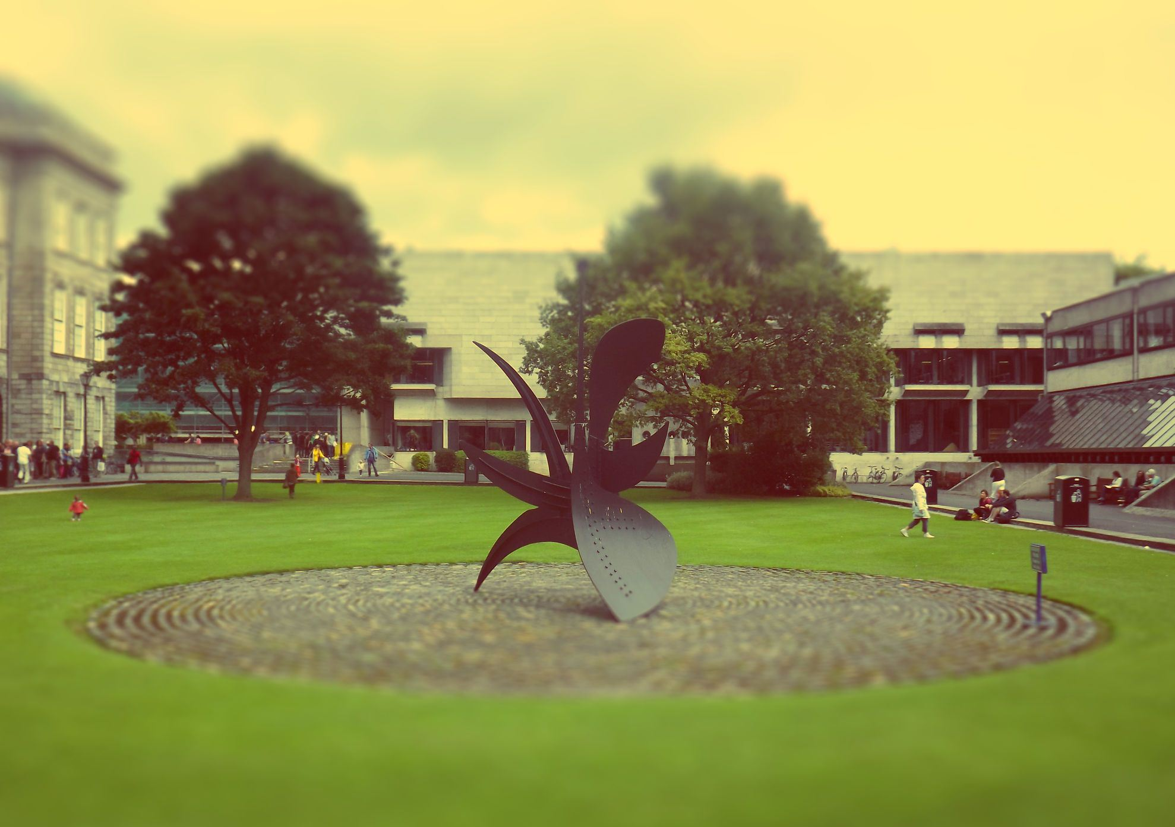
In this booklet, the Disability Service has created different sections which offer more information on teaching and supporting students with disabilities. Each section introduces a condition/diagnosis/difficulty, and goes on to explore how these may influence a student’s academic performance and participation in college life. The purpose of this information is to raise awareness of the challenges that can be experienced by students with disabilities. Each section suggests ways in which you, as a member of staff, can support students with disabilities. Bear in mind that these are general guidelines, and that every student is different- the difficulties and strategies identified are not exhaustive. Below, the services offered by the Disability Service and general strategies for staff to use to support students with disabilities are introduced.

Role of the College Disability Service:

Trinity College is a very large establishment with many different physical environments, administrative departments, academic and non-academic support services and IT systems. Students with a disability are encouraged to register with the College Disability Service in Trinity College to seek supports where the disability could affect their ability to participate fully in all aspects of their life in College. All students who register with Disability Service have an individual needs assessment with a Disability Officer to determine the support they require.
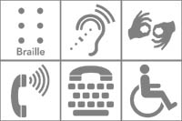
Following the Needs Assessment, the Disability Service generates a Learning Educational Needs Summary. This outlines a student’s disability, and how it affects their learning. The LENS report identifies supports and reasonable accommodations to which the student is entitled. The Disability Service may recommend and implement other supports for students such as library special borrowing privileges, exam accommodations, and assistive technology. If required, the Disability Service can also act as an advocate for the student.
Students with disabilities can also avail of the Unilink service. Unilink is a confidential, practical, occupational therapy support service for students who may be experiencing mental health difficulties and/or physical and sensory difficulties. Unilink explores difficulties a student may have with aspects of college life, and supports the student in developing strategies to manage these difficulties. Unilink is staffed by qualified Occupational Therapists.

General strategies staff can use to support students with disabilities

Follow Inclusive Curriculum practices:
The main way to support students with disabilities is to follow inclusive teaching and assessment practices. The Trinity Inclusive Curriculum Website is an extensive resource with good practice guidelines that enable you to support all students. Often, one action (e.g. circulating notes in advance) can benefit many different students for many different reasons. Academic staff can consider accessibility when designing curricula so as to lessen the need for future reasonable accommodations.
Implement reasonable accommodations
It is important for Schools and Departments to access student LENS reports on Sharepoint and to implement any reasonable accommodations recommended with efficiency and discretion. Please note that while these are recommendations, College has a duty to comply with (i) the Equal Status Acts 2000-2011 which provides that an educational establishment cannot discriminate in relation to the access of a student to any course, facility or benefit provided by the establishment and (ii) the Disability Act 2005, which places a statutory obligation on public service providers to support access to services and facilities for people with disabilities. Click here for a full explanation of the reasonable accommodations you will find in LENS reports. If you have any queries, we encourage you to contact the Disability Service.
Encourage disclosure

We encourage students to disclose if they have a disability so that College can work with the student on exploring the impact of their disability on college experience. This allows for any necessary reasonable accommodations to be identified and facilitated in collaboration with the student. A short sentence on the course outline handout at the start of the year to the effect that adjustments can be made for students with documented disabilities may encourage an apprehensive student to disclose. Students register with the Disability Service by providing documentation. When they meet with a Disability Officer, the student can decide how much information they wish to disclose to their department or school. Disclosure is particularly important for students on professional courses to consider, before going on placements.
Be mindful and open!

All students bring a unique set of strengths and experiences to college and students with disabilities are no exception. While many learn in different ways, their differences do not imply inferior abilities. Reducing course requirements for students with disabilities is not required, but instead it may be necessary to modify teaching and assessment practices to be more inclusive.

It is important to note that a lot of disabilities may not be so apparent, for example, mental health difficulties, medical illnesses, or learning difficulties.

Reading this information is a great first step in supporting students with disabilities. An understanding of the difficulties students with disabilities may face in college is very important. Students with disabilities are responsible for disclosing their disabilities and identifying what they need and implementing personal strategies to support them. The co-operation, flexibility, and understanding of academic and administrative staff are vital too. Every student is different. It is often helpful to ask a student that you may come into contact with how you can support them. If you are teaching staff, you can highlight at the beginning of a module that students are welcome to approach you if they have any particular difficulties that affect their learning.

Supporting students with Autistic Spectrum Disorder or Asperger’s Syndrome

Introduction:
Autistic Spectrum Disorder (ASD) is a term that is used as an umbrella term for a series of pervasive developmental, neurological disorders including Autism, Asperger Syndrome, Pervasive Developmental Disorder-Not Otherwise Specified (PDD-NOS). Asperger’s Syndrome (AS) is recognised as being at the high functioning end of the autistic spectrum. For the purposes of this information, we will use the acronym ASD to cover Asperger’s Syndrome also.
ASD is characterised by a triad of impairments or difficulties, in the absence of general learning difficulties. Individuals with ASD may experience difficulties in (i) social interaction and social relationships (ii) verbal and non-verbal communication, and (iii) imagination, behaviour, and flexibility of thought.
Students with ASD often have above average intelligence and high aptitudes for acquiring knowledge. These aspects can enable students with ASD to thrive in a college environment. The number of students with ASD entering Trinity College is increasing every year. It is important to understand that the difficulties identified below do not apply to all students with ASD.

Difficulties that may be experienced by university students with ASD or Asperger’s Syndrome
- Students may have a need for order and predictability. Students may find adapting to new routines or changing circumstances challenging. The transition to third level where days are largely non-routine can often be difficult for students. Students with ASD may have difficulties with organisation, and orientation to college locations and systems, particularly in their first year.
- People with ASD sometimes interpret language literally and may have difficulty understanding metaphors, sarcasm, unclear directions or ambiguous content.

- Students with ASD may be quite conscious of their performance in social situations, which can be a source of anxiety. Students may have difficulty getting to know new people, and building up relationships. Students with ASD may find group work situations challenging or stressful.

- Students with ASD may be hypersensitive to sensory stimuli (vision, hearing, touch, taste, or smell). As such, students may be easily distracted or overwhelmed by noisy environments, for example, lecture halls.

- Perfectionism can be a problem for students with ASD. A fear of failure and a determination to complete a perfect piece of work can lead to students procrastinating and getting ‘stuck’. Organising material, planning, and managing time and deadlines can be a significant challenge for many students.
- Students with ASD may experience difficulties with gross or fine motor skills, and can experience difficulty with handwriting or note taking.

Strategies staff can use to support students with ASD or Asperger’s Syndrome
- As explained here, students may have disclosed having ASD to their School through a LENS report. Access the LENS report for details on how you can support the student. Implement and support a student’s reasonable accommodations with efficiency and discretion. Be mindful of how having ASD may impact a student’s experience of college life.

- Provide clear and unambiguous instructions. Students with ASD may find it difficult to decode implied meaning in language. It is therefore suggested to use simple and clear language free from metaphors. It is also may beneficial to provide both written and verbal instruction for some students.

- Make lecture notes available in advance if possible. Students with ASD may have difficulty with fine motor skills, attention, and organisation and note taking in class can be difficult.
- Students with ASD may find it difficult to manage time and plan ahead. A clear timeline of events, assignments, and deadlines in the course handbook would support students to know when things are due.

- Students with ASD may find the transition from second to third level particularly difficult. Be particularly understanding at this time.

- Follow Trinity Inclusive Curriculum guidelines as much as possible.

Further information
Visit TCD’s Asperger's Syndrome Support Service website for videos made by students with Asperger’s Syndrome on their experiences in Trinity. This site also includes a useful guide for supporting students with ASD in third level.
If you would like more information or support, contact the Disability Service.
See the following links for more information about Asperger’s Syndrome or ASD and useful resources:
Asperger Syndrome Association of Ireland
Aspergers Advice
The National Autistic Society (UK)
The Online Asperger Syndrome Information and Support Centre
Assistive Technology in TCD
Student Learning Development

Supporting students with ADD or ADHD

Introduction:
Attention Deficit Disorder (ADD) and Attention Deficit Hyperactivity Disorder (ADHD) are characterised by inattention significantly affecting aspects of daily life. Hyperactivity and impulsivity can be particularly apparent within ADHD. These conditions are often considered together within the acronym ADHD and will be for the purposes of this information.
Many students entering college may already have a diagnosis of ADHD and have become accustomed to their possible difficulties, and may have developed effective coping strategies. Some students however may only receive a diagnosis when they come to college.

Difficulties that may be experienced by university students with ADHD
- The transition from the supported and structured environments of secondary school and home to college can prove difficult for students with ADHD. The nature of college learning environment can pose a challenge for students with ADHD. Self-directed learning may be particularly challenging.

- Students may miss important information in lectures because of poor concentration and difficulties taking notes. Students may lose focus in lectures due to distracting stimuli in the environment.

- Students with ADHD often have significant difficulties with organisation and time management in college. Students may have difficulty developing plans, and setting and remembering goals.

- Organising and sequencing information can be a challenge for students with ADHD. This may be evident in written work. Often, students with ADHD may initiate work without reading the instructions fully, or understanding exactly what is asked. This may result in incomplete or incorrect work.

- Students with ADHD may have associated mental health difficulties or learning difficulties.

Strategies staff can use to support students
- As explained here, students may have disclosed their ADHD to their School. Access the LENS report for details on how you can support the student. Implement and support a student’s reasonable accommodations with efficiency and discretion. Be mindful of how having ADHD may impact a student’s experience of college life.

- Make lecture notes available in advance if possible. As explained, a student with ADHD may have difficulty paying attention and writing notes in lectures. Access to lecture notes in advance allows the student to review and become familiar with the lecture content. Having access to the notes within the lecture (printed or on a laptop) facilitates the student to follow the format of the lecture, and add in notes as appropriate. Try to be consistent with where material can be accessed.
- Provide, where possible, course material that is presented through varied and accessible methods, to engage students with different learning styles. Typically, a college environment focuses on learning through the written word, with less emphasis on visual, auditory, and kinaesthetic (learning by doing) styles. Students with ADHD may have a preference for these alternative learning styles.

- Students with ADHD may find it difficult to manage time and plan ahead. A clear timeline of events, assignments, and deadlines in the course handbook would support students to know when things are due.

- A written outline of the course in the student handbook may assist a student with ADHD to follow the course and revise for exams. Provision of clear lecture notes on each topic can be very helpful for a student with ADHD. Try to avoid presenting too much information on each slide.

- Outlining each lecture at the beginning and highlighting new terms and key points can help a student to focus. Periodic summaries of the lecture and summaries at appropriate points in the course can also be helpful.
- Providing templates or guidance for assignments online may be useful for supporting a student to understanding the expectations of third level education.

- Prioritise reading lists if possible. Students with ADHD often find it difficult to access and organise information, so prioritising reading might help to direct the student to the most pertinent texts.
- Students with ADHD are often easily distracted. Be mindful when giving instructions or directions to be clear and concise.

- In many instances, a student with ADHD may also have an associated learning difficulty. If necessary, please refer to the guidelines for specific learning difficulties.

- Follow Trinity Inclusive Curriculum guidelines as much as possible.

Further information:
If you would like more information or support, contact the Disability Service.
See the following links for more information about ADHD and useful resources:
Third Level Guide for Students with ADHD by Declan Reilly, TCD.
ADDitude
HADD website
Assistive Technology in TCD
Student Learning Development

Supporting students who are blind or visually impaired

Introduction
Visual impairment is vision loss as a result of a significant limitation of visual capability resulting from either disease, trauma, or congenital or degenerative conditions that cannot be corrected by conventional means, such as refractive correction, medication, or surgery.
People are considered legally blind when visual acuity is 20/200 or less in the better eye with the use of corrective lenses. There are significant variations in visual impairment. Some people can distinguish only light. Some people may have only side vision. Some see everything as a blur while others have blank spots. Blind or visually impaired people often use a white cane or a guide dog.
Our College environment is essentially set up for sighted students. As such, students who are blind or visually impaired can experience significant challenges. Students with visual impairments are one of the most underrepresented groups in College. Students with visual impairments can encounter significant difficulties in the accessibility of their education.

Difficulties that may be experienced by university students who are blind or visually impaired
- Students are likely to have significant difficulty or be unable to see print, presentation slides, or whiteboards. Students are likely to have difficulty following the content of lectures with a heavy emphasis on visual aids.
- Students may be unable to access material in an accessible format, or convert material to an accessible format. The extra time spent making material accessible can significantly delay students in completing reading or assignments.
- Students may have a slower speed of work when using magnification or specialist software. Students may have slower speed of reading, or difficulty reading for longer periods. This can delay students in completing academic assignments.
- Students may have problems with orientation and mobility (particularly in unfamiliar locations). Changes to the timetable or room changes can be problematic if the student is not informed. The Disability Service has online resources on assisting students to navigate the college environment, click here.

Strategies staff can use to support students
- As explained here, students may have disclosed a visual impairment. Access the LENS report for details on how you can support the student. Implement and support a student’s reasonable accommodations with efficiency and discretion. Be mindful of how being blind or visually impaired may impact a student’s experience of college life.

- The effect of a visual impairment varies widely. Ask the student about what they think you might need to know. Encourage the student to approach you if they are having difficulty with the way in which you are presenting information.

- Make lecture notes, handouts and overheads available to the student well in advance of the lecture. This allows time for them to be recorded, enlarged, scanned into the student’s computer or transcribed into braille.

- Make lecture notes available via email or on the internet so that the student can access them using screen reading or magnification software on their computer.

- Try to keep the physical environment consistent. Blind or visually impaired students may develop mental schemas of how rooms are laid out which make them easier for them to navigate. If you intend to alter the layout of a room drastically then try to inform the student beforehand and offer them the opportunity to readjust to the new layout.

- Face the class when speaking and ensure that what is written on the board is also communicated verbally.

- You may need to greet a student who is blind or visually impaired by saying your name, as he or she may not recognise your voice.

- Never make fuss of, or feed, a guide dog- he/she is working. Ask the owner’s permission first.

- When guiding a person who is blind/visually impaired, walk slightly ahead of them, allowing them to take your arm just above the elbow. Always ask if a student requires assistance, they may not.

- Follow Trinity Inclusive Curriculum guidelines as much as possible.

Further information

If you would like more information or support, contact the Disability Service.
See the following links for more information about visual impairments and useful resources:
Assistive Technology in TCD
Student Learning Development
NCBI- Integrating students with sight loss at third level

Supporting students who are D/deaf or Hard of Hearing

Introduction
Hearing loss is measured in decibels hearing level (dBHL). A person who can hear sounds across a range of frequencies at 0 to 28dB is considered to have normal hearing. The thresholds for the different types of hearing are as follows:
Mild 25-39 dBHL
Moderate 40-69 dBHL
Severe 70-94 dBHL

Profoundly deaf people cannot hear sounds quieter than 95dB. In the Deaf community, the word deaf can mean different things- ‘deaf’ refers to a loss of hearing, whereas ‘Deaf’ with a capital ‘d’ refers to identified membership of a linguistic and cultural minority. Irish Sign Language (ISL) is the principal form of communication for Deaf people in Ireland. Sign language arose and developed from within Deaf communities. Deaf students often communicate using sign language and lip reading. Some D/deaf students use cochlear implants or hearing aids. A cochlear implant is a small, complex electronic device that can help to provide a sense of sound. A cochlear implant is very different from a hearing aid. Hearing aids amplify sounds so they may be detected by damaged ears. Cochlear implants bypass damaged portions of the ear and directly stimulate the auditory nerve.
A student who is hard of hearing has some degree of hearing loss. Students who are hard of hearing usually communicate using a combination of strategies that rely on his/her remaining degree of hearing ability which can be enhanced by a hearing aid or an assistive hearing device. These may include public address systems, induction loops and transmitter/receiver systems with a clip-on microphone for the lecturer.
A Loop System enables hearing aid users hear various sound sources in large rooms or reception areas, in auditoriums, offices, theatres, or other large public areas. A loop of insulated wire is fixed around a designated listening area and is connected to a power source, an amplifier and a microphone. Hearing aids which have the ‘T’ switch can be set at this position, thus allowing the user receive a signal, which is carried from the microphone to the amplifier and is transmitted through to the loop wire, similar to a transmitting aerial. A number of loop systems are installed around College. Click here to see the loop system locations.

Difficulties that may be experienced by university students who are D/deaf or Hard of Hearing
- Most information in the College environment is presented aurally. Students who are D/deaf or Hard of Hearing are at a distinct disadvantage during lectures as the medium of teaching is through the spoken word.
- Students are likely to miss out on information presented aurally during lectures or classes.

- Students who use ISL usually consider English as their second language. As such, students may have difficulty with learning and communicating through English such as spelling and grammar, reading for meaning, writing fluently and expressively,

- Students may have difficulties completing assignments or in exam situations due to difficulties with reading comprehension or written expression.

- Students may misinterpret information, particularly where there is possible ambiguity in terminology.

- Students may have difficulties in group situations; following the discussion and making contributions.

- For students who are Deaf or hard of hearing and who choose to speak, feedback mechanisms are limited; therefore, vocal control, volume and articulation may be affected. Students may have difficulty communicating orally.

Communicating with a student who is D/deaf or Hard of Hearing:

- Ask the student what is the best way for you to communicate with them.

- Be mindful of distractions and background noise and try to minimise these where possible.

- If you are finding it difficult to understand what a student is saying, ask them to repeat it or write it down.

- It is important to gain the student's attention (without startling him/her) before speaking, for example, by waving your hand discretely, tapping a microphone, and making eye contact.

- Speak at the same pace and volume as you would normally, speaking in a louder voice or excessively slowly may interfere with hearing aids or loop systems.

- If you are using video aids, ensure that they are subtitled.
- Repeat questions or remarks from other students in the room. Ensure important information, for example a change of room location, is communicated in a written format.

Guidelines if a student is lip reading:

Lip-reading is a demanding activity requiring great concentration. Three quarters of it is guesswork, therefore clear speech and contextual clues are vital.
- Face the class as you speak. The student would know best about where to sit.
- Speak clearly and a reasonable natural pace, and do not cover your mouth or face away.
- Take regular pauses.
- Do not stand in front of a light source as this creates a shadow over your face which makes it more difficult to lip read.
- Use of facial expression and gestures during a lecture all produce extra contextual information to reduce guesswork for the student.
- Try to review or give a summary of information covered.
- New vocabulary or acronyms are impossible to lip read, writing them on the board and giving an explanation helps.
- You cannot read and lip read at the same time, thus it is important to allow the person extra time to read passages/notes if you are explaining things.

Guidelines if a student is using an ISL interpreter:
- When communicating one-to-one, speak and look directly at the D/deaf person. The interpreter will convey the message in the first person and will communicate the meaning and the content of your speech. This is explained in this Deaf Awareness video by a Trinity graduate.
- The interpreter's role is to facilitate communication, not to participate, so all remarks should be addressed to the communicating parties and not the interpreter.
- Speak at your normal rate; the interpreter will alert you if you are moving too quickly. If you are taking questions from others then the interpreter may point at that person to indicate who is speaking.
- Interpreting (translation into Sign Language) is a demanding task and most interpreters need a break after half an hour of continuous interpreting.
- Be aware that sign language often does not have signs for specialised or technical words and the interpreter will need to fingerspell these words. It can be helpful to define these terms and list any new vocabulary on handouts.
- Ensure that both the student and the interpreter have a copy of all handouts before the lecture.
- Deaf students can only attend to one source of information at a time i.e. the lecturer (via the interpreter) or the visual aid (overheads, slides etc.).
- Ensure the lecture hall is well lit so that the student can see the interpreter clearly.

Guidelines for tutorials or group work:
- Tutorials can be particularly difficult, especially if the student is required to follow streams of conversation from different people in the group.
- Try to ensure that everyone in the group can be seen by the Deaf/Hard of Hearing student or their interpreter.
- Try to encourage students to speak one at a time in group situations.
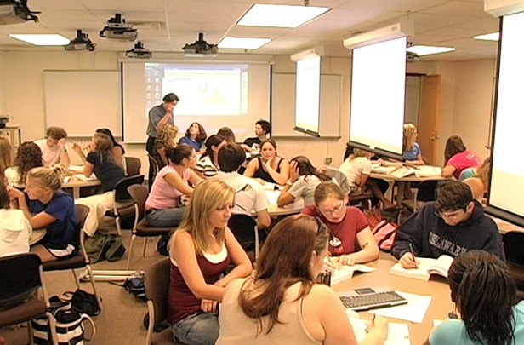

Strategies staff can use to support students:

- As explained here, students may have disclosed being D/deaf or Hard of Hearing to their School. Access the LENS report for details on how you can support the student. Implement and support a student’s reasonable accommodations with efficiency and discretion. Be mindful of how being unable to hear may impact a student’s experience of college life.

- Ask the student about what is the best way for you to communicate with them, and encourage the student to approach you if you are not delivering your information clearly. See the above guidelines for support in communicating with a student who is D/deaf or Hard of Hearing.

- View the Deaf Awareness videos on Youtube made by a Trinity graduate; Deaf Awareness Tips and Reflections on my final year.
- Make lecture notes available in advance if possible, so students can familiarise themselves with the language to expect in the lecture. Students who are Deaf or Hard of Hearing may rely more heavily on text books than other students, so providing a clear reading list at the beginning of the course can be very helpful.

- Ensure whatever information is communicated aurally is also available visually or written in notes.

- Follow Trinity Inclusive Curriculum guidelines as much as possible.

Further information
If you would like more information or support, contact the Disability Service.
See the following links for more information about being D/deaf or Hard of Hearing and useful resources:
Assistive Technology in TCD
Student Learning Development
Deaf Support in Third Level
Deafhear.ie

Supporting students with Developmental Co-ordination Disorder (DCD) or dyspraxia

Introduction

Developmental co-ordination disorder (DCD) is an umbrella term for gross and/or fine motor difficulties, motor planning difficulties, and sensory integration dysfunction. In general, DCD is now the preferred term instead of dyspraxia and the terms are used interchangeably for the purposes of this information. DCD implies difficulty in the co-ordination of movement. Gross motor skills (big movements of the larger muscles: arms, legs, torso, and feet) and fine motor skills (small movements in the smaller muscles of the fingers, toes, wrists, and mouth) are hard to learn and difficult to retain and generalise. People with DCD often have difficulties with attention and organisation.

Difficulties that may be experienced by university students with DCD or dyspraxia
- Students with DCD are likely to have difficulties with handwriting, copying diagrams, and writing notes from the board. Keyboard skills can be difficult to acquire.

- Students with DCD can have difficulties with postural control, balance, and co-ordination. Students with DCD may have difficulty with spatial awareness and may trip or fall more easily.

- Students may have difficulty with planning and organising their academic work.

- Students with DCD may have difficulty with fine motor skills for accuracy e.g. in laboratory work, or in precise clinical skills for courses such as Nursing.

- Concentration, time management, and planning can be very challenging for some students with DCD.
- Some students with DCD may have difficulty with expressing their thoughts clearly.

- Some people with DCD can be sensitive to sensory information such as sound, light, or touch.

- Students with DCD may have difficulties with written expression, work organisation, visual skills, oral skills, or numeracy skills.

- Students with DCD sometimes have associated mental health difficulties.

Suggestions for staff to support students
- As explained here, students may have disclosed DCD/dyspraxia to their School. Access the LENS report for details on how you can support the student. Implement and support a student’s reasonable accommodations with efficiency and discretion. Be mindful of how having DCD may impact a student’s experience of college life.

- Make lecture notes and other handouts available in advance if possible. As explained, a student with DCD may have difficulty writing notes in lectures. Having access to the notes within the lecture (printed or on a laptop) facilitates the student to follow the format of the lecture, and add in notes as appropriate.
- Students with DCD may find it difficult to manage time and plan ahead. A clear timeline of events, assignments, and deadlines in the course handbook would support students to know when things are due.

- A written outline of the course in the student handbook may assist students with DCD to follow the course and revise for exams. Provision of clear lecture notes on each topic can be very helpful for a student with DCD.

- Prioritise reading lists if possible. Students with DCD often find it difficult to access and organise information, so prioritising reading might help to direct the student to the most pertinent texts.

- Follow Trinity Inclusive Curriculum guidelines as much as possible.

Further information
If you would like more information or support, contact the Disability Service.
See the following links for more information about DCD and useful resources:
Assistive Technology in TCD
Student Learning Development
Dyspraxia Association of Ireland
Dyspraxia Foundation UK

Supporting students with neurological conditions

Introduction
Neurological conditions are disorders of the brain, spinal cord and nerves throughout the body. Many conditions may be stable, others may be variable and some will be progressive.
Major types of neurological conditions include Epilepsy, Huntington’s Disease, Multiple Sclerosis, Motor Neurone Disease, Friedreich’s Ataxia, Parkinson’s Disease, brain injury, stroke, and some speech and language difficulties. Speech, language, and communication difficulties include problems with articulation, voice strength, fluency problems, understanding others, expression, or being unable to speak.

Difficulties that may be experienced by university students with neurological conditions
Naturally, the conditions mentioned above and other neurological conditions vary in their symptoms and effects. In general, students with these types of illnesses:
- Often experience fatigue (physical, cognitive, and emotional exhaustion)
- May have difficulties with concentration and completion of tasks or assignments.
- Experience pain
- Have to take medication (with possible side effects)
- Can be more susceptible to stress, and illnesses could be exacerbated by times of stress.
- Can miss lectures due to medical appointments, illness, or time in hospital.
- Some students may have mobility or postural difficulties; with walking, climbing stairs, or remaining in one position for long periods of time.
- Writing and other fine motor activities (including computer use) may also be affected.
- Students may have difficulty with oral communication.

Strategies staff can use to support students
- As explained here, students may have disclosed a neurological condition to their School. Access the LENS report for details on how you can support the student. Implement and support a student’s reasonable accommodations with efficiency and discretion. Be mindful of how the neurological condition may impact a student’s experience of college life.

- Make lecture notes available in advance if possible. Students with neurological conditions may find it difficult to maintain their concentration during lectures. Having lecture notes in advance enables students within the lecture to reduce the amount of handwritten notes they need to take, allowing them to concentrate on the material being delivered. This may enable the student to conserve energy for the rest of the college day.

- Prioritise reading lists. This enables students to engage more easily with pertinent course texts.

- When planning course timetables, try to ensure timetabling gives all students sufficient time to move between teaching venues. Try to avoid significant location changes within a college day e.g. between Trinity main campus and Trinity Centre for Health Sciences, St. James’s Hospital.
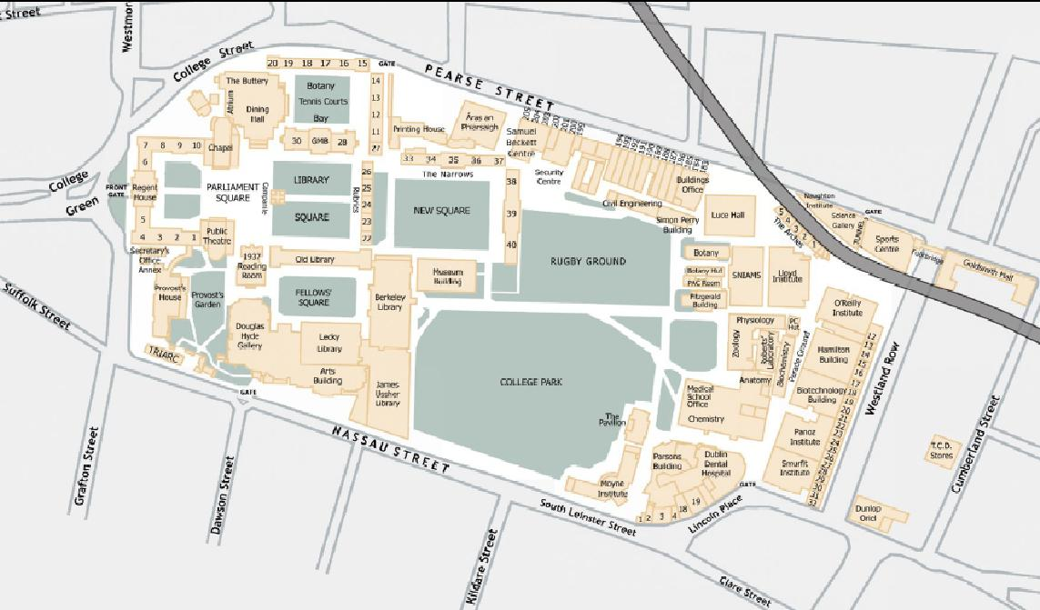

- Be mindful of keeping areas clear, to reduce the likelihood of accidents. In long lectures, it may be helpful to allow students a quick break. Avoid drawing attention to students who may need to leave class. Accommodate students who may need to sit in certain learning situations e.g. in labs or practical anatomy.
- Be patient when teaching students with speech, language, and communication difficulties. Give students the opportunity, without compelling them, to speak in class. Give students the time they require to express themselves. Do not be reluctant to ask the student to repeat a statement.

- Students with complex needs or severely reduced mobility may have a Personal Emergency Evacuation Plan (PEEPS). The information for the student’s safe evacuation in the event of an emergency will be contained in their LENS report. Training in the use of the evacuation equipment can be obtained from the Disability Service.

- Follow Trinity Inclusive Curriculum guidelines as much as possible.

Further information

If you would like more information or support, contact the Disability Service.
See the following links for more information about some neurological conditions and useful resources:
Assistive Technology in TCD
Student Learning Development
Acquired Brain Injury Ireland
MS Ireland
Ataxia Ireland
Irish Motor Neuron Disease Association
Huntington's Disease Association of Ireland
Brainwave- The Irish Epilepsy Association

Supporting students with mental health difficulties

Introduction
Mental health is an umbrella term that refers to how we perceive and feel about ourselves and others and the meaning that we derive from everyday life. It also relates to our ability to cope with change and transition and the stresses of everyday life.
Mental health is not the same as the absence of mental illness. The World Health Organisation defines mental health as ‘a state of well-being in which every individual realises his or her own potential, can cope with the normal stresses of life, can work productively and fruitfully, and is able to make a contribution to his or her community’.
Mental health is an essential component of general health and wellbeing. Poor mental health affects our ability to cope with and manage our lives, particularly during personal change and through key life events, and decreases our ability to participate fully in life. Mental health difficulties in students can develop in response to pressures at college, at work, at home, trauma, or relationship difficulties.
Many mental health difficulties are temporary, responding to medication, therapy, and rest. Some people may experience more long term difficulties which are interspersed with period of good and poor health.
Students with mental health difficulties can register with the Disability Service, to access services and advice, to support them in their student role.
Types of mental health diagnoses include: depression, anxiety, eating disorders, obsessive compulsive disorder, personality disorders, and schizophrenia.

Difficulties that may be experienced by university students with mental health difficulties

- Students may experience anxiety about day-to-day aspects of college.

- Students may have poor attendance at college due to low mood, anxiety, or fatigue.

- Students with mental health difficulties often have poor sleeping and eating patterns which can affect their concentration. It may also be difficult to concentrate in lectures or in the library due to low mood or anxious thoughts.

- The busy college environment can be overwhelming for students with mental health difficulties.

- Students may have low self-confidence in their ability to do things, and may procrastinate or find it difficult to get things done. Students may find it difficult to plan ahead and be organised. Meeting deadlines can be extremely challenging.

- Engaging in extra-curricular or social activities can be difficult for students with mental health difficulties.

- Students may be feeling very hopeless and isolated. Some mental health difficulties can cause significant changes in behaviour, and students may be more vulnerable or aggressive.

Strategies staff can use to support students
- As explained here, students may have disclosed a mental health difficulty to their School. Access the LENS report for details on how you can support the student. Implement and support a student’s reasonable accommodations with efficiency and discretion. Be mindful of how a mental health difficulty may impact a student’s experience of college life.

- Be familiar with the Trinity College Mental Health Policy.

- Make lecture notes available in advance if possible. Students with mental health difficulties may have difficulty attending lectures for various reasons. Some students may be anxious about the lecture environment. Other students may find it difficult to attend lectures due to low mood, concentration difficulties, or a disrupted sleep pattern. Providing lecture notes in advance enables the student to access the lecture content and to become acquainted with the subject material before the lecture. This practice may reduce uncertainty, and help the student to feel prepared and comfortable within the lecture. Having notes can also help to focus the student on the lecture content, instead of worrying about taking down all of the information being presented.

- Prioritised reading lists enable students to engage with the most pertinent course material.
- For many students, their condition may be variable and they may experience periods of particular difficulty. This may require some understanding and flexibility.
- Students may prefer not to discuss difficulties they are having but you can help by being available to listen if a student wishes to talk to somebody.
- If you do not feel equipped to help, encourage the student to talk to a professional in the College Health Service, the Student Counselling Service, or the Disability Service.

- Follow Trinity Inclusive Curriculum guidelines as much as possible.

- Encourage the promotion of positive mental health when possible. In 2012, the ‘5 A Day for Mental Health’ initiative was launched, a collaboration between the Unilink service, the Equality Fund, Students Union, and the Staff Office. The initiative seeks to promote positive mental health by encouraging TCD students and staff to engage in five simple activities every day to improve well-being in everyday life. Click here to find out more!

Further information
If you would like more information or support, contact the Disability Service.
See the following links for more information about mental health and useful resources:
Unilink Service
Trinity College Mental Health Management
College Health Mental Health Promotion
Student Counselling Service
College Health Centre
Assistive Technology in TCD
Student Learning Development
Headstrong- The National Centre for Youth Mental Health
Reach Out
Mental Health Ireland
Aware
Bodywhys
OCD Ireland
Shine

Supporting students with physical disabilities

This section introduces physical disability and some medical conditions that result in physical disabilities, and explores how these may impact a student’s academic performance and participation in college life. Here, the main focus is to suggest ways in which you as a staff member can support students with physical disabilities in their role of being a student.

Introduction
Physical disabilities result from conditions that affect the physical body. These can include conditions such as brain injuries, spinal cord injury, cerebral palsy, multiple sclerosis, spina bifida, and amputations. Severe respiratory and cardiac diseases can also affect mobility. Students with physical disabilities often face major obstacles within the College physical and social environment.

Difficulties that may be experienced by university students with physical disabilities
- Students may face difficulties with physical access to buildings and rooms on campus. Students may be unable to access some activities or events with peers.
- Students may have difficulty or be unable to write, hold, or manipulate objects. Students may, for example encounter difficulties in the use of the library for accessing and reading texts, and finding appropriate desk space.
- Students who use wheelchairs, crutches, canes, or prostheses may find it difficult moving from place to place, and face obstacles in the physical environment.
- It may take students more time to complete coursework.
- Students may tire easily, and find it difficult to maintain energy and stamina throughout the college day.
- Fatigue and weakness may make it difficult for the students to complete assignments and perform in exams

Strategies for staff to support students
- As explained here, students may have disclosed a physical disability to their School. Access the LENS report for details on how you can support the student. Implement and support a student’s reasonable accommodations with efficiency and discretion. Be mindful of how having a physical disability may impact a student’s experience of college life.

- Be conscious that the student may tire easily and may require rest periods or breaks during lectures, tutorials or class tests.

- Do not push a person’s wheelchair without their permission – offer help if you think it is required but do not impose it. When talking to a person who uses a wheelchair sit down (if possible) so that you are both on the same level.
- Make lecture notes available in advance if possible. Having lecture notes available online enables students to reduce the amount of handwritten notes they need to take during the lecture. This may enable the student to conserve energy for the rest of the college day. Some students with physical disabilities may have a note-taker.
- When planning course timetables, try to ensure timetabling gives all students sufficient time to move between teaching venues. Try to avoid significant location changes within a college day e.g. Trinity main campus and Trinity Centre for Health Sciences, St. James’s Hospital.

- See here for a map of accessible venues on campus and here for additional information on the location and accessibility of buildings in College.
- Students with complex needs or severely reduced mobility may have a Personal Emergency Evacuation Plan (PEEPS). The information for the student’s safe evacuation in the event of an emergency will be contained in their LENS report. Training in the use of the evacuation equipment can be obtained from the Disability Service.

- Follow Trinity Inclusive Curriculum guidelines as much as possible.

Further information
Assistive Technology in TCD
Student Learning Development

Supporting students with specific learning difficulties

This section introduces the different Specific Learning Difficulties (SpLDs) and explores how they may impact on a student’s academic performance and participation in college. Here, the main focus is to suggest ways in which you as a staff member can support students with specific learning difficulties (dyslexia, dysgraphia, and dyscalculia) within their role of being a student.

Introduction
A learning difficulty or disability is characterised by a discrepancy between intellectual capacity and achievement. There are three major specific learning difficulties: dyslexia, dysgraphia, and dyscalculia. Other learning difficulties include difficulties with auditory processing, memory, reading/visual difficulties.
Dyslexia is a language based learning difficulty which mainly affects the development of literacy and language related skills. Many people with dyslexia can experience difficulties in the following areas: memory, reading, writing, spelling, maths, organisation, and speech. The difficulties in these areas are not related to a person’s intelligence or cognitive skills.
Dysgraphia affects the student’s ability to write coherently regardless of their ability to read. Some of the problems include: poor structure of words, incomplete words and omitted words while writing, significant difficulty putting thoughts and ideas in writing, increased or decreased speed of handwriting.
Dyscalculia is a learning difficulty of arithmetic or Maths. The difficulty lies in the receptions, comprehension, or production of quantitative and spatial information. Students with dyscalculia may have difficulty in understanding simple number concepts, lack an intuitive grasp of numbers, and have problems learning number facts and procedures.

Difficulties that may be experienced by university students with specific learning difficulties
- Students with specific learning difficulties can underachieve within the education system unless they receive appropriate support.

- Students may underperform in college examinations or require more time to complete assignments than other students.

- Taking notes in lectures can be difficult for students with SpLDs.

- Students may have significant organisational difficulties.

- Students may have difficulty with handwriting and producing written work.

Suggestions for staff to support students
- As explained here, students may have disclosed a specific learning difficulty to their School. Access the LENS report for details on how you can support the student. Implement and support a student’s reasonable accommodations with efficiency and discretion. Be mindful of how having a specific learning difficulty may impact a student’s experience of college life.

- Make lecture notes available in advance if possible. Student with specific learning difficulties may have difficulty writing notes in lectures. Having access to the notes within the lecture (printed or on a laptop) facilitates the student to follow the format of the lecture, and add in notes as appropriate.
- A written outline of the course in the student handbook may assist student with learning difficulties to follow the course and revise for exams.
- Outlining each lecture at the beginning and highlighting new terms and key points can help a student to focus. Periodic summaries of the lecture and summaries at appropriate points in the course can also be helpful.

- Providing templates or guidance for assignments online may be useful for supporting a student to understanding the expectations of third level education. Providing clear feedback on assignments enables students to understand how they can improve.

- Provide, where possible, course material that is presented through varied and accessible methods, to engage students with different learning styles. Typically, a college environment focuses on learning through the written word, with less emphasis on visual, auditory, and kinaesthetic (learning by doing) styles. Students with specific learning difficulties may have a preference for these alternative learning styles. Consider using alternative assessment options, see for example, Trinity Inclusive Curriculum Assessment Choice.

- Follow Trinity Inclusive Curriculum guidelines as much as possible.

Further information
Student Learning Development
Assistive Technology in TCD
Dyslexia Association of Ireland

Supporting students with significant ongoing illnesses

Introduction
Some Trinity students have ongoing medical conditions or illnesses which may impact on their studies or college life. These illnesses are sometimes referred to as ‘hidden disabilities’ because they are less obvious.

Difficulties that may be experienced by university students with ongoing illnesses
Ongoing illnesses include Arthritis, Chronic Fatigue Syndrome, Cystic Fibrosis, Diabetes, Haemophilia, Crohn’s Disease, Fibromyalgia and many more. Naturally, these and other ongoing illnesses vary in their symptoms and effects. In general, students with these types of illnesses:
- Experience pain
- Experience fatigue (physical, cognitive, and emotional exhaustion)
- Have to take medication (with possible side effects)
- Can be more susceptible to stress, and illnesses could be exacerbated by times of stress.
- Can have weakened immune systems.
- Can miss lectures due to illness or hospitalisation.
- May have mobility difficulties or muscle weakness.

Strategies staff can use to support students
- As explained here, students may have disclosed a significant ongoing illness to their School. Access the LENS report for details on how you can support the student. Implement and support a student’s reasonable accommodations with efficiency and discretion. Be mindful of how a significant ongoing illness may impact a student’s experience of college life.

- Make lecture notes available in advance if possible. Students with ongoing illnesses may find it difficult to maintain their concentration during lectures. Having lecture notes in advance enables students within the lecture to reduce the amount of handwritten notes they need to take, allowing them to concentrate on the material being delivered. This may enable the student to conserve energy for the rest of the college day.

- Prioritise reading lists. This enables students to engage more easily with pertinent course texts.

- When planning course timetables, try to ensure timetabling gives all students sufficient time to move between teaching venues. Try to avoid significant location changes within a college day e.g. Trinity main campus and Trinity Centre for Health Sciences, St. James’s Hospital.

- Be mindful of keeping areas clear, to reduce the likelihood of accidents. In long lectures, it may be helpful to allow students a quick break. Avoid drawing attention to students who may need to leave class. Accommodate students who may need to sit in certain learning situations e.g. in labs or practical anatomy.
- Students with complex needs or severely reduced mobility may have a Personal Emergency Evacuation Plan (PEEPS). The information for the student’s safe evacuation in the event of an emergency will be contained in their LENS report. Training in the use of the evacuation equipment can be obtained from the Disability Service.

- Follow Trinity Inclusive Curriculum guidelines as much as possible.

Further information
If you would like more information or support, contact the Disability Service.
See the following links for more information about ongoing illnesses and useful resources:
Assistive Technology in TCD
Student Learning Development
The Cystic Fibrosis Association of Ireland
Arthritis Ireland
FibroIreland

