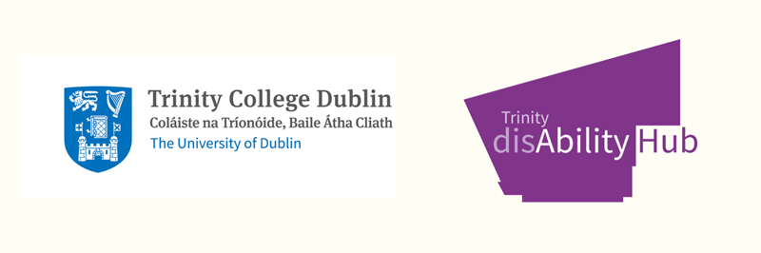

Consent to Disclose and Share Disability Information & Reasonable Accommodation Needs Assessment - Staff

Introduction:
Trinity College Dublin, the University of Dublin, is dedicated to ensuring an inclusive environment for all staff. Upholding the ethos of equal opportunities, Trinity is committed to aiding both students and staff with disabilities, emphasising anticipation of their unique needs. Trinity's established Code of Practice applying to the Employment of People with Disabilities and a guide for staff with disabilities and managers can be accessed here.

Disclosure and Reasonable Accommodations:
Staff members can disclose their disability either during recruitment or post-employment. HR oversees the interview process for prospective staff. For those disclosing a disability, Trinity will provide necessary reasonable accommodations, ensuring they can perform their roles efficiently. The Disability Service, adhering to the Code of Practice, will conduct an assessment to determine these accommodations.
Staff members are encouraged to disclose their disability to the Disability Service. This enables Trinity to collaborate with the employee to identify and facilitate any required reasonable accommodations in alignment with the manager.

Data Management and Sharing:
The Disability Service manages information provided by staff as 'sensitive personal data', safeguarding it under the Data Protection Act (1998-2003) and General Data Protection Regulation. While the information may be used for statistical and monitoring purposes, identities remain confidential. Specific medical documentation stays within the Disability Service, ensuring no third-party disclosures unless it’s essential for providing reasonable accommodations.

Purpose of Data Collection and Storage:
To determine the nature and appropriateness of reasonable accommodations, the Disability Service may collect, share, and store certain data about your disability. This includes:
- Personal details like name and Trinity Staff number.
- Employment specifics.
- Medical or disability-related information.
Such information might be shared with:
- Relevant University departments.
- Health Service or other suggested providers.
- Estates & Facilities.
- With your consent, named external professionals associated with your care.
All electronic data is securely stored on standalone hard drives, accessible only by the Disability Officer. Physical documents, upon scanning, are shredded. Data will be retained for 7 years post-graduation and then securely destroyed. Any statistical insights derived will be anonymised.

Terms of Reference for the Reasonable Accommodation Needs Assessment:
The Disability Service's assessment focuses exclusively on ascertaining the necessary reasonable accommodations to ensure staff can fulfil their roles effectively. It does not tackle workplace or interpersonal challenges. Such issues should be channelled through management, with guidance from Human Resources.

Declaration & Consent:
By signing below, you acknowledge understanding of the terms and conditions laid out and consent to the stated information disclosure:
- I request additional supports from the Trinity College Dublin Disability Service and understand my rights and responsibilities in the delivery of these supports.
- I consent to specific data sharing with:
- Line-Manager
- Human Resources – Employee Relations
- Other: ______________
- Other: ______________
If 'No' is ticked for any of the above options, you might be ineligible for accommodations requiring data disclosure.
- I consent to data retention by the Disability Service for the duration of my tenure requiring disability-related support.
Yes [ ] No [ ]

Personal Details:
Staff Name (BLOCK CAPITALS): __________________________________
Staff Number: ____________________________
Signature: _____________________________ Date: ________________

