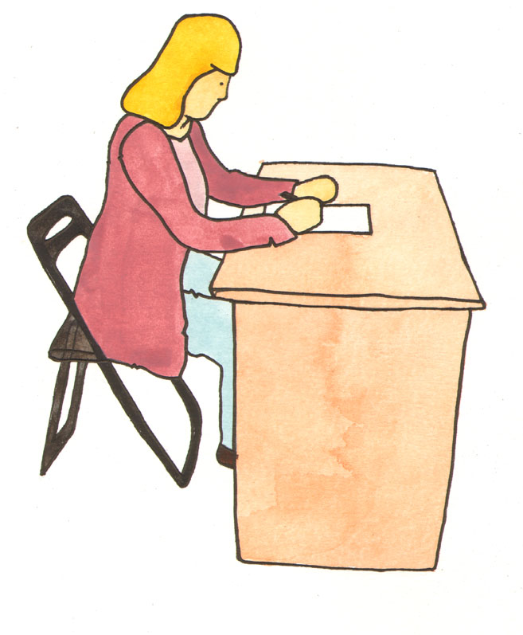

Top 10 Exam

Myths

1. You need to have a photographic memory.

Remembering key sources, dates or quotes is of course very useful, but marks will be awarded for demonstrating that you understand your subject.

2. Exam questions are written to trip you up and highlight your lack of knowledge.

College examiners want students to pass exams. It is in no-one’s interest to have large numbers of students failing exams. Examiners will seek to give you marks where they can.

3. Basically just put down everything you know about a subject and that should cover it.

You need to answer the question without waffling and rambling on at length about irrelevant stuff. It will not get you any more marks and examiners can spot when you are doing this….


4. There isn’t enough time to plan your answer.

You can brainstorm or mind map an exam answer in 5 minutes: introduction, main points, conclusion. This is one way of using any extra time you have been given. Planning stops you waffling.

5. An exam answer that has perfect spelling, grammar and punctuation will be awarded more marks.

Clearly you will lose marks if your work / diagrams / calculation are difficult to read and thus interpret. However marks are awarded for content i.e. ‘has the student answered the question, do they know what they are talking about’?

6. The more pages you write the better marks you will get.

Quality and relevance is more important than quantity. Short and concise answers that cover the main points accurately are preferable to 2 – 3 pages that don’t say much at all. So don’t be put off by the bod next to you who is on his 3rd answer booklet!



7. Staying up late / all night before an exam means you will remember more and get better marks.

It is a fact that the brain takes 24 hours to absorb, order and file information. Much of this re-organisation is done whilst you are asleep. Depriving yourself of sleep disrupts this process. Make a revision timetable and revise in a manageable way.

8. Talking about revision topics and questions with peers just before going into the exam, is a good way of doing last minute revision.

This will disrupt your concentration and is liable to make you panic. It may also make you doubt your own knowledge. Stay away from people who do this deliberately, find a quiet area to be by yourself.

9. I’m too nervous to eat anything beforehand, besides eating breakfast will make me feel sick. A full stomach is likely to make me feel sleepy and less alert.

Sitting a 3 hour exam on an empty stomach is more likely to make you less alert. You will find it difficult to concentrate with a rumbling stomach, and you may feel faint or tired due to low blood sugar. This might prompt you to leave an exam early before you have double-checked your work.

10. There’s no point in doing last minute revision, if I don’t know it now I never will.

Well it’s true that you are not going to learn off your topic / subject in a final 45 minutes of crash revision. However, there is nothing wrong with reviewing your mind maps or looking through flashcards. The best way to revise is to review your material:

- At the end of your study session
- One day after you revised the material
- One week later
- One month later

Our advice: Use the revision timetables on the next page to plan your study time. You can also download excellent subject revision planners from www.skoool.ie Go to:

Exam centre / Leaving Certificate / Select Revision Checklists from the menu bar at the right hand of the page.

DATE | SUBJECT 1 | SUBJECT 2 | SUBJECT 3
Mon
Tue
Wed
Thu
Fri
Sat
Sun
Mon
Tue
Wed
Thu
Fri
Sat
Sun

 | Monday | Tuesday | Wednesday | Thursday | Friday
8.00 - 9.00
9.00 - 10.00
10.00 - 11.00
11.00 - 12.00
12.00 - 1.00
1.00 - 2.00
2.00 - 3.00
3.00 - 4.00
4.00 - 5.00
5.00 - 6.00
6.00 - 7.00

