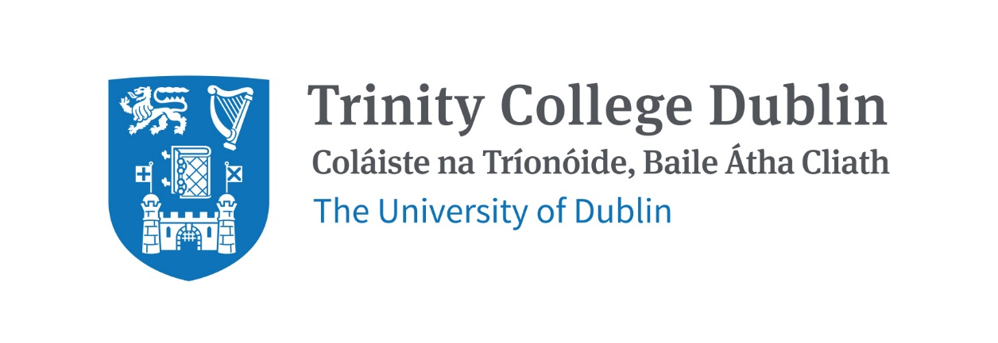

Trinity Business School

Managing Sustainability for Business Value

2026/27

MODULE CODE: BUU44XXXXX

MODULE NAME: Managing Sustainability for Business Value

ECTS: 20

PRE-REQUISITE: None

LECTURER: Dr Aisling Curley

E-MAIL: aicurley@tcd.ie
OFFICE HOURS: by appointment

MODULE DESCRIPTION
‘Our future business leaders need to be ninjas in being able to articulate how [sustainability] contributes to the bottom-line…’ Rebecca Donnellan, (EY Partner, Climate Change and Sustainability)

This module explores the business case for sustainability and how far this can be developed to enable business to profitably contribute to achieving the UN SDGs. It seeks to balance the realities of for-profit businesses with developing and achieving sustainability goals.

“Sustainable development requires an integrated approach that takes into consideration environmental concerns along with economic development.” (Sustainability | United Nations). Can businesses balance the triple bottom line? How far can organizations push the dual goals of becoming ‘best in the world’ and ‘best for the world’? (Elkington, 2018) 25 Years Ago I Coined the Phrase “Triple Bottom Line.” Here’s Why It’s Time to Rethink It.

This capstone explores:
- how industries and organizations can improve sustainability whilst enhancing their effectiveness and profitability
- where industries and organizations reach the limits of win-wins; the ability to satisfactorily balance sustainability and profitability
  - where the ideal action in terms of achieving sustainability differs from the ideal economic action (Donaldson 2025)
- what are the enablers and barriers to expanding the win-win boundaries
- how can the gap between sustainability and economic goals be reduced

LEARNING AND TEACHING APPROACH
Lectures, activities, assignments, tasks, and class discussions will aid students in developing the knowledge and skills to succeed on their capstone journey. However, ultimately success in this module relies on the independent work of the student.
There will be 2-hour in person classes weekly, along with 1-hour tutorials. Attendance is mandatory.
Students will need to prepare for each class and tutorial, to participate effectively.
The classes and tutorials will introduce module content and provide opportunities to practice and encourage development of transferrable skills, aligned with the desired Trinity Graduate Attributes: Think independently, Act Responsibly, Communicate Effectively and Develop Continuously. Students are expected to engage in critical and system thinking. This capstone seeks to enable students to have a transformative learning experience.
The responsibility to produce content of quality and meet deadlines rests on the student.

MODULE-LEVEL LEARNING OUTCOMES

- Explain, apply and connect core concepts, frameworks and theories to explore economic and sustainability goals (and the gap between these) for an industry and/or organisation.
- Demonstrate engagement with relevant literature
- Gather and analyse, macro, sector, organization, institutional and stakeholder data influencing the sustainability capabilities and limitations of industries and organisations
- Identify key challenges industries and organisations face in balancing effectiveness, profitability and sustainability ambitions
- Develop and justify viable recommendations for an organisation or industry to improve their sustainability whilst being mindful of economic imperatives.
- Demonstrate the development of professionalism through consistent, punctual attendance, preparation and participation in group tasks and discussion.

RELATION TO DEGREE

This module builds on related sustainability and business learning from modules in previous years, including but not limited to: BUU11580 Fundamentals of Management and Organisation, BUU11570 Enacting Sustainable Development, BUU22580 Business Ethics, BUU22594 Organisation Change for Sustainable Futures, BUU33580 International Governance and Sustainable Business (UN SDGs), BUU33804 Social and Environmental Innovation, and BUU33590 Business in Society.

This capstone requires a significant level of independent effort. Students will showcase their understanding of module content and related disciplines, and their research and critical thinking skills. Students will develop and demonstrate their ability to work independently, take responsibility, self-motivate, and communicate effectively. These are skills that are highly desirable as employees and for further advanced study.

This module aims to enable students to develop the knowledge, skills and motivation to influence businesses to have a more positive impact on the world and to mitigate harm.

ASSESSMENT
Provisional Assessment Scheme (TBC)
 | Assignment | % Grade | Rationale/description
1 | Attendance, Preparation and Participation (S1 &S2) | 5% | Attendance is essential because, significant learning will occur at lecture/workshops and tutorials through discussion and other activities.
3 | In Class exam (S1) | 25% | This will include questions to check knowledge, understanding and application of relevant module material, based on a brief case study/scenario that asks students to evaluate the case and provide analysis/insights/recommendations. Exam also requires students to complete a research proposal outlining and justifying the proposed research focus of their capstone project.
4 | Develop a case study and recommendations for an industry or organization from one of the two focus sectors* (S2) | 60% | Requires demonstration of research skills, including engagement with relevant literature and application of theory.
5 | Mini Viva - Presentation and Q&A (S2) | 10% | The presentation component is based on the three-minute thesis model (The 3 Minute Thesis – Principles of Scientific Communication), Students will meet individually with the module leader to present based on their written project. The presentation will be followed by a 10 minute Q&A. Students must pass the Viva to pass the module. This seeks to enable students to practice presentation skills and demonstrate their authentic engagement with their submitted work.
A penalty of 5% per day or part thereof will be applied to late assignments.
Use of AI is permitted but students must demonstrate significant own contribution to the assignment, this is what is graded. Students are not awarded credit for work produced by AI.
The case study assignment and the presentation submission must include the prescribed Assignment Cover Sheet which includes a declaration re AI use.

Attendance at lectures and tutorials is required, any student who attends less than two thirds of lectures and tutorials may be deemed non-satisfactory as per college regulations and may not be allowed to sit the final exam.

https://www.tcd.ie/undergraduate-studies/academic-progress/attendance-course-work.php

*2 focal sectors will be chosen for the Semester 2 assignments

Reassessment
In the event of a student failing the Semester 2 assignments, they must amend and resubmit their work within the deadline allocated by lecturer. (The student is graded based on the improvements between the original and the revised work.) If a student fails the exam or misses the exam for medical reasons an alternative exam (which may not include the Research Proposal component) will be scheduled during the supplemental period.

WORKLOAD
This is a 20-credit module, meaning 500 hours of work is needed over the course of the year.

Content | Indicative Number of Hours
Lecturing and Tutorial hours | 56
Reading of assigned materials and active reflection | 132
Assessment preparation and completion | 312
Total | 500

TEXTBOOKS AND REQUIRED READING RESOURCES

All required reading material will be available on Blackboard. Multiple copies of textbooks will be in the library or available as eBooks from TCD library database.

STUDENT PREPARATION FOR THE MODULE
All students will have read the material and submitted any required work/ preparatory task each week in advance of the lecture and tutorials.

COURSE COMMUNICATION
Please note that all course related email communication must be sent from your official TCD email address. Emails sent from other addresses will not be responded to.

Students are responsible for checking Blackboard and their College email regularly to ensure they are informed of any administrative information changes and any other matters relating to the Module.

Biographical Note:
Aisling Curley holds a PhD in Strategic Management and a BSc (hons) in Business and Information Technology, both from Trinity College Dublin. Her research engages with the intersections between Strategic Management, Industry Evolution and Digital Technology. She has over 20 years’ experience in the investment management industry.

