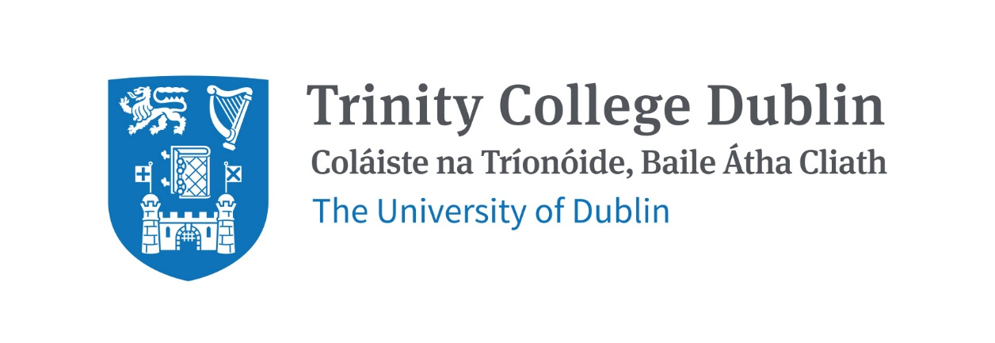

Trinity Business School

AUDIT & ASSURANCE

2026/27

MODULE CODE: BUU44670

MODULE NAME: AUDIT & ASSURANCE

ECTS: 5

Lecturer: Cormac Kavanagh

E-mail: KAVANC12@tcd.ie
Office Hours: Online by appointment (use email to arrange appointments)

MODULE DESCRIPTION

Analysis of modern auditing theory and practice, focusing on the application of key auditing procedures and enabling students to appreciate the function, role and reporting requirements of an auditor in providing assurance to users of financial statements.

LEARNING AND TEACHING APPROACH

Lectures that explain theoretical facts along with the use of International Standards of Auditing. Case studies will be used extensively to illustrate the application of theory

MODULE-LEVEL LEARNING OUTCOMES
On successful completion of this module, students should:
- Have an understanding of the audit function and be able to illustrate specific knowledge of key international auditing standards, as used in auditing practice worldwide.
- Demonstrate comprehension of the role, responsibility and duty of the auditor as well as the purpose, benefits and limitations of auditing.
- Assess the importance of ethics in auditing and the independence of the auditor.
- Outline the main steps in the audit process, understand the key pre-audit and planning activites.
- Evaluate and assess audit risk and its constituent components.
- Evaluate control procedures in an internal control system and understand substantive audit procedures performed across key business processes.
- Understand principles underpinning Audit Reporting.

WORKLOAD
Content | Indicative Number of Hours
Lecturing hours | 22
Preparation for lectures | 25
Group assignment | 18
Reading of assigned materials and active reflection on lecture and course content and linkage to personal experiences | 20
Final exam preparation | 40
Total | 125
Content | Indicative Number of Hours

TEXTBOOKS AND REQUIRED RESOURCES

Required core course textbook: All required material will be uploaded to Blackboard.

General Supplemental Readings: Additional technical auditing articles will also be uploaded to Blackboard.

Supplementary resources
Nangle, C.,External Auditing and Assurance: An Irish Textbook, 4th Edition
(2022), Chartered Accountants Ireland.
ACCA Paper, Audit and Assurance (AA), Workbook, (2025), BPP

Student preparation for the module
Students are expected to have read the relevant lecture notes (provided on Blackboard) before each class.

COURSE COMMUNICATION

Please note that all course related email communication must be sent from your official TCD email address. Emails sent from other addresses will not be attended to.

ASSESSMENT
End of Semester One Examination (70%) will be 2 hours in duration; The (30%) assignment will be posted on Blackboard and done at home by students.

Coursework will require students to identify real-world examples of audit failures and include the identification of examples of greenwashing and the economic importance of reliable sustainability reporting.

Reassessment will be 100% exam in the Reassessment period.

MODULE SCHEDULE

Term
Session | Date | Lecture & readings
1 |  | Introduction to Auditing and Assurance
2 |  | The Regulatory Framework
3 |  | Independence and Ethics
4 |  | Review and Reporting  Independent Auditor’s report
5 |  | The Audit Process, Pre-audit Activities and Planning
6 |  | Planning and Risk Assessment
 |  | Reading Week – No lectures
7 |  | Internal Controls (General)
8 |  | Internal Controls (Systems) – Revenue & Receivables,  Bank & Cash, Purchases & Payables,
 |  | Payroll & Inventory.
9 |  | Audit Evidence  - Management Letter, CAATS & Sampling  - Substantive Testing  Testing of Non-current assets
10 |  | Audit Evidence  - Audit of Inventory  - Audit of Revenue & Receivables  - Audit of Purchases & Payables  Audit Bank & Cash
11 |  | Completion Procedures  - Subsequent Events  - Going Concern  - Written representations  - Audit finalisation

Biographical Note:
Cormac Kavanagh FCCA, MSc Finance, CPA is currently Education Lead with Chartered Accountants Ireland. After spending a combined 13 years in Audit Practice and Industry Cormac commenced the pursuit of a full-time academic career in 1995 and continues his active academic engagement. Focused on teaching and lecturing to business students at undergraduate, postgraduate and professional levels Cormac’s teaching experience has been gained in Irish, Chinese and South-East Asian academic institutions. Cormac’s professional accountancy students have secured numerous national and global awards for academic excellence.

