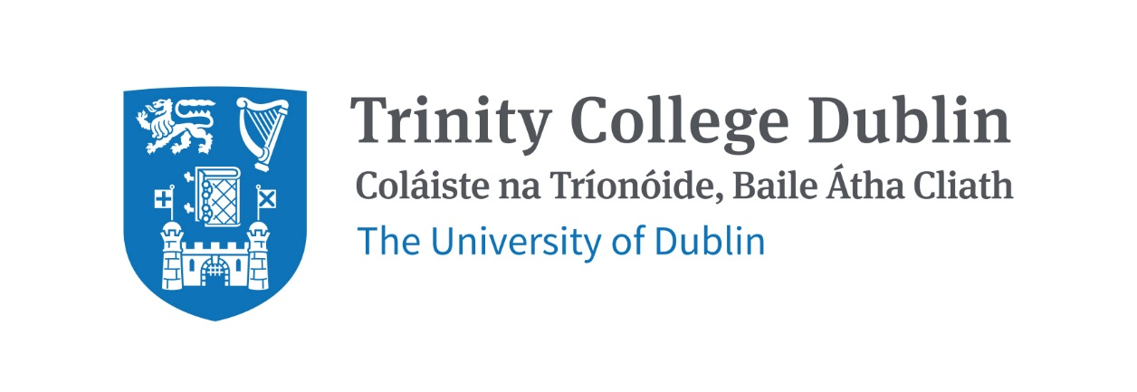

Trinity Business School

Derivatives 2026/27

MODULE CODE: BUU44650

MODULE NAME: Derivatives

ECTS: This course carries 5 ECTS credits.

Lecturer: Niamh Wylie

Phone: 087 4294294

E-mail: nwylie@tcd.ie
Office Hours: Room 224: By appointment, please email me to arrange.

MODULE DESCRIPTION

Derivatives have become extremely popular investment tools over the past 30 years, as they allow investors to tailor the amount and type of risk they take, be it risk associated with changes in interest rates, exchange rates, stock prices, commodity prices, inflation and so on. They are used by institutions as well as investors, sometimes to hedge unwanted risks and sometimes to take on additional risk motivated by views regarding future market movements. This module examines the primary types of derivatives (forwards, futures, options and swaps), shows how they are used to achieve various hedging and speculating objectives and outlines a framework for pricing derivatives. The objective is to provide a good grounding in techniques and approaches for the measurement and management of financial risks.

LEARNING AND TEACHING APPROACH

This module is structured around a series of lectures and tutorials. Lecture slides will be provided in advance of lectures. Students will be provided with practice questions and solutions will be discussed in tutorials.

MODULE-LEVEL LEARNING OUTCOMES
Having completed this module, you should be able to:
- Provide an understanding of derivatives and introduce the analytics of derivative valuation
- Demonstrate how to value forward, futures, swaps and options
- Describe and appraise how derivatives can be used to achieve various hedging and speculative strategies
- Discuss various types of derivatives such as options on stock indices and currencies, futures options and exotic options
- Evaluate previous derivative mishaps and what we can learn from them

WORKLOAD

Content | Indicative Number of Hours
Lecturing hours | 22
Preparation for lectures | 18
Individual mid-semester exam | 25
Group assignment | NA
Reading of assigned materials and active reflection on lecture and course content and linkage to personal experiences | 30
Final exam preparation | 30
Total | 125

TEXTBOOKS AND REQUIRED RESOURCES

Core course textbook:

Hull, J. (2022), Fundamentals of Futures and Options Markets, Ninth Edition, Pearson Education Limited

Reference will be made to additional material throughout the course. Please refer to Blackboard for details.

COURSE COMMUNICATION

Lecture slides, tutorial solutions, relevant journal articles, assessment descriptions, announcements and term results will be posted on Blackboard.

Please note that all course related email communication must be sent from your official TCD email address. Emails sent from other addresses will not be attended to.

ASSESSMENT

Assessment for this course will be as follows:

- Derivatives Mid-Semester Examination (Individual) – 20%

- Final Examination (Individual) – 80%

Note on assessment of students allowed to sit a supplemental exam
Students who fail this module must sit a supplemental examination. The supplemental examination results will account for 100% of the final mark for this module.

MODULE SCHEDULE

Week | Date & Venue | Lecture & readings
1 | TBC | Topic 1: Introduction – Hull, Chapter 1
2 | TBC | Topic 2: Forwards and Futures – Hull, Chapter 2, 3
3 | TBC | Topic 2: Forwards and Futures – Hull, Chapter 5, 6
4 | TBC | Topic 3: Swaps – Hull, Chapter 7, 8
5 | TBC | Topic 4: Options – Hull, Chapter 9, 10
6 | TBC | Topic 4: Options – Hull, Chapter 11 , Guest Speaker
7 | TBC | Reading Week
8 | TBC | Revision Class Test
9 | TBC | In-Class Test, Topic 5: Options Pricing – Hull, Chapter 12
10 | TBC | Topic 6: Options Pricing – Hull, Chapter 13, 15, 16
11 | TBC | Topic 6: Option Greeks – Hull, Chapter 17, Guest Speaker
12 | TBC | Review, Exam Preparation

Biographical Note:

Niamh Wylie is an Assistant Professor in Finance at Trinity Business School and a former investment professional with over 15 years’ experience in financial markets across Dublin and London. Following her degree in actuarial mathematics, Niamh worked in trading, derivatives, and investment management with institutions including IIB Bank, Ulster Bank, Royal Bank of Scotland, and Coutts, where she was a Director, managing portfolios for high net worth clients, investing in a range of assets and derivatives, including equities, bonds, commercial property, commodities, Index funds, Exchange Traded Funds (ETFs), futures, options and option hedging strategies. Niamh has been a guest speaker, TA and lecturer at Trinity College since 2017 in the subjects of Derivatives, Investment Analysis, Introduction to Finance, Fixed Income and Alternative Investments and Money & Banking. Niamh completed her PhD at Trinity Business School in 2024, examining the relationship between unconventional monetary policy and cryptocurrency markets, and she has published in leading international ABS journals. Her research interests include behavioural finance, unconventional monetary policy, traditional and digital asset markets and fostering public trust in institutions. In addition, Niamh has developed highly rated courses in machine learning and financial data analytics. Combining both her academic and industry experience, Niamh brings a practical, real-world perspective to the derivatives module, enhancing student learning and supporting future career prospects in finance.

