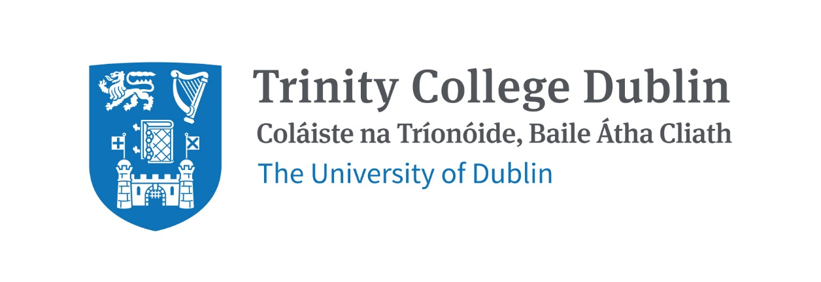

Trinity Business School

International Finance

2026/27

MODULE CODE: BUU44640

MODULE NAME: International Finance

ECTS: 5

Lecturer: Thomas Plunkett

Phone: 086-3265882

E-mail: tplunket@tcd.ie
Office Hours: By email appointment.

Pre- Requisite: Introduction to Finance

MODULE DESCRIPTION

As the international company becomes the norm rather than the exception, the need to
internationalise financial analysis tools is critical. This module is divided into two sections. The first section examines the global financial environment. It analyses exchange rate systems, studies international financial markets and details the theory and evidence on exchange rate
determination. It will also examine the role of capital flows, central bank policy, and emerging market dynamics in shaping global financial conditions.

The second section concentrates on global risk management. The objective is to
provide a good grounding in techniques and approaches for the management of financial risks, with an emphasis on exchange rate risks. This section defines the primary types of derivatives (forwards, futures and options), and illustrates how they are used to achieve various hedging and
speculating objectives to manage international financial risk.
Concluding the module, we will turn our attention to the urgent sustainability challenges
confronting our planet. We will examine the critical role that international companies play in progressing towards and achieving the United Nations' Sustainable Development Goals (SDGs).
LEARNING AND TEACHING APPROACH

This module is structured around a series of lectures, tutorials and additional readings. Tutorials will begin in week 2 of term and you will be assigned to a tutorial group on your portal. Students will be expected to prepare homework in advance of lectures and to contribute to discussions in tutorials. Participation in lectures is enhanced by engaging in polls and quizzes.

MODULE-LEVEL LEARNING OUTCOMES

(NOTE: 5 Learning Outcomes are recommended – with a minimum of 4 and a maximum of 7.)
- Understand the evolution of the current international monetary systems and the
role of the main international financial institutions.
- Critically appraise the extent to which the theories of exchange rate
determination explain exchange rate movements in today's globalised economy.
- Compare, contrast and evaluate the main parity relationships in international
finance.
- Understand the role of derivative instruments in managing international financial
risk, and evaluate alternative approaches to international financial risk
management within the firm.
- Examine the benefits of international portfolio investment vis-a-vis domestic-only diversification.
- Assess global sustainability challenges and the role of international companies in
achieving sustainable development objectives.

RELATION TO DEGREE

This course provides an understanding of the key concepts, theories, and practicalities of
international finance. It is highly relevant for anyone considering a future career in business,
finance, or related areas, particularly in foreign exchange (FX) risk management, due to the
increasingly globalized nature of business, and also asset management, treasury and central banking.

TEXTBOOKS AND REQUIRED RESOURCES
Required core course textbook:
Eiteman, D.K., Stonehill, A.I., &amp; Moffett, M.H. (2021). Multinational Business Finance (15th
ed. Global Edition). Pearson Education.

General Supplemental Readings
A variety of supplemental readings related to each topic will be assigned throughout the course
and posted on Blackboard.

Student preparation for the module
Students will be expected to prepare for lectures by reading the assigned material. Additionally,
they should be prepared to contribute to discussions in tutorials.

COURSE COMMUNICATION
Lecture slides, readings, tutorial questions and answers, and announcements will be posted on
Blackboard.
Please note that all course related email communication must be sent from your official TCD email
address. Emails sent from other addresses will not be attended to.

ASSESSMENT
Assessment for this course will be based as follows:
• 30% Mid-Term Exam
• 70% Final Exam

Students who fail the module will sit a supplemental exam. The supplemental exam will count
for 100% of the grade.

WORKLOAD
Content | Indicative Number of Hours
Lecturing hours | 22
Preparation for lectures | 15
Mid-term exam | 14
Reading of assigned materials and active  reflection on lecture and course content and  linkage to personal experiences | 44
Final exam preparation | 30
Total | 125

MODULE SCHEDULE

Term
Session | Date & Venue | Lecture & readings
1 | TBC | The Global Financial Environment – overview of international finance and globalisation.
2 | TBC | Foreign Exchange Markets & Instruments – how FX markets operate in practice.
3 | TBC | Exchange Rate Determination - What drives exchange rate movements
4 | TBC | International Parity Conditions – core theoretical relationships including CIP, UIP, PPP and Fisher
5 | TBC | Mid-Term Review – ahead of examination
6 | TBC | Foreign Exchange Risk Exposure - understanding exposure in multinational firms
7 | TBC | Hedging with Forwards and Futures - managing FX risk using linear derivatives
8 | TBC | Options and Advanced Hedging Strategies - managing risk with asymmetric instruments
9 | TBC | International Portfolio Investment - diversification across borders
10 | TBC | Sustainability & Global Finance - finance in the context of global challenges
11 | TBC | Final Review – ahead of examinationde

Biographical Note:
Thomas Plunkett is Designated Person for Investment Management at Prescient Fund Services Ireland, a regulated fund management company, where he is responsible for the oversight of investment managers and fund performance across a range of UCITS and alternative investment structures.

Thomas has over 20 years of experience in the investment industry. He began his career in hedge fund accounting and valuation with IFS (now State Street), and subsequently held similar roles with HSBC, Citi, and Citco. He later held the position of Head of Investment at Generali (now Utmost), with responsibility for investment oversight and strategy.

Thomas holds a BSc in Economics and Finance from University College Dublin and is both CIMA and CFA qualified. He is a member of the Board of CFA Society Ireland and chairs the Develop Future Professionals Committee.

