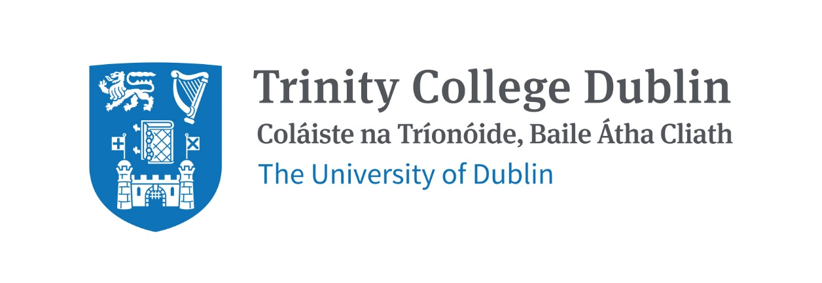

Trinity Business School

ECONOMIC POLICY AND BUSINESS HISTORY

2026/27

MODULE CODE: BUU44630

MODULE NAME: ECONOMIC POLICY AND BUSINESS HISTORY

ECTS: 20

Lecturer: Dr Emmet Oliver, BA, MA, Dip Corp Gov, PhD.

Phone: NA

E-mail: oliverem@tcd.ie
Office Hours: By appointment

Pre- Requisite:

Not available to exchange Students.

MODULE DESCRIPTION

This course provides students with a broad overview of the business history of Ireland and Europe from the inter-war period right through to 21st century and todays world of tariffs and economic nationalism. It will closely examine the historical structural transformation of Western economies, from manufacturing and industrial-based economies to todays services-led economic models. In an Irish context it will also examine the emergence of the ‘Celtic Tiger’ economy, plus subsequent economic crash, and the rise of the multinational sector. Various economic policies, technological developments and world conditions that drove developments in Irish and Europe business will be studied. It concentrates strongly on the idea of ‘transition’- the transition from free trade, to protectionism, to inward investment and now to decarbonisation and how these changes impact firms/sectors.

Students will be allocated a sector on which they will write a major research project analysing the characteristics, evolution, strategies, and major firms present in their allocated sector. Their source materials can come from back issues of newspapers, government reports, visits to company/national archives, national library, books, online sources and occasionally family and friends. Much of the material is non-digitised and has to be extracted, using research skills and the student’s judgement. Particularly important in the project is interpretation of the historical ‘traces’ the student locates and using this material to create a compelling narrative.

Students will have some choice over the sector on which their research will be conducted, but the project will be situated within the services segment of the economy, not manufacturing. There is no international consensus on what constitutes ‘services or the tertiary sector, but the United Nations, International Standard Industrial Classification (ISIC) is used by the majority of countries around the world as their national activity classification. Based on the ISIC, sectors that fall within the research project will be: retail (including wholesale/storage), transportation (trains, buses, aviation and aircraft leasing), hospitality (including hotels, restaurants, pubs) and tourism, information and communication technology and media, financial services (banks and building societies), real estate, professional services (accountancy, architecture, law, engineering), arts/entertainment, personal services (domestic service, hairdressing, dentistry, doctors) and construction. However students, in consultation with the lecturer, can suggest sectors outside these areas, where this is feasible and sufficient historical data is available.

LEARNING AND TEACHING APPROACH

MODULE-LEVEL LEARNING OUTCOMES
- Identify the key national and international developments that impact the evolution of particular sectors of the economy.
- Understand the critical economic policies that impact an economy and how they influence the evolution of firms and industries.
- Understand the key economic theories, models and frameworks that explain how economies grow and develop, and how this impacts the services economy, but also manufacturing.
- Apply key interpretative research skills, including historical approaches, to research material across sectors and time periods.
- Analyse how different firms maximise the benefits or minimise the costs of changes in economic policy and technology and in the legal, political, national and global economic environments.
- Communicate key facts and theoretical contributions succinctly and with precision by displaying strong writing skills.
RELATION TO DEGREE

WORKLOAD
Content | Indicative Number of Hours
Lecturing hours | 44
Preparation for lectures | 10
Individual assignment | 300
In-class assignments prep | 40
Reading of assigned materials and active reflection on lecture and course content and linkage to personal experiences | 70
Visual Aid gathering | 8
Total | 472

TEXTBOOKS AND REQUIRED RESOURCES

Required core course textbooks:

Cormac Ó’Grada, Rocky Road- The Irish Economy Since the 1920s (Manchester University Press).

Emmet Oliver, Irish Nation Building Government, Business and Power, 1922–1958 (Palgrave MacMillan).

General Supplemental Readings

Andy Bielenberg, Ray Ryan, An Economic History of Ireland Since Independence (Routledge)

Frank Barry, Industry and Policy, Independent Ireland, 1922-1972 (Oxford).

Student preparation for the module

Students should, as soon as practical, borrow or purchase a copy of the core readings above and begin their reading. Students would ideally also keep up to date on current events, via the Financial Times or similar, accessible via TCD Library, as much of the course, while historical in nature, will also reflect contemporary economic developments.

COURSE COMMUNICATION

Blackboard and email. Please note that all course related email communication must be sent from your official TCD email address. Emails sent from other addresses will not be attended to.

ASSESSMENT
60% of the course mark is available to be awarded for the major research project and the remaining 40% will be awarded for an in-class test at the end of academic term. This will be an hour long and test students on the lecture material itself, testing students retrieval and analytical skills, whereas the research project will test their research and interpretive skills. Students will also be asked to snap a visual ‘ghost sign’ aid in semester one, using their phone. This will not be graded, but students are asked to complete this small project as part of the broader learning on the course.

The major research project will be due for submission at the end of the teaching year, in April 2027. Students will be offered a selection of sectors to research, with the periodisation involved stretching from (early) 1922 to 1958 and (late) 1958 to 2006. Students submit a draft/early ideas in December, to which the lecturer will provide some feedback. In summary the assessment is a two-part structure:

- End of year in-class test (40%)
- Capstone research project (60%)

Session | Date & Venue | Lecture & Readings
Michaelmas Term | Week of Sept 15  First Lecture  Room: (TBC) | - Introduction to course topic and course requirements.  - Brief overview of Irish industrial history from independence to the present time.  - Guide to project. Grading guidelines etc.  - Identification of sectors upon which students may choose to conduct their research
Hilary Term | Week of Jan 19th  First Lecture  Room: (TBC) | - Breakdown of sectors, exploration of post-WW2 economy.  - Early draft submission of project- return of first comments.  - Move into economic downturns of the 1970s/1980s.  - Exploration of transition to decarbonisation of economy.  - End of year test in class

INDICATIVE MODULE SCHEDULE

Lecture 1 | Intro: what you can expect, plus what is expected of you; brief overview of Irish and Europe economic/business history, from Act of Union to collapse of Celtic Tiger and subsequent recovery; key themes; what we know; don’t know.
2 | Services Economy- Definitions, causes of services transition, tradeability, productivity, measurement.
3 | Business-government relations theories. Services implications
4 | Pre-independence Irish business establishment- The Anglo-Irish model
5 | Decline of laissez-faire system to rise of regulated markets
6 | 1932-1948 economic policy, manufacturing
7 | 1948-1973 economic policy manufacturing
8 | Retail and trade in Ireland and Europe; 19th and 20th century
9 | Financial services; property and construction in Ireland and Europe
10 | Personal and professional services, hospitality, leisure & entertainment
11 | Transport, Information and communication technology/
12 | War economy, economic dirigisme, self sufficiency.
13 | The ‘dark 50s’: fiscal errors and immigration boats.
14 | Economic Development- Les Trente Glorieuses in Europe, the Whitaker Lemass era/opening up
15 | Northern Ireland- An economy divided.
16 | The 70s- Oil, inflation and death of the Philips Curve
17 | 1980s- Fiscal consolidation, IFSC, and the birth of the Celtic Tiger
18 | Rise and fall of the Tiger; The Decarbonisation Era, Covid years, Trump.
19 | End of Year In-Class Test

Biographical Note:

LECTURER:

Dr Emmet Oliver, BA, MA, Dip Corp Guv, PhD, is a business historian, lecturer and doctoral graduate of the School of Business, Trinity College. Emmet’s research area is the history of Ireland’s services economy from independence onwards, with a particular focus on Government economic and industrial policy. Emmet has previously worked in several areas of the Irish economy, including at IDA Ireland, the Irish Government’s inward investment agency, where he was a member of the management committee. He has also worked in the pharmaceutical sector. Emmet worked as a financial and economic journalist with The Irish Times, Bloomberg and Independent.ie, and as Editor of the Business Post. Emmet has also lectured at Dublin City University and UCD Quinn School. Emmet has also holds qualifications in corporate governance and Modern Irish History. He is the author of Irish Nation Building Government, Business and Power, 1922–1958 (Palgrave Macmillan) and was short listed for the Coleman Prize for this PhD on government-business relations in independent Ireland by the Association of Business Historians in 2025.

