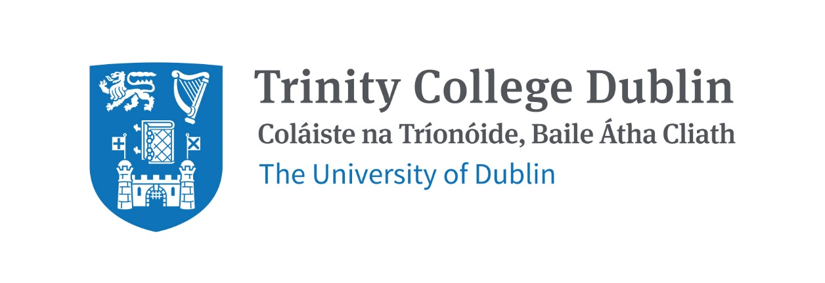

Trinity Business School

Advances in Marketing Theory and Practice 2026/27

MODULE CODE: BUU44551

MODULE NAME: Advances in Marketing Theory and Practice

ECTS: This course carries 5 ECTS credits.

Lecturer: Dr Radu Dimitriu and Dr Ronika Chakrabarti

E-mail: radu.dimitriu@tcd.ie // ronika.chakrabarti@tcd.ie

Phone
Office Hours: By appointment

MODULE DESCRIPTION

This module covers a variety of topical marketing issues including understanding and acting on customer journeys, delivering consumer value, branding, sensorial marketing, marketing at the base of the pyramid and in emerging markets, or pricing. The course also centres you in the contemporary marketing challenges and introduces you to the high-level real-world issues to the forefront of marketing practice. The module is designed for students who enjoy reading and applying marketing theory and frameworks to real-life case studies and situations. Students are encouraged to present their ideas on a continuous basis, and to get involved in class and tutorial discussions and debates.

LEARNING AND TEACHING APPROACH

The module consists of lectures and tutorials arranged as follows:
- Lecture times and venue: TBC
- Tutorials times and venue: TBC
Tutorial Dates: TBC

The first lecture of the semester sets out the expectations, assessment and logistics of the module. Subsequently, each lecture introduces and debates a current topic in marketing theory and practice, as detailed in the outline below. Material for each lecture (e.g., readings, recordings and portfolio task requirements/case studies) will be made available before each lecture, via Blackboard. Students must cover the material for each lecture in advance, and come prepared to contribute to class discussions. The on campus, face-to-face, lectures will have an interactive format, with discussions focusing on clarifying concepts from the lecture material. Students are also encouraged to discuss their planned work for the portfolio task assignments.

Later, the tutorials will give students and their teams the chance to present their (closer to completion) portfolio task work with the Teaching Assistant. Please make sure to come well-prepared, and be ready to ask specific questions. It is expected that you have done the work in advance, and that you are prepared to have thoughtful and informed conversation with the TA on the assigned themes. For some of the Monday tutorials (please see below) the discussion will centre on assigned case studies, rather than on portfolio assignments; please make sure to prepare these case studies for discussion at the respective tutorials.

MODULE-LEVEL LEARNING OUTCOMES
Having successfully completed this module, the student should be able to:

- Acknowledge and use the different levers that marketers have in their repertoires;
- Demonstrate the application of marketing theories and frameworks in front of colleagues and lecturers;
- Understand and act on consumers’ behavioural drivers and on their decision journeys;
- Analyse and critique companies’ current marketing practices and strategies, including from an ethics and sustainability standpoint;
- Advise on appropriate marketing strategies to create customer value;
- Discern the extent to which marketing theories, principles and tools can be applied in an environment becoming more and more digitalized;
- Work and communicate effectively as part of a diverse-background team to conduct marketing research and apply marketing frameworks and tools.

RELATION TO DEGREE

The module aims to develop your capability to understand, criticize and develop marketing activities and strategies. True marketers place customers at the forefront of their efforts and aim to deliver better customer value than competitors do. Along with other business disciplines taught in your degree, the module contributes to your development as an all-rounded business student who acknowledges the importance of marketing and digital marketing for delivering successful business strategies.
WORKLOAD
Content | Indicative Number of Hours
Lecturing hours | 22 lecture hours + 8 tutorial hours / semester
Preparation for lectures | 26 hours / semester
Individual assignment | 40 hours / semester
Group assignment | 32 hours /semester
Reading of assigned materials and active reflection on lecture and course content and linkage to personal experiences | 22 hours / semester
Final exam preparation | -
Total | 150 hours / semester*

TEXTBOOKS AND REQUIRED RESOURCES

Required core course textbook:
N/A

General Supplemental Readings

- Marketing Management, by Philip Kotler, Kevin Keller, Mairead Brady, Malcolm Goodman, Torben Hansen, 5th European edition, Person, 2024.
- Strategic Brand Management, by Kevin Lane Keller, 4th edition, Pearson, 2013.

Student preparation for the module

To prepare for lectures, students will be required read the articles and documents posted on Blackboard. To prepare for and participate in the tutorials, students will be required to carefully read the portfolio tasks and case studies, as well as be ready to present their solutions in class together with the teammates.

COURSE COMMUNICATION

Please note that all course related email communication must be sent from your official TCD email address. Emails sent from other addresses will not be attended to.

Communication from the teaching team will be sent via Blackboard, and via email from the following e-mail addresses: radu.dimitriu@tcd.ie & ronika.chakrabarti@tcd.ie

ASSESSMENT

Assessment will be based on the following components:

- Continuous assessment (including participation), as group work - 50%
  - Students working in teams will be required to deliver 4 out of the 5 portfolio tasks during the semester. Only the first 4 submitted tasks during the semester will be graded. The requirements for each portfolio task will be shared before lectures, and the student group work on the portfolio tasks will be debated during the online tutorials. The groups will then submit their portfolio task work after the respective tutorials, to count toward the overall portfolio.
  - Some tutorials will consist of tasks (such as providing solutions to case studies) which do not formally count toward the portfolio mark; however, students teams are encouraged to present their work and solutions in class during such tutorials, as active participation will provide student teams with a chance to increase the mark they receive for their portfolio submissions.

- End-semester essay, as individual work – 50%
  - Students will be required to deliver a maximum 1,500 (minimum 1,200) word individual essay on a focussed angle of a topic covered during the semester.

Supplemental assessment

Students who fail the course will be required the deliver a maximum 3,000 (minimum 2,500) word essay on a topic advised by the module leader, counting for 100% of marks
MODULE SCHEDULE

Lectures take place on the dates and at the places specified below. Changes will be communicated in class and/or posted as early as feasible on the course intranet site.

1 | TBC | - Course introduction + Marketing strategy at the base of the pyramid and subsistence marketplaces (part 1)
2 | TBC | - Marketing strategy at the base of the pyramid and subsistence marketplaces (part 2)  - Practitioner - Consumer journeys & Innovation strategy
3 | TBC | - Consumer behaviour & decision making. Consumer journeys (cont.)  - Portfolio task 1: map a consumer decision journey + discuss implications (9 Feb ’26)  - No tutorial during reading week and the week after it
4 | TBC | - Consumer communities and marketplaces  - Portfolio task 2: analyse a brand community (16 Feb ’26)
5 | TBC | - Creating & delivering customer value  - Portfolio task 3 – analyse the customer value delivered by a service or product of your choice, and suggest how this value can be improved or updated (23 Feb ’26)
6 | TBC | - Marketing: meeting needs vs. creating needs? Developed and base of the pyramid market perspectives  - Practitioner - Base of the pyramid strategy
7 | TBC | - Branding principles & the consumer psychology of brands  - Discussion of branding case study (16 Mar ’26)
8 | TBC | - Brand Strategy  - Portfolio task 4 build a centrality-distinctiveness map for a market of your choice and discuss strategies (23 Mar ’26)
9 | TBC | - Sensorial branding  - Portfolio task 5 – analyse a brand/offering along sensorial dimensions (30 Mar ’26)
10 | TBC | - Pricing you offer  - Discussion of pricing case study (6 Apr ’26)
11 | TBC | - Semester wrap-up/ in-class discussion of semester essay

Biographical Note:

Radu Dimitriu is Associate Professor in Marketing at Trinity College Dublin, who specializes in consumer behaviour and psychology. In recent years, his research has focused on how consumer respond to technology, including AI-enabled technologies such as chatbots and autonomous products, or to sensory-enabling technologies in VR (virtual reality). Other areas of interest are branding, social media marketing, and CSR and consumer prosocial behaviour. His has published in top-tier international journals including Psychology & Marketing, International Journal of Research in Marketing, Industrial Marketing Management, European Journal of Marketing, Technological Forecasting & Social Change, and Journal of Business Research.

After Radu joined Trinity in 2018, he has held a number of leadership roles, including that MBA Director (Full Time MBA programme), during 2020-2023. He has been teaching on MBA, MSc, BSc and PhD programmes, on subjects including marketing strategy, principles of marketing, branding and experimental methods. Radu completed his PhD in marketing at the Norwegian School of Business BI. Prior to joining Trinity, he worked with Cranfield School of Management in the UK.

His industry experience includes positions in consulting and business analytics. He
speaks several languages including English, Spanish, French, Norwegian, Portuguese
and his mother tongue, Romanian.

Ronika Chakrabarti is an Associate Professor of Marketing. She has been a visiting scholar at Kellogg School of Management, Northwestern University and Cambridge Judge Business School, University of Cambridge. Ronika is deeply interested in research that questions how markets can be shaped in complex environments at the Base of the Pyramid (BoP)/ Subsistence Marketplaces and how interventions are being designed by hybrid organisations to address vulnerable consumers-producers-communities. She has co-chaired international conferences and immersion workshops in Tanzania, India and the United States with the Subsistence Marketplaces Group on addressing marketing and marketplace needs. Further to this, she is working in the area of Sustainability and Business Markets. At Trinity Business School Ronika has taught Marketing Strategy on the Full-time MBA and Executive MBA; Entrepreneurial Scaling on the Flexible Executive MBA and served as the Director of the MSc Marketing. Her work has been published in leading international journals that include, Strategic Entrepreneurship Journal, Journal of Business Research, Industrial Marketing Management and Marketing Theory.
Appendix to the module outline

College policy on plagiarism:

Plagiarism is interpreted by the University as the act of presenting the work of others as one’s own work without acknowledgement, and as such, is considered to be academically fraudulent. The University considers plagiarism to be a major offence and it is subject to the disciplinary procedures of the University.

The University’s full statement is set out in the University Calendar, Part I, “General regulations and information”:
http://www.tcd.ie/about/calendar/pdf/general_information.pdf.

More details can be found at: http://tcd-ie.libguides.com/plagiarism

Note that students’ work will be checked for plagiarism using detection software such as SafeAssign or similar; this software is deployed in a ‘self-regulatory’ fashion, i.e. students can check their own output from the software before final submission to the lecturer, in order to assist students in appropriate academic referencing.

Generative AI Declaration

Students will be required when submitting coursework to make a generative AI declaration to indicate any use of generative AL tools for their projects, explain for which parts of the submission AI software was used, and how it helped improve the learning process within the University’s ethical guidelines.

Academic integrity

All students taking this module are assumed to accept and abide by the University’s statement on integrity

