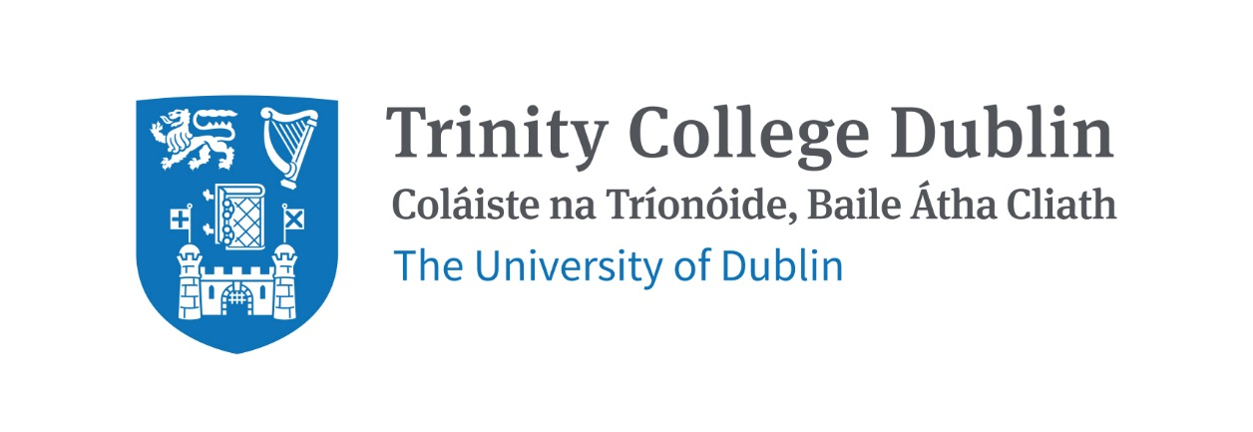

Trinity Business School

Financial Reporting and Analysis I 2026/27

MODULE CODE: BUU44531

MODULE NAME: Financial Reporting and Analysis I

ECTS: 5 ECTS

Lecturer: Niamh Lynch

E-mail: nlynch6@tcd.ie
Office Hours: By appointment (use email to arrange appointments)

Pre- Requisite: BUU33531 Financial Accounting I / BUU33532 Financial Accounting II

Available to Exchange students: Yes

MODULE DESCRIPTION
This module seeks to build on previous exposure to financial accounting concepts introduced in BUU33531/BUU33532 Financial Accounting I and II, and techniques providing a more rigorous and expanded framework in the preparation and analysis of financial statements. It emphasises the major elements of measurement, recognition, and disclosure in contemporary financial reporting. Financial statements will be considered across a variety of business scenarios. The module highlights the emergence of the global dimension of financial reporting through the adoption of international accounting standards. It also deals with selected complex standards, in particular those dealing with provisions, income taxes, financial instruments, revenue recognition, and other financial reporting issues. The module also examines current developments in accounting associated with integrated reporting, sustainability/ESG reporting, and ethics.

LEARNING AND TEACHING APPROACH
Classes will involve a mixture of lectures, discussions, examples, and questions. We will review scenarios, compare theory to real life, and from the knowledge and skills you learn prepare financial statements based on international accounting standards. Question packs have been assigned for each topic, and students are encouraged to do these. Accounting is an applied field and thus best approached by practicing the applications.

MODULE-LEVEL LEARNING OUTCOMES
- Possess a detailed knowledge of the regulatory and conceptual frameworks of accounting.
- Construct and analyse financial reports conforming with statutory requirements and international accounting standards.
- Understand, apply, and critique a range of international accounting standards.
- Construct appropriate accounts relating to the measurement and recognition of revenue.
- Critique the ethical consideratiions and current developments in financial reporting (in particular sustainability/ESG reporting requirements).

RELATION TO DEGREE
The module supports a number of the learning outcomes of the overall undergraduate programmes. Specifically, it enables students to:

- Identify, critically evaluate and synthesise the substantive theories, frameworks and models, both qualitative and quantitative, that are used in fields of enquiry related to business, management and the social sciences.
- Analyse and solve a variety of problems in the private and public sectors from a multi-disciplinary knowledge basis of theories, tools and techniques in business and the social sciences.
- Communicate effectively in oral and written modes in professional and academic settings.
- Apply knowledge and understanding of the social and ethical dimensions of management and research in both the public and private sectors of society and to apply this knowledge effectively in management and research contexts.
- Work effectively as an individual and in teams.
- Demonstrate the ability to engage productively with a changing social, cultural, and technological environment.

WORKLOAD
Content | Indicative Number of Hours
Lecturing hours | 22
Preparation for lectures | 33
Group assignment | 15
Reading of assigned materials and active reflection on lecture and course content and linkage to personal experiences | 15
Final exam preparation | 40
Total | 125

TEXTBOOKS AND REQUIRED RESOURCES

Required core course textbook:
- Melville (2025), International Financial Reporting, 9th edition. The 8th edition of the book is also fine.

General Supplemental Readings
- Alexander et al (2023), International Financial Reporting & Analysis, 9th Edition
- Elliott and Elliott (2022), Financial Accounting and Reporting, 20th Edition
- Connolly (2023), International Financial Accounting and Reporting, 6th Edition (Revised)
- Professional journals: Accountancy Ireland (Chartered Accountants Ireland) / Accounting and Business (ACCA) / Financial Management (CIMA)
- Useful websites for keeping up to date with current developments: Iasplus.com / Cruncher.ie / Ethicsboard.org
- Useful websites for honing your skills: Accountingcoach.com / IFRSBox.com
- Podcasts: PwC IFRS Talks / Accountancy Ireland

Student preparation for the module
Students are expected to have read the relevant chapters and lecture notes (provided on Blackboard) before each class.

COURSE COMMUNICATION
Administrative information and relevant changes (e.g., dates, times, venues, group membership, deadlines, etc.) will be posted on the course Blackboard page. Students taking this course are responsible for:
- checking their college email regularly
- checking the course Blackboard page regularly
- ensuring that they have access to the course Blackboard page.

Please note that all course related email communication must be sent from your official TCD email address. Emails sent from other addresses will not be attended to.

ASSESSMENT
- Annual report project [30%]: Groups (3-5 students) analyse a real-world accounting issue through the lens of the lecture material. Full details provided in due course. Submission in November 2026.
- Examination [70%]: To be taken in December 2026.

Note on assessment of students allowed to sit a supplemental exam: Students who have failed the module and are invited to sit a supplemental exam will be examined by a written exam only. Previous CA (continuous assessment) will not be taken into account in such an examination.

MODULE SCHEDULE

Semester 1 - Michaelmas Term
Topic | Details | Readings (additionally, we will refer to extra readings/podcasts on the lecture notes, which are required unless advised otherwise)
1 | Regulatory framework | Lecture notes, Chapter 1 (Melville)
2 | Conceptual framework | Lecture notes, Chapter 2 (Melville)
3 | Current developments: Integrated reporting, sustainability/ESG reporting, ethics | Lecture notes, Chapters 30 and 31 (Alexander et al.), ethics, CSR, and sustainability reporting
4 | Non-current assets held for sale and discontinued operations | Lecture notes, Chapter 8 (Melville), IFRS 5
5 | Provisions and events after the reporting period | Lecture notes, Chapter 12 (Melville), IAS 10, IAS 37
6 | Income taxes (current tax only) | Lecture notes, Chapter 15 (Melville, pg 243-245), IAS 12
7 | Revenue from contracts with customers | Lecture notes, Chapter 13 (Melville), IFRS 15
8 | Presentation of financial statements | Lecture notes, Chapter 3 (Melville), IAS 1, IFRS 18

Biographical Note:
Niamh is a Teaching Fellow in Accounting at Trinity Business School. Niamh qualified as a Chartered Accountant having completed her training with a Big Four accounting firm. Niamh is an award-winning lecturer and her teaching responsibilities include undergraduate and postgraduate financial reporting modules.`Niamh is currently undertaking her PhD in Accounting and has received awards from both the Irish Accounting and Finance Association (IAFA) and British Accounting and Finance Association (BAFA, Financial Reporting and Business Communications conference) for her research. Niamh holds a first-class honours Bachelor of Business Studies (Specialism in Finance) from Dublin City University and is also a graduate of Trinity’s Postgraduate Diploma in Accounting.

