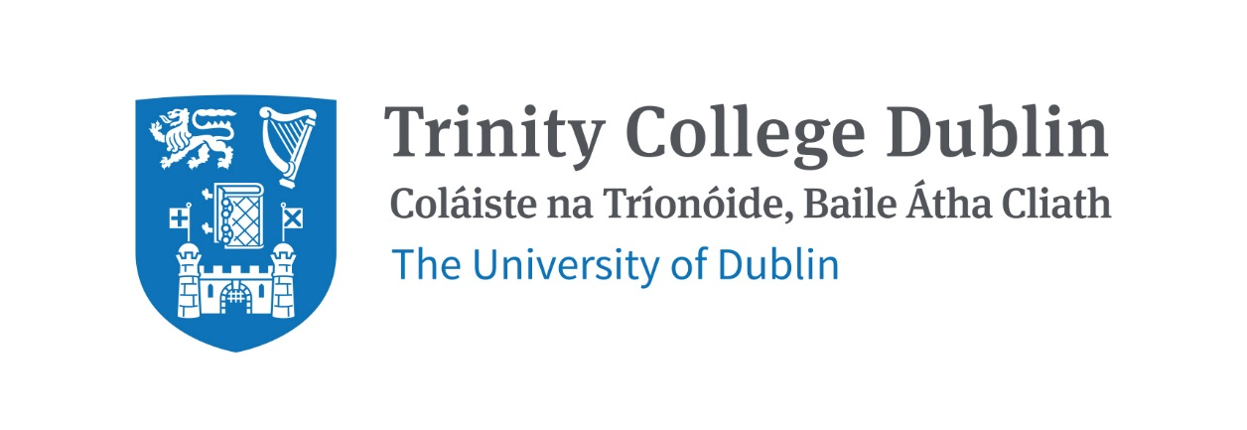

Trinity Business School

Strategic Management Theory & Practice

2026/2027

MODULE CODE: BUU44501
MODULE NAME: Strategic Management Theory & Practice
ECTS: 10 ECTS
Lecturer: Dr Aisling Curley
E-mail: aicurley@tcd.ie
Office Hours: By appointment

Pre- Requisite: None

Available to exchange Students: No

MODULE DESCRIPTION
Strategy aids managers in decision making and taking action by providing a toolbox to enable them to assess their firm in relation to the environment they operate in and therefore make sense out of chaos (Porter, 1983; Ronda-Pupo & Guerras-Martin, 2012).

This module explores strategic management, engaging with theory and practice. It provides an introduction to the application of the core theories/frameworks/models from this multi-disciplinary field. Students will have the opportunity to explore the strategy process and apply strategic management tools. They will practice gathering organisation, industry and macro environment information, analysing data through theories/frameworks/models to develop insights to inform decision making and development of feasible recommendations. A central aim of the module is to develop students’ capacity for informed strategic decision-making.

Activities are at the core of strategic advantage: firm’s decisions in regard to how and which activities are done, and ‘fit among activities’ matters, as strategic advantage is the output of the totality of a firm’s activities (Porter, 1996:77). Successful strategies emerge from ongoing cohesion between a firm’s activities, resources and the wider environment.

LEARNING AND TEACHING APPROACH
Lectures will comprise lecture components, along with individual and small group activities and discussions, designed to enable students to develop the knowledge and skills to apply strategic management learning in real world organisations.
There will be 2-hour in person classes weekly, along with five 1-hour tutorials in each semester.
Students are expected to prepare for each lecture and tutorial, to participate effectively.
The classes and tutorials will introduce module content and provide opportunities to practice strategic management and encourage development of valuable transferrable skills.
The student is responsible for the quality of learning that they achieve.

MODULE-LEVEL LEARNING OUTCOMES

Having completed this module, the student should be able to:
- Explain and evaluate core strategic management theories, frameworks, concepts and process
- Collate sufficient data and literature to inform strategic analysis for organizations
- Apply Core Strategic Management theories to organisations and industries to produce strategic analysis
- Leverage Analysis to diagnose key challenges/opportunities and develop insights and feasible recommendations for organisations
- Collaborate with team members to create and communicate effective strategic management analysis and insights

RELATION TO DEGREE

Strategic Management builds on learning from business modules studied throughout your degree.
Students are expected to showcase their understanding of Strategic Management course material and related disciplines, their research, analytical and systems thinking skills in the assignments and exam. Students will develop and demonstrate their ability to work in teams and independently, take responsibility, and communicate effectively. These are skills that are highly desirable as employees and for further advanced study.

This module aims to enable students to develop the ability to take a holistic perspective, make informed decisions under conditions of uncertainty to enable organisations to operate successfully and sustainably.

WORKLOAD

This 10-credit course runs across the two semesters during 2026-2027. The total workload comprises 250-hours. This will include attending lectures and tutorials, preparing for lectures, and tutorials, preparing for and completing assignments and an exam etc.
Content | Indicative Number of Hours
Lecturing hours | 40
Tutorials | 10
Preparation for Lectures and Tutorials and Reflection etc. | 105
Group assignment | 45
Final exam preparation | 50
Total | 250

TEXTBOOKS AND REQUIRED RESOURCES

Required core course textbook Exploring Strategy: Text & Cases, 14th Edition, 2026, by Whittington, Regnér, Angwin, Hautz, Johnson and Scholes. Published by Pearson
- Printed and Online copies will be available via the Trinity College Library

General Supplemental Readings
Other strategy books, supplementary readings, videos and podcasts will be suggested and/or assigned as the module progresses. All of these will generally be available via the library, online or provided via Blackboard.

Student preparation for the module
Students will be expected to read the core text and read/watch/listen to supplementary article readings/videos/podcasts and other tasks assigned in advance of lectures. Students are expected to contribute to class tasks and discussions during lectures and tutorials.

COURSE COMMUNICATION
Lecture slides and readings etc., assignment descriptions and announcements will be posted on Blackboard.

Please note that all course related email communication must be sent from your official TCD email address. Emails sent from other addresses will not be attended to.

ASSESSMENT
The assessment for this course is split between 2 Team Assignments and 1 Exam. The breakdown is as follows:

 | Assignment | % Grade | Date/Deadline
1 | Team Case Study (S1) | 20% | TBC
2 | Team Case Study (S2) | 20% | TBC
3 | Exam [Online in Class during term time S2] | 60% | TBC
A penalty of 5% per day or part thereof will be applied to late assignments.
Use of AI is permitted for assignments, but students must demonstrate significant own contribution to the assignment, this is what is graded. Students are not awarded credit for work produced by AI.
Assignment submissions must include the prescribed Assignment Cover Sheet which includes a declaration re AI use. AI use is not permitted in the exam.
Peer Evaluation will influence the grades of individual students for Team Assignments

Reassessment
In the event of a student/team failing the team assignments, there is no opportunity to resubmit. If a student fails the module or misses the exam for medical reasons a supplementary exam will be scheduled during the reassessment period as per the calendar. The supplementary exam will account for 100% of the module grade.

Attendance at lectures and tutorials is required, any student who attends less than two thirds of lectures and tutorials may be deemed non-satisfactory as per college regulations and may not be allowed to sit the final exam.

https://www.tcd.ie/undergraduate-studies/academic-progress/attendance-course-work.php

MODULE SCHEDULE - TBC

Term
Session | Date | Topic | Lecture & readings
1
2
3
4
5
6
Reading Week
8
9
10
11
12

Biographical Note:
Aisling Curley holds a PhD in Strategic Management and a BSc (hons) in Business and Information Technology, both from Trinity College Dublin. Her research engages with the intersections between Strategic Management, Industry Evolution and Digital Technology. She has over 20 years’ experience in the investment management industry.

