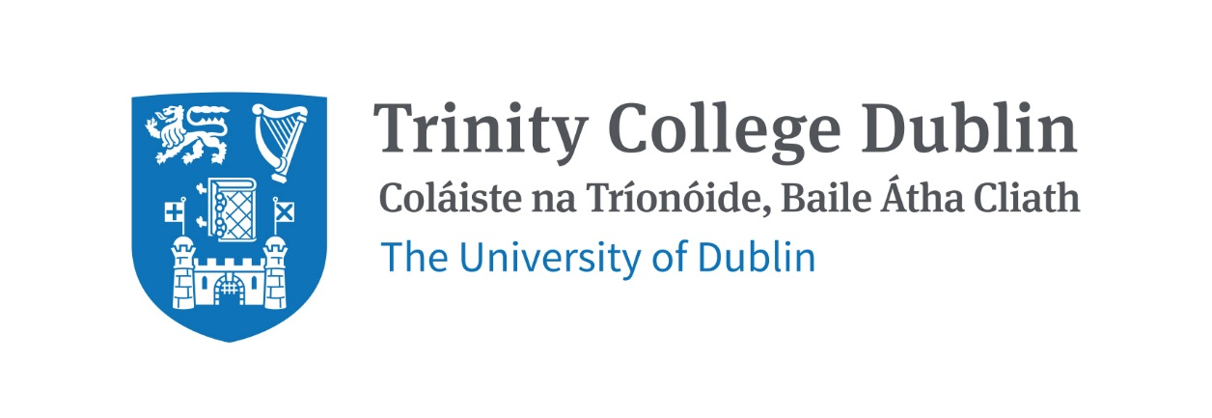

Trinity Business School

QUALITATIVE RESEARCH METHODS

2026/27
Module Outline
(Provisional: subject to minor amendments)

MODULE CODE: BUU22593

MODULE NAME: QUALITATIVE RESEARCH METHODS
ECTS: 5

Lecturer: David Horan

Teaching Assistant: Lindiwe Mpofu

Phone: +35318968052

E-mails: horand3@tcd.ie
Lectures: 10-11am, Thursdays; Friday 5-6pm Semester 1.
Classes commence in Week 4 (on 17 September).
Venue: Tbc
Tutorials: To be held in weeks 6, 11-15. Further details will follow
Office Hours: Thursdays 2-3pm. Room B215 (Trinity Business School).
Pre-Requisites: None

MODULE DESCRIPTION
This module introduces students to the area of qualitative research. As opposed to quantitative research, with a focus on numbers, with qualitative research the focus is on text, and geared towards understanding social and cultural phenomena. Instead of mathematical modelling and statistical analysis, qualitative research employs research methods such as action research, case study research, ethnography and grounded theory. The module will explore research design and selected research methods, underlying assumptions and ethical principles related to research as well as data collection and data analysis techniques. Examples from business and management and the sustainability literature will be discussed in class.

LEARNING AND TEACHING APPROACH
The approach in this module is primarily face-to-face. It is expected that students should complete the relevant pre-reading and engage actively in class discussions and group activities. Tutorials will also take place at scheduled times.

MODULE-LEVEL LEARNING OUTCOMES
Having completed this module, you should be able to:
- Explain the difference between qualitative and quantitative research;
- Develop a basic qualitative research proposal;
- Explain the underlying assumptions and ethical principles related to research;
- Apply – at a basic level – four distinct qualitative research methods; and
- Explain – at a basic level – approaches to data collection and data analysis.

RELATION TO DEGREE
This module forms part of a suite of modules of Trinity Business School across the four years of our business-related degree programmes. This module is focused on developing qualitative skills that will enable the development of technically capable and conceptually proficient graduates who can thrive in a dynamic and fast-changing environment. The module will serve to develop students’ understanding and skills in relation to qualitative research and will serve as a foundation for possible qualitative research projects at a postgraduate level.

WORKLOAD

This is a 5-credit module that requires 125 hours of study. These hours include reading of assigned materials, watching video material, attending online lectures, participating in online discussions, working on assignments and writing the final exam.

Content | Indicative Number of Hours
Preparation for lectures (including reading of assigned materials and active reflection on module content) | 29
Lecturing hours | 24
Preparation for MCQ assessment | 36
Preparation for essay assessment | 36
Total | 125

Tutorials will take place in a select number of weeks (five or six) throughout the semester. Students will be pre-assigned to a tutorial group. The content of tutorials will focus on teaching students vital practical skills required for doing qualitative research, including instruction in relevant software programs (e.g., NVivo). Tutorial content will build on the lecture content and the TA’s background and knowledge/skills in qualitative research.

TEXTBOOK AND REQUIRED RESOURCES

Required core course textbook:

Myers, M.D. (2019). Qualitative Research in Business & Management. Sage.
Amazon link

Supplemental Readings:

Saunders, M., Lewis, P., & Thornhill, A. (2019). Research methods for business students. Pearson education.

Bell, E., Harley, B., & Bryman, A. (2022). Business research methods. Oxford university press.

Palmer, D., Dick, B., & Freiburger, N. (2009). Rigor and Relevance in Organization Studies. Journal of Management Inquiry, 18(4), 265-272. Available at https://journals.sagepub.com/stoken/rbtfl/0QYNQJXU7INORYI7F9XHY9/pdf/10.1177/1056492609343491

COURSE COMMUNICATION

Please note that all course related email communication must be sent from your official TCD email address. Emails sent from other addresses will not be attended to.

ASSESSMENT

Assessment in this module will comprise two elements:

- MCQ test (30% of the overall grade) that will examine the complete content covered throughout this module.
- End of term exam (70% of the overall grade) that will examine specific topics covered in this module in more detail.

Further information on the assessment will follow.

Note on assessment of students allowed to sit a supplemental exam
Re-assessment involves retaking a 100% exam. Students who do not obtain an overall pass mark for this module (40%), will have the opportunity to be reassessed by a re-take exam (weighted at 100% )

Attendance at lectures and tutorials is required, any student who attends less than two thirds of lectures and tutorials may be deemed non-satisfactory as per college regulations and may not be allowed to sit the final exam.
https://www.tcd.ie/undergraduate-studies/academic-progress/attendance-course-work.php

MODULE SCHEDULE

Michaelmas Term
Week | Date | Lecture & readings
4 | 17, 18 September, 2026 | Overview of qualitative research  This unit will address the purpose and benefits of qualitative research, and explain the differences between quantitative and qualitative research. The concept of triangulation will also be discussed.  Preparation: Myers, Chapters 1 and 2
5 | 24, 25 September, 2026 | Research design and philosophical perspectives  This unit will explore the essential features of a qualitative research design, and explain the components of a research proposal. It will also explore the underlying assumptions in research, and discuss the differences between positivist, interpretive and critical research.  Preparation: Myers, Chapters 3 and 4
6 | 1, 2 October, 2026 | Research ethics  This unit will introduce the important ethical principles related to research, and explain ethical dilemmas that can arise in the practice of research. Particular attention will be given to plagiarism.  Preparation: Myers, Chapter 5  Guest Speaker Friday 5-6pm: Subject Librarian for Business, Dr. David MacNaughton (Trinity).  Tutorial (1) will be held this week: “Conducting Literature Reviews”
7 | 8, 9 October, 2026 | Case study research  This unit provides an overview of case study research.  Preparation: Myers, Chapter 7  Guest Speaker Friday 5-6pm, Dr. Aisling Curley, Trinity Business School.
8 | 15, 16 October, 2026 | Ethnographic research  This unit provides an overview of ethnographic research.  Preparation: Myers, Chapter 8  Guest Speaker Friday 5-6pm, Dr. Declan Cahill, Trinity Business School.
9 | 22, 23 October, 2026 | Action research  This unit provides an overview of action research.  Preparation: Myers, Chapter 6  Guest Speaker Friday 5-6pm: Prof. David Coghlan, Trinity Business School.
10 |  | Study/Review
11 | 5, 6 November, 2026 | Online research  This unit provides an overview of qualitative research using internet resources.  Preparation: Read Whitling R., Pritchard, K. (2021) “Collecting Qualitative Data Using Digital Methods for Business and Management Students”, Sage. Chapters 1,2,4,5.  Guest Speaker Friday 5-6pm: Dr. Ayushi Tandon, Trinity Business School.  Tutorial (2) will be held this week “The Ethics Approval Process”
12 | 12, 13 November, 2026 | Data collection  This unit introduces qualitative data collection techniques: interviews, participant observation/fieldwork and the use of documents.  Preparation: Myers, Chapters 10, 11 and 12.  Tutorial (3) will be held this week. “Survey and Interview Techniques”
13 | 19, 20 November, 2026 | Data Analysis 1  This unit provides an overview of approaches to analyzing and interpreting qualitative data, including coding, thematic analysis, content analysis.  Preparation: Myers, Chapters 13  Tutorial (4) will be held this week. “Thematic Analysis”
14 | 26, 27 November, 2026 | Data analysis 2  This unit provides an overview of approaches to analyzing and interpreting qualitative data, including hermeneutics, semiotics and narrative analysis.  Preparation: Myers, Chapters 14, 15 and 16  Tutorial (5) will be held this week. “NVivo: Using Documents and Content Analysis”  MCQ Test will be held this week during class time.
15 | 3, 4 December, 2026 | Review Class - Writing up your research  This final unit will explore some of the issues associated with writing up and publishing qualitative research.  Preparation: Myers, Chapters 17, 18 and 19  Tutorial (6) will be held this week. “Developing a basic qualitative research proposal”

Biographical Note:

Dr David Horan is an Assistant Professor at Trinity Business School, specialized in governance for sustainable development. At Trinity, his main research interests focus on UN sustainable development agendas, multi-stakeholder implementation, and business actions and cross-sector partnerships for the Sustainable Development Goals (SDGs). Prior to joining the School in Autumn 2022, Dr. Horan was awarded a Marie Curie Fellowship to undertake research and engagement for the SDGs that included a two-year secondment at the UN. He is author of "A New Approach to Partnerships for SDG Transformations" and has been invited to speak on transformative partnerships at UN forums and meetings. He is an Advisor on SDG Partnerships at Stakeholder Forum for a Sustainable Future, an international non-profit in consultative status with the UN Economic and Social Council. His recent publications appear in International Environmental Agreements, Sustainability Science, Global Policy, and The International Journal of Management Education. Dr. Horan is interested in supervising Ph.D. and M.Sc. students in areas of sustainable business such as business SDG strategies, responsible/integrated leadership, cross-sector partnerships and stakeholder theory, engaged research, SDG data and indicators, and sustainability/ESG reporting.

