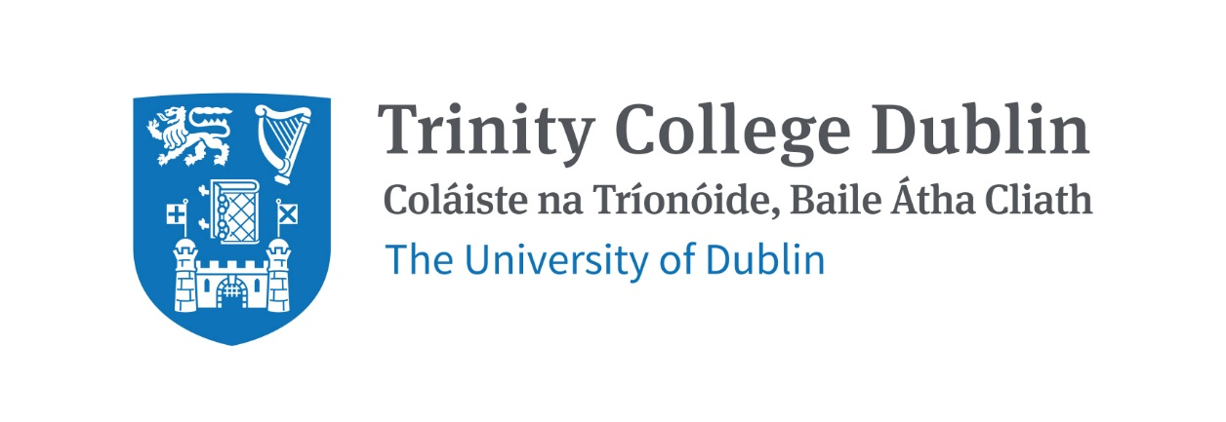

Trinity Business School

Business Ethics 2026/27

MODULE CODE: BUU22580

MODULE NAME: Business Ethics

ECTS: 5 ECTS

Lecturer: Dr. Michael Markunas

E-mail: markunam@tcd.ie
Office Hours: by appointment

MODULE DESCRIPTION

This module considers the source and scope of our moral obligations in business. The first segment of the module involves the high-up questions of whether ethics belongs in the domain of business and what business is for. The second segment of the module considers whether firms themselves have moral responsibilities, the extent of those responsibilities, and whether we should hold them responsible. The third segment considers a variety of other ethical issues when engaging in business, from selling dubious products to whether it’s okay to invest in immoral companies and beyond.

LEARNING AND TEACHING APPROACH

The approach taken involves students doing close readings of recent and innovative texts from a variety of subfields. This is coupled with detailed lectures for background context and distillation of the main ideas as well as time in class for students to become comfortable discussing these challenging ideas together. Papers and examinations offer students further opportunities to consider how these ideas interact and, ultimately, how they feel about them.

LEARNING OUTCOMES

LO1: Become familiar with the essential theoretical approaches to business ethics and the role of the corporation in society.

LO2: Develop an understanding of the views concerning the extent of corporate obligations and the ethics related to other business practices such as paying, selling, buying and investing.

LO3: Develop critical thinking, reading, and writing skills on contemporary issues in business ethics.

LO4: Develop an ability to discuss challenging social and political issues productively with peers.

WORKLOAD
Content | Indicative Number of Hours
Lecturing hours | 2 per week for 11 weeks
Preparation for lectures | 1 per week for 11 weeks
Individual assignments | 20
Reading of assigned materials | 4 per week for 11 weeks
Final exam preparation | 20
Total | 121

TEXTBOOKS AND REQUIRED RESOURCES

Required core course textbook:

There is no textbook required.

General Supplemental Readings

All readings will be provided through Blackboard.

Student preparation for the module

Students should read assigned reading before each class and consider how it connects with readings done before.

Assessment

In-class Term Test – 20%
Final exam – 80%

More detail to follow

Students who fail the module will need to submit a supplemental exam. The supplemental exam will count for 100% of the grade.

Attendance at lectures and tutorials is required, any student who attends less than two thirds of lectures and tutorials may be deemed non-satisfactory as per college regulations and may not be allowed to sit the final exam.
https://www.tcd.ie/undergraduate-studies/academic-progress/attendance-course-work.php

Biographical Note:

Dr. Markunas completed an M.Phil. and PhD in Philosophy at University College London. He did his undergraduate work at UC Berkeley. He is a Fellow of the Higher Education Academy and has taught across a wide range of modules. His research lies at the intersection of business ethics, epistemology, and social ontology. His work has been published in venues such as Synthese, Proceedings of the International Wittgenstein Symposium, The Institute of Philosophy and What to do about now?

