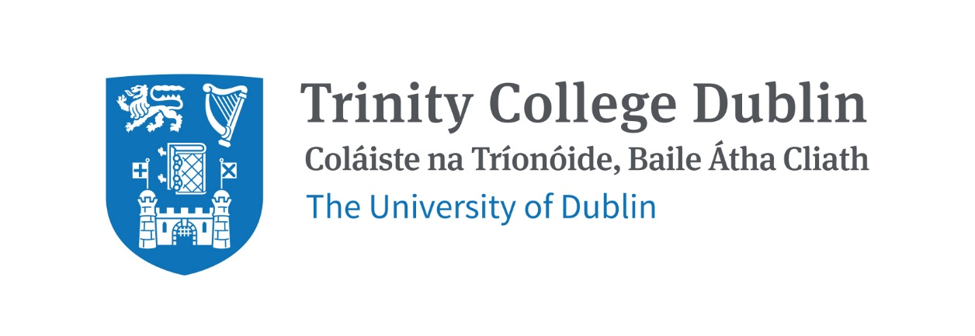

Trinity Business School

Introduction to Operations Management

2026/2027

MODULE CODE: BUU22560
MODULE NAME: Introduction to Operations Management
ECTS: 5
Lecturer: Dr. Annika Mies
E-mail: MiesA@tcd.ie
Office Hours: After class or by appointment (please email to arrange)

Pre- Requisite: none

Available to exchange students: Yes

MODULE DESCRIPTION
This module provides students with the fundamental principles of operations management in both service and manufacturing contexts, exploring key operational functions to meet societal, strategic and operational objectives and transform inputs into value-adding outputs in an efficient and sustainable manner. The module equipts students with knowledge critical to responsible business practice, emphasising the importance of “Getting Things Done” within the interdependence of operational decision-making and sustainability challenges.
LEARNING AND TEACHING APPROACH
The module is delivered through weekly lectures and tutorial sessions that combine conceptual, theory-led input with practical insights and application to real-world case studies. Weekly lectures will focus on key theories and concepts. Weekly tutorials will focus on exercises and case study discussions. Students are expected to read and engage with all course materials and attend all sessions.

MODULE-LEVEL LEARNING OUTCOMES

Having completed this module, the student should be able to:
- Understand and describe the fundamental concepts of operations management and their relevance to organisational performance.
- Apply key operations management tools and frameworks to analyse real-world business scenarios.
- Analyse the relationship between operational decisions and wider economic, environmental, and social implications.
- Evaluate alternative operations strategies in service and manufacturing context using relevant criteria.

RELATION TO DEGREE
Operations lie at the heart of how organisations transform input to create and deliver value. This module supports students in developing a comprehensive understanding of operational processes and the ways in which organisations design and manage systems to deliver value in an effective, responsible, and sustainable manner. It aligns closely with broader themes in business management, including strategic management, product and service design and supply chain management.

WORKLOAD
Content | Indicative Number of Hours
Lecturing hours | 22
Preparation for lectures and tutorials | 22
Tutorials | 11
Additional reading and active reflection on course contents and practice links | 22
Term assessment preparation | 22
Final exam preparation | 22
Total | 121

TEXTBOOKS AND REQUIRED RESOURCES

Required core course textbooks:
Slack, N. Brandon-Jones, A. 2022. Operations Management. Tenth edition. Pearson Education Limited.
We will cover selected sections of the textbook. The respective chapters are indicated in the module schedule. Note: we will not always cover the entire chapters.
There are some physical copies of this edition of the textbook in the college library as well as access to ebook copies: Operations Management, Slack, Nigel | Library Catalogue.
You can also refer to older editions available in the college library. Please note: These differ to some extend in content, structure and examples from the 2022 (10th edition) version that we will be using in the module.

General Supplemental Readings
Further readings and materials will be assigned throughout the course and will be posted on Blackboard.

Student preparation for the module
Students are advised to read or watch the recommended materials after each part of the course and immediately start preparing for the mid-term and end-term assessments. They will also be expected to attend weekly lectures and tutorial sessions and contribute to class discussions and participate in class assignments. Please access materials on Blackboard weekly and read, listen, and engage as required.

COURSE COMMUNICATION
Lecture slides and readings, assignment descriptions and announcements will be posted on Blackboard.

Please note that all course related email communication must be sent from your official TCD email address. Emails sent from other addresses will not be attended to.

ASSESSMENT
The assessment for this course is split between a mid-term assessment and an end-term assessment. The breakdown is as follows:
- Mid-Term Assessment (20%): in-person online exam after reading week
- End-Term Assessment (80%): in-person on-paper exam during assessment period.

There may be optional in-class assignments that allow for gaining extra points. These will be announced in class.

Students who fail the module will need to attend a final in-person on-paper exam. This supplemental assessment will count for 100% of the grade.

Attendance at lectures and tutorials is required, any student who attends less than two thirds of lectures and tutorials may be deemed non-satisfactory as per college regulations and may not be allowed to sit the final exam. https://www.tcd.ie/undergraduate-studies/academic-progress/attendance-course-work.php

No generative AI tools are allowed in the assignments and assessments in this module.

PLAGIARISM
Please note the plagiarism provisions in the General Regulations of the University Calendar for the current year, and make sure you have completed the Online Tutorial on avoiding plagiarism 'Ready, Steady, Write', located at https://libguides.tcd.ie/academic-integrity/ready-steady-write

MODULE SCHEDULE

Term
Session | Date | Topic | Lecture & readings
1 |  | Introduction to Operations Management | Chapter 1
2 |  | Operations Performance, Strategy | Chapters 2 / 3
3 |  | Process Design | Chapter 6
4 |  | Layout and Flow | Chapter 7
5 |  | Process Technology | Chapter 8
6 |  | People in Operations | Chapter 9
Reading Week
8 |  | Planning & Control | Chapter 10
9 |  | Inventory & Supply Chain Management | Chapters 12 / 13
10 |  | Lean Management | Chapters 15 / 16
11 |  | Quality Management | Chapter 17
12 |  | Risk management,  Exam preparation | Chapter 18

Biographical Note:

Annika Mies is an Assistant Professor in Operations Management and Sustainable Systems at Trinity Business School, Trinity College Dublin. She holds a PhD in the field of Sustainability and Operations Management and an MSc in Sustainability Management from the University of Kassel (Germany), and a BA in Business and Cultural Studies from the University of Duisburg-Essen (Germany). Her research is in the field of Sustainable Operations and Supply Chain Management, with a particular interest in social sustainability, unintended consequences and systemic interdependences. She published in leading journals, such as the Journal of Business Ethics and Business Strategy and the Environment. Annika Mies has taught a range of Undergraduate and Postgraduate courses on Sustainability Management, Circular Economy, Sharing Economy, Paradoxes and Unintended Consequences in various contexts, Decision Support Tools and Sustainability in the Digital Workplace.

