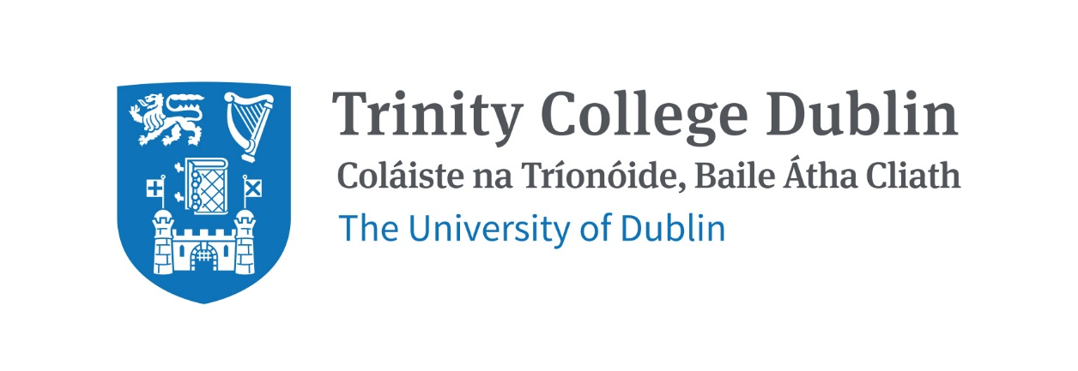

Trinity Business School

Social and Environmental Innovation

2026/2027

MODULE CODE: BUU33804
MODULE NAME: Social and Environmental Innovation
ECTS: 5
Lecturer: Dr Sheila Cannon, Associate Professor of Social Innovation
E-mail: cannonsh@tcd.ie
Office Hours: By appointment

Pre- Requisite: None

Available to exchange Students: Yes

MODULE DESCRIPTION
Social innovation is the process of developing and implementing effective solutions to challenging, systemic societal and environmental issues. The module will critically assess the evidence in support of social innovation and examine origin, theory and practice – local and international - in social entrepreneurship, impact measurement, scaling impact, and social value creation. We will consider the organisational settings that social innovators adopt, including social enterprises, cooperatives, nature based enterprises, social purpose businesses, charities, NGOs, nonprofits, and hybrids. In this course, participants will work with theory, case studies and their own projects to identify how social innovation can respond to and even drive social-economic-political change in the current context.

LEARNING AND TEACHING APPROACH
The approach to teaching and learning will be evidenced based, interactive and learner centred. Firstly, lecture content and concepts will be based on theories and research from peer reviewed publications. Social innovation is an applied social science involving organisations and individuals who claim to make real social change. These claims will be explored and analysed using real world case studies. Students will be encouraged to question and explore the evidence base for any claim or theory. Secondly, interactive and learner centred approaches will engage students in the learning process in a holistic way, encouraging students to draw on their existing knowledge and interests, and participate in new knowledge creation in groups.

MODULE-LEVEL LEARNING OUTCOMES

Having successfully completed this module, the student should be able to:

- Identify the distinctive characteristics and attributes of social innovation, innovating and innovators;
- Critically evaluate relevant theory associated with social innovation and social entrepreneurship in local and international contexts;
- Analyse initiatives to create social and environmental impact and bring about social and environmental change, and provide critical evaluation and constructive feedback of those initiatives;
- Apply the tools and theories of social innovating and social entrepreneurship to new contexts, including new social and environmental issues and challenges.
- Understand how to meaningfully contribute to innovative social business ideas through researching, implementing and analysing impactful action.

RELATION TO DEGREE
Year three of a Trinity undergraduate business degree focuses on practice: learning by doing. In this module, students will have the opportunity to apply theories and tools they have learned in the first two years of their business degree to the context of social innovation. There will also be new theories and tools specific to social innovation, social entrepreneurship and social purpose organisations. Much of this learning will be through studying examples of different social innovations and innovators.

By applying commercial tools to social innovation, students will learn the limits of these tools, and where tensions arise between social, environmental and economic/financial goals. While there are examples of win-win and triple bottom line situations, there are also times when there are trade-offs. There will be plenty of opportunities in this module to integrate and synthesise ideas, theories and techniques learned outside the formal taught courses, such as previous learning, professional and volunteer experiences, and personal knowledge.

WORKLOAD
Content | Indicative Number of Hours
Lecturing hours | Lectures: 22 hours  Tutorials: 10
Preparation for lectures | 8
Individual assignment / Exam prep | 10
Group assignment | 30
Reading of assigned materials and active reflection on lecture and course content and linkage to personal experiences | 30
Total | 110

TEXTBOOKS AND REQUIRED RESOURCES

Required core readings:

Sheila Cannon and Concepción Galdón (2024). Promise, Pitfalls, and Potential of Social Entrepreneurship: Positive Change Unleashed, Routledge

Kahn, Kenneth B. "Understanding innovation.” Business Horizons 61.3 (2018): 453-460

Nicholls, Alex, Julie Simon, and Madeleine Gabriel. New frontiers in social innovation research (2015). Introduction and chapters 1 and 2.

These texts are available online, in the library, and on Blackboard. Further readings will be specified and/or supplied through Blackboard.

Student preparation for the module
Students are expected to complete the readings and other materials before each lecture. They will be expected to contribute to class discussions and participate in class activities. Attendance will be taken in class, as participating in this module is key to the learning outcomes.

COURSE COMMUNICATION
Lecture slides and readings, assignment descriptions and announcements will be posted on Blackboard.

Please note that all course related email communication must be sent from your official TCD email address. Emails sent from other addresses will not be attended to.

ASSESSMENT
Multiple Choice Exam: 20% of mark
Group project: 80% of mark. This includes an action to help scale a real social innovation and a group report analysing that action. Each group member will have to describe their role in and contribution to the project.

Students who fail the module will be allowed to sit a supplemental exam.

Attendance at lectures and tutorials is required, any student who attends less than two thirds of lectures and tutorials may be deemed non-satisfactory as per college regulations:

https://www.tcd.ie/undergraduate-studies/academic-progress/attendance-course-work.php

BIOGRAPHICAL NOTE:

Dr Sheila Cannon
Sheila is Associate Professor of Social Innovation in Trinity Business School. Her research focuses on organising for social change, including social enterprise, digital social innovation, social movements and social and environmental purpose organisations. Sheila teaches social innovation at undergraduate and master’s levels. Sheila is Academic Director of the Trinity MBA Programme, and Director of Engagement at the Trinity Centre for Social Innovation, where she connects research, practice and learning to deliver real-world impact. She is a member of the Board of Shuttle Knit CLG, a social enterprise employing women Travellers to create knitwear and address historic exclusion, based in her hometown, Wicklow.

Before returning to academia, Sheila worked in the nonprofit sector in peacebuilding organisations for over 12 years, in the Balkans and in Ireland. She was Director of Development at the Glencree Centre for Peace and Reconciliation, and Programme Director at the Centre for Democracy and Reconciliation in Southeast Europe. She has a Bachelor’s degree in The Classics from Vassar College, New York. She has expertise in project development and management, grant writing, facilitating groups, teaching and qualitative research.

Sheila’s most recent book is How to Organize Transdisciplinary Research: Transformative action and knowledge co-production (Elgar, 2026), edited by Paul Coughlan, Sheila M. Cannon, and David Coghlan. This book presents guidance through case examples, frameworks and instructions on how to collaborate with multiple disciplines, with both researchers and practitioners, to deliver research with real-world impact. Conducting research and implementing change are two separate endeavours with different modes of action and assumptions; combining them requires translation and deliberate cooperation. The outcome is co-creating knowledge that shapes action.

