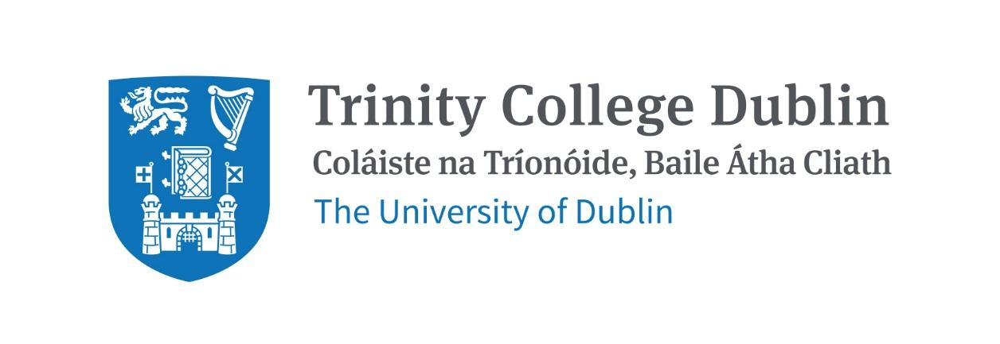

Trinity Business School

Financial Markets and Institutions

2026/2027

MODULE CODE: BUU33760
MODULE NAME: Financial Markets and Institutions
ECTS: 5 ECTS
Lecturer: Dr Fang Yao
E-mail: fang.yao@centralbank.ie
Office Hours: TBC

Pre- Requisite: BUU22550 Introduction to Finance

Available to exchange Students: Yes

MODULE DESCRIPTION
This module primarily focuses on understanding financial and economic concepts relating to the characteristics in banking and financial markets. This module attempts to provide students with a comprehensive understanding of the functioning of financial markets and the crucial role that financial institutions play in the economy. Students will explore different types of financial markets, number of financial crises that have occurred in recent decades, their causes and impacts on the real economy. Finally, students will examine financial regulation and the regulatory changes that have been implemented to attempt to prevent future crises.

LEARNING AND TEACHING APPROACH
This module is structured around a series of lectures and readings including research papers on emerging trends, as well as in-class discussions and group presentations.

MODULE-LEVEL LEARNING OUTCOMES

Having completed this module, the student should be able to:

- Understand the role of financial markets and institutions in the economy
- Examine the policies employed to mitigate financial risks and crisis
- Examine some of the financial crises that have occurred, their causes and effects
- Describe and evaluate the regulation that has been put in place to prevent future crises.
- Understand the role of central banks in financial stability and the health of financial systems.

RELATION TO DEGREE

WORKLOAD
Content | Indicative Number of Hours
Lecturing hours | 22
Preparation for lectures | 8
Individual assignment | 10
Group assignment | 15
Reading of assigned materials and active reflection on lecture and course content and linkage to personal experiences | 50
Final exam preparation | 20
Total | 125

TEXTBOOKS AND REQUIRED RESOURCES

Required core course textbooks:

Mishkin, F.S. & Eakins, S.G. (2023), Financial Markets and Institutions, (10th ed.), Harlow: Pearson Education.
De Haan, J., Schoenmaker, D., and Wierts, P. (2020), Financial Markets and Institutions: A European Perspective, (4th ed.), Cambridge: Cambridge University Press.

General Supplemental Readings

Readings will be assigned throughout the course and will be posted on Blackboard.

Student preparation for the module
Students are advised to read recommended articles in advance of each part of the course. They will also be expected to contribute to class discussions and participate in class assignments.

COURSE COMMUNICATION
Lecture slides and readings, assignment descriptions and announcements will be posted on Blackboard.

Please note that all course related email communication must be sent from your official TCD email address. Emails sent from other addresses will not be attended to.

ASSESSMENT
The assessment for this course is split between continuous assessment and final exam. The breakdown is as follows:

Continuous assessment: 30%
- Group project presentation (15%) Some important criteria considered when grading projects include: (1) creativity (2) originality and (3) engagement
- Individual report on group project (15%) Some important criteria considered when grading projects include: (1) originality (2) application of class materials (3) relevance

Final exam: 70%

Students who fail the module will need to submit a supplemental final assessment. The supplemental assessment will count for 100% of the grade.

Attendance at lectures and tutorials is required, any student who attends less than two thirds of lectures and tutorials may be deemed non-satisfactory as per college regulations and may not be allowed to sit the final exam.

https://www.tcd.ie/undergraduate-studies/academic-progress/attendance-course-work.php

PLAGIARISM

Please note the plagiarism provisions in the General Regulations of the University Calendar for the current year, and make sure you have completed the Online Tutorial on avoiding plagiarism 'Ready, Steady, Write', located at https://libguides.tcd.ie/academic-integrity/ready-steady-write

POLICY ON THE USE OF GENERATIVE AI TOOLS
Note: due to the assessment format, this policy used within the wider Trinity Business School is flagged, but unlikely to be relevant for this module.

The module leader may grant the use of generative AI tools for an assessment. If AI is permitted the following generative AI declaration must be included
Generative AI Declaration
Please choose A or B with regards to your use of generative AI tools in this project:
• A. Nothing to declare. I did not use generative AI software.
• B. I used generative AI software.
If you answer A and the module leader finds evidence that you used AI software, this behaviour will be considered as unethical, the assignment will be failed, and you will be penalized accordingly with reference to the TCD policy on academic misconduct. If you answer B, please clearly explain for which parts of submission you used AI software and how it helped you to improve your learning process within ethical guidelines. You should include your answer – 300 to 600 words approx.- in the appendix.
If the module leader has any concerns about the validity of any work undertaken by a student either before or after assessment submission, they may request any of the following three things.
  - Using Gibb’s (1988) reflective model, students may be asked to write a reflective piece on their learning of between 1000 to 2000 words.
  - A student may be asked to submit a 10-minute video presentation of their assessment.
  - A student may be asked to engage in a 10-minute Q&A about their assessment over zoom or in person.
If the module leader finds evidence for undeclared use of ChatGPT or other AI software, this behaviour will be considered as unethical, the assignment will be failed, and the student/s will be penalized accordingly with reference to the TCD policy on academic misconduct.

MODULE SCHEDULE

Term

Session | Date | Topic | Lecture & readings
1 | 18th Jan | Introducing core concepts: Direct and Indirect finance | - Introduction to Financial Markets  - Introduction to Financial Institutions  - Overview of financial system’s structure  - Indirect finance- Commercial banks: depository and lending functions, Investment banks and insurance companies
2 | 25th Jan | Financial Markets | - Money markets vs. capital markets  - Primary markets vs. secondary markets  - Spot markets vs. derivatives markets  - Equity markets, foreign reserve markets, bond markets etc
3 | 1st Feb  (Bank holiday – session to be recorded) | Financial Institutions: structure and functions | - Bank balance sheets – assets and liabilities  - Basics of banking  - Capital management  - Bank performance
4 | 8th Feb | Central Banks and Monetary Policy | - Defining central banks and core functions  - Role of central banks in monetary policy, financial stability and banking supervision  - Objectives of monetary policy  - Tools of monetary policy: conventional and unconventional
5 | 15th Feb | Green central banking
6 | 22nd Feb | Financial crisis | - Causes and consequences of financial crisis  - 2008 financial global crisis  - Too big to fail institutions  - Systemic risk  - Role of central banks in monitoring and addressing systemic risk
Reading Week
8 | 1st March | Study/review week  (no lecture)
9 | 8th March | Regulatory framework and prudential measures | Guest lecture
10 | 15th March |  | - Presentations
11 | 22nd March |  | - Presentations
12 | 5th April (Bank holiday – session to be recorded) |  | - Revision  - Exam format

Biographical Note:

Dr. Fang Yao is a Senior Economist in the Macro Finance Division at the Central Bank of Ireland. He holds a PhD in Economics from Humboldt University of Berlin.

Dr. Yao's primary research focus is on macroeconomics, DSGE modelling, household finance, housing markets, and the impacts of macroprudential policy, examining how regulatory measures affect mortgage lending, house prices, and household resilience. He has published his work in high-quality leading international journals including the Journal of Money, Credit and Banking, Journal of Housing Economics, Macroeconomic Dynamics, International Review of Economics and Finance, and Journal of International Money and Finance, among others. Beyond his academic contributions, Dr. Yao engages with the policy forum, especially central banking, by producing high-quality and impactful research outputs focusing on the implications of loan-to-value restrictions, mortgage credit conditions, and household financial resilience.

Prior to joining the Central Bank of Ireland in 2020, Dr. Yao worked as an Economist at the Reserve Bank of New Zealand, where he contributed to central banking analytics, research, and financial stability analysis. He also served as a Lecturer in the Department of Macroeconomics at the University of Erlangen-Nuremberg.

