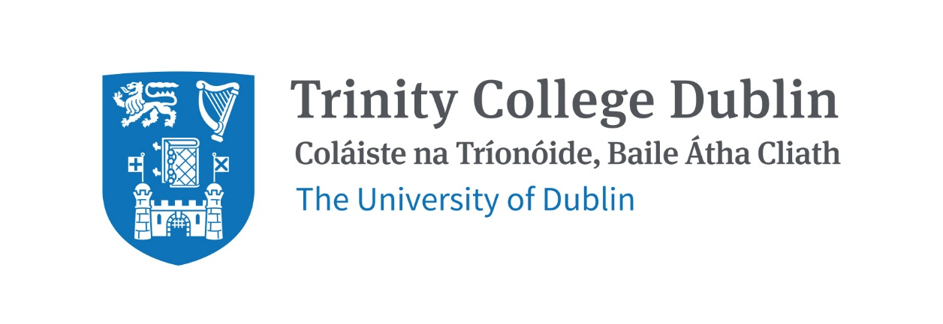

Trinity Business School

INVESTMENTS

2026/27

MODULE CODE: BUU33680

MODULE NAME: INVESTMENTS

ECTS: 5

Lecturer: Benjamin Lynch (blynch6@tcd.ie)

Office Hours: To be advised at the start of term

Pre- Requisite: BUU22550 Introduction to Finance

MODULE DESCRIPTION

Investing is a fundamental activity for individuals and institutions seeking to allocate capital, manage risk and build wealth over time. This module introduces the theory and practice of investment management and examines how investors make decisions under conditions of risk and uncertainty. The module covers the characteristics of major asset classes, portfolio construction and diversification, asset pricing models, market efficiency, investment funds and risk management. Students will develop practical skills in constructing portfolios, evaluating investment opportunities and managing investment risk. The course examines both traditional theories of investment and contemporary developments in financial markets, including sustainable investing and long-term value creation. Students will explore how prices are expected to behave in equilibrium and how they behave in reality, the role of market inefficiencies and behavioural biases, and how environmental and social externalities may affect asset values, risks and investment decisions. Throughout the module, students will become familiar with the concepts, analytical tools and practical techniques used by portfolio managers, investment analysts and other professionals working in the financial services industry.

LEARNING AND TEACHING APPROACH

This module is structured around a series of lectures, tutorials and readings. Tutorials will begin in week 2 of term and you will be assigned to a tutorial group on your portal. Students will be expected to prepare homework in advance and to contribute to discussions in tutorials.

Attendance is expected at all lectures and tutorials and attendance at tutorials will be recorded. As per college regulations, any student who attends less than two thirds of lectures and tutorials may be deemed non-satisfactory and may not be allowed to sit the final exam.

https://www.tcd.ie/undergraduate-studies/academic-progress/attendance-course-work.php

MODULE-LEVEL LEARNING OUTCOMES

Having successfully completed this module, students should be able to:
- Explain the characteristics and uses of major financial assets, investment vehicles and portfolio management strategies.
- Assess traditional investment theories and pricing models, and evaluate how market imperfections and environmental and social externalities may affect investment decisions.
- Evaluate the relationship between risk, return and the covariance of asset returns, and how these contribute to overall portfolio risk and performance.
- Use financial mathematics to calculate the optimal allocation of investment capital between risky assets such as equity, bonds and alternative assets.
- Apply investment theory and financial market data to evaluate investment opportunities, develop investment strategies and manage portfolio risk
- Critique the theories underlying asset pricing models such as the Single Index Model, the CAPM and Modern Portfolio Theory, and evaluate the principles of sustainable finance in the context of these models.

RELATION TO DEGREE
This course provides an understanding of the key concepts of the theories and practicalities of investing in risky assets in order to allocate consumption over time. It introduces the principles of sustainable finance. It is highly relevant for anyone considering a future career in the financial services industry or related career.

WORKLOAD
Content | Indicative Number of Hours
Lecturing hours | 22
Preparation for lectures | 8
Assignment | 25
Reading of assigned materials and active reflection on lecture and course content and linkage to personal experiences | 50
Final exam preparation | 20
Total | 125

TEXTBOOKS AND REQUIRED RESOURCES
The textbooks for this module are:

- Bodie, Kane & Marcus, Investments, McGraw-Hill. Any recent edition of this textbook will suffice. Alternatively the college library contains many other excellent textbooks on Investments which may also be consulted.
- Schoenmaker & Schramade, Principles of Sustainable Finance, Oxford University Press
This text is available in ebook and hardcopy from the TCD library.

General Supplemental Readings
Additional readings will also be assigned throughout the course and will be posted on Blackboard.
To access the Financial Times app for free on your phone create an account using your tcd login: https://www-ft-com.elib.tcd.ie/join/licence/f36c268d-3e6d-4c28-b451-3a143c5b9660/details or access the FT website https://libguides.tcd.ie/az.php?q=financial%20times. You can access the Economist at https://www-proquest-com.elib.tcd.ie/publication/publications_41716?accountid=14404.

Student preparation for the module
If you have not used Excel previously, I would strongly recommend that you complete this linked-in-learning course before the end of the first week of the module, https://www.linkedin.com/learning/excel-essential-training-office-365-microsoft-365/getting-started-with-excel-for-office-365?u=2217001. You can access all linked in learning courses for free using your tcd login, you may want to do other or more advanced excel courses, or choose an alternative excel course for your version of excel. You will be expected from the start of term to be able to use excel.

COURSE COMMUNICATION
Lecture slides, readings, tutorial questions and answers, assignment descriptions and announcements will be posted on Blackboard.
Please only send emails from your tcd email address, and address both me and teaching assistants respectfully (no hi, hiya, with no name), please check your programme handbook and module outline first to check if your question can be answered there, and if you feel that the answer to your question might benefit the whole class, please consider asking the question during lectures/tutorials.
Assessment for this course will be based as follows:
- 30% Group Assignment
- 70% Exam

Each group will have a maximum of six members. You may choose your own group and self-enrol your group on blackboard. Further details on the project will be available in the assignments folder on blackboard, and will be discussed in class.

A penalty for late submission will apply. Students unable to submit an assignment for medical reasons must produce a medical certificate within three working days of the missed submission date. Certificates received after that time will not be accepted.

Students who fail the module will sit a supplemental exam. The supplemental exam will count for 100% of the grade.

PLAGIARISM

Please note the plagiarism provisions in the General Regulations of the University Calendar for the current year, and make sure you have completed the Online Tutorial on avoiding plagiarism 'Ready, Steady, Write', located at https://libguides.tcd.ie/academic-integrity/ready-steady-write

POLICY ON THE USE OF GENERATIVE AI TOOLS
Note: due to the assessment format, this policy used within the wider Trinity Business School is flagged, but unlikely to be relevant for this module.

The module leader may grant the use of generative AI tools for an assessment. If AI is permitted the following generative AI declaration must be included
Generative AI Declaration
Please choose A or B with regards to your use of generative AI tools in this project:
• A. Nothing to declare. I did not use generative AI software.
• B. I used generative AI software.
If you answer A and the module leader finds evidence that you used AI software, this behaviour will be considered as unethical, the assignment will be failed, and you will be penalized accordingly with reference to the TCD policy on academic misconduct. If you answer B, please clearly explain for which parts of submission you used AI software and how it helped you to improve your learning process within ethical guidelines. You should include your answer – 300 to 600 words approx.- in the appendix.
If the module leader has any concerns about the validity of any work undertaken by a student either before or after assessment submission, they may request any of the following three things.
  - Using Gibb’s (1988) reflective model, students may be asked to write a reflective piece on their learning of between 1000 to 2000 words.
  - A student may be asked to submit a 10-minute video presentation of their assessment.
  - A student may be asked to engage in a 10-minute Q&A about their assessment over zoom or in person.
If the module leader finds evidence for undeclared use of ChatGPT or other AI software, this behaviour will be considered as unethical, the assignment will be failed, and the student/s will be penalized accordingly with reference to the TCD policy on academic misconduct.

MODULE SCHEDULE

Week of Term | Topic | Book Chapters (Readings will be added on Blackboard)
1 | - Introduction to Investments and the Life Cycle model of investing  - The Opportunity Set | Bodie et al, Ch 1, 2 & 3  S & S, Ch 1
2 | - Measuring Risk and Return  - Risk and Risk Aversion | Bodie Ch 5 & 6
3 | - Portfolio Effects  - The Efficient Frontier, Short Selling | Bodie Ch 6, 7 & 8
4 | - Optimising Investment Choice  - The Single Index Model | Bodie Ch 6, 7 & 8
5 | - The CAPM  - Efficient Market Hypothesis | Bodie Ch 9 & 11
6 | - Fundamental analysis and valuation  - Technical analysis
7 | Reading Week
8 | - Bonds  - Bond Markets | Bodie Ch 14 & 16  S & S Ch 9
9 | - Indices and Funds  - Alternative Investments | Bodie Ch 4 & 26
10 | - Guest Lecture  - Futures I | Bodie Ch 22
11 | - Futures II  - Options I | Bodie Ch 20
12 | - Options II  - Module Recap and Revision | Bodie Ch 20

Topic 1:

The first week will serve as an introduction to the course, discussing the life cycle model of investing, the challenges and opportunities presented by sustainable investment, and the opportunity set of the risk free and risky financial assets. In the second week we will examine different ways of measuring the return and risk of financial assets and how risk aversion affects investor choice.

Topic 2:

This section describes portfolio effects, covariance matrices and how to build an efficient frontier of the investment opportunity set. It also discusses short sales, and building an efficient frontier with and without short sales restrictions.

Topic 3:

Given the difficulty of building covariance matrices for large numbers of assets, we discuss the first of our asset pricing models, the Single Index Model. We then move on to discussing the most widely used equilibrium model, the Capital Asset Pricing Model. Finally, we discuss some of the many other equilibrium models, their uses and their limitations.

Topic 4:

We then move on to discussing the Investment Environment, looking at how products are issued and traded, and the main types of financial assets. We discuss asset allocation and how this is done in practice, especially when trying to match liabilities.

Topic 5:

We discuss the hypothesis of efficient markets, moving on to discuss the mispricing of externalities in traditional economic models and the principle of sustainable finance and long term value creation.

Topic 6:

Next we discuss bond markets and their role in capital allocation, as well as an analysis of indices and funds.

Topic 7:

Finally, we introduce derivatives and describe their use for risk management in Investment Portfolios, we will examine forward, future and option contracts and their applications.

Biographical Note:

Dr. Benjamin Lynch is Assistant Professor in Sustainable Finance at Trinity Business School. Benjamin completed a PhD in Sustainable Finance from Trinity Business School in 2022. His overarching research interests relates to investigating the incentives for investors and firms to alter the sustainability of their practices. His research portfolio encompasses a diverse range of topics within sustainable finance including the value and risk implications of varying levels of ESG (Environmental, Social, and Governance) performance, Carbon markets, and the importance of materiality in ESG integration investment strategies. Benjamin's research has been published in academic journals such as the European Journal of Finance and the International Journal of Finance & Economics. He regularly contributes to publications and events in the area of sustainable finance at national and international level in the academic and professional communities. He has lectured on courses in Sustainable Finance, ESG and Responsible Financial Management, Corporate Finance, International Finance, and Financial Markets & Institutions.

