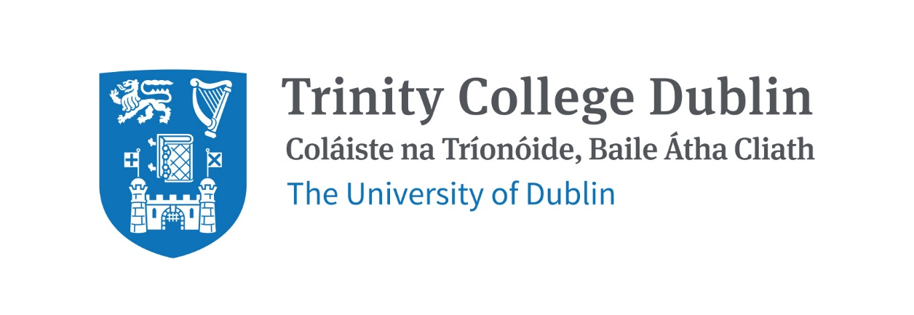

Trinity Business School

Business in Society

2026/2027

MODULE CODE: BUU33590
MODULE NAME: Business in Society
ECTS: 5
Lecturer: Dr Maria Gallo
E-mail: gallom@tcd.ie
Lecture Time: 10:00am – 12:00pm Fridays, Michaelmas Term, Venue TBC
Tutorials: TBC
Pre- Requisite: N/A
Available to exchange Students: Yes
Office Hours: TBC (after mid-term)

MODULE DESCRIPTION
The business – society relationship is a complex one with demands from societal, economic, and ethical challenges. This third-year undergraduate module critically examines the evolving relationship between business in society, exploring how organisations generate economic value while balancing the needs of diverse stakeholders.
By engaging with key theories and concepts, students critically examine themes related to business and social responsibility in the Irish and global context including business ethics, corporate social responsibility (CSR), corporate governance and business-government partnerships. The module also investigates the dynamics of external stakeholders, demonstrating how organisations leverage community relations, philanthropy, employee relations and corporate alumni networks are mechanisms to create social value, strengthen legitimacy, and build sustainable relationships with society. Through the analysis of contemporary cases and practical examples, students will evaluate how organisations respond to societal expectations and complex social issues.

LEARNING AND TEACHING APPROACH
The approach in this module is primarily in-person learning in class and tutorials. It is expected that students should complete the relevant pre-reading and engage actively in class discussions and group activities. Group activities will take place at scheduled times in the module.

MODULE-LEVEL LEARNING OUTCOMES

Having completed this module, the student should be able to:

- Evaluate theories of society and the concepts of the role of business in society.
- Assess the strategic, social and ethical dimensions of corporate social responsibility (CSR), and corporate governance.
- Explain and analyse business ethics and how business engages in partnership with government.
- Examine the role of stakeholder relationships, strategic philanthropy community and employee relations to create social value and enhance business legitimacy
- Apply relevant theories, strategies and tools to design business responses to societal challenges that balance social, economic and environmental objectives.

RELATION TO DEGREE
This module forms part of a suite of modules of Trinity Business School across the four years of our business-related degree programmes. This suite is focused on building awareness of and critically analysing a range of philosophical, ethical and societal issues and trends that affect the relationship between business and society. The aim is to enable the development of technically capable and conceptually proficient graduates who can thrive in a dynamic and fast-changing business environment. The module will serve to develop students’ understanding, knowledge and skills in critical analysis as well as provide valuable context for all other modules.

WORKLOAD
Content | Indicative Number of Hours
Lecturing hours (including tutorials) | 28
Preparation for lectures | 22
Group assignment | 20
Reading of assigned materials and active reflection on lecture and course content and linkage to personal experiences | 25
Final exam preparation | 25
Total | 120

TEXTBOOKS AND REQUIRED RESOURCES

Readings will be assigned by unit and available in the final version of this syllabus and will be posted on Blackboard.

Student preparation for the module
Students are advised to read recommended articles in advance of each part of the module. They will also be expected to meaningfully participate in class discussions, tutorials and workshops.

COURSE COMMUNICATION
Lecture slides and readings, assignment descriptions and announcements will be posted on Blackboard. Please note that lecture slides on their own will not replace attending classes as concepts will we will discussed complemented by active class participation.

Please note that all course related email communication must be sent from your official TCD email address. Emails sent from other addresses will not be attended to.

ASSESSMENT
The assessment for this course is split between a group assignment, class participation and a final exam. The breakdown is as follows:

Group Assignment (40%)
Class Participation (including attendance) (10%)
Final Exam (50%)

A detailed syllabus outlining the assignment will be posted on Blackboard before the first day of class.

Students who fail the module will need to sit a supplemental exam worth 100% of the assessment.

Attendance at lectures and tutorials is required, any student who attends less than two thirds of lectures and tutorials may be deemed non-satisfactory as per college regulations and may not be allowed to sit the final exam.

https://www.tcd.ie/undergraduate-studies/academic-progress/attendance-course-work.php

MODULE SCHEDULE
Michaelmas Term
Session (Week) | Date | Topic | Lecture & readings
1 (3) | 18 September 2026 | Introduction to Business in Society | All readings will be updated in this syllabus prior to the start of the module
2 (4) | 25 September 2026 | Strategic Management of Stakeholder Relationships | Tutorial 1 – commences this week
3 (5) | 2 October 2026 | Corporate Social Responsibility (CSR) | Tutorial 2
4 (6) | 9 October 2026 | Business and Ethics | No tutorial this week
5 (7) | 16 October 2026 | Social Value & Legitimacy I: Philanthropy and Community Relations | Tutorial 3
6 (8) | 23 October 2026 | Social Value & Legitimacy II: Employee Relations and Corporate Alumni | Tutorial 4
Reading Week (9)
8 (10) | 6 November 2026 | Social Value & Legitimacy Workshop | Tutorial 5
9 (11) | 13 November 2026 | Corporate Governance and Accountability | Tutorial 6
10 (12) | 20 November 2026 | Group workshop | No tutorial this week  (Group assignment due)
11 (13) | 27 November 2026 | Business, Government and Public Policy | Tutorial 7
12 (14) | 4 December 2026 | Review class | Tutorial 8 (Review)
NB: Tutorials will be scheduled in advance of the first day of class and added to the final syllabus.

Biographical Note:

Dr Maria Gallo is an Assistant Professor in Social Innovation at Trinity Business School. Her research focuses on philanthropy including pro-social behaviour such as volunteering, alumni engagement and financial donations. Her research was awarded the HS Warwick Award for Outstanding Published Research by the Council for the Advancement and Support of Education. She is currently completing research on women engaged in high net worth philanthropy in Ireland with colleagues in the Centre for Social Innovation at TBS. Previously, she was the expert alumni advisor at CERN in Switzerland and is a member of an implementation group for Ireland’s National Philanthropy Policy.

She completed her doctorate at the University of Sheffield in 2010 and her MA in Public Sector Management at University College Dublin. She holds a Postgraduate Certificate in Teaching and Learning in Higher Education from the University of Galway. She completed her undergraduate studies in Political Science and Criminology at the University of Toronto. She is the author of The Alumni Way: Building Lifelong Value from Your University Investment published by Policy Press – Bristol University Press with a second edition to be published in March 2027.

