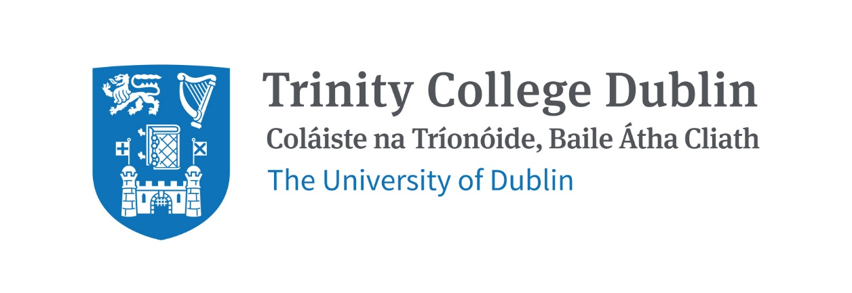

Trinity Business School

Work and well-being in organisations 2026 – 27

Module code: BU11560

ECTS: 5

Lecturer: | Dr Kiera Dempsey-Brench
Email: | Kiera.dempsey-brench@tcd.ie
Office hours: | After class or by appointment (please email to arrange) – room 206 TBS

MODULE DESCRIPTION
The World Health Organisation (WHO) has established the workplace as one of the priority settings for health promotion in the 21st century. Given that the workplace has a direct influence on the physical, mental, emotional, economic, and social well-being of workers, their families and society, it is important that the leaders of today and tomorrow recognise their role in ensuring employees have workplace well-being. This module provokes students to critically assess and analyse the work and well-being landscape, the tensions that exist, and strategies to help forge positive workplace relations and engagement so that workplace well-being can be optimised. Students will be introduced to topics such as organisational culture and leadership, stress management, burnout, happiness, failure, resilience and workplace design and learn how these apply to the individual, organisational and societal level.

LEARNING AND TEACHING APPROACH
The module is built around a total of 18-hour classes, which will include a mix of lectures, guest speakers, group work, case studies, and interactive discussion.

The prescribed materials (e.g., articles and activities) for this module are used to complement the material we will cover each week in class. You will be able to download or view relevant content for each week in advance of class. Please review this content and complete the recommended reading prior to class so you can participate in class discussions and exercises.

For each topic, reading references are provided, but you are encouraged to read widely around each topic. It is also important to keep informed about recent developments in the wider business context and consider the impact such developments can have on your personal wellbeing, and how that might influence external factors and environments, such as the work environment.

Students are expected to actively participate in the in-class activity and group work, with the aim of facilitating the formation of their capacity for independent inquiry, critical appraisal and sound judgment. Preparation for lectures and attendance at lectures are essential.

MODULE-LEVEL LEARNING OUTCOMES
- Understand and critically evaluate the importance of well-being in organisational settings.
- Explain and explore work-related factors that influence well-being in organisations.
- Critically analyse and assess the impact of cognitive, emotional and physical stress and its impact on well-being.
- Identify and develop strategies to help achieve inclusive workplaces that promote well-being.
- Search for and identify reliable, appropriate and high-quality research, and evaluate its relevance to real-world work and well-being examples, independently and in teams.

WORKLOAD
Content | Indicative Number of Hours
Lecturing hours | 22
Preparation for lectures (including reading of assigned materials and active reflection on lecture and course content and linkage to personal experiences | 22
Individual assignments | 30
Total | 74

TEXTBOOKS AND REQUIRED RESOURCES

Required core course textbook
There is no required textbook for this course.

General readings
Reading will be provided on Blackboard to students.

Student preparation for the module
The responsibility for learning for this module is on the student. The lectures are designed to provide the ideal learning environment. To get the best out of the lectures, preparation must be done by the student.

Printouts of some of the slides which will be used over the course of the module will be made available on the Blackboard.

Lecture notes are not published material and should not be the sole resource to be used for revision purposes or for preparing continuous assessments. Lecture notes, particularly slides, should be considered part of each lecture, they are offered to assist participants through the taking of notes, but should never be considered a substitute for taking notes. When notes are offered in advance of a lecture certain slides may be incomplete or left blank. It is up to learners to complete these notes.

COURSE COMMUNICATION
Communication will be through the course Blackboard site: http://mymodule.tcd.ie

Copies of the Lecture Power Point presentations will be posted on this site before each lecture.

Other reading materials as well as administrative information - e.g., dates, times, venues, deadlines, etc. will also be found on this site.

Students must ensure that they check their college email and visit the Blackboard course site regularly.

Please note that all course related email communication must be sent from your official TCD email address. Emails sent from other addresses will not be attended to.

ASSESSMENT
Individual continuous assignment | Part 1: Tuesday 27th October at 10am  Part 2: Weekly from week beginning 26th October  Part 3: Tuesday 8th December at 10am via Blackboard | 100%  (see assignment brief for breakdown)

Guidelines for preparing assignments
Students will be provided with guidelines on the assignments at the beginning of the module, with opportunities for drop-in sessions outside of class time to ask questions on the assignments.

All materials pertaining to the assignment will be posted on Blackboard.

Assignments are due by the specified due time and date.

Any exceptions to these conditions must be obtained from the module leader in advance.

All assignments are required to be submitted to Blackboard. See http://www.tcd.ie/CAPSL/students/integrity-plagarism/ for more information on university policies on assessments and plagiarism.

Note on assessment of students allowed to sit a supplemental exam

Students who have failed the module and are allowed to submit an assigned individual assignment will be examined by this individual assignment only. Previous CA (continuous assessment) will not be taken into account in the overall module grade.

MODULE SCHEDULE

Session, date & room | Title | Pre-work and readings
1  23nd Sept  TBS 328 | Introduction to module | - Read article: Bakker, A. B., & Demerouti, E. (2007). The job demands‐resources model: State of the art. Journal of Managerial Psychology, 22(3), 309-328.
2  30th Sept  Room 231 | Stress management and happiness | - Read article: Schwartz, T. (2012). Stress is not your enemy . Harvard Business Review. April 24. Available at: https://hbr.org/2012/04/stress-is-not-your-enemy  - Read article: Mogilner Holmes, C. (2018).’ What kind of happiness do people value most?’ Harvard Business Review. November 18. Available at: https://hbr.org/2018/11/what-kind-of-happiness-do-people-value-most#:~:text=We%20found%20that%20those%20who,uncertain%20and%20life%20is%20short  Preparation work: Do Big Five Personality test (https://prosper.liverpool.ac.uk/postdoc-resources/reflect/the-big-five/) Reflect on your results: (1) what surprised you/didn’t surprise you? (2) Are there results you’d like to change? (3)How do you think this might influence you when it comes to stress management.
3  7th Oct  Room 231 | Burnout | - Read case study: Goldman Sach’s case study  - Preparation work: Upload a picture of what burnout looks like to you. Upload to Blackboard by Monday 6th at midday (12pm, noon).
4  14th Oct  Room 231 | The subtle art of cues | - Read article: Fiske, S.T., Cuddy, A.J., & Glick, P. (2007). Universal dimensions of social cognition: Warmth and competence. TRENDS in Cognitive Sciences, 11(2), p9 77-84.
5  21st October  Room 231 | Positive psychology and individual assignment breakdown | Reading/viewing TBA (Keep your eyes peeled on Blackboard, as required pre-work will be posted to here).
27th Oct  Room 231 | Reading week | Reading week
6  4th Nov  Room 231 | Psychological safety and growth mindset | We are joined by guest lecturer Sophie Dooley, who will share insights on psychological safety and growth mindset.  Reading/viewing TBA (Keep your eyes peeled on Blackboard, as required pre-work will be posted to here).
7  11th Nov  Room 231 | Organisational culture | - Read case study: Theranos: Whistle-blowing in the workplace  - Preparation work: What would you have done in Cheung’s position?  Suggested watching: The Dropout (Disney+)
8  18th Nov  Room 231 | Team resilience | Reading/viewing TBA (Keep your eyes peeled on Blackboard, as required pre-work will be posted to here).
9  25th Nov  Room 231 | Industry guest lecture | We will have guest speakers from industry to discuss well-being in practice.  Reading/viewing TBA (Keep your eyes peeled on Blackboard, as required pre-work will be posted to here).
10  2nd Dec  Room 231 | Workplace design & drop in session on individual assignment | - Read article: Augustin, S. (2014, October 28). Rules for designing an engaging workplace. Harvard Business Review. Available online: https://hbr.org/2014/10/rules-for-designing-an-engaging-workplace  In the second part of the session, students will be able to seek feedback/ask questions about their individual assignment.

Biographical Note:

Dr Kiera Dempsey-Brench is an Assistant Professor in Human Resource Management and Programme Director of the Masters in Human Resource Management at Trinity Business School, Trinity College Dublin. She holds a BSc (Hons) in International Business with Spanish, an MSc in Management and Corporate Sustainability, and a PhD in Business. She has held previous positions as an Assistant Professor in Management at Maynooth University.

Kiera’s research is guided by an overarching agenda on how organisations can develop employees’ professional and leadership skills, whilst simultaneously making a positive impact on the community. Kiera is passionate in driving forward human resource management (HRM) and corporate social responsibility (CSR) in research and practice, so that social challenges can be mitigated. As such, a large line of her inquiry looks at the intersection of HR and CSR. She explores how HR and CSR functions break down silos in order to collaborate to create value, and what factors influence or inhibit the collaboration process. She is also interested in responsible management and social initiatives, such as employee volunteering and international service-learning assignments.

Kiera’s research appears in high-rated journals, such as the International Journal of Human Resource Management, MIT Sloan Management Review, and Human Resource Management Review. Her work has also been recognised internationally and won awards, such as the Best Paper in the 2021 Management Education Division of the Academy of Management Conference. Lastly, Kiera advocates for bridging the scholarly-practitioner divide, and has collaborated and consulted a number of Fortune 500 organisations to solve existing business problems and create new knowledge.

