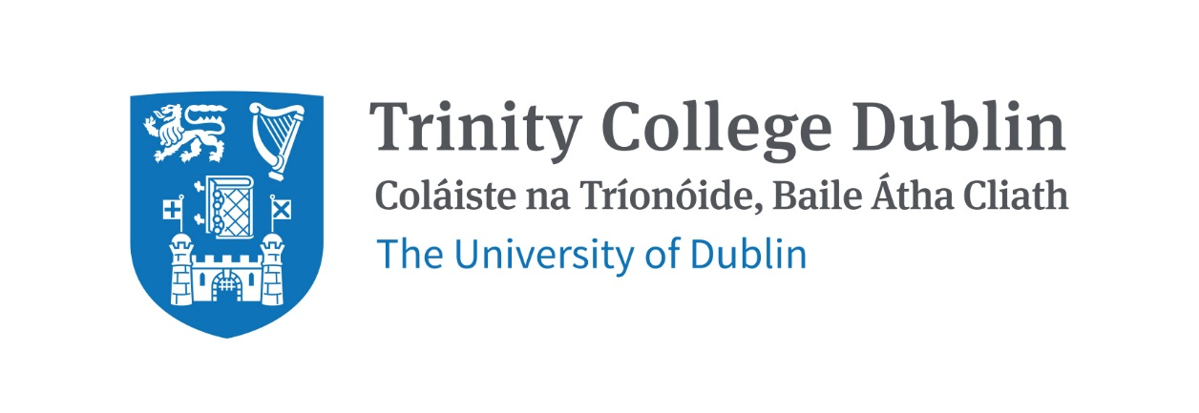

Trinity Business School

FUNDAMENTALS OF PHILOSOPHY, ETHICS AND SOCIAL SCIENCE

2026/27

MODULE CODE: BUU11540

MODULE NAME: FUNDAMENTALS OF PHILOSOPHY, ETHICS AND

SOCIAL SCIENCE

ECTS: 10 ECTS

Lecturer: Dr. Michael Markunas

E-mail: markunam@tcd.ie
Office Hours: By appointment

MODULE DESCRIPTION

This module is an introduction to a broad range of topics within philosophy, ethics, and the social sciences. It arms students with the conceptual tools and the context needed to frame and evaluate challenging questions about what we should do in business and society at large.

In the Michaelmas semester, we focus on understanding various wrongs with an emphasis on those we are likely to encounter in business (e.g., imposing risks, corruption, exploitation). We will discuss both what these kinds of behaviour are and what’s bad about them, as well as how they might be avoided and what should happen when they are not.

In the Hillary semester, the focus shifts towards our positive obligations to others and how best to use social institutions to satisfy them. This requires us to engage with economic and political theory, and it calls us to question not only the grounds for and scope of our duties but also the ways that historical and economic factors influence the roles of the market and the state.

LEARNING AND TEACHING APPROACH

The approach taken involves students doing close readings of recent and innovative texts from a variety of subfields. This is coupled with detailed lectures for background context and distillation of the main ideas as well as tutorials for students to become comfortable discussing these challenging ideas together. Papers and examinations offer students further opportunities to consider how these ideas interact and, ultimately, what they think about them.

LEARNING OUTCOMES

LO1: Become familiar with the primary philosophical methodology of reasoning and conceptual analysis.

LO2: Become familiar with current issues and methodology in social science, particularly in economics, sociology, and political theory.

LO3: Leverage the conceptual tools of ethics and political theory to frame and understand challenging normative questions in contemporary business contexts.

LO4: Develop critical thinking, reading, and writing skills on contemporary business-ethical debates including the extent of our personal, economic, and political obligations.

LO5: Develop an ability to discuss these challenging issues productively with peers.

WORKLOAD
Content | Indicative Number of Hours
Lecturing hours | 2 per week for 22 weeks
Preparation for lectures | 1 per week for 22 weeks
Individual assignments | 20
Reading of assigned materials and active reflection on lecture and course content and linkage to personal experiences | 4 per week for 22 weeks
Final exam preparation | 20
Total | 194

TEXTBOOKS AND REQUIRED RESOURCES

Required core course textbook:

There is no textbook required. All required readings will be provided through Blackboard.

General Supplemental Readings

The following two background books may prove useful to alongside the module. Both are available at the Boland Library and available for purchase online at reasonable costs.

- What is this thing called ethics? By Christopher Bennett
- An Introdcution to Political Philosophy by Jonathan Wollf

Student preparation for the module

Students should read assigned reading before each class and consider how it connects with readings done before.

COURSE COMMUNICATION

Please note that all course related email communication must be sent from your official TCD email address. Emails sent from other addresses will not be attended to.

ASSESSMENT
In-class Term Essay (30%): due towards end of Michaelmas term
Final exam (70%): to be taken at end of Hilary Term

More detail to follow.

Students who fail the module will need to submit a supplemental exam. The supplemental exam will count for 100% of the grade.

Attendance at lectures and tutorials is required, any student who attends less than two thirds of lectures and tutorials may be deemed non-satisfactory as per college regulations and may not be allowed to sit the final exam.
https://www.tcd.ie/undergraduate-studies/academic-progress/attendance-course-work.ph

Biographical Note:

Dr. Markunas completed an M.Phil. and PhD in Philosophy at University College London. He did his undergraduate work at UC Berkeley. He is a Fellow of the Higher Education Academy and has taught across a wide range of modules. His research lies at the intersection of business ethics, epistemology, and social ontology. His work has been published in venues such as Synthese, Proceedings of the International Wittgenstein Symposium, The Institute of Philosophy and What to do about now?

